A Team Constructions
It’s the middle of winter and Hannibal, Face, BA and Murdoch have been captured (again!). Their captures have foolishly looked them in a warehouse with tools and materials as well as BA’s van. Their plan is to make some attachments to the van so that it is streamline and acts as a snowplough.
Can you help them construct a scale model of the pieces they need to make?


Use a scale of 1cm:50cm.
The van is 2.5 metres wide and 5 metres long.
They need the triangles below that are not drawn to scale:
Shape | Position on BA’s van
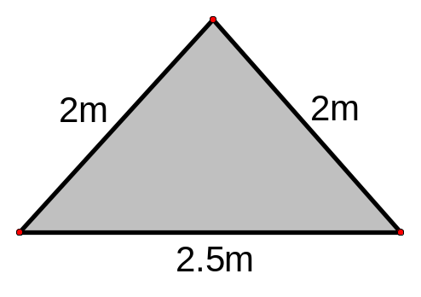 | For the front of the van.
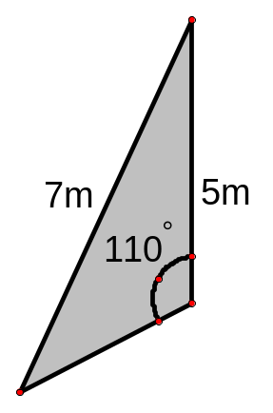 | For the side of the van.
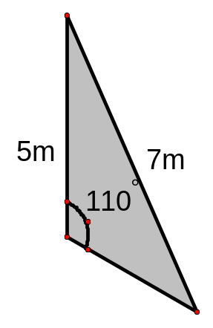 | For the other side of the van.

You only have a pencil, ruler, compass and protractor at your disposal!

