QQQ – Statistics Year 1 – Chapter 6 – DRVs & Binomial Distribution (Version 2)
Total Marks: 24
(24 = Platinum, 22 = Gold, 19 = Silver, 16 = Bronze)
1. The probability distribution for the discrete random variable $X$ is shown below.
$x$ | 1 | 2 | 3 | 4 | 5
$\text{P}(X=x)$ | 0.2 | 0.15 | $a$ | 0.27 | 0.14

Find the value of $a$. [1]
(Total 1 marks)
OCR MEI June 2022 Paper 2 Q1
2. A game consists of spinning a circular wheel divided into numbered sectors as shown below.
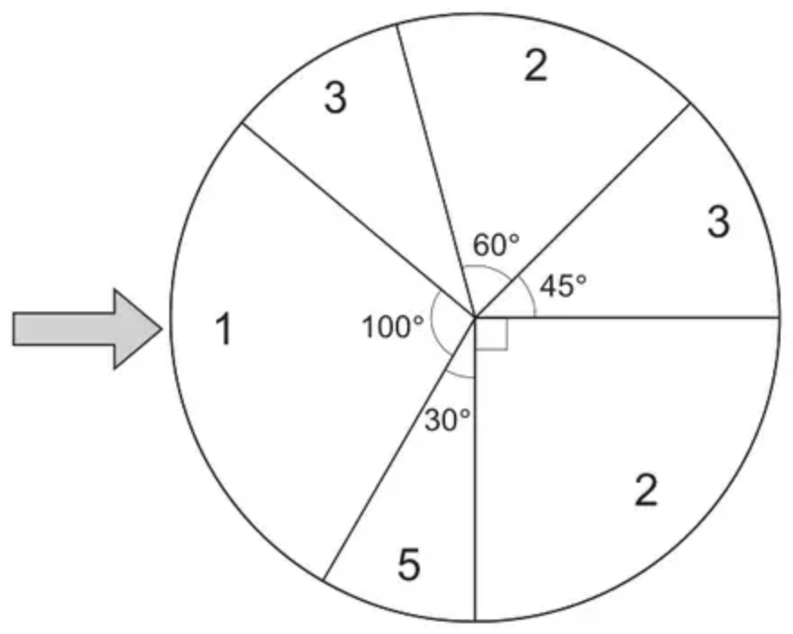
On each spin the score, $X$, is the value shown in the sector that the arrow points to when the spinner stops.
The probability of the arrow pointing at a sector is proportional to the angle subtended at the centre by that sector.
(a) Show that $\text{P}(X=1)=\frac{5}{18}$ [1 mark]
(b) Complete the probability distribution for $X$ in the table below.
$x$ | 1
$\text{P}(X=x)$ | $\frac{5}{18}$

[2 marks]
(Total 3 marks)
AQA June 2020 Paper 2 Q17
3. It is known that 3% of the batteries sold in a supermarket are faulty.
Batteries are sold in packs of 12.
It can be assumed that the number of faulty batteries in a pack can be modelled by a binomial distribution.
(a) State one assumption, in context, necessary for the binomial distribution to be valid. [1 mark]
(b) A pack of batteries is chosen at random.
Find the probability that exactly one battery in this pack is faulty. [1 mark]
(c) A quality control supervisor tests 10 randomly chosen packs for faulty batteries.
Find the probability that at least two of the chosen packs have exactly one battery which is faulty. [2 marks]
(Total 4 marks)
AQA June 2025 Paper 2 Q18
4. The discrete random variable $X$ is modelled by the probability distribution defined by:
$$\text{P}(X=x)=\{\begin{matrix}cx & x=1,2 \\ kx^{2} & x=3,4 \\ 0 & \text{otherwise}\end{matrix}$$
where $k$ and $c$ are constants.
(a) State, in terms of $k$, the probability that $X=3$ [1 mark]
(b) Given that $\text{P}(X⩾3)=3×\text{P}(X⩽2)$
Find the exact value of $k$ and the exact value of $c$. [4 marks]
(Total 5 marks)
AQA June 2022 Paper 2 Q15
5. The probability that Janice sees a kingfisher on any particular day is 0.3. She notes the number, $X$, of days in a week on which she sees a kingfisher.
(i) State one necessary condition for $X$ to have a binomial distribution. [1]
Assume now that $X$ has a binomial distribution.
(ii) Find the probability that, in a week, Janice sees a kingfisher on exactly 2 days. [1]
Each week Janice notes the number of days on which she sees a kingfisher.
(iii) Find the probability that Janice sees a kingfisher on exactly 2 days in a week during at least 4 of 6 randomly chosen weeks. [3]
(Total 5 marks)
OCR A June 2018 Paper 1 Q11
6. A fair 5-sided spinner has sides numbered 1, 2, 3, 4 and 5
The spinner is spun once and the score of the side it lands on is recorded.
(a) Write down the name of the distribution that can be used to model the score of the side it lands on. (1)
The spinner is spun 28 times.
The random variable $X$ represents the number of times the spinner lands on 2
(b)
(i) Find the probability that the spinner lands on 2 at least 7 times.
(ii) Find $\text{P}(4⩽X<8)$ (5)
(Total 6 marks)
Edexcel June 2019 Statistics Q3
Solutions
1.
Scheme | Marks | AO
$a=0.24$ | B1 | 1.1
 | [1]

Notes
NB $0.2+0.15+a+0.27+0.14=1$
2.
Mark scheme (a)
Scheme | Marks | AO
Shows clearly where $\frac{5}{18}$ comes from.  Need to see $\frac{100}{360}$ and simplification. | B1 | 3.1b
 | (1)

Typical solution
$$\text{P}(X=1)=\frac{100}{360}$$
$$=\frac{5}{18}$$
Mark scheme (b)
Scheme | Marks | AO
States at least one pair of $(X,\text{P}(X=x))$ correctly | M1 | 1.1a
Completes table correctly ACF | A1 | 1.1b
 | (2)
 | (3 marks)

Typical solution
$X$ | 2 | 3 | 5
$\text{P}(X=x)$ | $\frac{5}{12}$ | $\frac{2}{9}$ | $\frac{1}{12}$

3.
Mark scheme (a)
Scheme | Marks | AO
States one assumption in context.  Accept  • One battery being faulty is independent of any other battery OE  • Two possible outcomes Battery is faulty or not faulty  • The probability of a battery being faulty is constant at 3%  But not fixed number of trials | E1 | 3.5b
 | (1)

Typical solution
One battery being faulty is independent of any other battery being faulty.
Mark scheme (b)
Scheme | Marks | AO
Obtains AWFW [0.2575, 0.26] | B1 | 1.1b
 | (1)

Typical solution
P(1 battery is faulty) = 0.2575
Mark scheme (c)
Scheme | Marks | AO
States B(10, their $p$) from (b) | M1 | 3.4
Obtains AWFW [0.77, 0.78] | A1 | 1.1b
 | (2)
 | (4 marks)

Typical solution
Use a $X∼\text{B}(10,0.2575)$ model
$$\text{P}(X⩾2)=1−\text{P}(X⩽1)$$
$$=1−0.2275…$$
$$=0.772$$
4.
Mark scheme (a)
Scheme | Marks | AO
Obtains $9k$ | B1 | 1.1b
 | (1)

Typical solution
$$9k$$
Mark scheme (b)
Scheme | Marks | AO
Uses probabilities $c$, $2c$, $9k$, $16k$ | B1 | 1.1b
Uses $\text{Σ}p=1$ to obtain an equation in $k$ and $c$, at least one term in $k$ or $c$ correct  or  Uses ratio of 1:3(:4) to obtain an equation either in $c$ related to 0.25 or in $k$ related to 0.75. At least one term in $k$ or $c$ correct  [$c+2c=0.25$; $9k+16k=0.75$] | M1 | 3.1a
Uses ratio of 1:3 to find an equation in $k$ and $c$, at least one term in $k$ or $c$ correct  or  Obtains a second equation in $k$ or $c$ using the ratio of 1:3(:4), at least one term in $k$ or $c$ correct | M1 | 1.1a
Obtains correct exact values for $k$ and $c$ (ACF but must be exact) | A1 | 1.1b
 | (4)
 | (5 marks)

Typical solution
$$c+2c+9k+16k=1$$
$$3c+25k=1$$
$$9k+16k=3(c+2c)$$
$$25k=9c$$
$$c=\frac{1}{12}$$
$$k=\frac{3}{100}$$
5.
Mark scheme (i)
Scheme | Marks | AO
Prob of seeing a kingfisher is the same each day  OR Seeing a kingfisher on one day is independent of other days | B1 | 3.5b
 | [1]

Notes
B1: oe
In context
Not: Prob of seeing kingfisher is indep
Mark scheme (ii)
Scheme | Marks | AO
$0.318$ (3 sf) | B1 | 3.4
 | [1]

Notes
B1: BC Allow 0.32 or 0.317
Mark scheme (iii)
Scheme | Marks | AO
$0.318$ or their (ii) used in a calculation | M1 | 3.1b
$1−\text{P}(X⩽3)$ using $p=0.318$ or their (ii) | M1 | 1.1
$=0.0854$ | A1 | 1.1
 | [3]

Notes
M1 (first): or B(6, their (ii)) stated
M1 (second): or $\text{P}(X=4,5,6)$ attempted using $p=0.318$ or their (ii)
A1: Allow 0.0845 to 0.0875 Allow 2 sf BC
6.
Mark scheme (a)
Scheme | Marks | AO
(Discrete) uniform (distribution) | B1 | 1.2
 | (1)

Notes
Continuous uniform is B0
Mark scheme (b)
Scheme | Marks | AO
$\text{B}(28,0.2)$ | B1 | 3.3
(i) $\text{P}(X⩾7)=1−\text{P}(X⩽6)[=1−0.6784…]$ | M1 | 3.4
awrt 0.322 | A1 | 1.1b
(ii) $\text{P}(4⩽X<8)=\text{P}(X⩽7)−\text{P}(X⩽3)[=0.818…−0.160…]$ | M1 | 3.1b
awrt 0.658 | A1 | 1.1b
 | (5)
 | (6 marks)

Notes
B1: for identifying correct model, $\text{B}(28,0.2)$
allow B, bin or binomial
may be implied by one correct answer or sight one correct probability i.e. awrt 0.678, awrt 0.818 or awrt 0.160
$\text{B}(0.2,28)$ is B0 unless it is used correctly
(i)
M1: Writing or using $1−\text{P}(X⩽6)$ or $1−\text{P}(X<7)$
A1: awrt 0.322 (correct answer only scores M1A1)
(ii)
M1: Writing or using $\text{P}(X⩽7)−\text{P}(X⩽3)$
or $\text{P}(X<8)−\text{P}(X<4)$
or $\text{P}(X=4)+\text{P}(X=5)+\text{P}(X=6)+\text{P}(X=7)$
Condone $\text{P}(4)$ as $\text{P}(X=4)$, etc.
A1: awrt 0.658 (correct answer only scores M1A1)

