QQQ – Pure Year 2 – Chapter 8 – Parametric Equations (Version 2)
Total Marks: 23
(23 = Platinum, 21 = Gold, 18 = Silver, 16 = Bronze)
1.
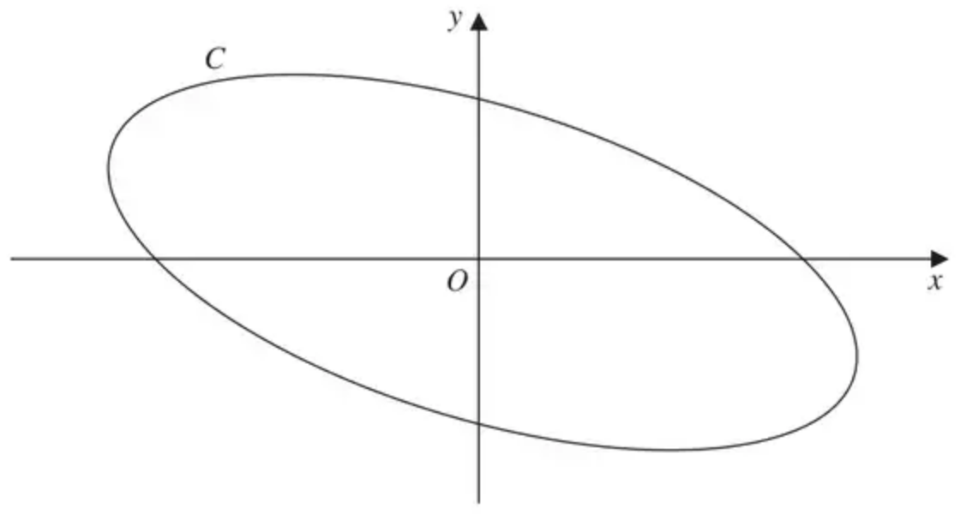
Figure 3
Figure 3 shows a sketch of the curve $C$ with parametric equations
$$x=4cos⁡(t+\frac{π}{6}), y=2sin⁡t, 0⩽t<2π$$
(a) Show that
$$x+y=2\sqrt{3}cos⁡t$$
(3)
(b) Show that a cartesian equation of $C$ is
$$(x+y)^{2}+ay^{2}=b$$
where $a$ and $b$ are integers to be determined. (2)
(Total 5 marks)
Edexcel C4 June 2014 Q5
2. Fig. 12 shows a curve C with parametric equations $x=4t^{2},y=8t$. The point P, with parameter $t$, is a general point on the curve. Q is the point on the line $x+4=0$ such that PQ is parallel to the $x$-axis. R is the point $(4,0)$.
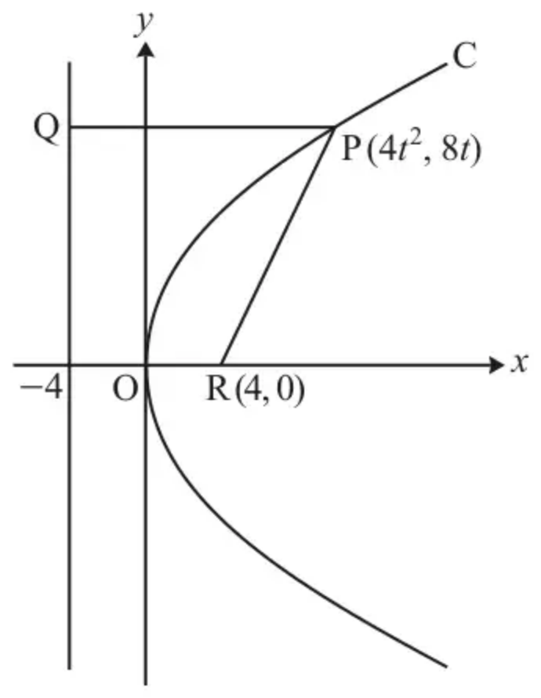
Fig. 12
(a) Show algebraically that P is equidistant from Q and R. [4]
(b) Find a cartesian equation of C. [2]
(Total 6 marks)
OCR MEI June 2019 Paper 1 Q12
3. The curve $C$ is defined, for $0⩽t<2π$, by the parametric equations
$x=4k+ksin⁡t, y=2+4cos⁡t,$
where $k$ is a constant.
(a) Find a cartesian equation for $C$. You do not need to simplify your answer. [2]
You are given that $C$ is a circle.
(b)
(i) Determine the radius of $C$. [2]
(ii) Find the possible coordinates for the centre of $C$. [2]
(Total 6 marks)
OCR A June 2024 Paper 3 Q6
4.
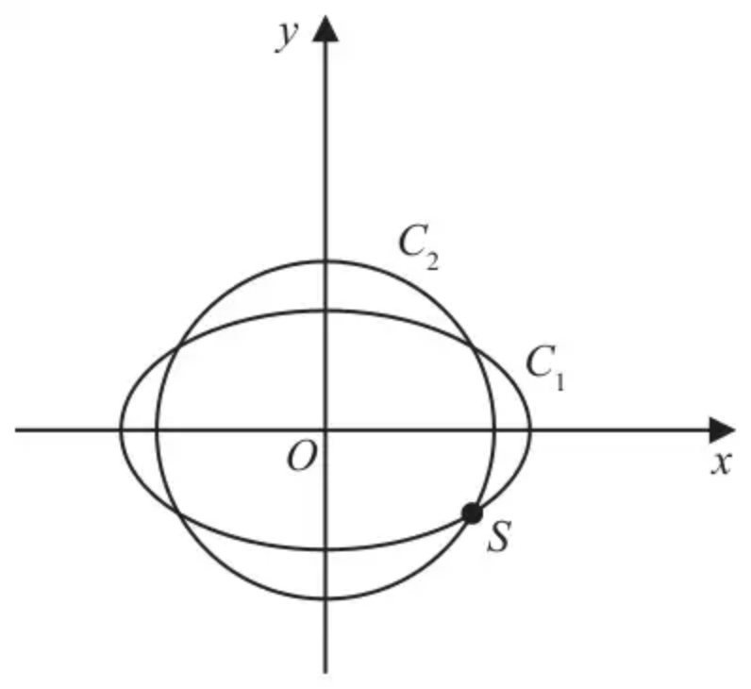
Figure 2
The curve $C_{1}$ with parametric equations
$$x=10cos⁡t, y=4\sqrt{2}sin⁡t, 0⩽t<2π$$
meets the circle $C_{2}$ with equation
$$x^{2}+y^{2}=66$$
at four distinct points as shown in Figure 2.
Given that one of these points, $S$, lies in the 4th quadrant, find the Cartesian coordinates of $S$. (6)
(Total 6 marks)
Edexcel June 2019 Paper 2 Q4
Solutions
1.
Mark scheme (a)
Scheme | Marks
$x=4cos⁡(t+\frac{π}{6}), y=2sin⁡t$
Main Scheme  $x=4(cos⁡tcos⁡(\frac{π}{6})−sin⁡tsin⁡(\frac{π}{6}))$  $cos⁡(t+\frac{π}{6})→cos⁡tcos⁡(\frac{π}{6})±sin⁡tsin⁡(\frac{π}{6})$ | M1 oe
So, $\{x+y\}=4(cos⁡tcos⁡(\frac{π}{6})−sin⁡tsin⁡(\frac{π}{6}))+2sin⁡t$  Adds their expanded $x$ (which is in terms of $t$) to $2sin⁡t$ | dM1
$=4((\frac{\sqrt{3}}{2})cos⁡t−(\frac{1}{2})sin⁡t)+2sin⁡t$
$=2\sqrt{3}cos⁡t∗$  Correct proof | A1 *
 | (3)

Notes
Alternative Method 1
Scheme | Marks
$x=4(cos⁡tcos⁡(\frac{π}{6})−sin⁡tsin⁡(\frac{π}{6}))$  $cos⁡(t+\frac{π}{6})→cos⁡tcos⁡(\frac{π}{6})±sin⁡tsin⁡(\frac{π}{6})$ | M1 oe
$=4((\frac{\sqrt{3}}{2})cos⁡t−(\frac{1}{2})sin⁡t)=2\sqrt{3}cos⁡t−2sin⁡t$
So, $x=2\sqrt{3}cos⁡t−y$  Forms an equation in $x$, $y$ and $t$. | dM1
$x+y=2\sqrt{3}cos⁡t∗$  Correct proof | A1 *
 | (3)

Question 5 Notes
M1: $cos⁡(t+\frac{π}{6})→cos⁡tcos⁡(\frac{π}{6})±sin⁡tsin⁡(\frac{π}{6})$ or $cos⁡(t+\frac{π}{6})→(\frac{\sqrt{3}}{2})cos⁡t±(\frac{1}{2})sin⁡t$
Note: If a candidate states $cos⁡(A+B)=cos⁡Acos⁡B±sin⁡Asin⁡B$, but there is an error in its application then give M1.
Awarding the dM1 mark which is dependent on the first method mark
Main dM1: Adds their expanded $x$ (which is in terms of $t$) to $2sin⁡t$
Note: Writing $x+y=…$ is not needed in the Main Scheme method.
Alt 1 dM1: Forms an equation in $x$, $y$ and $t$.
A1*: Evidence of $cos⁡(\frac{π}{6})$ and $sin⁡(\frac{π}{6})$ evaluated and the proof is correct with no errors.
Note: $\{x+y\}=4cos⁡(t+\frac{π}{6})+2sin⁡t$, by itself is M0M0A0.
Mark scheme (b)
Scheme | Marks
Main Scheme  ${(\frac{x+y}{2\sqrt{3}})}^{2}+{(\frac{y}{2})}^{2}=1$  Applies ${cos⁡}^{2}t+{sin⁡}^{2}t=1$ to achieve an equation containing only $x$’s and $y$’s. | M1
$⇒\frac{(x+y)^{2}}{12}+\frac{y^{2}}{4}=1$
$⇒(x+y)^{2}+3y^{2}=12$  $(x+y)^{2}+3y^{2}=12$ $\{a=3,b=12\}$ | A1
 | (2)
 | (5 marks)

Notes
Alternative Method 1
Scheme | Marks
$(x+y)^{2}=12{cos⁡}^{2}t=12(1−{sin⁡}^{2}t)=12−12{sin⁡}^{2}t$
So, $(x+y)^{2}=12−3y^{2}$  Applies ${cos⁡}^{2}t+{sin⁡}^{2}t=1$ to achieve an equation containing only $x$’s and $y$’s. | M1
$⇒(x+y)^{2}+3y^{2}=12$  $(x+y)^{2}+3y^{2}=12$ | A1
 | (2)

Alternative Method 2
Scheme | Marks
$(x+y)^{2}=12{cos⁡}^{2}t$  As $12{cos⁡}^{2}t+12{sin⁡}^{2}t=12$  then $(x+y)^{2}+3y^{2}=12$ | M1, A1
 | (2)

M1: Applies ${cos⁡}^{2}t+{sin⁡}^{2}t=1$ to achieve an equation containing only $x$’s and $y$’s.
A1: leading $(x+y)^{2}+3y^{2}=12$
SC: Award Special Case B1B0 for a candidate who writes down either
• $(x+y)^{2}+3y^{2}=12$ from no working
• $a=3,b=12$, but does not provide a correct proof.
Note: Alternative method 2 is fine for M1 A1
Note: Writing $(x+y)^{2}=12{cos⁡}^{2}t$ followed by $12{cos⁡}^{2}t+a(4{sin⁡}^{2}t)=b⇒a=3,b=12$ is SC: B1B0
Note: Writing $(x+y)^{2}=12{cos⁡}^{2}t$ followed by $12{cos⁡}^{2}t+a(4{sin⁡}^{2}t)=b$
• states $a=3,b=12$
• and refers to either ${cos⁡}^{2}t+{sin⁡}^{2}t=1$ or $12{cos⁡}^{2}t+12{sin⁡}^{2}t=12$
• and there is no incorrect working
would get M1A1
2.
Mark scheme (a)
Scheme | Marks | AO
$x=4t^{2}, y=8t$  $\text{PQ}=4+4t^{2}$ | B1 | 2.1
${\text{PR}}^{2}=(4t^{2}−4)^{2}+(8t)^{2}$ | M1 | 2.1
$=16t^{4}+32t^{2}+16$ | M1 | 2.1
$=(4+4t^{2})^{2}={\text{PQ}}^{2}$  So equidistant | A1 | 2.1
 | [4]

Notes
Due to the error on the paper, all candidates will get 4 marks for question 12(a) and all candidates will get 2 marks for 12 (b). The MS for the correct question is given for completeness.
(The question paper as sat printed $y=4t$; OCR’s post-exam correction changes it to $y=8t$, as shown here.)
M1: Use of distance formula
M1: Must show some algebraic manipulation
Correct expression for PR or PR²
A1: Conclusion comparing PQ and PR or PQ² and PR²
Mark scheme (b)
Scheme | Marks | AO
Substitute $t=\frac{y}{8}$ to obtain $x=4{(\frac{y}{8})}^{2}$ | M1 | 1.1a
$y^{2}=16x$ | A1 | 1.1b
 | [2]

Notes
M1: Rearranged equation must be used
allow use of $t=\frac{\sqrt{x}}{2}$ oe used for M1A0.
A1: Allow any equivalent form including $y=±4\sqrt{x}$
3.
Mark scheme (a)
Scheme | Marks | AO
$x=4k+ksin⁡t,y=2+4cos⁡t$  $sin⁡t=\frac{x−4k}{k},cos⁡t=\frac{y−2}{4}$ and use of ${sin⁡}^{2}t+{cos⁡}^{2}t=1$ | M1 | 3.1a
$\frac{(x−4k)^{2}}{k^{2}}+\frac{(y−2)^{2}}{16}=1$ | A1 | 1.1
 | [2]

Notes
M1: Re-arranges to obtain both $sin⁡t=\frac{x±4k}{k}$ and $cos⁡t=\frac{y±2}{4}$ and use ${sin⁡}^{2}t+{cos⁡}^{2}t=1$ to eliminate $t$
A1: Allow any correct un-simplified cartesian form not involving trigonometric terms
ISW once a correct answer seen
SC for part (a): If M0 awarded then SC B1 for $y=2+4cos⁡(arcsin⁡(\frac{x−4k}{k}))$ or $x=4k+ksin⁡(arccos⁡(\frac{y−2}{4}))$ or $arcsin⁡(\frac{x−4k}{k})=arccos⁡(\frac{y−2}{4})$ (or any correct form in terms of trig. functions – allow ${cos⁡}^{−1}$ for $arccos⁡$ etc.)
If considering one branch only e.g. $y(=2+4\sqrt{1−{sin⁡}^{2}t})=2+4\sqrt{1−{(\frac{x−4k}{k})}^{2}}$ this scores M1 only (or equivalent expression for $x$)
If considering both branches e.g. $y(=2±4\sqrt{1−{sin⁡}^{2}t})=2±4\sqrt{1−{(\frac{x−4k}{k})}^{2}}$ then this scores M1 A1 (or equivalent expression for $x$)
Note a (common) correct answer for M1 A1 is: $x^{2}+y^{2}=16k^{2}+8k(x−4k)+(x−4k)^{2}+4+4(y−2)+(y−2)^{2}$
Mark scheme (b)
Scheme | Marks | AO
(i) $C$ is a circle $⇒k^{2}=16$ | M1 | 3.1a
$r=4$ | A1 | 1.1
 | [2]
(ii) $(16,2),(−16,2)$ | B2 | 2.2a  2.2a
 | [2]

Notes
(b)(i)
M1: Setting $c$ and $d$ equal in their $\frac{(x±a)^{2}}{c}+\frac{(y±b)^{2}}{d}=1$ or stating that $ymin⁡=−2$ and $ymax⁡=6$
Possibly implied by correct value for $r$ www
A1: $r=±4$ is A0 unless replaced with positive $r$ only
(b)(ii) B2: B1 for either one correct centre or both $x$-coordinates correct
These marks are dependent on $r=4$ from correct working or www
4.
Scheme | Marks | AO
$C_{1}:x=10cos⁡t,y=4\sqrt{2}sin⁡t,0⩽t<2π;C_{2}:x^{2}+y^{2}=66$
Way 1  $(10cos⁡t)^{2}+(4\sqrt{2}sin⁡t)^{2}=66$ | M1 | 3.1a
$100(1−{sin⁡}^{2}t)+32{sin⁡}^{2}t=66$ or $100{cos⁡}^{2}t+32(1−{cos⁡}^{2}t)=66$ | M1  A1 | 2.1  1.1b
$100−68{sin⁡}^{2}t=66⇒{sin⁡}^{2}t=\frac{1}{2}⇒sin⁡t=…$ or $68{cos⁡}^{2}t+32=66⇒{cos⁡}^{2}t=\frac{1}{2}⇒cos⁡t=…$ | dM1 | 1.1b
Substitutes their solution back into the relevant original equation(s) to get the value of the $x$-coordinate and value of the corresponding $y$-coordinate.  Note: These may not be in the correct quadrant | M1 | 1.1b
$S=(5\sqrt{2},−4)$ or $x=5\sqrt{2},y=−4$ or $S=(\text{awrt}7.07,−4)$ | A1 | 3.2a
Note: Give final A0 for writing $x=5\sqrt{2},y=−4$ followed by $S=(−4,5\sqrt{2})$
 | (6)
 | (6 marks)

Notes
Way 2
Scheme | Marks | AO
$\{{cos⁡}^{2}t+{sin⁡}^{2}t=1⇒\}{(\frac{x}{10})}^{2}+{(\frac{y}{4\sqrt{2}})}^{2}=1\{⇒32x^{2}+100y^{2}=3200\}$ | M1 | 3.1a
$\frac{x^{2}}{100}+\frac{66−x^{2}}{32}=1$ or $\frac{66−y^{2}}{100}+\frac{y^{2}}{32}=1$ | M1  A1 | 2.1  1.1b
$32x^{2}+6600−100x^{2}=3200$, $x^{2}=50⇒x=…$ or $2112−32y^{2}+100y^{2}=3200$, $y^{2}=16⇒y=…$ | dM1 | 1.1b
Substitutes their solution back into the relevant original equation(s) to get the value of the corresponding $x$-coordinate or $y$-coordinate.  Note: These may not be in the correct quadrant | M1 | 1.1b
$S=(5\sqrt{2},−4)$ or $x=5\sqrt{2},y=−4$ or $S=(\text{awrt}7.07,−4)$ | A1 | 3.2a
 | (6)

Way 3
Scheme | Marks | AO
$\{C_{2}:x^{2}+y^{2}=66⇒\}x=\sqrt{66}cos⁡α,y=\sqrt{66}sin⁡α$  $\{C_{1}=C_{2}⇒\}10cos⁡t=\sqrt{66}cos⁡α,4\sqrt{2}sin⁡t=\sqrt{66}sin⁡α$  $\{{cos⁡}^{2}α+{sin⁡}^{2}α=1⇒\}{(\frac{10cos⁡t}{\sqrt{66}})}^{2}+{(\frac{4\sqrt{2}sin⁡t}{\sqrt{66}})}^{2}=1$ | M1 | 3.1a
then continue with applying the mark scheme for Way 1

Way 4
Scheme | Marks | AO
$(10cos⁡t)^{2}+(4\sqrt{2}sin⁡t)^{2}=66$ | M1 | 3.1a
$100(\frac{1+cos⁡2t}{2})+32(\frac{1−cos⁡2t}{2})=66$ | M1  A1 | 2.1  1.1b
$50+50cos⁡2t+16−16cos⁡2t=66⇒34cos⁡2t+66=66$  $⇒cos⁡2t=…$ | dM1 | 1.1b
Substitutes their solution back into the original equation(s) to get the value of the $x$-coordinate and value of the $y$-coordinate.  Note: These may not be in the correct quadrant | M1 | 1.1b
$S=(5\sqrt{2},−4)$ or $x=5\sqrt{2},y=−4$ or $S=(\text{awrt}7.07,−4)$ | A1 | 3.2a
 | (6)

Way 5
Scheme | Marks | AO
$(10cos⁡t)^{2}+(4\sqrt{2}sin⁡t)^{2}=66$ | M1 | 3.1a
$(10cos⁡t)^{2}+(4\sqrt{2}sin⁡t)^{2}=66({sin⁡}^{2}t+{cos⁡}^{2}t)$ | M1  A1 | 2.1  1.1b
$100{cos⁡}^{2}t+32{sin⁡}^{2}t=66{sin⁡}^{2}t+66{cos⁡}^{2}t⇒34{cos⁡}^{2}t=34{sin⁡}^{2}t$  $⇒tan⁡t=…$ | dM1 | 1.1b
Substitutes their solution back into the relevant original equation(s) to get the value of the $x$-coordinate and value of the corresponding $y$-coordinate.  Note: These may not be in the correct quadrant | M1 | 1.1b
$S=(5\sqrt{2},−4)$ or $x=5\sqrt{2},y=−4$ or $S=(\text{awrt}7.07,−4)$ | A1 | 3.2a
 | (6)

Notes for Question 4
Way 1
M1: Begins to solve the problem by applying an appropriate strategy.
E.g. Way 1: A complete process of combining equations for $C_{1}$ and $C_{2}$ by substituting the parametric equation into the Cartesian equation to give an equation in one variable (i.e. $t$) only.
M1: Uses the identity ${sin⁡}^{2}t+{cos⁡}^{2}t≡1$ to achieve an equation in ${sin⁡}^{2}t$ only or ${cos⁡}^{2}t$ only
A1: A correct equation in ${sin⁡}^{2}t$ only or ${cos⁡}^{2}t$ only
dM1: dependent on both the previous M marks
Rearranges to make $sin⁡t=…$ where $−1⩽sin⁡t⩽1$ or $cos⁡t=…$ where $−1⩽cos⁡t⩽1$
Note: Condone 3rd M1 for ${sin⁡}^{2}t=\frac{1}{2}⇒sin⁡t=\frac{1}{4}$
M1: See scheme
A1: Selects the correct coordinates for $S$
Allow either $S=(5\sqrt{2},−4)$ or $S=(\text{awrt}7.07,−4)$
Way 2
M1: Begins to solve the problem by applying an appropriate strategy.
E.g. Way 2: A complete process of using ${cos⁡}^{2}t+{sin⁡}^{2}t≡1$ to convert the parametric equation for $C_{1}$ into a Cartesian equation for $C_{1}$
M1: Complete valid attempt to write an equation in terms of $x$ only or $y$ only not involving trigonometry
A1: A correct equation in $x$ only or $y$ only not involving trigonometry
dM1: dependent on both the previous M marks
Rearranges to make $x=…$ or $y=…$
Note: their $x^{2}$ or their $y^{2}$ must be $>0$ for this mark
M1: See scheme
Note: their $x^{2}$ and their $y^{2}$ must be $>0$ for this mark
A1: Selects the correct coordinates for $S$
Allow either $S=(5\sqrt{2},−4)$ or $S=(\text{awrt}7.07,−4)$ or $S=(\sqrt{50},−4)$ or $S=(\frac{10}{\sqrt{2}},−4)$
Way 3
M1: Begins to solve the problem by applying an appropriate strategy.
E.g. Way 3: A complete process of writing $C_{2}$ in parametric form, combining the parametric equations of $C_{1}$ and $C_{2}$ and applying ${cos⁡}^{2}α+{sin⁡}^{2}α≡1$ to give an equation in one variable (i.e. $t$) only.
then continue with applying the mark scheme for Way 1
Way 4
M1: Begins to solve the problem by applying an appropriate strategy.
E.g. Way 4: A complete process of combining equations for $C_{1}$ and $C_{2}$ by substituting the parametric equation into the Cartesian equation to give an equation in one variable (i.e. $t$) only.
M1: Uses the identities $cos⁡2t≡2{cos⁡}^{2}t−1$ and $cos⁡2t≡1−2{sin⁡}^{2}t$ to achieve an equation in $cos⁡2t$ only
Note: At least one of $cos⁡2t≡2{cos⁡}^{2}t−1$ or $cos⁡2t≡1−2{sin⁡}^{2}t$ must be correct for this mark.
A1: A correct equation in $cos⁡2t$ only
dM1: dependent on both the previous M marks
Rearranges to make $cos⁡2t=…$ where $−1⩽cos⁡2t⩽1$
M1: See scheme
A1: Selects the correct coordinates for $S$
Allow either $S=(5\sqrt{2},−4)$ or $S=(\text{awrt}7.07,−4)$ or $S=(\sqrt{50},−4)$ or $S=(\frac{10}{\sqrt{2}},−4)$
Way 5
M1: Begins to solve the problem by applying an appropriate strategy.
E.g. Way 5: A complete process of combining equations for $C_{1}$ and $C_{2}$ by substituting the parametric equation into the Cartesian equation to give an equation in one variable (i.e. $t$) only.
M1: Uses the identity ${sin⁡}^{2}t+{cos⁡}^{2}t≡1$ to achieve an equation in ${sin⁡}^{2}t$ only and ${cos⁡}^{2}t$ only with no constant term
A1: A correct equation in ${sin⁡}^{2}t$ and ${cos⁡}^{2}t$ containing no constant term
dM1: dependent on both the previous M marks
Rearranges to make $tan⁡t=…$
M1: See scheme
A1: Selects the correct coordinates for $S$
Allow either $S=(5\sqrt{2},−4)$ or $S=(\text{awrt}7.07,−4)$ or $S=(\sqrt{50},−4)$ or $S=(\frac{10}{\sqrt{2}},−4)$

