QQQ – Pure Year 2 – Chapter 8 – Parametric Equations (Version 1)
Total Marks: 23
(23 = Platinum, 21 = Gold, 18 = Silver, 16 = Bronze)
1. A curve $C$ has parametric equations
$$x=\frac{t^{2}+5}{t^{2}+1} y=\frac{4t}{t^{2}+1} t∈\text{R}$$
Show that all points on $C$ satisfy
$$(x−3)^{2}+y^{2}=4$$
(3)
(Total 3 marks)
Edexcel October 2021 Paper 1 Q13
2. A curve $C$ has parametric equations
$$x=3+2sin⁡t, y=4+2cos⁡2t, 0⩽t<2π$$
(a) Show that all points on $C$ satisfy $y=6−(x−3)^{2}$ (2)
(b)
(i) Sketch the curve $C$.
(ii) Explain briefly why $C$ does not include all points of $y=6−(x−3)^{2},x∈\text{R}$ (3)
The line with equation $x+y=k$, where $k$ is a constant, intersects $C$ at two distinct points.
(c) State the range of values of $k$, writing your answer in set notation. (5)
(Total 10 marks)
Edexcel June 2018 Paper 1 Q14
3.
(a) At time $t$ hours after a high tide, the height, $h$ metres, of the tide and the velocity, $v$ knots, of the tidal flow can be modelled using the parametric equations
$$v=4−{(\frac{2t}{3}−2)}^{2}$$
$$h=3−2\sqrt[3]{t−3}$$
High tides and low tides occur alternately when the velocity of the tidal flow is zero.
A high tide occurs at 2 am.
(i) Use the model to find the height of this high tide. [1 mark]
(ii) Find the time of the first low tide after 2 am. [3 marks]
(iii) Find the height of this low tide. [1 mark]
(b) Use the model to find the height of the tide when it is flowing with maximum velocity. [3 marks]
(c) Comment on the validity of the model. [2 marks]
(Total 10 marks)
AQA June 2019 Paper 1 Q15
Solutions
1.
Scheme | Marks | AO
$(x−3)^{2}+y^{2}={(\frac{t^{2}+5}{t^{2}+1}−3)}^{2}+{(\frac{4t}{t^{2}+1})}^{2}$ | M1 | 3.1a
$=\frac{{(2−2t^{2})}^{2}+16t^{2}}{{(t^{2}+1)}^{2}}=\frac{4+8t^{2}+4t^{4}}{{(t^{2}+1)}^{2}}$ | dM1 | 1.1b
$\frac{4(t^{4}+2t^{2}+1)}{{(t^{2}+1)}^{2}}=\frac{4{(t^{2}+1)}^{2}}{{(t^{2}+1)}^{2}}=4∗$ | A1* | 2.1
 | (3)
 | (3 marks)

Notes
M1: Attempts to substitute the given parametric forms into the Cartesian equation or the lhs of the Cartesian equation. There may have been an (incorrect) attempt to multiply out the $(x−3)^{2}$ term.
dM1: Attempts to combine (at least the lhs) using correct processing into a single fraction, multiplies out and collects terms on the numerator.
A1*: Fully correct proof showing all key steps
Alt
Scheme | Marks | AO
$x=\frac{t^{2}+5}{t^{2}+1}⇒xt^{2}+x=t^{2}+5⇒t^{2}=\frac{5−x}{x−1}$  $y=\frac{4t}{t^{2}+1}⇒y^{2}=\frac{16t^{2}}{{(t^{2}+1)}^{2}}=\frac{16(\frac{5−x}{x−1})}{{(\frac{5−x}{x−1}+1)}^{2}}$ | M1 | 3.1a
$y^{2}=\frac{16(\frac{5−x}{x−1})}{{(\frac{5−x}{x−1}+1)}^{2}}=16(\frac{5−x}{x−1})×{(\frac{(x−1)}{5−x+x−1})}^{2}⇒y^{2}=(5−x)(x−1)$ | dM1 | 1.1b
$y^{2}=(5−x)(x−1)⇒y^{2}=6x−x^{2}−5$  $⇒y^{2}=4−(x−3)^{2}$ or other intermediate step  $⇒(x−3)^{2}+y^{2}=4∗$ | A1* | 2.1
 | (3)

M1: Adopts a correct strategy for eliminating $t$ to obtain an equation in terms of $x$ and $y$ only. See scheme.
Other methods exist which also lead to an appropriate equation. E.g using $t=\frac{y}{x−1}$
dM1: Uses correct processing to eliminate the fractions and start to simplify
A1*: Fully correct proof showing all key steps
2.
Mark scheme (a)
Scheme | Marks | AO
Attempts to use $cos⁡2t=1−2{sin⁡}^{2}t⇒\frac{y−4}{2}=1−2{(\frac{x−3}{2})}^{2}$ | M1 | 2.1
$⇒y−4=2−4×\frac{(x−3)^{2}}{4}⇒y=6−(x−3)^{2}$ * | A1* | 1.1b
 | (2)

Notes
M1: Uses $cos⁡2t=1−2{sin⁡}^{2}t$ in an attempt to eliminate $t$
A1*: Proceeds to $y=6−(x−3)^{2}$ without any errors
Allow a proof where they start with $y=6−(x−3)^{2}$ and substitute the parametric coordinates. M1 is scored for a correct $cos⁡2t=1−2{sin⁡}^{2}t$ but A1 is only scored when both sides are seen to be the same AND a comment is made, hence proven, or similar .
Mark scheme (b)
Scheme | Marks | AO
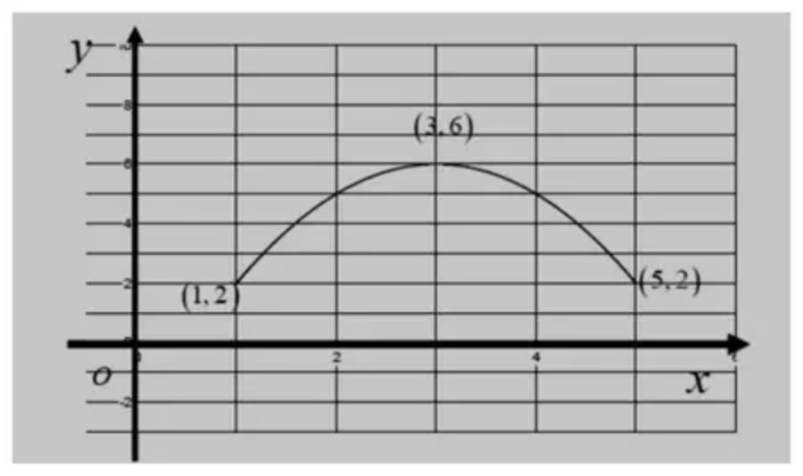  $∩$ shaped parabola | M1 | 1.1b
Fully correct with 'ends' at $(1,2)$ & $(5,2)$ | A1 | 1.1b
Suitable reason : Eg states as $x=3+2sin⁡t,1⩽x⩽5$ | B1 | 2.4
 | (3)

Notes
(b) M1: For sketching a $∩$ parabola with a maximum in quadrant one. It does not need to be symmetrical
A1: For sketching a $∩$ parabola with a maximum in quadrant one and with end coordinates of $(1,2)$ and $(5,2)$
B1: Any suitable explanation as to why $C$ does not include all points of $y=6−(x−3)^{2},x∈\text{R}$
This should include a reference to the limits on sin or cos with a link to a restriction on $x$ or $y$.
For example
‘As $−1⩽sin⁡t⩽1$ then $1⩽x⩽5$’ Condone in words ‘$x$ lies between 1 and 5’ and strict inequalities
‘As $sin⁡t⩽1$ then $x⩽5$’ Condone in words ‘$x$ is less than 5’
‘As $−1⩽cos⁡(2t)⩽1$ then $2⩽y⩽6$’ Condone in words ‘$y$ lies between 2 and 6’
Withhold if the statement is incorrect Eg "because the domain is $2⩽x⩽5$"
Do not allow a statement on the top limit of $y$ as this is the same for both curves
Mark scheme (c)
Scheme | Marks | AO
Either finds the lower value for $k=7$  or deduces that $k<\frac{37}{4}$ | B1 | 2.2a
Finds where $x+y=k$ meets $y=6−(x−3)^{2}$  $⇒k−x=6−(x−3)^{2}$ and proceeds to 3TQ in $x$ or $y$ | M1 | 3.1a
Correct 3TQ in $x$ $x^{2}−7x+(k+3)=0$  Or $y$ $y^{2}+(7−2k)y+(k^{2}−6k+3)=0$ | A1 | 1.1b
Uses $b^{2}−4ac=0⇒49−4×1×(k+3)=0⇒k=(\frac{37}{4})$  or  $(7−2k)^{2}−4×1×(k^{2}−6k+3)=0⇒k=(\frac{37}{4})$ | M1 | 2.1
Range of values for $k=\{k:7⩽k<\frac{37}{4}\}$ | A1 | 2.5
 | (5)
 | (10 marks)

Notes
B1: Deduces either
• the correct that the lower value of $k=7$ This can be found by substituting into $(5,2)$
$x+y=k⇒k=7$ or substituting $x=5$ into $x^{2}−7x+(k+3)=0⇒25−35+k+3=0⇒k=7$
• or deduces that $k<\frac{37}{4}$ This may be awarded from later work
M1: For an attempt at the upper value for $k$.
Finds where $x+y=k$ meets $y=6−(x−3)^{2}$ once by using an appropriate method.
Eg. Sets $k−x=6−(x−3)^{2}$ and proceeds to a 3TQ
A1: Correct 3TQ $x^{2}−7x+(k+3)=0$ The = 0 may be implied by subsequent work
M1: Uses the "discriminant" condition. Accept use of $b^{2}=4ac$ oe or $b^{2}…4ac$ where ... is any inequality leading to a critical value for $k$. Eg. one root $⇒49−4×1×(k+3)=0⇒k=\frac{37}{4}$
A1: Range of values for $k=\{k:7⩽k<\frac{37}{4}\}$ Accept $k∈[7,\frac{37}{4})$ or exact equivalent
Alternative (c)
Scheme | Marks | AO
As above | B1 | 2.2a
Finds where $x+y=k$ meets $y=6−(x−3)^{2}$ once by using an appropriate method. Eg. Sets gradient of $y=6−(x−3)^{2}$ equal to $−1$ | M1 | 3.1a
$−2x+6=−1⇒x=3.5$ | A1 | 1.1b
Finds point of intersection and uses this to find upper value of $k$.  $y=6−(3.5−3)^{2}=5.75$ Hence using $k=3.5+5.75=9.25$ | M1 | 2.1
Range of values for $k=\{k:7⩽k<9.25\}$ | A1 | 2.5

3.
Mark scheme (a)
Scheme | Marks | AO
(i) Uses model with t=0 to find correct value of h  AWRT 5.9 | B1 | AO3.4
(ii) Uses v=0 to set up quadratic equation for t | M1 | AO3.4
Obtains t = 6  PI correct answer | A1 | AO1.1b
Interprets their lowest positive solution correctly  NMS can score 3 | A1F | AO3.2a
(iii) Obtains correct h for their positive t provided h < 5.88  Accept 0.12  If given to more decimal places AWFW 0.115 to 0.116  FT their t allow negative h | B1F | AO3.4

Typical solution
(i)
5.88metres
(ii)
$$0=4−{(\frac{2t}{3}−2)}^{2}$$
$$t=6$$
8 am
(iii)
0.12m
Mark scheme (b)
Scheme | Marks | AO
Identifies t=3 (for maximum velocity) | B1 | AO3.1b
Substitutes their t into model for h  PI their answer | M1 | 3.4
Finds correct height with units | A1 | 3.2a

Typical solution
$$t=3$$
$$h=3−2\sqrt[3]{3−3}$$
$h=$ 3 metres
Mark scheme (c)
Scheme | Marks | AO
Explains that the validity of the model is limited by time. | B1 | 3.5b
Explains that the height continues to decrease after 6 hours (or after the first cycle or first low tide).  Or explains there are no other times when v=0 | B1 | 3.5a
 | (10 marks)

Typical solution
The model breaks down after one cycle of the tide.
After 6 hours the model shows the height continues to decrease.

