QQQ – Pure Year 2 – Chapter 2 – Functions (Version 2)
Total Marks: 24
(24 = Platinum, 22 = Gold, 19 = Silver, 16 = Bronze)
1. The point $P(6,−4)$ lies on the curve with equation $y=\text{f}(x),x∈\text{R}$
Find the point to which $P$ is mapped when the curve with equation $y=\text{f}(x)$ is transformed to the curve with equation
(a) $y=\text{f}(x+2)$ (1)
(b) $y={\text{f}}^{−1}(x)$ (1)
(c) $y=2∣\text{f}(x)∣−3$ (2)
(Total 4 marks)
Edexcel June 2025 Paper 1 Q1
2. The straight line $y=5−2x$ is shown in the diagram.
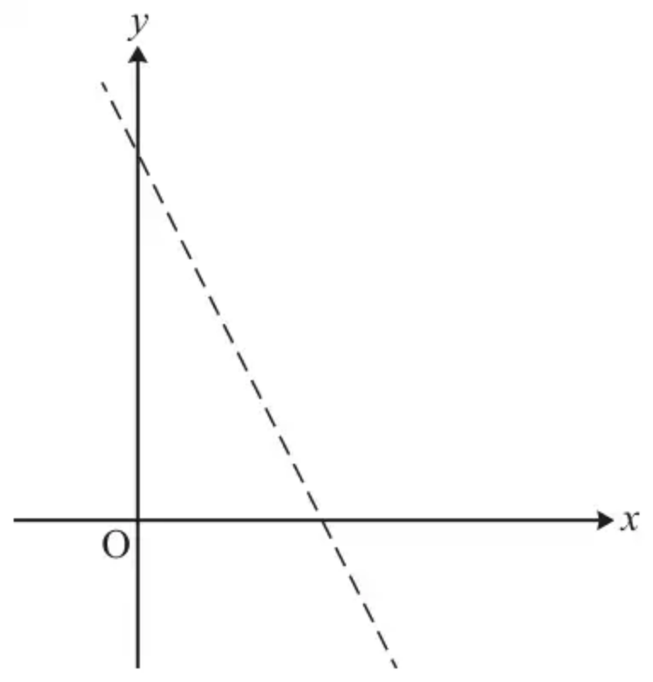
(a) On the copy of the diagram in the Printed Answer Booklet, sketch the graph of $y=\text{∣}5−2x\text{∣}$. [1]
(b) Solve the inequality $\text{∣}5−2x\text{∣}<3$. [3]
(Total 4 marks)
OCR MEI June 2023 Paper 3 Q2
3. The function $\text{f}$ is defined by
$$\text{f}(x)=\frac{1}{2}(x^{2}+1),x⩾0$$
(a) Find the range of $\text{f}$. [1 mark]
(b)
(i) Find ${\text{f}}^{−1}(x)$ [3 marks]
(ii) State the range of ${\text{f}}^{−1}(x)$ [1 mark]
(c) State the transformation which maps the graph of $y=\text{f}(x)$ onto the graph of $y={\text{f}}^{−1}(x)$ [1 mark]
(d) Find the coordinates of the point of intersection of the graphs of $y=\text{f}(x)$ and $y={\text{f}}^{−1}(x)$ [2 marks]
(Total 8 marks)
AQA June 2019 Paper 1 Q6
4. In this question you must show detailed reasoning.
The functions f and g are defined for all real values of $x$ by

$$\text{f}(x)=x^{3} \text{and} \text{g}(x)=x^{2}+2.$$

(i) Write down expressions for
(a) $\text{fg}(x)$, [1]
(b) $\text{gf}(x)$. [1]
(ii) Hence find the values of $x$ for which $\text{fg}(x)−\text{gf}(x)=24$. [6]
(Total 8 marks)
OCR A June 2018 Paper 3 Q4
Solutions
1.
Mark scheme (a)
Scheme | Marks | AO
$(4,−4)$ or e.g. $x=4,y=−4$ o.e. | B1 | 1.1b
 | (1)

Notes
General guidelines for all parts:
Remember to check answers written against the questions.
If there is any contradiction, mark the answers given in the body of the scripts.
If there is no labelling, mark the responses in the order given.
The coordinates need to be values not just a calculation e.g. not $6−2$ for 4
Points can be written as a coordinate pair or separately as $x=…,y=…$
Do not allow coordinates written the wrong way round but isw if necessary e.g. $x=4,y=−4→(−4,4)$ scores B1 and isw
Condone missing brackets (one or both) e.g. $x=4,y=−4$ or $(4,−4$ or $4,−4$ for $(4,−4)$
Condone a missing comma e.g. $(4−4)$ for $(4,−4)$
Condone use of a semi-colon e.g. $(4;−4)$ for $(4,−4)$
Condone vector notation e.g. $(\begin{matrix}4 \\ −4\end{matrix})$ for $(4,−4)$ and condone $(\frac{4}{−4})$
B1: $(4,−4)$ o.e. see above
Mark scheme (b)
Scheme | Marks | AO
$(−4,6)$ or e.g. $x=−4,y=6$ o.e. | B1 | 1.1b
 | (1)

Notes
General guidelines for all parts:
Remember to check answers written against the questions.
If there is any contradiction, mark the answers given in the body of the scripts.
If there is no labelling, mark the responses in the order given.
The coordinates need to be values not just a calculation e.g. not $6−2$ for 4
Points can be written as a coordinate pair or separately as $x=…,y=…$
Do not allow coordinates written the wrong way round but isw if necessary e.g. $x=4,y=−4→(−4,4)$ scores B1 and isw
Condone missing brackets (one or both) e.g. $x=4,y=−4$ or $(4,−4$ or $4,−4$ for $(4,−4)$
Condone a missing comma e.g. $(4−4)$ for $(4,−4)$
Condone use of a semi-colon e.g. $(4;−4)$ for $(4,−4)$
Condone vector notation e.g. $(\begin{matrix}4 \\ −4\end{matrix})$ for $(4,−4)$ and condone $(\frac{4}{−4})$
B1: $(−4,6)$ o.e. see above
Mark scheme (c)
Scheme | Marks | AO
$(6,…)$ or $(…,5)$ or $x=6$ or $y=5$ o.e. | M1 | 1.1b
$(6,5)$ or $x=6$ and $y=5$ | A1 | 1.1b
 | (2)
 | (4 marks)

Notes
General guidelines for all parts:
Remember to check answers written against the questions.
If there is any contradiction, mark the answers given in the body of the scripts.
If there is no labelling, mark the responses in the order given.
The coordinates need to be values not just a calculation e.g. not $6−2$ for 4
Points can be written as a coordinate pair or separately as $x=…,y=…$
Do not allow coordinates written the wrong way round but isw if necessary e.g. $x=4,y=−4→(−4,4)$ scores B1 and isw
Condone missing brackets (one or both) e.g. $x=4,y=−4$ or $(4,−4$ or $4,−4$ for $(4,−4)$
Condone a missing comma e.g. $(4−4)$ for $(4,−4)$
Condone use of a semi-colon e.g. $(4;−4)$ for $(4,−4)$
Condone vector notation e.g. $(\begin{matrix}4 \\ −4\end{matrix})$ for $(4,−4)$ and condone $(\frac{4}{−4})$
M1: One correct coordinate. See above.
A1: Both coordinates correct. See above.
Note that M0A1 is not a possible mark profile.
Note that in part (c), some candidates show their thinking by transforming the point piecewise e.g. $(6,−4)→(6,4)→(6,8)→(6,5)$
In such cases, mark their final pair of coordinates
2.
Mark scheme (a)
Scheme | Marks | AO
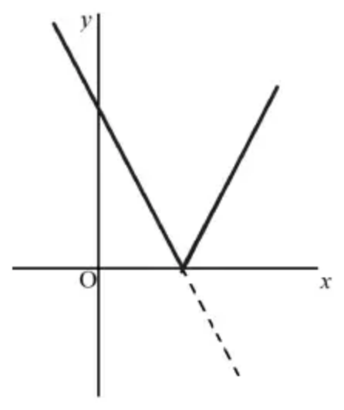 | B1 | 1.1
 | [1]

Notes
B1: Going over the given line above the $x$-axis and to the left of the $y$-axis and then going up from the $x$-axis at the same angle (by eye)
Condone right hand line segment dotted/dashed
Mark scheme (b)
Scheme | Marks | AO
$−3<5−2x<3$ | M1 | 1.1a
$2<2x<8$  $1<x<4$ oe e.g. ‘$1<x$ and $x<4$’ | A2 | 1.1  1.1
 | [3]

Notes
M1: Could be treated as two separate inequalities (at least one correct) in $x$ not $\text{∣}x\text{∣}$
OR $(5−2x)^{2}<9$
If only one linear inequality in $x$ stated scores M0 A0 A0
OR $4x^{2}−20x+16<0$ or $x^{2}−5x+4<0$
OR $(x−1)(x−4)<0$
Allow M1 if treated as equations in $x$ not $\text{∣}x\text{∣}$
A2: A1 if only one inequality correct
OR for $1⩽x⩽4$
OR for $1<x$, $x<4$
OR for ‘$1<x$ or $x<4$’
3.
Mark scheme (a)
Scheme | Marks | AO
Deduces the range of $\text{f}$  Accept $\text{f}(x)⩾\frac{1}{2}$,  $y⩾\frac{1}{2}$ or $[0.5,\text{∞})$  OE | B1 | AO2.2a

Typical solution
$$\{y:y⩾\frac{1}{2}\}$$
Mark scheme (b)
Scheme | Marks | AO
(i) Rearranges formula, isolating squared term with at least one correct step seen. | M1 | 1.1a
Obtains inverse function in any correct form. | A1 | 1.1b
Obtains correct inverse function using ${\text{f}}^{−1}(x)=…$ and states correct domain | A1 | 2.5
(ii) States correct range  Accept ${\text{f}}^{−1}(x)⩾0$  OE | B1 | 1.1b

Typical solution
(i)
$$y=\frac{1}{2}(x^{2}+1)$$
$$2y=x^{2}+1$$
$$2y−1=x^{2}$$
$$x=\sqrt{2y−1}$$
$${\text{f}}^{−1}(x)=\sqrt{2x−1}$$
$$x⩾\frac{1}{2}$$
(ii)
$$\{y:y⩾0\}$$
Mark scheme (c)
Scheme | Marks | AO
Recalls correct transformation | B1 | 1.2

Typical solution
Reflection in $y=x$
Mark scheme (d)
Scheme | Marks | AO
Forms equation using two of the three expressions  $x=\frac{x^{2}+1}{2}=\sqrt{2x−1}$  allow their $\sqrt{2x−1}$  PI by correct answer | M1 | 3.1a
Obtains x=1 and y=1  CSO | A1 | 1.1b
 | (8 marks)

Typical solution
$$x=\frac{x^{2}+1}{2}$$
$$(1,1)$$
4.
Mark scheme (i)(a)
Scheme | Marks | AO
$\text{fg}(x)=\text{f}(x^{2}+2)=(x^{2}+2)^{3}$ | B1 | 1.1
 | [1]

Mark scheme (i)(b)
Scheme | Marks | AO
$\text{gf}(x)=\text{g}(x^{3})=(x^{3})^{2}+2(=x^{6}+2)$ | B1 | 1.1
 | [1]

Notes
B1: No simplification required
Mark scheme (ii)
Scheme | Marks | AO
DR  $(x^{2}+2)^{3}=(x^{2})^{3}+3(x^{2})^{2}(2)+3(x^{2})(2)^{2}+2^{3}$ | M1 | 1.1
$\text{fg}(x)=x^{6}+6x^{4}+12x^{2}+8$ | A1 | 1.1
$\text{fg}(x)−\text{gf}(x)=24⇒6x^{4}+12x^{2}−18=0$ | A1 | 2.1
$x^{4}+2x^{2}−3=0⇒(x^{2}−1)(x^{2}+3)=0$ | M1 | 1.1
$x^{2}+3=0$ has no real solutions | A1 | 2.4
$x^{2}−1=0⇒x=±1$ | A1 | 2.2a
 | [6]

Notes
M1: Binomial expansion of their $(x^{2}+2)^{3}$ - correct powers and coefficients
Allow one slip
M1: Correct method for solving their quadratic in $x^{2}$
If M0 next two marks become B marks
A1: $x^{2}+3\text{≠}0$ is acceptable for this mark

