QQQ – Pure Year 2 – Chapter 2 – Functions (Version 1)
Total Marks: 25
(25 = Platinum, 23 = Gold, 20 = Silver, 17 = Bronze)
1. It is given that
• $\text{f}(x)=±\frac{1}{\sqrt{x}},x>0$
• $\text{g}(x)=\frac{x}{x−3},x>3$
• $\text{h}(x)=x^{2}+2,x∈\text{R}$.
(a) Explain why $\text{f}(x)$ is not a function. [1]
(b) Find $\text{gh}(x)$. [2]
(c) State the domain of $\text{gh}(x)$. [1]
(Total 4 marks)
OCR MEI June 2023 Paper 2 Q12
2.
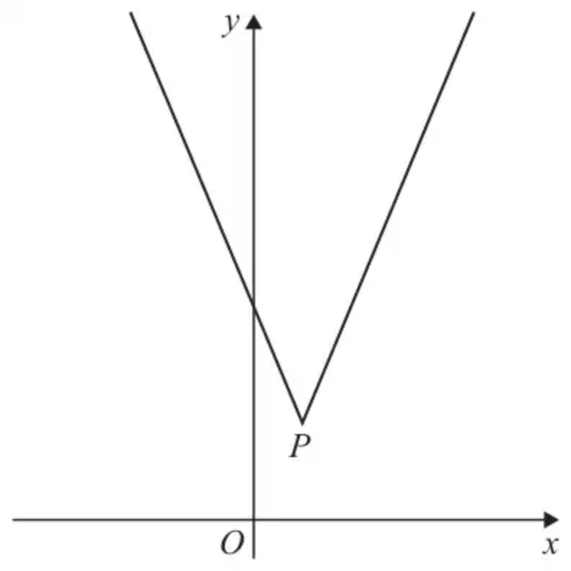
Figure 1
Figure 1 shows a sketch of the graph with equation
$$y=3∣x−2∣+5$$
The vertex of the graph is at the point $P$, shown in Figure 1.
(a) Find the coordinates of $P$. (2)
(b) Solve the equation
$$16−4x=3∣x−2∣+5$$
(2)
A line $l$ has equation $y=kx+4$ where $k$ is a constant.
Given that $l$ intersects $y=3∣x−2∣+5$ at 2 distinct points,
(c) find the range of values of $k$. (2)
(Total 6 marks)
Edexcel June 2024 Paper 1 Q6
3.
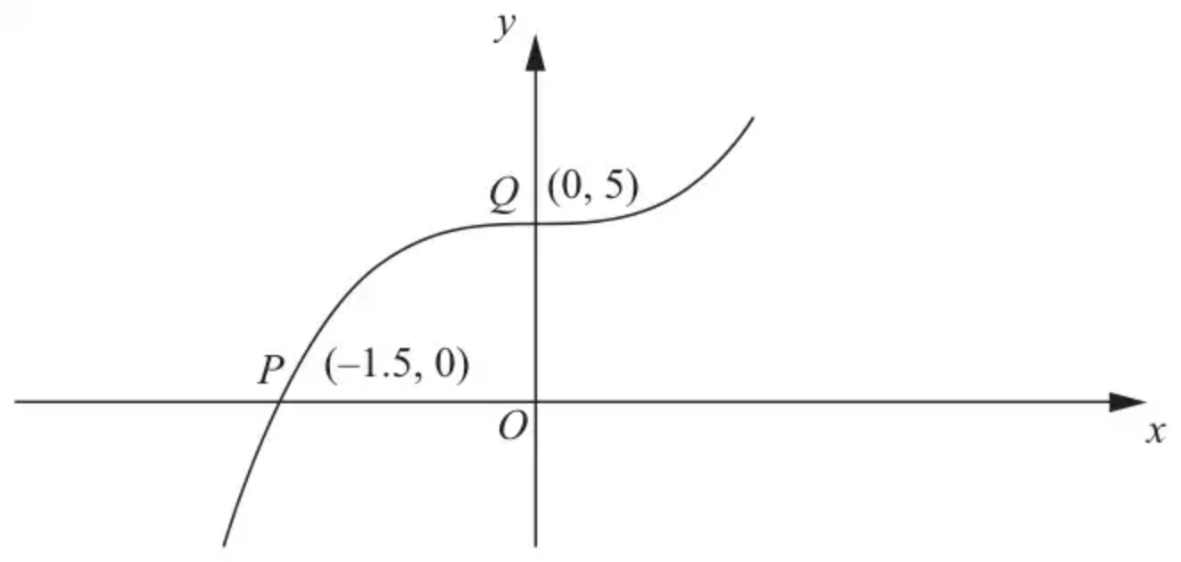
Figure 2
Figure 2 shows part of the curve with equation $y=\text{f}(x)$
The curve passes through the points $P(−1.5,0)$ and $Q(0,5)$ as shown.
On separate diagrams, sketch the curve with equation
(a) $y=∣\text{f}(x)∣$ (2)
(b) $y=\text{f}(∣x∣)$ (2)
(c) $y=2\text{f}(3x)$ (3)
Indicate clearly on each sketch the coordinates of the points at which the curve crosses or meets the axes.
(Total 7 marks)
Edexcel C3 June 2012 Q4
4. The function f is defined by
$$\text{f}(x)=3+\sqrt{x−2} x∈\text{R} x>2$$
(a) State the range of f (1)
(b) Find ${\text{f}}^{−1}$ (3)
The function g is defined by
$$\text{g}(x)=\frac{15}{x−3} x∈\text{R} x\text{≠}3$$
(c) Find $\text{gf}(6)$ (2)
(d) Find the exact value of the constant $a$ for which
$$\text{f}(a^{2}+2)=\text{g}(a)$$
(2)
(Total 8 marks)
Edexcel June 2023 Paper 1 Q7
Solutions
1.
Mark scheme (a)
Scheme | Marks | AO
because it’s neither a one-to-one nor a many-to-one (mapping)  do not allow  eg because it’s neither a one-to-one nor a many-to-one function | B1 | 2.4
 | [1]

Notes
B1: allow because it’s one-to-many (mapping)
allow eg because each value of $x$ is mapped to two values oe
do not allow
eg because it’s a one-to-many function
Mark scheme (b)
Scheme | Marks | AO
$\frac{x^{2}+2}{x^{2}+2−3}$ | M1 | 1.1
$\frac{x^{2}+2}{x^{2}−1}$ or $\frac{x^{2}+2}{(x−1)(x+1)}$ | A1 | 1.1
 | [2]

Mark scheme (c)
Scheme | Marks | AO
$\text{∣}x\text{∣}>1$  or $x<−1$ or $x>1$  or $x<−1,x>1$  or $x<−1∪x>1$ | B1 | 1.1
 | [1]

Notes
B1: do not allow
eg $x<−1$ and $x>1$
eg $−1>x>1$
2.
Mark scheme (a)
Scheme | Marks | AO
$x=2$ or $y=5$ | B1 | 1.1b
$P(2,5)$ | B1 | 2.2a
 | (2)

Notes
B1: One correct coordinate. Either $x=2$ or $y=5$ or (2, …) or (…,5) seen.
B1: Deduces $(2,5)$ Accept written separately e.g. $x=2$, $y=5$ isw after a correct answer.
Condone 2, 5 without the brackets.
Mark scheme (b)
Scheme | Marks | AO
$16−4x=3(x−2)+5⇒x=…$ | M1 | 1.1b
$x=\frac{17}{7}$ | A1 | 2.1
 | (2)

Notes
M1: Attempts to solve the correct equation without modulus signs $16−4x=3(x−2)+5⇒x=…$
Must reach a value for $x$. Ignore attempts at e.g. $16−4x=3(2−x)+5$
A1: $x=\frac{17}{7}$ o.e. exact answer and no other values. If other values have been found they must be rejected or the $x=\frac{17}{7}$ clearly selected. Answer only implies both marks.
Note: $x=$ “2.75” coming from $5=16−4x$ may be found as part of their working to establish which branch of the modulus graph the line $y=16−4x$ intersects. If this is the case it need not be “rejected” provided it is not clearly stated as one of their solutions.
Those that achieve $\text{∣}x\text{∣}=\frac{17}{7}$ can score BOD M1A0.
Alternative by squaring:
$$\begin{matrix} & 16−4x=3∣x−2∣+5⇒11−4x=3∣x−2∣ \\ & ⇒16x^{2}−88x+121=9(x^{2}−4x+4) \\ & ⇒7x^{2}−52x+85=0⇒x=5,\frac{17}{7}\end{matrix}$$
M1: Isolates the $∣x−2∣$ (or $3∣x−2∣$), squares both sides and solves the resulting 3TQ using the usual rules and may be by calculator, leading to a value for $x$.
A1: Selects the $\frac{17}{7}$ or rejects any other values as in main scheme.
Mark scheme (c)
Scheme | Marks | AO
$kmax⁡=3$ or $kmin⁡=\frac{\text{“}5\text{”}−4}{\text{“}2\text{”}}$ | M1 | 3.1a
$\frac{1}{2}<k<3$ | A1 | 2.5
 | (2)
 | (6 marks)

Notes
M1: Correct method to find either critical value (following through on their $P$).
Either $k$ {=} 3 or $k$ {=} $\frac{\text{“}5\text{”}−4}{\text{“}2\text{”}}$ scores M1 without evidence of an incorrect method.
Note that $k=3$ occasionally appears from use of the discriminant on $x(k−3)+5=0,$ and scores M0 unless there is an alternative valid reason given.
Allow the use of e.g. $m=$ in place of $k=$ here but do not allow $x=$ or $y=$
A1: Correct range in terms of $k$ in acceptable notation with no incorrect method seen.
Use of e.g. $x$ is A0. Allow “and” or “$∩$” to join the regions but not “or” or “,” or “$∪$”
Accept e.g. $(0.5,3)$ ; $k∈(\frac{1}{2},3)$ ; $k<3$ and $k>\frac{1}{2}$ ; $k>\frac{1}{2}∩k<3$
but not $\frac{1}{2}<x<3$ ; $\frac{1}{2}⩽k⩽3$ ; $[\frac{1}{2},3]$ ; $k>\frac{1}{2}∪k<3$ ; $k>\frac{1}{2},k<3$ ; $k>\frac{1}{2}$ or $k<3$
Alt 1 via solving simultaneous equations:
$$\begin{matrix} & \text{e.g.}kx+4=3(x−2)+5⇒kx+4=3x−1⇒x=−\frac{5}{k−3} \\ & kx+4=3(2−x)+5⇒kx+4=11−3x⇒(k+3)x=7 \\ & ⇒(k+3)(\frac{−5}{k−3})=7⇒k=\frac{1}{2}\end{matrix}$$
M1: Sets $kx+4=3(x−2)+5$ and $kx+4=3(2−x)+5$, eliminates $x$, and solves for $k$
A1: As main scheme.
Alt 2 via squaring and the discriminant:
$$\begin{matrix} & kx+4=3∣x−2∣+5⇒kx−1=3∣x−2∣ \\ & ⇒k^{2}x^{2}−2kx+1=9(x^{2}−4x+4) \\ & ⇒(k^{2}−9)x^{2}+(36−2k)x−35=0 \\ & ⇒(36−2k)^{2}−4(k^{2}−9)(−35)=0 \\ & ⇒144k^{2}−144k+36=0⇒k=\frac{1}{2}\end{matrix}$$
M1: Sets $kx+4=3∣x−2∣+5$, isolates $∣x−2∣$ (or $3∣x−2∣$), squares both sides, uses $b^{2}−4ac…0$ where … is any equality or inequality, and solves the resulting 3TQ using the usual rules and may be by calculator, leading to a value for $k$.
Condone slips in expanding the brackets.
A1: As main scheme.
Alt 3 via Domain for the right hand branch of the modulus graph:
$$\begin{matrix} & kx+4=3x−1⇒x=\frac{−5}{k−3}>2 \{\text{or}x=\frac{5}{3−k}>2\} \\ & ⇒k−3<0 \{\text{and}⇒−5<2(k−3)\} \\ & ⇒k<3 \{\text{and}⇒0.5<k\}\end{matrix}$$
M1: Sets $kx+4=3(x−2)+5$, makes $x$ the subject, sets > 2 and deduces a critical value.
A1: As main scheme.
3.
Mark scheme (a)
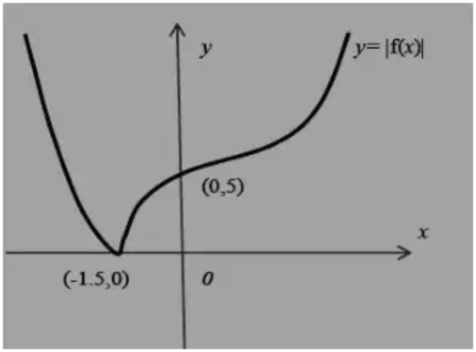
Scheme | Marks
Shape including cusp | B1
(-1.5, 0) and (0, 5) | B1
 | (2)

Notes
Note that this appears as M1A1 on EPEN
B1 Shape (inc cusp) with graph in just quadrants 1 and 2. Do not be overly concerned about relative gradients, but the left hand section of the curve should not bend back beyond the cusp
B1 This is independent, and for the curve touching the x-axis at (-1.5, 0) and crossing the y-axis at (0,5)
Mark scheme (b)
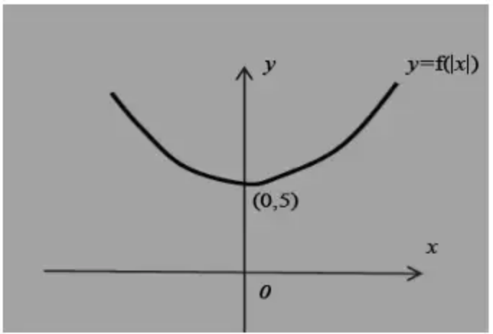
Scheme | Marks
Shape | B1
(0,5) | B1
 | (2)

Notes
Note that this appears as M1A1 on EPEN
B1 For a U shaped curve symmetrical about the y- axis
B1 (0,5) lies on the curve
Mark scheme (c)
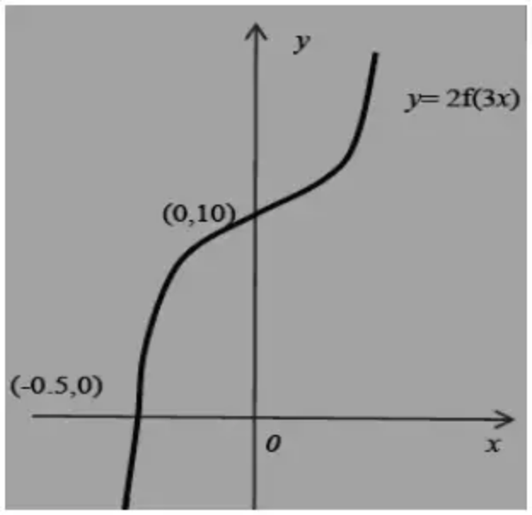
Scheme | Marks
Shape | B1
(0,10) | B1
(-0.5, 0) | B1
 | (3)
 | (7 marks)

Notes
Note that this appears as M1B1B1 on EPEN
B1 Correct shape- do not be overly concerned about relative gradients. Look for a similar shape to f(x)
B1 Curve crosses the y axis at (0, 10). The curve must appear in both quadrants 1 and 2
B1 Curve crosses the x axis at (-0.5, 0). The curve must appear in quadrants 3 and 2.
In all parts accept the following for any co-ordinate. Using (0,3) as an example, accept both (3,0) or 3 written on the y axis (as long as the curve passes through the point)
Special case with (a) and (b) completely correct but the wrong way around mark - SC(a) 0,1 SC(b) 0,1
Otherwise follow scheme
4.
Mark scheme (a)
Scheme | Marks | AO
$\text{f}(x)>3$ | B1 | 1.1b
 | (1)

Notes
B1: $\text{f}(x)>3$ o.e.
e.g. $y>3$, $\text{range}>3$, $\text{f}(x)∈(3,\text{∞})$, $\{\text{f}(x):\text{f}(x)>3\}$, $\text{f}>3$ but not e.g. $x>3$, $\text{f}(x)⩾3$, $[3,\text{∞})$
Mark scheme (b)
Scheme | Marks | AO
$y=3+\sqrt{x−2}⇒x=…$ | M1 | 1.1b
${\text{f}}^{−1}(x)=(x−3)^{2}+2$ | A1 | 1.1b
$x>3$ | B1ft | 2.2a
 | (3)

Notes
M1: Sets $y=3+\sqrt{x−2}$ and attempts to make x the subject (or vice versa). Look for the correct order of operations so score for an expression of the form $(x=)(y±3)^{2}±2$ or $(y=)(x±3)^{2}±2$
A1: ${\text{f}}^{−1}(x)=(x−3)^{2}+2$ Also accept ${\text{f}}^{−1}:x→(x−3)^{2}+2$. Condone ${\text{f}}^{−1}=(x−3)^{2}+2$ (or ${\text{f}}^{−1}=y=(x−3)^{2}+2$) but do not allow just $y=…$ or ${\text{f}}^{−1}:y=$
Also accept other equivalent expressions such as ${\text{f}}^{−1}(x)=x^{2}−6x+11$ (simplified or unsimplified)
B1ft: $x>3$ or follow through on their part (a). The omission of $x∈\text{R}$ is condoned.
Allow equivalent answers such as $x∈(\text{“}3\text{”},\text{∞})$ or $\{x:x>\text{“}3\text{”}\}$
Note: It is also acceptable to define ${\text{f}}^{−1}$ in any variable e.g. as ${\text{f}}^{−1}(t)=(t−3)^{2}+2 t>3$ as long as the variable is used consistently to score M1A1B1. If another variable is used other than x it must be fully defined e.g. ${\text{f}}^{−1}(t)=…$ not just ${\text{f}}^{−1}=…$
Mark scheme (c)
Scheme | Marks | AO
$\text{f}(6)=3+\sqrt{6−2}=5⇒\text{g}(\text{“}5\text{”})=\frac{15}{\text{“}5\text{”}−3}=…$ | M1 | 1.1b
$=\frac{15}{2}$ | A1 | 1.1b
 | (2)

Notes
M1: Substitutes $x=6$ into f and substitutes the result into g to find a value for $\text{gf}(6)$.
Allow an attempt to substitute $x=6$ into $\text{gf}(x)=\frac{15}{\sqrt{x−2}}$ condoning slips. They must proceed to find a value. Condone arithmetical slips and bracket errors/omissions. Condone for M1 attempts where when dealing with $\sqrt{x−2}$ leads to two different answers e.g. $\frac{15}{\sqrt{6−2}}→±\frac{15}{2}$
A1: $\frac{15}{2}$ only oe isw once a correct answer is seen
Mark scheme (d)
Scheme | Marks | AO
$3+\sqrt{a^{2}+2−2}=\frac{15}{a−3}⇒\text{“}a^{2}−9=15\text{”}$ | M1 | 1.1b
$a=2\sqrt{6}$ | A1 | 2.2a
 | (2)
 | (8 marks)

Notes
M1: Attempts to form the equation $3+\sqrt{a^{2}+2−2}=\frac{15}{a−3}$, and proceeds to a quadratic in a (usually $a^{2}=k$ or $a^{2}−k=15$ but condone arithmetical, miscopying and sign slips. Condone equations which would lead to complex roots.
May be implied by a correct exact answer.
Alternatively, they attempt to form the equation $a^{2}+2={\text{f}}^{−1}\text{g}(a)⇒a^{2}+2={(\frac{15}{a−3}−3)}^{2}+2$
$⇒(a+3)(a−3)=15⇒a^{2}−9=15$ (condone slips)
They should be square rooting both sides so that $\sqrt{a^{2}+2−2}→a$, before multiplying both sides by $a−3$ and rearranging so that the $a^{2}$ term comes from their “$(a+3)(a−3)$”
May be implied by a correct exact answer for their quadratic in a but a correct decimal answer does not imply this mark.
A1: $(a=)2\sqrt{6}$ or accept $\sqrt{24}$ (they must reject the negative solution if found as $\text{f}(a^{2}+2)\text{≠g}(a)$ when $a=−2\sqrt{6}$) $\sqrt{6}×\sqrt{4}$ is A0
isw $\sqrt{24}$ followed by $4\sqrt{6}$ (incorrect manipulation of the surd) but not followed by $±\sqrt{24}$ o.e.
A decimal answer on its own or multiple answers e.g. $±\sqrt{24}$ score A0.

