QQQ – Pure Year 1 – Chapter 11 – Vectors (Version 2)
Total Marks: 25
(25 = Platinum, 23 = Gold, 20 = Silver, 17 = Bronze)
1. [In this question the unit vectors $\text{i}$ and $\text{j}$ are due east and due north respectively.]
A stone slides horizontally across ice.
Initially the stone is at the point $A(−24\text{i}−10\text{j})$ m relative to a fixed point $O$.
After 4 seconds the stone is at the point $B(12\text{i}+5\text{j})$ m relative to the fixed point $O$.
The motion of the stone is modelled as that of a particle moving in a straight line at constant speed.
Using the model,
(a) prove that the stone passes through $O$, (2)
(b) calculate the speed of the stone. (3)
(Total 5 marks)
Edexcel November 2021 Paper 1 Q4
2. The triangle $PQR$ is such that $\vec{PQ}=3\text{i}+5\text{j}$ and $\vec{PR}=13\text{i}−15\text{j}$
(a) Find $\vec{QR}$ (2)
(b) Hence find $∣\vec{QR}∣$ giving your answer as a simplified surd. (2)
The point $S$ lies on the line segment $QR$ so that $QS:SR=3:2$
(c) Find $\vec{PS}$ (2)
(Total 6 marks)
Edexcel June 2022 Paper 1 Q3
3.
(a) Simplify $2(\begin{matrix}6 \\ −3\end{matrix})−3(\begin{matrix}−1 \\ 2\end{matrix})$. [2]
(b) The vector $\text{a}$ is defined by $\text{a}=r(\begin{matrix}6 \\ −3\end{matrix})+s(\begin{matrix}−1 \\ 2\end{matrix})$, where $r$ and $s$ are constants.
Determine two pairs of values of $r$ and $s$ such that $\text{a}$ is parallel to the $y$-axis and $\text{∣}\text{a}\text{∣}=3$. [5]
(Total 7 marks)
OCR A October 2021 Paper 1 Q4
4. In this question you must show detailed reasoning.
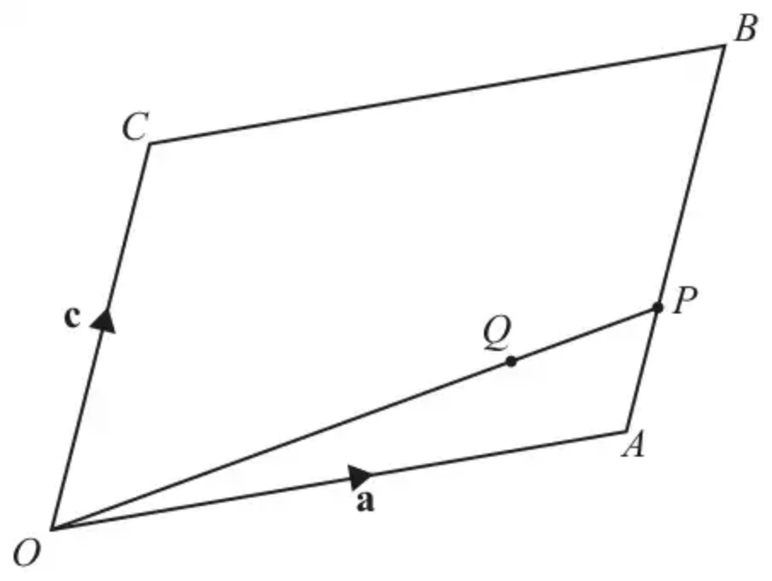
The diagram shows a parallelogram $OABC$. The position vectors of $A$ and $C$ are $\text{a}$ and $\text{c}$ respectively.
• The point $P$ lies on $AB$ such that $AP=\frac{1}{3}AB$.
• The point $Q$ lies on $OP$ such that $OQ=\frac{3}{4}OP$.
(a) Show that $\vec{OQ}=\frac{3}{4}\text{a}+\frac{1}{4}\text{c}$. [4]
(b) Hence show that $Q$ lies on $AC$. [3]
(Total 7 marks)
OCR A June 2025 Paper 1 Q7
Solutions
1.
Mark scheme (a)
Scheme | Marks | AO
Attempts to compare the two position vectors.  Allow an attempt using two of $\vec{AO},\vec{OB}$ or $\vec{AB}$  E.g. $(−24\text{i}−10\text{j})=−2×(12\text{i}+5\text{j})$ | M1 | 1.1b
Explains that as $\vec{AO}$ is parallel to $\vec{OB}$ (and the stone is travelling in a straight line) the stone passes through the point $O$. | A1 | 2.4
 | (2)

Notes
M1: Attempts to compare the two position vectors. Allow an attempt using two of $\vec{AO},\vec{OB}$ or $\vec{AB}$ either way around.
E.g. States that $(−24\text{i}−10\text{j})=−2×(12\text{i}+5\text{j})$
Alternatively, allow an attempt finding the gradient using any two of $AO$, $OB$ or $AB$
Alternatively attempts to find the equation of the line through $A$ and $B$ proceeding as far as $y=…x$ Condone sign slips.
A1: States that as $\vec{AO}$ is parallel to $\vec{OB}$ or as $AO$ is parallel to $OB$ (and the stone is travelling in a straight line) the stone passes through the point $O$. Alternatively, shows that the point $(0,0)$ is on the line and concludes (the stone) passes through the point $O$.
Alt (a)
Scheme | Marks | AO
Attempts to find the equation of the line which passes through $A$ and $B$  E.g. $y−5=\frac{5+10}{12+24}(x−12) (y=\frac{5}{12}x)$ | M1 | 1.1b
Shows that when $x=0,y=0$ and concludes the stone passes through the point $O$. | A1 | 2.4

Mark scheme (b)
Scheme | Marks | AO
Attempts distance $AB=\sqrt{(12+24)^{2}+(10+5)^{2}}$ | M1 | 1.1b
Attempts speed $=\frac{\sqrt{(12+24)^{2}+(10+5)^{2}}}{4}$ | dM1 | 3.1a
Speed $=9.75{\text{ms}}^{−1}$ | A1 | 3.2a
 | (3)
 | (5 marks)

Notes
M1: Attempts to find the distance $AB$ using a correct method.
Condone slips but expect to see an attempt at $\sqrt{a^{2}+b^{2}}$ where $a$ or $b$ is correct
dM1: Dependent upon the previous mark. Look for an attempt at $\frac{\text{distance}AB}{4}$
A1: $9.75{\text{ms}}^{−1}$ Requires units
2.
Mark scheme (a)
Scheme | Marks | AO
$\vec{QR}=\vec{PR}−\vec{PQ}=13\text{i}−15\text{j}−(3\text{i}+5\text{j})$ | M1 | 1.1a
$=10\text{i}−20\text{j}$ | A1 | 1.1b
 | (2)

Notes
M1: Attempts subtraction either way round. This cannot be awarded for adding the two vectors. If no method shown it may be implied by one correct component.
eg $10\text{i}−10\text{j}$ on its own can score M1.
A1: Correct answer. Allow $10\text{i}−20\text{j}$ and $(\begin{matrix}10 \\ −20\end{matrix})$ but not $(\begin{matrix}10\text{i} \\ −20\text{j}\end{matrix})$
Mark scheme (b)
Scheme | Marks | AO
$∣\vec{QR}∣=\sqrt{\text{“}10{\text{”}}^{2}+\text{“}(−20){\text{”}}^{2}}$ | M1 | 2.5
$=10\sqrt{5}$ | A1ft | 1.1b
 | (2)

Notes
M1: Correct use of Pythagoras. Attempts to “square and add” before square rooting. The embedded values are sufficient. Follow through on their $\vec{QR}$
A1ft: $10\sqrt{5}$ following (a) of the form $±10\text{i}±20\text{j}$
Mark scheme (c)
Scheme | Marks | AO
$\vec{PS}=\vec{PQ}+\frac{3}{5}\vec{QR}=3\text{i}+5\text{j}+\frac{3}{5}(\text{“}10\text{i}−20\text{j}\text{”})=…$  or  $\vec{PS}=\vec{PR}+\frac{2}{5}\vec{RQ}=13\text{i}−15\text{j}+\frac{2}{5}(\text{“}−10\text{i}+20\text{j}\text{”})=…$ | M1 | 3.1a
$=9\text{i}−7\text{j}$ | A1 | 1.1b
 | (2)
 | (6 marks)

Notes
M1: Full attempt at finding a $\vec{PS}$. They must be attempting $\vec{PQ}±\frac{3}{5}\vec{QR}$ or $\vec{PS}=\vec{PR}±\frac{2}{5}\vec{RQ}$ but condone arithmetical slips after that.
Cannot be scored for just stating eg $\vec{PQ}±\frac{3}{5}\vec{QR}$
Follow through on their $\vec{QR}$. Terms do not need to be collected for this mark. If no method shown it may be implied by one correct component following through on their $\vec{QR}$
A1: Correct vector as shown. Allow $9\text{i}−7\text{j}$ and $(\begin{matrix}9 \\ −7\end{matrix})$.
Only withhold the mark for $(\begin{matrix}9\text{i} \\ −7\text{j}\end{matrix})$ if the mark has not already been withheld in (a) for $(\begin{matrix}10\text{i} \\ −20\text{j}\end{matrix})$
Alt (c) (Expressing $\vec{PS}$ in terms of the given vectors) They must be attempting $\frac{2}{5}\vec{PQ}+\frac{3}{5}\vec{PR}$
M1: $(\vec{PS}=\vec{PQ}+\frac{3}{5}\vec{QR}=\vec{PQ}+\frac{3}{5}(\vec{PR}−\vec{PQ}))$
$⇒\frac{2}{5}\vec{PQ}+\frac{3}{5}\vec{PR}=\frac{2}{5}(3\text{i}+5\text{j})+\frac{3}{5}(13\text{i}−15\text{j})=…$
A1: Correct vector as shown. Allow $9\text{i}−7\text{j}$ and $(\begin{matrix}9 \\ −7\end{matrix})$.
Only withhold the mark for $(\begin{matrix}9\text{i} \\ −7\text{j}\end{matrix})$ if the mark has not already been withheld in (a) for $(\begin{matrix}10\text{i} \\ −20\text{j}\end{matrix})$
3.
Mark scheme (a)
Scheme | Marks
$(\begin{matrix}15 \\ −12\end{matrix})$ or $15\text{i}−12\text{j}$ | B1  B1
 | [2]

Notes
B1 for each element. Allow $\text{i}$, $\text{j}$ notation without “squiggles”
(corrected from the printed mark scheme: the part total is printed as [1]; the paper and the two B1 marks give [2])
Mark scheme (b)
Scheme | Marks
$6r−s=0$  $s=6r$ | M1
$0^{2}+(9r)^{2}=9$ | M1
$81r^{2}=9$ | A1
$r=±\frac{1}{3}$ | A1
$r=\frac{1}{3}$ and $s=2$ or $r=−\frac{1}{3}$ and $s=−2$ | A1
 | [5]

Notes
M1: Attempt $\text{∣}\text{a}{\text{∣}}^{2}=9$, or $\text{∣}\text{a}\text{∣}=3$; allow in terms of both $r$ and $s$
A1: Allow just $r=\frac{1}{3}$
A1: Correctly paired
4.
Mark scheme (a)
Scheme | Marks | AO
DR  $\vec{OP}=\text{a}+\vec{AP}$ or $\text{c}+\text{a}+\vec{BP}$ | M1 | 3.1a
$\vec{OP}=\text{a}+\frac{1}{3}\text{c}$ | A1 | 1.1
$\vec{OQ}=\frac{3}{4}\vec{OP}=\frac{3}{4}(\text{a}+\frac{1}{3}\text{c})$ | M1 | 1.1
$=\frac{3}{4}\text{a}+\frac{1}{4}\text{c}$ AG | A1 | 1.1
 | [4]

Notes
M1: soi
A1: If labelled then must be correctly identified as $\vec{OP}$
M1: Use of $\vec{OQ}=\frac{3}{4}\vec{OP}$ with their $\vec{OP}$ soi, may use $\vec{OQ}=3\vec{QP}$
A1: Must see an intermediate step, as a minimum $\frac{3}{4}(\text{a}+\frac{1}{3}\text{c})$ oe
Mark scheme (b)
Scheme | Marks | AO
DR  $\vec{AQ}=\frac{3}{4}\text{a}+\frac{1}{4}\text{c}−\text{a}[=\frac{1}{4}\text{c}−\frac{1}{4}\text{a}]$  $[\vec{AC}=\text{c}−\text{a}]$ | M1 | 1.1
$⇒\vec{AQ}=\frac{1}{4}\vec{AC}$ or $\vec{AC}$ is a [scalar] multiple of $\vec{AQ}$ or $\vec{AQ}$ is parallel to $\vec{AC}$ or $\vec{AC}=4\vec{AQ}$ | A1 | 2.1
Hence $Q$ lies on $AC$ AG | A1 | 2.2a
 | [3]

Notes
M1: Or $\vec{QC}[=−\vec{OQ}+\vec{OC}]=−\frac{3}{4}\text{a}−\frac{1}{4}\text{c}+\text{c}[=\frac{3}{4}\text{c}−\frac{3}{4}\text{a}]$
A1: oe, e.g. $\vec{QC}=\frac{3}{4}\vec{AC}$
may see ‘$Q,A,C$ colinear’ but must be justified.
A1: Correct conclusion, dep $\vec{AQ}=\frac{1}{4}\vec{AC}$ oe seen www
Other methods may be seen, e.g. using $\vec{CQ}$ or $\vec{QA}$
Alternative method
Scheme | Marks
$\frac{3}{4}\text{a}+\frac{1}{4}\text{c}$ is of the form $α\text{a}+(1−α)\text{c}$ | M2
Hence $Q$ lies on $AC$ | A1

