QQQ – Pure Year 1 – Chapter 11 – Vectors (Version 1)
Total Marks: 23
(23 = Platinum, 21 = Gold, 18 = Silver, 16 = Bronze)
1. Given that the point $A$ has position vector $4\text{i}−5\text{j}$ and the point $B$ has position vector $−5\text{i}−2\text{j}$,
(a) find the vector $\vec{AB}$, (2)
(b) find $∣\vec{AB}∣$.
Give your answer as a simplified surd. (2)
(Total 4 marks)
Edexcel June 2018 Paper 1 Q3
2. Relative to a fixed origin $O$
• the point $A$ has coordinates $(3,−8)$
• the point $B$ is such that $\vec{AB}=−5\text{i}+2\text{j}$
(a) Find the exact value of $∣\vec{OB}∣$ (3)
(b) Find the size of angle $OAB$, giving your answer in degrees to one decimal place. (3)
(Total 6 marks)
Edexcel June 2025 Paper 1 Q3
3. [In this question the unit vectors $\text{i}$ and $\text{j}$ are due east and due north respectively.]
A coastguard station $O$ monitors the movements of a small boat.
At 10:00 the boat is at the point $(4\text{i}−2\text{j})$ km relative to $O$.
At 12:45 the boat is at the point $(−3\text{i}−5\text{j})$ km relative to $O$.
The motion of the boat is modelled as that of a particle moving in a straight line at constant speed.
(a) Calculate the bearing on which the boat is moving, giving your answer in degrees to one decimal place. (3)
(b) Calculate the speed of the boat, giving your answer in $\text{km}{\text{h}}^{−1}$ (3)
(Total 6 marks)
Edexcel October 2020 Paper 1 Q2
4. $OABC$ is a parallelogram with $\vec{OA}=\text{a}$ and $\vec{OC}=\text{c}$. $P$ is the midpoint of $AC$.
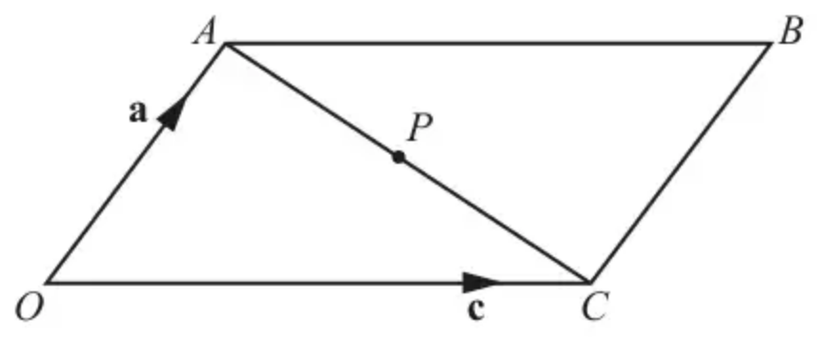
(i) Find the following in terms of $\text{a}$ and $\text{c}$, simplifying your answers.
(a) $\vec{AC}$ [1]
(b) $\vec{OP}$ [2]
(ii) Hence prove that the diagonals of a parallelogram bisect one another. [4]
(Total 7 marks)
OCR A June 2018 Paper 1 Q7
Solutions
1.
Mark scheme (a)
Scheme | Marks | AO
Attempts $\vec{AB}=\vec{OB}−\vec{OA}$ or similar | M1 | 1.1b
$\vec{AB}=−9\text{i}+3\text{j}$ | A1 | 1.1b
 | (2)

Notes
M1: Attempts subtraction either way around.
This may be implied by one correct component $\vec{AB}=±9\text{i}±3\text{j}$
There must be some attempt to write in vector form.
A1: cao (allow column vector notation but not the coordinate)
Correct notation should be used. Accept $−9\text{i}+3\text{j}$ or $(\begin{matrix}−9 \\ 3\end{matrix})$ but not $(\begin{matrix}−9\text{i} \\ 3\text{j}\end{matrix})$
Note that, in cases where there is no working, the correct answer implies M1A1 in each part of this question
Mark scheme (b)
Scheme | Marks | AO
Finds length using 'Pythagoras' $\text{∣}AB\text{∣}=\sqrt{(−9)^{2}+(3)^{2}}$ | M1 | 1.1b
$\text{∣}AB\text{∣}=3\sqrt{10}$ | A1ft | 1.1b
 | (2)
 | (4 marks)

Notes
M1: Correct use of Pythagoras theorem or modulus formula using their answer to (a)
Note that $\text{∣}AB\text{∣}=\sqrt{(9)^{2}+(3)^{2}}$ is also correct.
Condone missing brackets in the expression $\text{∣}AB\text{∣}=\sqrt{−9^{2}+(3)^{2}}$
Also allow a restart usually accompanied by a diagram.
A1ft: $\text{∣}AB\text{∣}=3\sqrt{10}$ ft from their answer to (a) as long as it has both an $\text{i}$ and $\text{j}$ component.
It must be simplified, if appropriate. Note that $±3\sqrt{10}$ would be M1 A0
Note that, in cases where there is no working, the correct answer implies M1A1 in each part of this question
2.
Mark scheme (a)
Scheme | Marks | AO
$(∣\vec{OB}∣=)\sqrt{(…)^{2}+(±2)^{2}}$ or $(∣\vec{OB}∣=)\sqrt{(±6)^{2}+(…)^{2}}$  or  $({∣\vec{OB}∣}^{2}=)(…)^{2}+(±2)^{2}$ or $({∣\vec{OB}∣}^{2}=)(±6)^{2}+(…)^{2}$ | M1 | 1.1b
$(∣\vec{OB}∣=)\sqrt{(±2)^{2}+(±6)^{2}}$ | dM1 | 1.1b
$\sqrt{40}$ or $2\sqrt{10}$ | A1 | 1.1b
 | (3)

Notes
Note that marks in (a) can be scored in (b) as long as they are not contradictory.
Note that they are not asked for $\vec{OB}$ in (a) but $∣\vec{OB}∣$. As such, all they need are the magnitudes of the components of $\vec{OB}$ to find $∣\vec{OB}∣$ so you can ignore if $\vec{OB}$ is correct or not in both parts and full marks can be awarded even if there are sign errors in their $\vec{OB}$ if they write it as a vector.
(a)
M1: Attempts $∣\vec{OB}∣$ or ${∣\vec{OB}∣}^{2}$ with one component correct and the other component non-zero.
Allow $\sqrt{(±2)^{2}+(…)^{2}}$ or $\sqrt{(±6)^{2}+(…)^{2}}$ or $(…)^{2}+(±2)^{2}$ or $(±6)^{2}+(…)^{2}$
and condone e.g. $−2^{2}$ or $−6^{2}$
But it must clearly not be an attempt at e.g. $∣\vec{AB}∣$ e.g. $\sqrt{5^{2}+2^{2}}$
dM1: Complete and correct method for $∣\vec{OB}∣$ i.e. $∣\vec{OB}∣=\sqrt{(±2)^{2}+(±6)^{2}}$
A1: $\sqrt{40}$ or $2\sqrt{10}$ only but isw if they then use decimals.
Mark scheme (b)
Scheme | Marks | AO
$∣\vec{OA}∣=\sqrt{73}$ or $∣\vec{AB}∣=\sqrt{29}$ | B1 | 1.1b
$40=73+29−2\sqrt{73}\sqrt{29}cos⁡OAB⇒cos⁡OAB=\frac{73+29−40}{2\sqrt{73}\sqrt{29}}$  $⇒OAB={cos⁡}^{−1}(\frac{73+29−40}{2\sqrt{73}\sqrt{29}})$  or  $cos⁡OAB=\frac{73+29−40}{2\sqrt{73}\sqrt{29}}⇒OAB=…$ | M1 | 3.1a
$OAB=47.6^{∘}$ | A1 | 1.1b
 | (3)
 | (6 marks)

Notes
Note that marks in (a) can be scored in (b) as long as they are not contradictory.
Note that they are not asked for $\vec{OB}$ in (a) but $∣\vec{OB}∣$. As such, all they need are the magnitudes of the components of $\vec{OB}$ to find $∣\vec{OB}∣$ so you can ignore if $\vec{OB}$ is correct or not in both parts and full marks can be awarded even if there are sign errors in their $\vec{OB}$ if they write it as a vector.
Beware in (b) that assuming $OAB$ is right angled can give answers that look approximately correct e.g. $sin⁡OAB=\frac{OB}{AB}=\frac{\sqrt{40}}{\sqrt{73}}⇒OAB={sin⁡}^{−1}\frac{\sqrt{40}}{\sqrt{73}}=47.75…$ but is an incorrect method.
In (b) mark the method that is most successful.
(b) Way 1: Cosine rule
B1: Finds either of $∣\vec{OA}∣=\sqrt{73}$ or $∣\vec{AB}∣=\sqrt{29}$ allow for sight of these values even if not associated with a vector. They may be seen on a diagram or embedded in an attempt at the cosine rule. May be implied by decimal values (see diagram)
M1: A complete and correct method for finding angle $OAB$ with their $OA$, $OB$ and $AB$.
Correct attempt at the cosine rule leading to a value for angle $OAB$ using arccos.
Following the correct use of the cosine rule, if a value for angle $OAB$ is just written down or there is no evidence of arccos, you may need to check.
Following the correct use of the cosine rule, sufficient evidence could be e.g.
$cos⁡OAB=k⇒OAB={cos⁡}^{−1}k=…$
A1: awrt $47.6^{∘}$ Condone omission of degrees symbol.
(b) Way 2: Right angled triangles
B1: Finds any of ${tan⁡}^{−1}(\frac{8}{3})=69.4^{∘}$, ${tan⁡}^{−1}(\frac{2}{5})=21.8^{∘}$, ${tan⁡}^{−1}(\frac{3}{8})=20.6^{∘}$, ${tan⁡}^{−1}(\frac{5}{2})=68.2^{∘}$
May be implied.
M1: A complete and correct method for finding angle $OAB$.
e.g. attempts ${tan⁡}^{−1}(\frac{5}{2})−{tan⁡}^{−1}(\frac{3}{8})$ or ${tan⁡}^{−1}(\frac{8}{3})−{tan⁡}^{−1}(\frac{2}{5})$ or $90^{∘}−{tan⁡}^{−1}(\frac{3}{8})−{tan⁡}^{−1}(\frac{2}{5})$
leading to a value for angle $OAB$.
A1: awrt $47.6^{∘}$ Condone omission of degrees symbol.
(b) Way 3: Scalar product
B1: Finds $\vec{AO}∙\vec{AB}=(\begin{matrix}−3 \\ 8\end{matrix})∙(\begin{matrix}−5 \\ 2\end{matrix})=15+16=31$
Allow $±\vec{AO}∙±\vec{AB}=±31$
M1: A complete and correct method for finding angle $OAB$ with their $OA$, $OB$ and $AB$.
e.g. $31=∣\vec{AO}∣∣\vec{AB}∣cos⁡OAB=\sqrt{3^{2}+8^{2}}\sqrt{5^{2}+2^{2}}cos⁡OAB⇒cos⁡OAB=\frac{31}{\sqrt{73}\sqrt{29}}⇒OAB=…$
If e.g. $\vec{OA}∙\vec{AB}$ is attempted then they need to find e.g. $OAB=180^{∘}−{cos⁡}^{−1}(\frac{−31}{\sqrt{73}\sqrt{29}})$
Following the correct use of the scalar product, if a value for angle $OAB$ is just written down or there is no evidence of arccos, you may need to check.
A1: awrt $47.6^{∘}$ Condone omission of degrees symbol.
There may be other methods for finding angle $OAB$.
For reference:
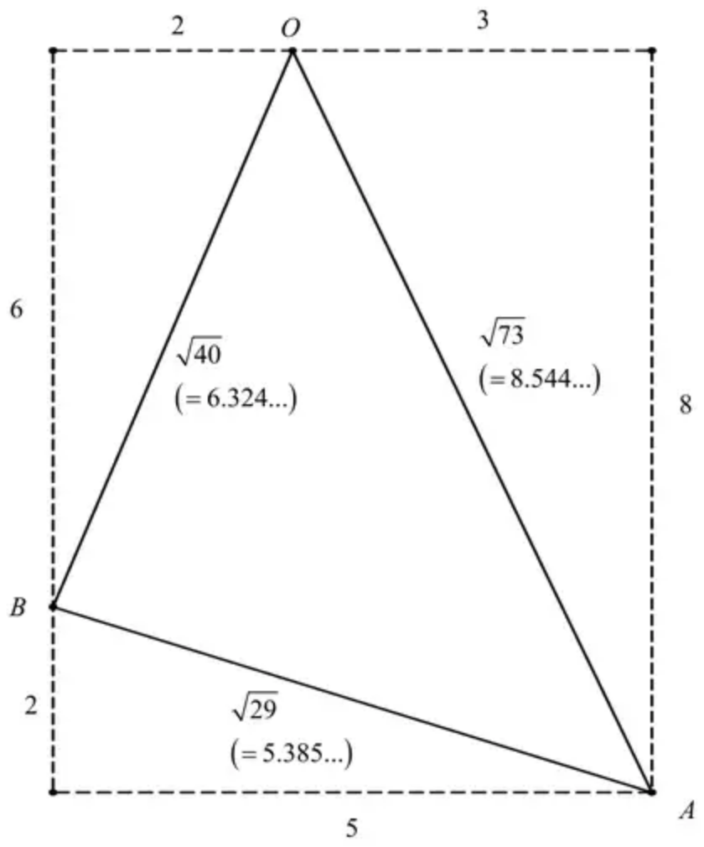
3.
Mark scheme (a)
Scheme | Marks | AO
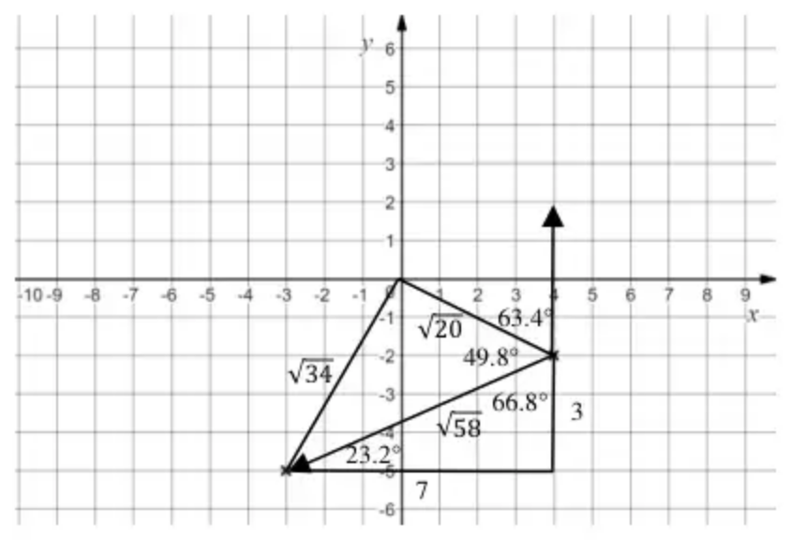
Attempts to find an "allowable" angle Eg $tan⁡θ=\frac{7}{3}$ | M1 | 1.1b
A full attempt to find the bearing Eg $180^{∘}+\text{“}67^{∘}\text{”}$ | dM1 | 3.1b
Bearing = awrt $246.8^{∘}$ | A1 | 1.1b
 | (3)

Notes
Score these two parts together.
M1: Attempts an allowable angle. (Either the “66.8”, “23.2” or (“49.8” and “63.4”))
$tan⁡θ=±\frac{7}{3},tan⁡θ=±\frac{3}{7},tan⁡θ=±\frac{−2−−5}{4−−3}$ etc
There must be an attempt to subtract the coordinates (seen or applied at least once)
If part (b) is attempted first, look for example for $sin⁡θ=±\frac{7}{\text{“}\sqrt{58}\text{”}},cos⁡θ=±\frac{7}{\text{“}\sqrt{58}\text{”}}$, etc
They may use the cosine rule and trigonometry to find the two angles in the scheme. See above. Eg award for $cos⁡θ=\frac{\text{“}58\text{”}+\text{“}20\text{”}−\text{“}34\text{”}}{2×\text{“}\sqrt{58}\text{”}×\text{“}\sqrt{20}\text{”}}$ and $tan⁡θ=±\frac{4}{2}$ or equivalent.
dM1: A full attempt to find the bearing. $180^{∘}+arctan⁡\frac{7}{3},270^{∘}−arctan⁡\frac{3}{7},360^{∘}−\text{“}49.8^{∘}\text{”}−\text{“}63.4^{∘}\text{”}$. It is dependent on the previous method mark.
A1: Bearing = awrt $246.8^{∘}$ oe. Allow S $66.8^{∘}$ W
Mark scheme (b)
Scheme | Marks | AO
Attempts to find the distance travelled = $\sqrt{(4−−3)^{2}+(−2+5)^{2}}=(\sqrt{58})$ | M1 | 1.1b
Attempts to find the speed = $\frac{\sqrt{58}}{2.75}$ | dM1 | 3.1b
= awrt 2.77 $\text{km}{\text{h}}^{−1}$ | A1 | 1.1b
 | (3)
 | (6 marks)

Notes
M1: Attempts to find the distance travelled. Allow for $d^{2}=(4−−3)^{2}+(−2+5)^{2}$
You may see this on a diagram and allow if they attempt to find the magnitude from their “resultant vector” found in part (a).
dM1: Attempts to find the speed. There must have been an attempt to find the distance using the coordinates and then divide it by 2.75. Alternatively they could find the speed in $\text{km}\text{mi}{\text{n}}^{−1}$ and then multiply by 60
A1: awrt 2.77 $\text{km}{\text{h}}^{−1}$
4.
Mark scheme (i)(a)
Scheme | Marks | AO
$\text{c}−\text{a}$ oe | B1 | 1.2
 | [1]

Notes
Allow without arrows or squiggles throughout
Mark scheme (i)(b)
Scheme | Marks | AO
$\text{a}+\frac{1}{2}(\text{c}−\text{a})$ or $\text{c}+\frac{1}{2}(\text{a}−\text{c})$ | M1 | 3.1a
$=\frac{1}{2}(\text{a}+\text{c})$ or $\frac{1}{2}\text{a}+\frac{1}{2}\text{c}$ | A1 | 1.1b
 | [2]

Notes
M1: $\text{a}+\frac{1}{2}$ their (a) or $\text{c}−\frac{1}{2}$ their (a)
A1: Correct ans without wking: M1A1
Allow without arrows or squiggles throughout
Mark scheme (ii)
Scheme | Marks | AO
$\vec{OB}=(\text{a}+\text{c})$ | M1 | 3.1a
$⇒\vec{OP}=\frac{1}{2}\vec{OB}$ Must see previous line | A1* | 1.1
$⇒P$ is midpt of $OB$  or $OPB$ is a straight line and $OP=PB$ | dep*A1 | 2.1
Hence diagonals of //m bisect one another | E1 | 2.2a
 | [4]

Notes
M1: $\vec{PB}=\text{a}+\frac{1}{2}(\text{c}−\text{a})$ or $\text{a}+\frac{1}{2}$ their (i)(a)
or $\text{c}+\frac{1}{2}(\text{a}−\text{c})$
$(=\frac{1}{2}(\text{a}+\text{c})$ oe), ft their (i)(a)
or $\vec{PB}=\text{c}−\frac{1}{2}$ their (i)(a)
NB $\vec{PB}=\frac{1}{2}(\text{a}+\text{c})$ without justification: M0A0A0E0
A1*: $⇒\vec{PB}=\vec{OP}$ or similar with $\vec{BP}$ or $\vec{BO}$
E1: dep M1A1A1
Allow without arrows or squiggles throughout

