QQQ – Mechanics Year 2 – Chapter 6 – Projectiles (Version 2)
Total Marks: 22
(22 = Platinum, 20 = Gold, 18 = Silver, 15 = Bronze)
1. In this question use $g$ = 9.8 m s⁻²
A ball is projected from a point on horizontal ground with an initial velocity of 7 m s⁻¹ at an angle $θ$ above the horizontal.
The ball reaches a maximum vertical height of $h$ metres above the ground.
(a) Show that
$$h=2.5{sin⁡}^{2}θ$$
[3 marks]
(b) Hence, given that $0^{∘}⩽θ⩽60^{∘}$, find the maximum value of $h$. [2 marks]
(c) Nisha claims that the larger the size of the ball, the greater the maximum vertical height will be.
State whether Nisha is correct, giving a reason for your answer. [1 mark]
(Total 6 marks)
AQA June 2022 Paper 2 Q13
2.
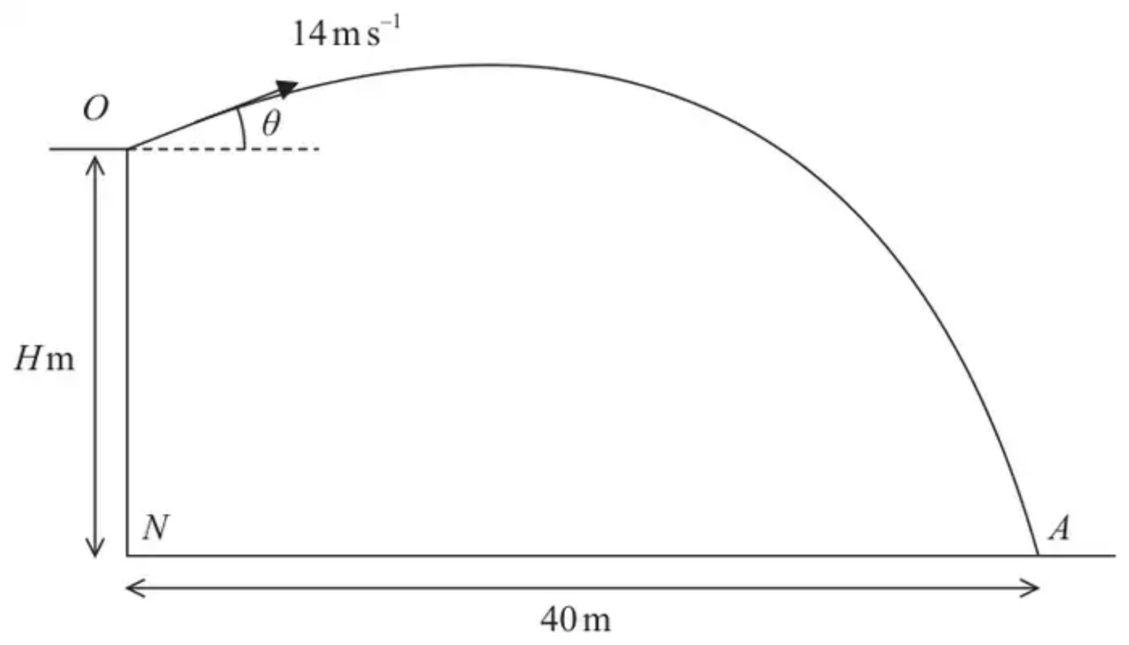
Figure 3
A small stone is projected with speed $14{\text{m s}}^{−1}$ from a point $O$ on the top of a cliff.
The point $O$ is $H$ metres vertically above the point $N$.
Point $N$ is on horizontal ground.
The stone is projected at an angle $θ$ above the horizontal, where $tan⁡θ=\frac{1}{2}$
The stone strikes the horizontal ground at the point $A$, where $NA=40$ m, as shown in Figure 3.
The stone is modelled as a particle moving freely under gravity.
Using this model, find
(a) the value of $H$ (5)
(b) the maximum height of the stone above the horizontal ground. (3)
(Total 8 marks)
Edexcel June 2025 Paper 3 Mechanics Q5
3. A vertical cliff is 73.5 m high. Two stones $A$ and $B$ are projected simultaneously. Stone $A$ is projected horizontally from the top of the cliff with speed 28 m s${}^{−1}$. Stone $B$ is projected from the bottom of the cliff with speed 35 m s${}^{−1}$ at an angle $α$ above the horizontal. The stones move freely under gravity in the same vertical plane and collide in mid-air. By considering the horizontal motion of each stone,
(a) prove that $cos⁡α=\frac{4}{5}$. (4)
(b) Find the time which elapses between the instant when the stones are projected and the instant when they collide. (4)
(Total 8 marks)
Edexcel M2 June 2006 Q5
Solutions
1.
Mark scheme (a)
Scheme | Marks | AO
Obtains $7sin⁡θ$ for vertical component of initial velocity | B1 | 1.1b
Uses $v^{2}=u^{2}+2as$ with $v=0$  Or  uses appropriate constant acceleration equations that form a complete method to obtain $h$ eg finds $t$ then subs into $s=ut+\frac{1}{2}at^{2}$ | M1 | 3.3
Completes argument substituting $s=h$, $v=0$, $u=7sin⁡θ$ and $a=−9.8$ to show the given result.  Accept negative values used consistently  AG | R1 | 2.1
 | (3)

Typical solution
$$u=7sin⁡θ$$
$$v^{2}=u^{2}+2as$$
$$0=49{sin⁡}^{2}θ−19.6h$$
So
$$h=2.5{sin⁡}^{2}θ$$
Mark scheme (b)
Scheme | Marks | AO
Substitutes any value of $θ$ in the range $0<θ⩽60$ to obtain a height greater than zero | M1 | 1.1a
Deduces $h$ = 1.9  AWRT 1.9 or $\frac{15}{8}$ | A1 | 2.2a
 | (2)

Typical solution
$$θ=60^{∘}$$
$$h=2.5{sin⁡}^{2}60$$
$$h=1.9$$
Mark scheme (c)
Scheme | Marks | AO
States that Nisha is incorrect and refers to air resistance or ball modelled as a particle | E1 | 3.5a
 | (1)
 | (6 marks)

Typical solution
Nisha is incorrect
The model ignores air resistance which gets greater as ball gets larger
2.
Mark scheme (a)
Scheme | Marks | AO
Using horizontal motion | M1 | 3.3
$14cos⁡θ×t=40$ | A1 | 1.1b
Using vertical motion | M1 | 3.4
$(s=)14sin⁡θ×t−\frac{1}{2}gt^{2}$ oe with down as positive. | A1 | 1.1b
OR
Using the equation of the path
$(s=)40tan⁡θ−\frac{g×40^{2}}{2×14^{2}{cos⁡}^{2}θ}$ oe | M2 A2
$(H=)30$ or 30.0 | A1 | 1.1b
 | (5)

Notes
N.B. Penalise the use of $g=9.81$ once (the first time it is used) for the whole question.
All marks available if they use a different letter for $θ$
M1: Complete method, using the horizontal motion, to give an equation in $t$ and $θ$ only, condone sin/cos confusion and sign errors
($θ$ may or may not be substituted for)
A1: Correct equation ($t$ and/or $θ$ may or may not be substituted for)
M1: Complete method, using the vertical motion, to give an equation in $t$ and $θ$ only, condone sin/cos confusion and sign errors
($t$ and/or $θ$ may or may not be substituted for)
A1: Correct equation ($t$ and/or $θ$ may or may not be substituted for)
N.B. Just mark the RHS of the equation for this A mark.
OR
M2 A2: Quoting and using correctly the equation of the path.
N.B. No marks if they misquote the equation and no marks if they put in 14 and/or 40 incorrectly.
These 4 marks are indivisible i.e. all 4 or 0.
A1: $H=30$ or 30.0 to 2 or 3 sf, after use of $g=9.8$, obtained correctly.
Mark scheme (b)
Scheme | Marks | AO
Using vertical motion OR Using cons. of energy | M1 | 2.1
$0^{2}=(14sin⁡θ)^{2}−2gh$ OR $\frac{1}{2}m(14^{2}−(14cos⁡θ)^{2})=mgh$ | A1 | 1.1b
32 (m) | A1ft | 1.1b
 | (3)
 | (8 marks)

Notes
N.B. Penalise the use of $g=9.81$ once (the first time it is used) for the whole question.
All marks available if they use a different letter for $θ$
M1: Complete method to give equation in $h$ and $θ$ only, condone sin/cos confusion and sign errors
They may find $t$ first: $0=14sin⁡θ−gt⇒t=\frac{14sin⁡θ}{g}$
then $h=(14sin⁡θ)\frac{14sin⁡θ}{g}−\frac{1}{2}g{(\frac{14sin⁡θ}{g})}^{2}$
or $h=−\frac{1}{2}(−g){(\frac{14sin⁡θ}{g})}^{2}$
or $h=\frac{(14sin⁡θ+0)}{2}(\frac{14sin⁡θ}{g})$
A1: Correct equation
A1ft: $∣\text{their}H∣+2$, to 2sf or 3sf
3.
Mark scheme (a)
Scheme | Marks
$x_{A}=28t$ $x_{B}=35cos⁡αt$ | B1 B1
Meet $⇒28t=35cos⁡αt⇒cos⁡α=28\text{/}35=4\text{/}5∗$ | M1 A1
 | (4)

Mark scheme (b)
Scheme | Marks
$y_{A}=73.5−\frac{1}{2}gt^{2}$ $y_{B}=21t−\frac{1}{2}gt^{2}$ | B1 B1
Meet $⇒73.5=21t⇒t=\overset{‾}{3.5\text{s}}$ | M1 A1
 | (4)
 | (8 marks)

