QQQ – Mechanics Year 2 – Chapter 6 – Projectiles (Version 1)
Total Marks: 23
(23 = Platinum, 21 = Gold, 18 = Silver, 16 = Bronze)
1. A cannonball is fired from a point on horizontal ground at $100\text{m}{\text{s}}^{−1}$ at an angle of $25^{∘}$ above the horizontal. Ignoring air resistance, calculate
(a) the greatest height the cannonball reaches, [3]
(b) the range of the cannonball. [4]
(Total 7 marks)
OCR MEI June 2019 Paper 1 Q9
2. A pebble is thrown horizontally at $14\text{m}{\text{s}}^{−1}$ from a window which is 5 m above horizontal ground. The pebble goes over a fence 2 m high $d$ m away from the window as shown in Fig. 9. The origin is on the ground directly below the window with the $x$-axis horizontal in the direction in which the pebble is thrown and the $y$-axis vertically upwards.
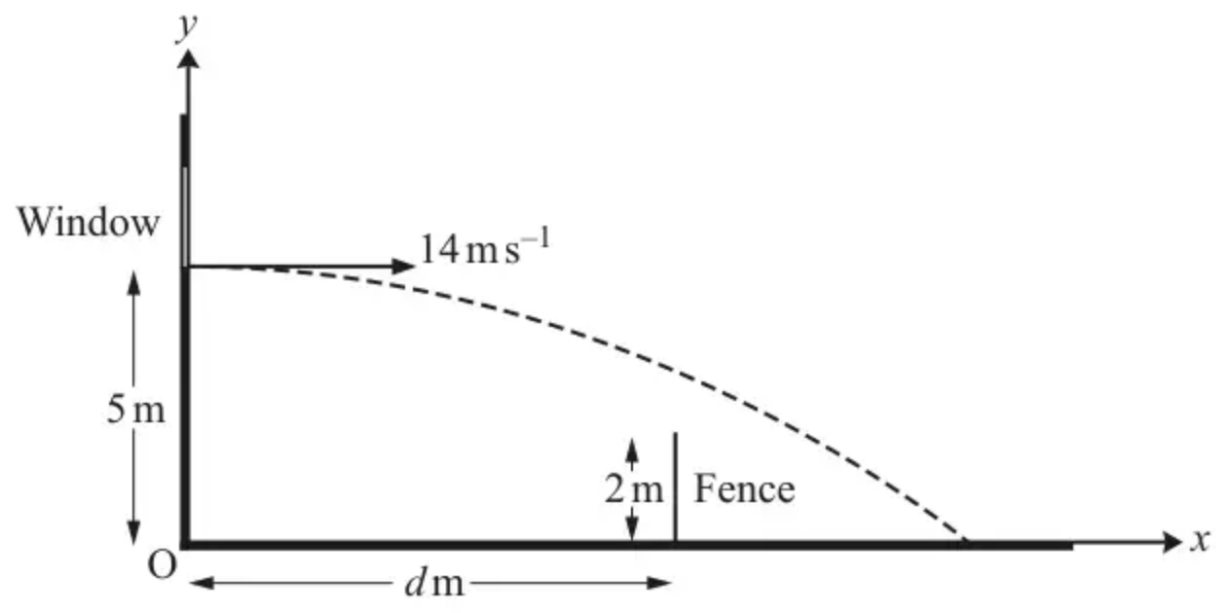
Fig. 9
(i) Find the time the pebble takes to reach the ground. [3]
(ii) Find the cartesian equation of the trajectory of the pebble. [4]
(iii) Find the range of possible values for $d$. [3]
(Total 10 marks)
OCR MEI June 2018 Paper 1 Q9
3. A ball is projected forward from a fixed point, $P$, on a horizontal surface with an initial speed $u$ m s⁻¹, at an acute angle $θ$ above the horizontal.
The ball needs to first land at a point at least $d$ metres away from $P$.
You may assume the ball may be modelled as a particle and that air resistance may be ignored.
Show that
$$sin⁡2θ⩾\frac{dg}{u^{2}}$$
[6 marks]
(Total 6 marks)
AQA June 2020 Paper 2 Q17
Solutions
1.
Mark scheme (a)
Scheme | Marks | AO
Vertical motion $u_{y}=100sin⁡25^{∘},v_{y}=0$  $v^{2}=u^{2}+2as$  $0=(100sin⁡25^{∘})^{2}−2×9.8×s$ | M1  B1 | 3.3  1.1a
$s=\frac{42.26^{2}}{19.6}=91.1$ m (3sf) | A1 | 3.2a
 | [3]

Notes
M1: Use of suvat equation(s) with $v=0$ leading to a value for $s$. Allow sign errors
eg from $t=4.31$ s
B1: Correct component of velocity soi
A1: cao
Mark scheme (b)
Scheme | Marks | AO
Vertical motion $u_{y}=100sin⁡25^{∘},y=0$  $s=ut+\frac{1}{2}at^{2}⇒0=(100sin⁡25^{∘})t−4.9t^{2}$  $t(100sin⁡25^{∘}−4.9t)=0⇒t=0$ or $8.62…$ | M1  A1 | 3.3  1.1a
$x=(100cos⁡25^{∘})×8.62…=781.678…$ | M1 | 1.1a
Range is 782 m (3sf) | A1 | 1.1b
 | [4]

Notes
M1: Use of suvat equation(s) with $y=0$ and their $u_{y}\text{≠}100$ leading to a value for $t$. Allow sign errors
A1: Correct value or expression for $t$ from correct working
Can be BC
M1: Use of horizontal motion equation with $u_{x}=100cos⁡25^{∘}$
Allow for sin/cos interchange used throughout part (b).
A1: FT their value for $t$
2.
Mark scheme (i)
Scheme | Marks | AO
Vertical motion $u=0$ | B1 | 3.3
$s=ut+\frac{1}{2}at^{2}$  $−5=0−\frac{9.8}{2}t^{2}$ | M1 | 3.4
$t=\sqrt{\frac{10}{9.8}}=1.01\text{s}$ | A1 | 1.1b
 | [3]

Notes
B1: Using $u=0$ in the vertical direction to model horizontal motion soi
M1: Using suvat equation(s) to find $t$. Allow sign errors and incorrect value for $u$.
A1: Must follow from working where the signs are consistent.
Mark scheme (ii)
Scheme | Marks | AO
$x=14t$ | B1 | 3.3
$y=5−4.9t^{2}$ | B1 | 3.3
So cartesian equation is  $y=5−4.9{(\frac{x}{14})}^{2}[=5−\frac{x^{2}}{40}]$ | M1  A1 | 1.1a  1.1b
 | [4]

Notes
B1: May be implied
B1: May be implied
M1: Attempt to eliminate $t$
A1: Any form
Mark scheme (iii)
Scheme | Marks | AO
EITHER  When $y=2 y=5−\frac{x^{2}}{40}=2\text{m}$  $\frac{x^{2}}{40}=3$ | M1 | 3.4
$x=\sqrt{120}=10.9544…$ | A1 | 1.1b
$[0<]d<11.0\text{m}$ | E1 | 3.2a
 | [3]

Notes
M1: Using their equation of trajectory and $y=2$
A1: Must be 11.0 or better
E1: Allow “Fence must be less than 10.95 m from the origin.” FT their value
SC2 for $d<\sqrt{80}[=8.94]$
SC1 for $d=\sqrt{80}[=8.94]$
OR
Scheme | Marks
When $y=2 2=5−4.9t^{2}$  $t=0.782$  When $t=0.782 x=14×0.782=10.95$ | M1
$[0<]d<11.0\text{m}$ | A1  A1

M1: Both steps required for M1
A1: Must be 11.0 or better
A1: Allow “Fence must be less than 10.95 m from the origin.”
Allow if the origin is taken to be at window height and the top of the wall is 3m below the window.
Signs must be consistent for A1
3.
Scheme | Marks | AO
Models vertical motion using a suitable constant acceleration equation, to find the time of flight.  Condone consistent sine/ cosine error | M1 | 3.3
Obtains correct equation or inequality for t  Must use g not numerical value | A1 | 1.1b
Models horizontal displacement  Condone consistent sine/ cosine error | M1 | 3.3
Obtains correct equation or inequality to model horizontal displacement | A1 | 1.1b
Eliminates $t$, where t is time of flight, from their horizontal and vertical models to obtain an expression in terms of u, g and $θ$ only. | M1 | 3.4
Completes reasoned argument to obtain stated result. Must justify stated inequality must have used correct resolution of u throughout | R1 | 2.1
 | (6 marks)

Typical solution
Vertically:
$$0=t×usin⁡θ−0.5×g×t^{2}$$
$$t=\frac{2usin⁡θ}{g}$$
Horizontally:
$$x=utcos⁡θ$$
$$x=u\frac{2usin⁡θ}{g}cos⁡θ,$$
using $sin⁡2θ=2sin⁡θcos⁡θ$
$$x=\frac{u^{2}sin⁡2θ}{g}$$
Since $x⩾d$
$$\frac{u^{2}sin⁡2θ}{g}⩾d$$
$$sin⁡2θ⩾\frac{dg}{u^{2}}$$

