QQQ – Mechanics Year 2 – Chapter 5 – Resolving Forces & Friction (Version 2)
Total Marks: 24
(24 = Platinum, 22 = Gold, 19 = Silver, 16 = Bronze)
1.
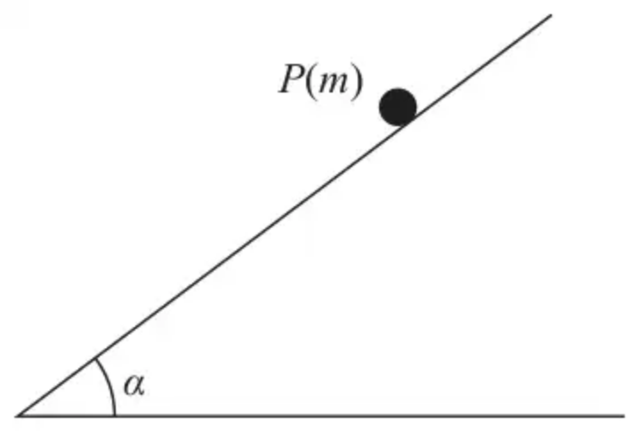
Figure 3
A particle $P$ of mass $m$ is held at rest at a point on a rough inclined plane, as shown in Figure 3.
It is given that
• the plane is inclined to the horizontal at an angle $α$, where $tan⁡α=\frac{5}{12}$
• the coefficient of friction between $P$ and the plane is $μ$, where $μ<\frac{5}{12}$
The particle $P$ is released from rest and slides down the plane.
Air resistance is modelled as being negligible.
Using the model,
(a) find, in terms of $m$ and $g$, the magnitude of the normal reaction of the plane on $P$, (2)
(b) show that, as $P$ slides down the plane, the acceleration of $P$ down the plane is
$$\frac{1}{13}g(5−12μ)$$
(4)
(c) State what would happen to $P$ if it is released from rest but $μ⩾\frac{5}{12}$ (1)
(Total 7 marks)
Edexcel June 2024 Paper 3 Mechanics Q3
2. In this question use $g=9.8{\text{m s}}^{−2}$
A boy attempts to move a wooden crate of mass 20 kg along horizontal ground. The coefficient of friction between the crate and the ground is 0.85
(a) The boy applies a horizontal force of 150 N. Show that the crate remains stationary. [3 marks]
(b) Instead, the boy uses a handle to pull the crate forward. He exerts a force of 150 N, at an angle of $15^{∘}$ above the horizontal, as shown in the diagram.
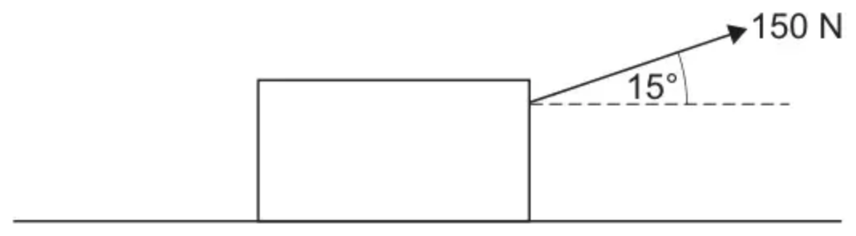
Determine whether the crate remains stationary.
Fully justify your answer. [5 marks]
(Total 8 marks)
AQA June 2018 Paper 2 Q13
3.
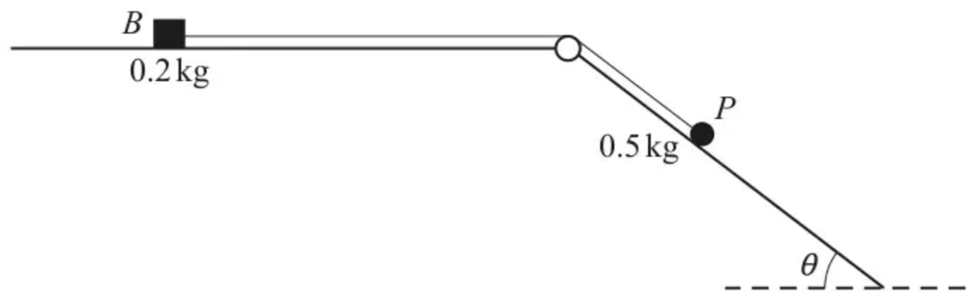
The diagram shows a small block $B$, of mass $0.2\text{kg}$, and a particle $P$, of mass $0.5\text{kg}$, which are attached to the ends of a light inextensible string. The string is taut and passes over a small smooth pulley fixed at the intersection of a horizontal surface and an inclined plane.
The block can move on the horizontal surface, which is rough. The particle can move on the inclined plane, which is smooth and which makes an angle of $θ$ with the horizontal where $tan⁡θ=\frac{3}{4}$.
The system is released from rest. In the first 0.4 seconds of the motion $P$ moves $0.3\text{m}$ down the plane and $B$ does not reach the pulley.
(a) Find the tension in the string during the first 0.4 seconds of the motion. [4]
(b) Calculate the coefficient of friction between $B$ and the horizontal surface. [5]
(Total 9 marks)
OCR A June 2019 Paper 3 Q9
Solutions
1.
Mark scheme (a)
Scheme | Marks | AO
$(R=)mgcos⁡α$ | M1 | 3.4
$=\frac{12}{13}mg$ | A1 | 1.1b
 | (2)

Notes
M1: Correct no. of terms, condone sin/cos confusion and sign errors, dimensionally correct.
Allow use of a different symbol for the angle.
A1: Accept $0.92mg$ or better. Must be positive.
Mark scheme (b)
Scheme | Marks | AO
Equation of motion down the plane | M1 | 2.1
$mgsin⁡α−F=ma$ or $mgsin⁡α−F=−ma$ | A1 | 1.1b
$(F=)μ×\text{their}R$ | M1 | 3.4
$\frac{1}{13}g(5−12μ)$ * | A1* | 2.2a
 | (4)

Notes
M1: Correct no. of terms, condone sin/cos confusion and sign errors
(M0 if they use $g$ for $a$)
N.B. Must be using $mg$ or $m$ not $W$ for the weight.
A1: Any correct equation e.g. $mgsin⁡α=ma+F$
N.B. $F$ does not need to be substituted.
M1: $μ×$ their $R$ seen (possibly on a diagram), any trig does not need to be replaced.
M0 if they use $μ=\frac{5}{12}$
M0 for just $μR$ with $R$ not replaced.
A1*: Given answer correctly obtained, with at least one further line of working with both trig ratios substituted as fractions.
Allow $\frac{g}{13}(5−12μ)$ or $\frac{g(5−12μ)}{13}$
Mark scheme (c)
Scheme | Marks | AO
$P$ wouldn’t move | B1 | 2.4
 | (1)
 | (7 marks)

Notes
B1: e.g. $P$ (or the particle or the object) would stay at rest, $P$ would not slide down, would not roll down the plane, static equilibrium, equilibrium at rest
Allow ‘it’ for $P$ or just ‘stays at rest oe’
B0 for wouldn’t accelerate, would be in equilibrium (only), would stop
N.B. Ignore reasons but not contradictions.
2.
Mark scheme (a)
Scheme | Marks | AO
Uses model for maximum friction $=μmg$ | B1 | AO3.3
Makes an appropriate comparison | M1 | AO1.1a
Explains clearly why crate remains stationary | E1 | AO2.4

Typical solution
$$Fmax⁡=μmg$$
$$=0.85×20×9.8$$
$$=166.6\text{N}$$
150 < 166.6
$∴$ crate does not move
Mark scheme (b)
Scheme | Marks | AO
Forms an equation by resolving vertically  Condone one of sign error or cos error | M1 | AO3.1b
Obtains correct reaction force | A1 | AO1.1b
Uses maximum friction $=μR$  With ‘their’ reaction force  Must identify maximum or limiting friction | B1F | AO1.1b
Compares $150cos⁡15^{∘}$ with ‘their’ maximum friction | M1 | AO1.1a
Explains, using their values, why the crate begins to move. | E1F | AO2.4
 | (8 marks)

Typical solution
$$20g=R+150sin⁡15^{∘}$$
$$R=157.177\text{N}$$
$$Fmax⁡=μ×157.177$$
$$=133.6\text{N}$$
$$150cos⁡15^{∘}=145\text{N}$$
145 > 133.6
$∴$ crate begins to move
3.
Mark scheme (a)
Scheme | Marks | AO
$0.3=\frac{1}{2}a×0.4^{2}(⇒a=3.75)$ | B1 | 3.1b
$0.5gsin⁡θ−T=0.5a$ | M1 | 3.3
$0.5g×\frac{3}{5}−T=0.5×3.75$ | A1ft | 1.1
$T=1.065\text{N}$ | A1 | 1.1
 | [4]

Notes
B1: Cao seen or implied by correct $T$
M1: Use of N II parallel to the plane (correct number of terms) – weight must be resolved (but allow sin/cos confusion in component of the weight – may still be in terms of $θ$ and $a$ (or their incorrect values of $θ$ and $a$))
Allow sign errors but M0 if using $0.5g$ for the mass on the rhs or if only resolving the mass (e.g. $0.5sin⁡θ$) on the lhs
A1ft: 'correct' equation in terms of $T$ with their $a$
Allow $0.5g×sin⁡36.9−T=0.5×\text{‘}3.75\text{’}$ or $0.5g×sin⁡0.644−T=0.5×\text{‘}3.75\text{’}$ (in radians)
A0 if $a=0$ or $±g$ (or a component of $g$)
A1: Allow 1.07 www
Mark scheme (b)
Scheme | Marks | AO
$R=0.2g$ | B1 | 1.1
$T−F=0.2a$ or $T−μR=0.2a$ | M1* | 3.3
$1.065−F=0.2(3.75)$ | A1 | 1.1
$0.315=μ×0.2×9.8$ | M1dep* | 3.4
$μ=0.161$ | A1 | 1.1
 | [5]

Notes
B1: Where $R$ is the normal contact force of surface acting on $B$ – may be implied in N II applied horizontally
M1*: Use of N II horizontally for $B$ or $0.5gsin⁡θ−F=0.7a$ for the whole system (M0 if any other mass used for whole system)
Correct number of terms (M0 if mass is $0.2g$) – allow sign errors
A1: Or for a correct statement without explicitly seeing $F$ e.g. $1.065−0.2gμ=0.2(3.75)$ (which would imply the next M mark as well)
$F=0.315$ or $μR=0.315$ or $F=0.32$
M1dep*: Use of $F=μR$ where $R=0.2g$ - may be implied in N II applied horizontally
A1: Allow awrt 0.161 or 0.163 from using $T=1.07$ www
$μ=\frac{9}{56}$

