QQQ – Mechanics Year 2 – Chapter 5 – Resolving Forces & Friction (Version 1)
Total Marks: 22
(22 = Platinum, 20 = Gold, 18 = Silver, 15 = Bronze)
1.
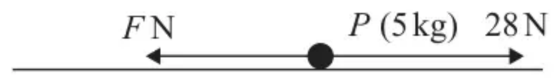
Figure 1
A particle $P$ has mass 5 kg.
The particle is pulled along a rough horizontal plane by a horizontal force of magnitude 28 N.
The only resistance to motion is a frictional force of magnitude $F$ newtons, as shown in Figure 1.
(a) Find the magnitude of the normal reaction of the plane on $P$ (1)
The particle is accelerating along the plane at $1.4{\text{m s}}^{−2}$
(b) Find the value of $F$ (2)
The coefficient of friction between $P$ and the plane is $μ$
(c) Find the value of $μ$, giving your answer to 2 significant figures. (1)
(Total 4 marks)
Edexcel June 2023 Paper 3 Mechanics Q2
2. A 15 kg box is suspended in the air by a rope which makes an angle of $30^{∘}$ with the vertical. The box is held in place by a string which is horizontal.
(a) Draw a diagram showing the forces acting on the box. [1]
(b) Calculate the tension in the rope. [2]
(c) Calculate the tension in the string. [2]
(Total 5 marks)
OCR MEI June 2019 Paper 1 Q13
3.
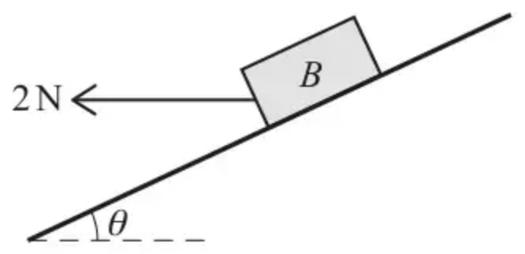
A block $B$ of weight $10\text{N}$ lies at rest in equilibrium on a rough plane inclined at $θ$ to the horizontal. A horizontal force of magnitude $2\text{N}$, acting above a line of greatest slope, is applied to $B$ (see diagram).
(a) Complete the diagram in the Printed Answer Booklet to show all the forces acting on $B$. [1]
It is given that $B$ remains at rest and the coefficient of friction between $B$ and the plane is 0.8.
(b) Determine the greatest possible value of $tan⁡θ$. [5]
(Total 6 marks)
OCR A June 2023 Paper 3 Q9
4. Fig. 11 shows two blocks at rest, connected by a light inextensible string which passes over a smooth pulley. Block A of mass 4.7 kg rests on a smooth plane inclined at $60^{∘}$ to the horizontal. Block B of mass 4 kg rests on a rough plane inclined at $25^{∘}$ to the horizontal. On either side of the pulley, the string is parallel to a line of greatest slope of the plane. Block B is on the point of sliding up the plane.
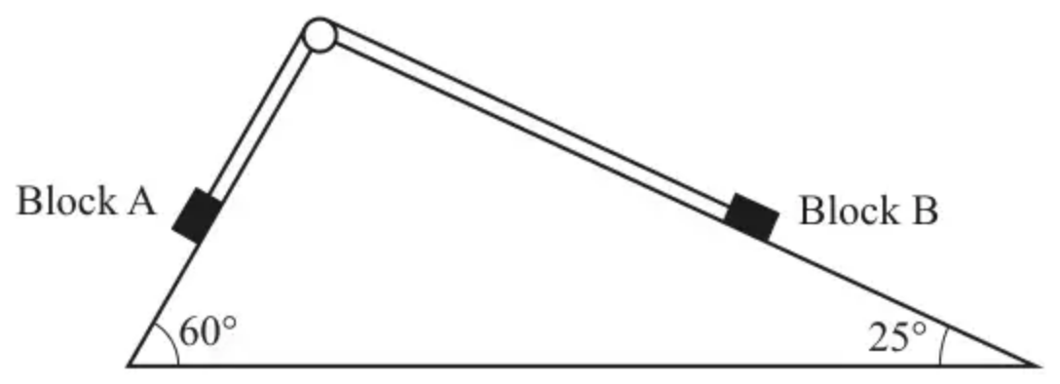
Fig. 11
(i) Show that the tension in the string is 39.9 N correct to 3 significant figures. [2]
(ii) Find the coefficient of friction between the rough plane and Block B. [5]
(Total 7 marks)
OCR MEI June 2018 Paper 1 Q11
Solutions
1.
Mark scheme (a)
Scheme | Marks | AO
Resolve vertically, $R=5g=49$ (N) | B1 | 1.1b
 | (1)

Notes
B1: Allow either $5g$ or 49. No penalty for using $g=9.81$ or 10.
Ignore any working. Must be a positive number.
B0 if $m$ is involved.
N.B. Could be seen on a diagram, provided it’s clearly the reaction.
Mark scheme (b)
Scheme | Marks | AO
Equation of motion: $28−F=5×1.4$ | M1 | 3.1a
$F=21$ | A1 | 1.1b
 | (2)

Notes
M1: Equation with correct terms, dimensionally correct, condone sign errors.
A1: cao but allow $\frac{15g}{7}$. Ignore units.
Mark scheme (c)
Scheme | Marks | AO
$μ=0.43$ (2sf required) | B1 ft | 3.4
 | (1)
 | (4 marks)

Notes
B1ft: $μ=\frac{\text{their (b)}}{\text{their (a)}}$. Answer must be a positive number given to 2sf.
N.B.
B0 if they use $g=9.81$ or 10 in this part of the question.
Do not allow restarts.
Allow $μ>1$.
2.
Mark scheme (a)
Scheme | Marks | AO
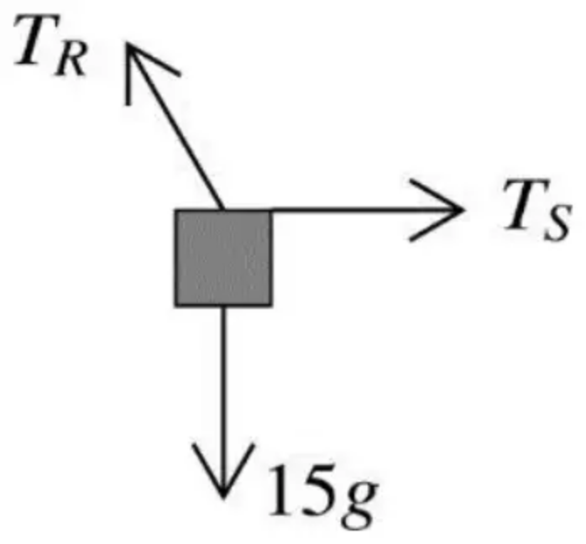 | B1 | 1.1a
 | [1]

Notes
B1: Three forces in approximately correct directions, with arrows and labels; tensions must be distinct
Accept $W$ or $mg$ for the weight; condone missing $g$ for this mark
Mark scheme (b)
Scheme | Marks | AO
Resolve vertically: $T_{R}cos⁡30^{∘}=15g$ | M1 | 3.3
$T_{R}=\frac{15×9.8}{cos⁡30^{∘}}=98\sqrt{3}=170$ N (3sf) | A1 | 1.1b
 | [2]

Notes
M1: Forming equilibrium equation (allow sin/cos interchange)
A1: Oe
Mark scheme (c)
Scheme | Marks | AO
Resolve horizontally: $T_{S}=T_{R}sin⁡30^{∘}$ | M1 | 1.1a
$T_{S}=84.9$ N (3sf) | A1 | 1.1b
 | [2]

Notes
M1: Allow sin/cos interchange if consistent with (b)
Accept $T_{S}=15gtan⁡30^{∘}$
A1: Oe
3.
Mark scheme (a)
Scheme | Marks | AO
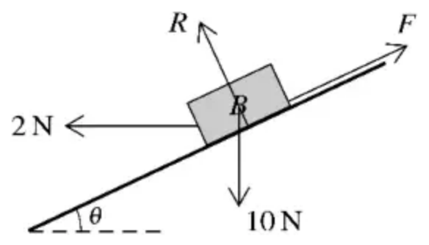 | B1 | 1.2
 | [1]

Notes
B1: Correct force diagram showing the weight, normal contact, and frictional contact forces only (but ignore labelling of these forces even if labelled incorrectly) but must include all arrows pointing in the correct direction – the line of action of all forces must pass through the block (or imply passing through the block) but do not need to be attached to the block
Ignore components of any of the three forces if shown – if only components shown then B0
Mark scheme (b)
Scheme | Marks | AO
 | M1* | 3.3
$R+2sin⁡θ=10cos⁡θ$  $F=2cos⁡θ+10sin⁡θ$ | A1  A1 | 1.1  1.1
$2cos⁡θ+10sin⁡θ⩽0.8(10cos⁡θ−2sin⁡θ)$ | M1dep* | 3.4
$10cos⁡θ+50sin⁡θ⩽40cos⁡θ−8sin⁡θ$  $(tan⁡θ⩽\frac{30}{58}⇒\text{greatest value of})tan⁡θ$ is $\frac{15}{29}$ | A1 | 2.2a
 | [5]

Notes
M1*: Resolving parallel or perpendicular to the plane – correct number of terms - must be using 10 for the weight so no marks until this value used/applied (however, see SC in the final A mark)
Allow sin/cos confusion and sign errors – but the 2 and 10 must be resolved and the $R$ and $F$ should not (if considering $⊥$ & $∥$)
A1 A1: Condone $⩽$ or $⩾$ with $F$ for this mark but withhold the final A mark
Where $R$ is the normal contact force and $F$ is the frictional contact force
M1dep*: Applying $F⩽μR$ or $F=μR$ to obtain an equation/inequality in $θ$ only – where $R$ and $F$ are a linear combination of the correct number of relevant resolved terms
A1: oe e.g. $\frac{30}{58}$ but A0 for $\frac{6}{11.6}$ as a final answer. Allow awrt 0.517. Isw if candidates go on to work out $θ$. Allow $tan⁡θ⩽\frac{15}{29}$ (oe) as a final answer
Can use equals throughout (no justification required) But not $tan⁡θ<\frac{15}{29}$
If using $10g$ for the weight, then SC M1* A1 A0 M1dep* A0 max (where the first A mark is for both equations correct using $10g$ rather than 10)
Alternative for first three marks
Scheme | Marks
Resolving vertically and horizontally | M1*
$Rcos⁡θ+Fsin⁡θ=10$ | A1
$Fcos⁡θ=2+Rsin⁡θ$ | A1

M1*: M1 conditions as above
A1: Final M1dep* and A marks as above
4.
Mark scheme (i)
Scheme | Marks | AO
Component of weight down the plane  $4.7gsin⁡60^{∘}$ | B1 | 2.1
Equilibrium equation  $T=4.7gsin⁡60^{∘}$  $=39.889…$ so $T=39.9$ to 3 sf | E1 | 3.3
 | [2]

Notes
AG
B1: Award if seen
E1: Must be clear that 39.9 N is the tension and not just component of weight
Mark scheme (ii)
Scheme | Marks | AO
Resolve perpendicular to the slope  $N$ is the normal reaction between plane and block B  $N=4gcos⁡25^{∘}$ | B1 | 1.1a
Resolve up the slope  $T−F−4gsin⁡25^{∘}=0$ | M1  A1 | 3.3  1.1b
On the point of sliding so  $F=μN=μ×4gcos⁡25^{∘}$ | M1 | 3.1b
$μ=\frac{4.7gsin⁡60^{∘}−4gsin⁡25^{∘}}{4gcos⁡25^{∘}}=0.656$ to 3sf | A1 | 1.1b
 | [5]

Notes
B1: Need not be evaluated here $[≈35.5]$
M1: Allow only sign errors
A1: $F$ need not be evaluated here $[≈23.3]$
M1: Do not allow for $F⩽μN$ unless = used subsequently. FT their values.
A1: FT (notice this answer is 0.657 if 39.9 used for $T$)
If only values are seen used, it must be clear that the values used are friction and normal reaction.

