QQQ – Mechanics Year 2 – Chapter 4 – Moments (Version 2)
Total Marks: 23
(23 = Platinum, 21 = Gold, 18 = Silver, 16 = Bronze)
1. A straight uniform rod, $AB$, has length 6 m and mass 0.2 kg
A particle of weight $w$ newtons is fixed at $A$.
A second particle of weight $3w$ newtons is fixed at $B$.
The rod is suspended by a string from a point $x$ metres from $B$.
The rod rests in equilibrium with $AB$ horizontal and the string hanging vertically as shown in the diagram below.
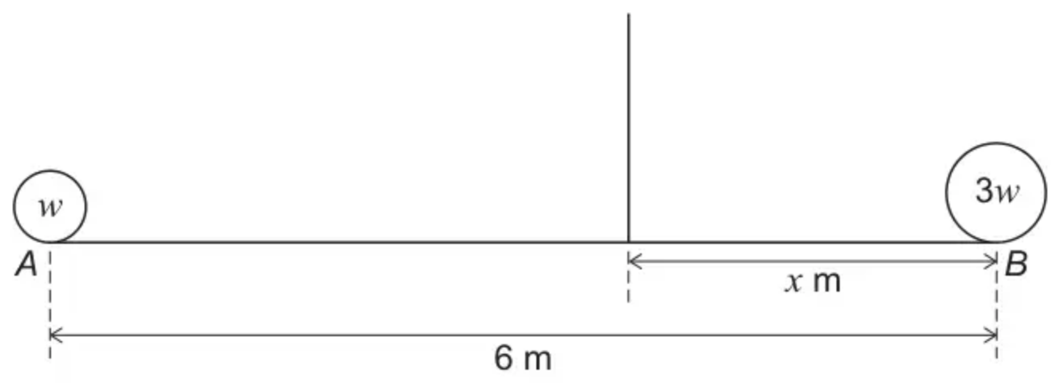
Show that
$$x=\frac{3w+0.3g}{2w+0.1g}$$
[4 marks]
(Total 4 marks)
AQA June 2021 Paper 2 Q16
2. A uniform ruler AB has mass 28 g and length 30 cm. As shown in Fig. 6, the ruler is placed on a horizontal table so that it overhangs a point C at the edge of the table by 25 cm.
A downward force of $F$ N is applied at A. This force just holds the ruler in equilibrium so that the contact force between the table and the ruler acts through C.
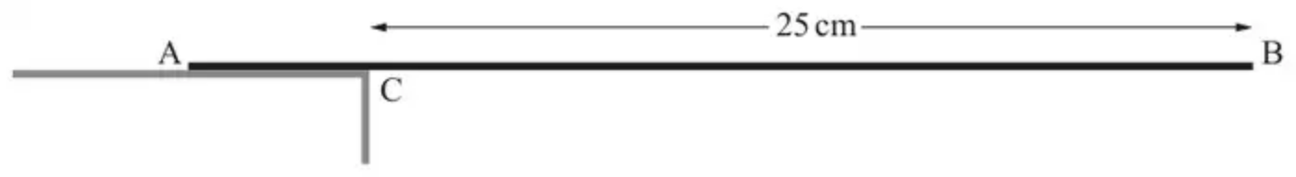
Fig. 6
(a) Complete the force diagram in the Printed Answer Booklet, labelling the forces and all relevant distances.
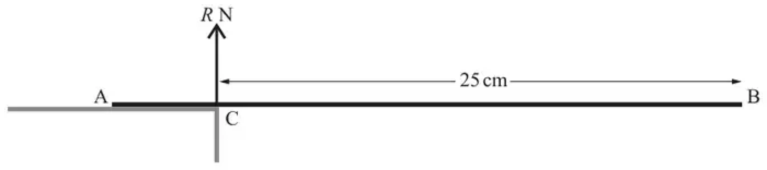
[2]
(b) Calculate the value of $F$. [2]
(Total 4 marks)
OCR MEI October 2020 Paper 1 Q6
3.
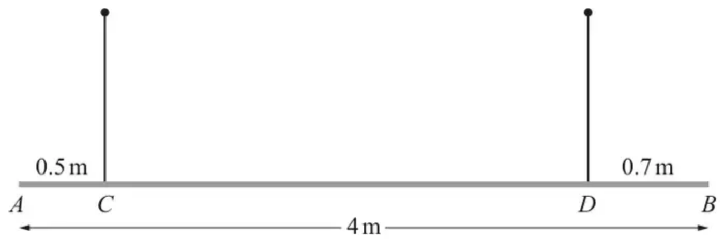
A beam, $AB$, has length $4\text{m}$ and mass $20\text{kg}$. The beam is suspended horizontally by two vertical ropes. One rope is attached to the beam at $C$, where $AC=0.5\text{m}$. The other rope is attached to the beam at $D$, where $DB=0.7\text{m}$ (see diagram).
The beam is modelled as a non-uniform rod and the ropes as light inextensible strings.
It is given that the tension in the rope at $C$ is three times the tension in the rope at $D$.
(a) Determine the distance of the centre of mass of the beam from $A$. [5]
A particle of mass $m\text{kg}$ is now placed on the beam at a point where the magnitude of the moment of the particle's weight about $C$ is $3.5mg\text{N}\text{m}$. The beam remains horizontal and in equilibrium.
(b) Determine the largest possible value of $m$. [2]
(Total 7 marks)
OCR A October 2021 Paper 3 Q12
4.
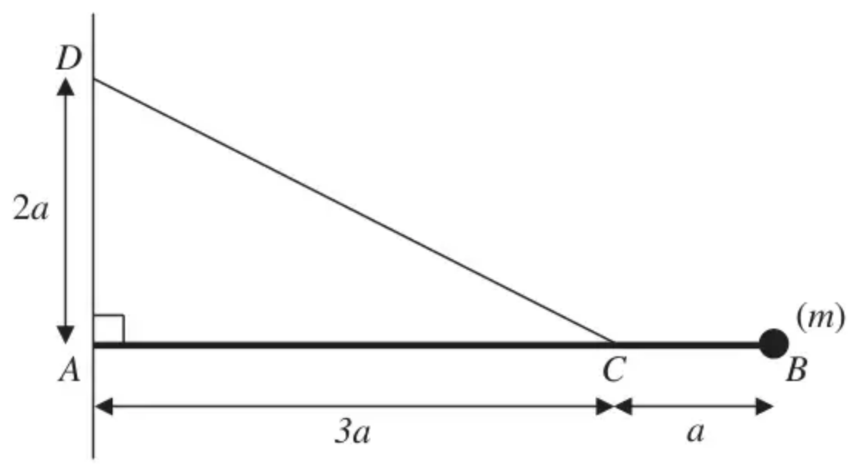
Figure 2
Figure 2 shows a uniform rod $AB$ of mass $m$ and length $4a$. The end $A$ of the rod is freely hinged to a point on a vertical wall. A particle of mass $m$ is attached to the rod at $B$. One end of a light inextensible string is attached to the rod at $C$, where $AC=3a$. The other end of the string is attached to the wall at $D$, where $AD=2a$ and $D$ is vertically above $A$. The rod rests horizontally in equilibrium in a vertical plane perpendicular to the wall and the tension in the string is $T$.
(a) Show that $T=mg\sqrt{13}$. (5)
The particle of mass $m$ at $B$ is removed from the rod and replaced by a particle of mass $M$ which is attached to the rod at $B$. The string breaks if the tension exceeds $2mg\sqrt{13}$. Given that the string does not break,
(b) show that $M⩽\frac{5}{2}m$. (3)
(Total 8 marks)
Edexcel M2 June 2010 Q6
Solutions
1.
Scheme | Marks | AO
Takes moments about the point of suspension to form a moments equation involving $w$ and $x$ with one term correctly expressed.  or  Takes moments about any other point to form a moments equation involving $w$, $x$ and $T$ with one term correctly expressed.  If moments taken about $A$ then $0.2g(3)+3w(6)=T(6−x)$  If moments taken about $B$ then $w(6)+0.2g(3)=Tx$ | M1 | 3.3
Forms a dimensionally correct moments equation with two terms correctly expressed | M1 | 1.1a
Forms a fully correct equation involving $w$, $x$ and $g$ only  If moments taken about $A$ or $B$ then $T$ = 4$w$ +0.2$g$ must have been substituted at this point | A1 | 1.1b
Obtains given answer showing at least the step  $x(4w+0.2g)=6w+0.6g$  OE  or  $x=\frac{6w+0.6g}{4w+0.2g}$  OE  Must have fully corrected any error involving weight and mass throughout  AG | R1 | 2.1
 | (4 marks)

Typical solution
Take moments about the point of suspension
$$3wx=(3−x)0.2g+(6−x)w$$
$$4wx+0.2gx=6w+0.6g$$
$$2(2w+0.1g)x=6w+0.6g$$
$$∴x=\frac{3w+0.3g}{2w+0.1g}$$
2.
Mark scheme (a)
Scheme | Marks | AO
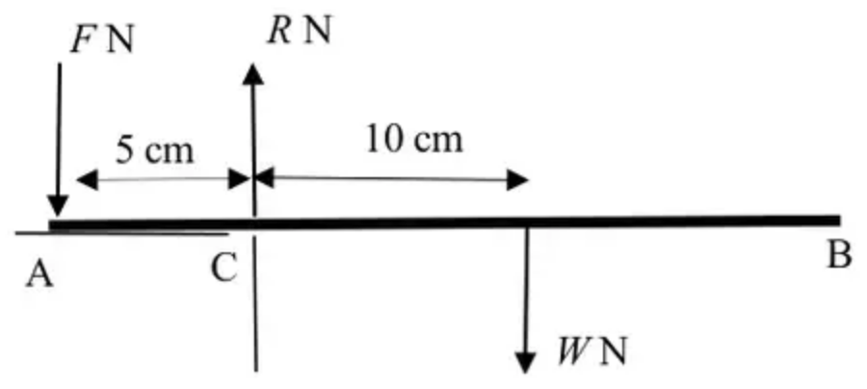 | B1  B1 | 1.1a  1.1
 | [2]

Notes
B1: F and their weight even if not labelled in roughly correct position
R is already drawn in Printed Answer Booklet
B1: Distances labelled. Allow for 5cm and any measurements that show that the weight is acting in the centre of the ruler.
Mark scheme (b)
Scheme | Marks | AO
Take moments about C  $10×0.028g=5F$ | M1 | 1.1a
$F=0.549$ N | A1 | 1.1
 | [2]

Notes
M1: Moments about any point with all relevant forces seen. Allow their weight and one incorrect distance
[Value of R is 0.8232 N]
A1: allow $\frac{7}{125}g$ oe
3.
Mark scheme (a)
Scheme | Marks | AO
$\begin{matrix}0.5T_{C}+(4−0.7)T_{D}=20g\overset{ˉ}{x} & \text{(moments about}A\text{)} \\ (\overset{ˉ}{x}−0.5)(20g)=(4−1.2)T_{D} & \text{(moments about}C\text{)} \\ (4−1.2)T_{C}=20g(4−0.7−\overset{ˉ}{x}) & \text{(moments about}D\text{)} \\ 0.7T_{D}+(4−0.5)T_{C}=20g(4−\overset{ˉ}{x}) & \text{(moments about}B\text{)} \\ (\overset{ˉ}{x}−0.5)T_{C}=(4−0.7−\overset{ˉ}{x})T_{D} & \text{(moments about com)}\end{matrix}$ | M1*  A1FT | 3.3  1.1
$T_{C}=3T_{D}$ or $T_{C}=3T$ and $T_{D}=T$ | B1 | 3.3
$T_{C}=147(=15g)$ and/or $T_{D}=49(=5g)$ (from $T_{C}+T_{D}=20g$) used in relevant moment equation(s) | M1dep* | 1.1
$\overset{ˉ}{x}=1.2(\text{m})$ | A1 | 2.2a
 | [5]

Notes
M1*: Moments (with correct number of terms) about $A$, $C$, $D$, $B$ or com
$\overset{ˉ}{x}$ is the centre of mass of the rod from $A$
Allow $g$ to be absent
A1FT: Follow though their $T_{C}$ and $T_{D}$ (allow just $T$) and allow $W$ for $20g$
B1: Correct relationship(s) for the tensions at $C$ and $D$ (soi)
M1dep*: Equation in $\overset{ˉ}{x}$ only, e.g.,
• $W=4T$ and any one mom. eq.
• $4T=20g$ and any one mom. eq.
• $W=20g$ and any two mom. eq.
M0 if tension used are the same in both ropes
A1: Must be 1.2 as question asks for com from $A$
Alternative: B1 as main scheme (soi), then M1 for splitting 2.8 in the ratio 1: 3 or 3:1 then A1 for correct 1:3 then B2 for $0.5+0.25(2.8)=1.2(\text{m})$
Mark scheme (b)
Scheme | Marks | AO
$0.7mg=20g(4−\overset{ˉ}{x}−0.7)$ (moments about $D$)  $20g(\overset{ˉ}{x}−0.5)+3.5mg=(4−0.5−0.7)(20g+mg)$ (moments about $C$) | M1 | 3.1b
$m=60$ | A1 | 2.2a
 | [2]

Notes
M1: Moments about $D$ (oe) – correct number of terms – if taking moments about another point then must set $T_{C}=0$ and $T_{D}=20g+mg$
Allow $g$ to be absent
4.
Mark scheme (a)
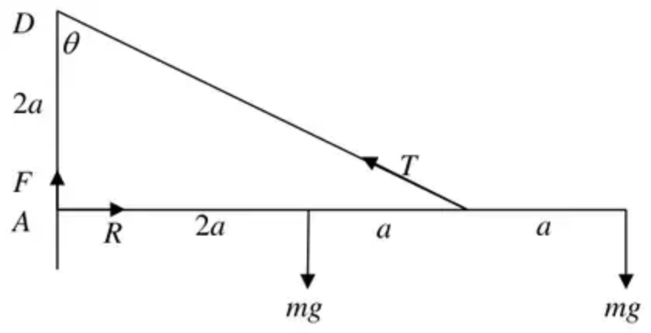
Scheme | Marks
$\text{M}(A) 3a×Tcos⁡θ=2amg+4amg$ | M1 A1 A1
$cos⁡θ=(\frac{2}{\sqrt{9+4}}=)\frac{2}{\sqrt{13}}$ | B1
$\frac{6}{\sqrt{13}}T=6mg$
$T=mg\sqrt{13}∗$ | A1
 | (5)

Mark scheme (b)
Scheme | Marks
$3a×T×cos⁡θ=2amg+4aMg$ | M1
$T=\frac{(2mg+4Mg)}{6}\sqrt{13}⩽2mg\sqrt{13}$ | A1
$mg+2Mg<6mg$
$M⩽\frac{5}{2}m∗$ cso | A1
 | (3)
 | (8 marks)

