QQQ – Mechanics Year 2 – Chapter 4 – Moments (Version 1)
Total Marks: 23
(23 = Platinum, 21 = Gold, 18 = Silver, 16 = Bronze)
1. A uniform rod, $AB$, has length 7 metres and mass 4 kilograms.
The rod rests on a single fixed pivot point, $C$, where $AC=2$ metres.
A particle of weight $W$ newtons is fixed at $A$, as shown in the diagram.
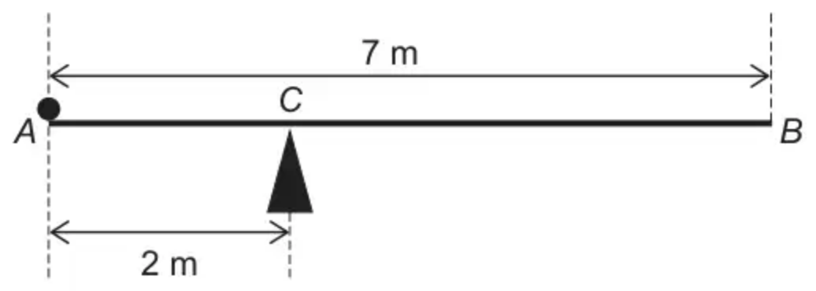
The system is in equilibrium with the rod resting horizontally.
(a) Find $W$, giving your answer in terms of $g$. [2 marks]
(b) Explain how you have used the fact that the rod is uniform in part (a). [1 mark]
(Total 3 marks)
AQA June 2020 Paper 2 Q13
2. Fig. 4 shows a uniform beam of mass 4 kg and length 2.4 m resting on two supports P and Q. P is at one end of the beam and Q is 0.3 m from the other end.
Determine whether a person of mass 50 kg can tip the beam by standing on it. [3]
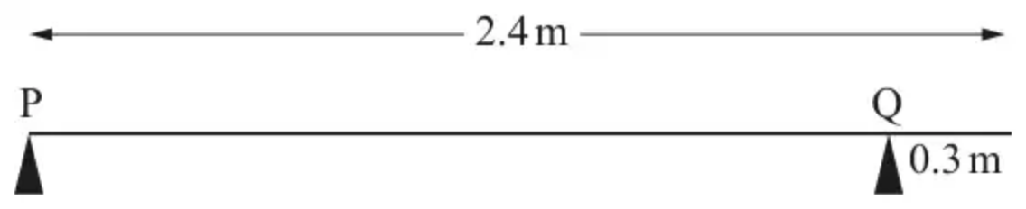
Fig. 4
(Total 3 marks)
OCR MEI June 2019 Paper 1 Q4
3.
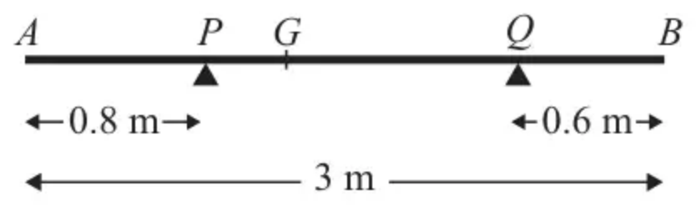
Figure 1
A non-uniform rod $AB$ has length 3 m and mass 4.5 kg. The rod rests in equilibrium, in a horizontal position, on two smooth supports at $P$ and at $Q$, where $AP=0.8$ m and $QB=0.6$ m, as shown in Figure 1. The centre of mass of the rod is at $G$. Given that the magnitude of the reaction of the support at $P$ on the rod is twice the magnitude of the reaction of the support at $Q$ on the rod, find
(a) the magnitude of the reaction of the support at $Q$ on the rod, (3)
(b) the distance $AG$. (4)
(Total 7 marks)
Edexcel M1 June 2012 Q2
4.
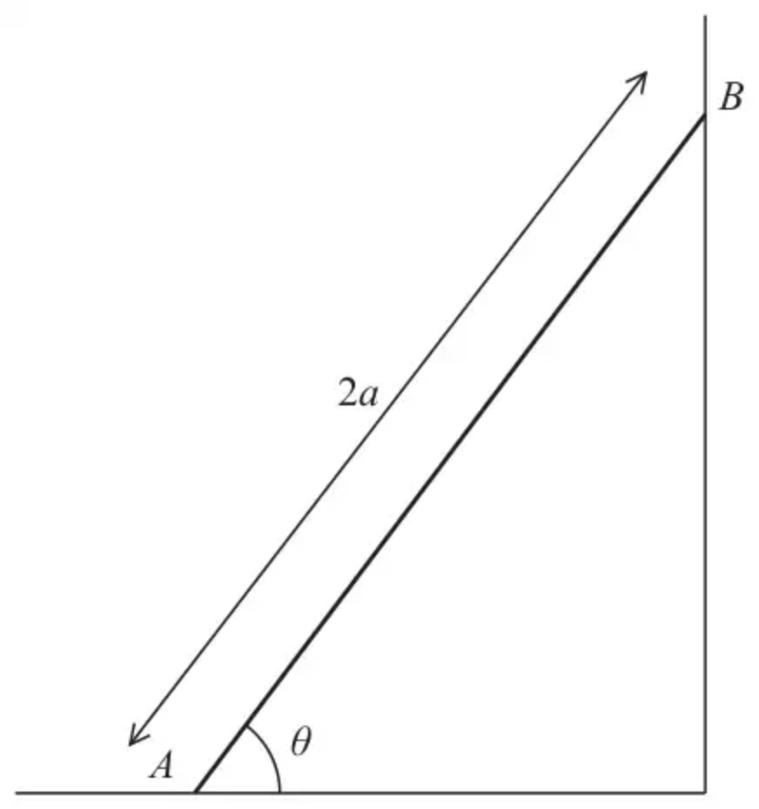
Figure 2
A beam $AB$ has mass $m$ and length $2a$.
The beam rests in equilibrium with $A$ on rough horizontal ground and with $B$ against a smooth vertical wall.
The beam is inclined to the horizontal at an angle $θ$, as shown in Figure 2.
The coefficient of friction between the beam and the ground is $μ$
The beam is modelled as a uniform rod resting in a vertical plane that is perpendicular to the wall.
Using the model,
(a) show that $μ⩾\frac{1}{2}cot⁡θ$ (5)
A horizontal force of magnitude $kmg$, where $k$ is a constant, is now applied to the beam at $A$.
This force acts in a direction that is perpendicular to the wall and towards the wall.
Given that $tan⁡θ=\frac{5}{4}$, $μ=\frac{1}{2}$ and the beam is now in limiting equilibrium,
(b) use the model to find the value of $k$. (5)
(Total 10 marks)
Edexcel October 2021 Paper 3 Mechanics Q3
Solutions
1.
Mark scheme (a)
Scheme | Marks | AO
Finds a moment of a force about any point.  Must have the form force x distance.  Can be awarded for example for 2w, 7w, 5R, 2R  Condone use of 9.8, 9.81, 10 instead of g | M1 | 3.4
Obtains w$=3g$  CAO | A1 | 1.1b
 | (2)

Typical solution
$$2W=1.5×4g$$
$$W=3g$$
Mark scheme (b)
Scheme | Marks | AO
Explains that the weight of the rod acts through the midpoint or the centre of mass is at the midpoint (of the rod) OE | E1 | 3.5a
 | (1)
 | (3 marks)

Typical solution
The rod is uniform so its weight acts at the centre
2.
Scheme | Marks | AO
Let $R_{\text{P}}$ and $R_{\text{Q}}$ be the normal reactions upwards  Assume the person stands on the end beyond Q and that the beam is in equilibrium  Taking moments about Q: | M1 | 3.1b
$50g×0.3+R_{P}×2.1=4g×0.9$ | A1 | 1.1b
$R_{P}=\frac{3.6g−15g}{2.1}[=−53.2]<0$  So the beam will tip. | A1 | 3.2a
 | [3]

Notes
M1: Finding moment of a force about any point
If the weight of the person shown between P and Q allow M1 maximum.
A1: Correct equation from moments about Q
Could also be obtained from moments about P and resolving to evaluate $R_{P}$
A1: Conclusion must be clear from correct working ($R_{\text{P}}$ need not be evaluated but must be clear that it is negative)
Alternative solution
Scheme | Marks
If the person stands $x$ m beyond Q so that the beam is on the point of tipping $R_{\text{P}}=0$  Taking moments about Q | M1
$4g×0.9=50gx$ giving $x=0.072$ | A1
$0.072<0.3$  so this is possible while standing on the beam | A1

M1: Finding moment of a force about any point
A1: Correct equation from moments about Q
A1: Conclusion must be clear from correct working and reference to 0.3 m
Second alternative solution
Scheme | Marks
Largest clockwise moment of the weight of the person about Q is $50g×0.3=15g[=147]$ | M1
Anticlockwise moment of the weight of the beam is $4g×0.9=3.6g[=35.28]$ | A1
The moment of the person’s weight is larger so the beam will tip | A1

M1: Finding moment of a force about any point
A1: Both correct moments about Q required
A1: Conclusion must be clear from a comparison of moments of two forces
SC 2 (omitting $g$)
$0.9×4<0.3×50$
$3.6<15$
So the beam will tip.
3.
Mark scheme (a)
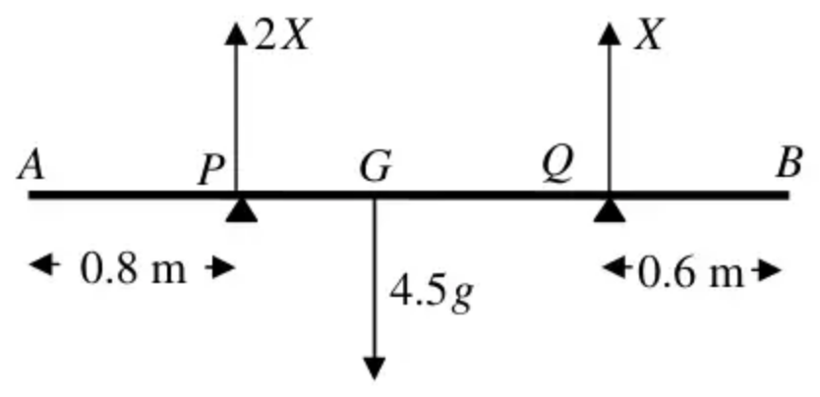
Scheme | Marks
$↑$ $2X+X=4.5g$ | M1 A1
Leading to $X=\frac{3g}{2}$ or 14.7 or 15 (N) | A1
 | (3)

Notes
First M1 for a complete method for finding $R_{Q}$, either by resolving vertically, or taking moments twice, with usual criteria (allow M1 even if $R_{P}=2R_{Q}$ not substituted)
First A1 for a correct equation in either $R_{Q}$ or $R_{P}$ ONLY.
Second A1 for 1.5g or 14.7 or 15 (A0 for a negative answer)
Mark scheme (b)
Scheme | Marks
M$(A)$ $4.5g×AG=(2X)×0.8+X×2.4$ | M1 A2 ft (1,0)
$AG=\frac{4}{3}$ (m), 1.3, 1.33,... | A1
 | (4)
 | (7 marks)

Notes
First M1 for taking moments about any point, with usual criteria.
A2 ft for a correct equation (A1A0 one error, A0A0 for two or more errors, ignoring consistent omission of g’s) in terms of $X$ and their $x$ (which may not be $AG$ at this stage)
Third A1 for $AG=4\text{/}3$, 1.3, 1.33,….. (any number of decimal places, since g cancels) need ‘$AG=$’ or $x$ marked on diagram
N.B. if $R_{Q}=2R_{P}$ throughout, mark as a misread as follows:
(a) M1A1A0 (resolution method) (b) M1A0A1A1, assuming all work follows through correctly..
4.
Mark scheme (a)
Scheme | Marks | AO
Part (a) is a ‘Show that..’ so equations need to be given in full to earn A marks
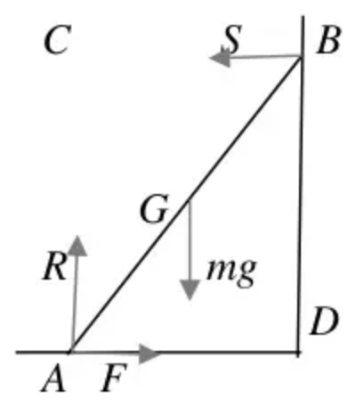
Moments equation: (M1A0 for a moments inequality) | M1 | 3.3
M$(A)$, $mgacos⁡θ=2Sasin⁡θ$  M$(B)$, $mgacos⁡θ+2Fasin⁡θ=2Racos⁡θ$  M$(C)$, $F×2asin⁡θ=mgacos⁡θ$  M$(D)$, $2Racos⁡θ=mgacos⁡θ+2Sasin⁡θ$  M$(G)$, $Racos⁡θ=Fasin⁡θ+Sasin⁡θ$. | A1 | 1.1b
$(↕)R=mg$ OR $(↔)F=S$ | B1 | 3.4
Use their equations (they must have enough) and $F⩽μR$ to give an inequality in $μ$ and $θ$ only (allow DM1 for use of $F=μR$ to give an equation in $μ$ and $θ$ only) | DM1 | 2.1
$μ⩾\frac{1}{2}cot⁡θ$ * | A1* | 2.2a
 | (5)

Notes
M1: Any moments equation with correct terms, condone sign errors and sin/cos confusion
A1: Correct equation
B1: Correct equation
DM1: Dependent on M1, for using their equations (they must have enough) and $F⩽μR$ to give an inequality in $μ$ and $θ$ only
(allow M1 for use of $F=μR$ to give an equation in $μ$ and $θ$ only)
A1*: Given answer correctly obtained with no wrong working seen (e.g. if they use $F=μR$ anywhere, A0)
Mark scheme (b)
Scheme | Marks | AO
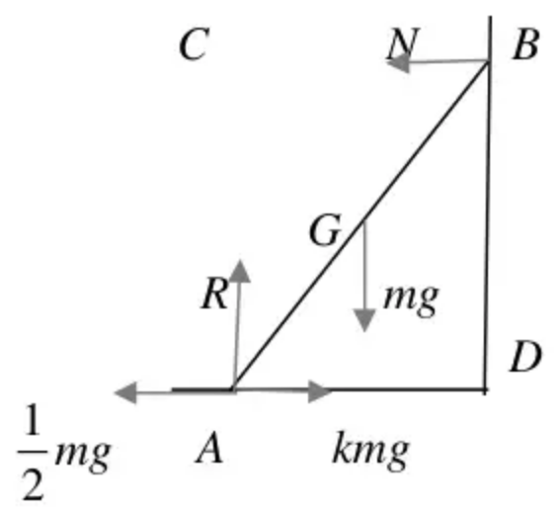
Moments equation: | M1 | 3.4
M$(A)$, $mgacos⁡θ=2Nasin⁡θ$  M$(B)$, $mgacos⁡θ+2kmgasin⁡θ=2Racos⁡θ+\frac{1}{2}mg2asin⁡θ$  M$(D)$, $2Racos⁡θ=mgacos⁡θ+N2asin⁡θ$  M$(G)$, $kmgasin⁡θ+Nasin⁡θ=\frac{1}{2}mgasin⁡θ+Racos⁡θ$ | A1 | 1.1b
S.C. M$(C)$, $mgacos⁡θ+\frac{1}{2}mg2asin⁡θ=kmg2asin⁡θ$ M1A1B1
$1+\frac{5}{4}=\frac{5k}{2}$ M1
$k=0.9$ A1
$N=kmg−F$ OR $R=mg$ | B1 | 3.3
Use their equations (they must have enough) to solve for $k$ (numerical) | DM1 | 3.1b
$k=0.9$ oe | A1 | 1.1b
 | (5)
 | (10 marks)

Notes
M1: Any moments equation with correct terms, condone sign errors
A1: Correct equation
B1: Correct equation
DM1: Dependent on M1, for using their equations (they must have enough) with trig substituted, to solve for $k$, which must be numerical.
A1: cao

