QQQ – Mechanics Year 1 – Chapter 9 – Time-Series Graphs (Version 2)
Total Marks: 24
(24 = Platinum, 22 = Gold, 19 = Silver, 16 = Bronze)
1. The diagram below shows a velocity-time graph for a particle moving with velocity $v$ m s⁻¹ at time $t$ seconds.
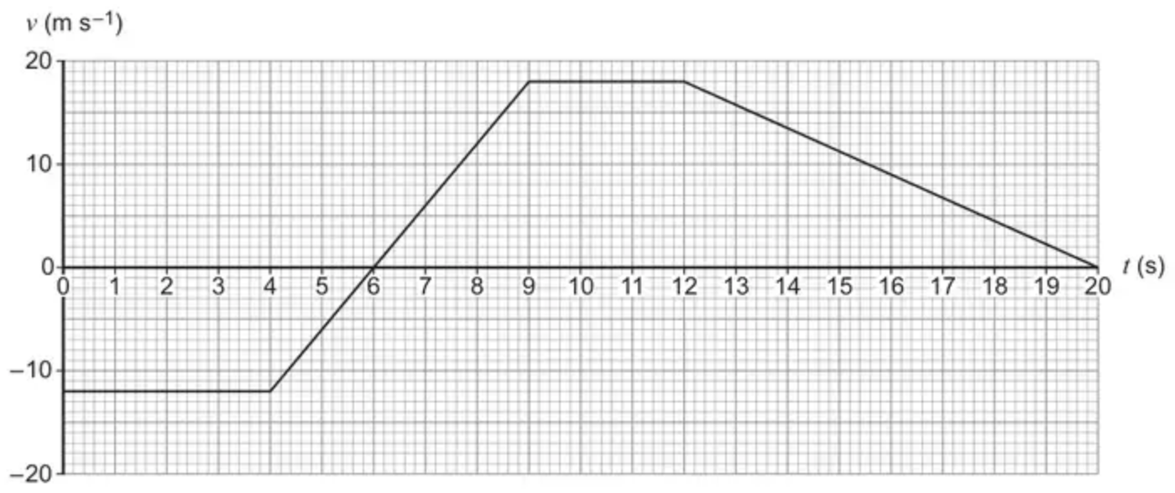
Which statement is correct?
Tick (✓) one box. [1 mark]
• The particle was stationary for $9⩽t⩽12$
• The particle was decelerating for $12⩽t⩽20$
• The particle had a displacement of zero when $t=6$
• The particle’s speed when $t=4$ was $−12$ m s⁻¹
(Total 1 marks)
AQA June 2019 Paper 2 Q10
2. A car starting from rest moves forward in a straight line.
The motion of the car is modelled by the velocity–time graph below:
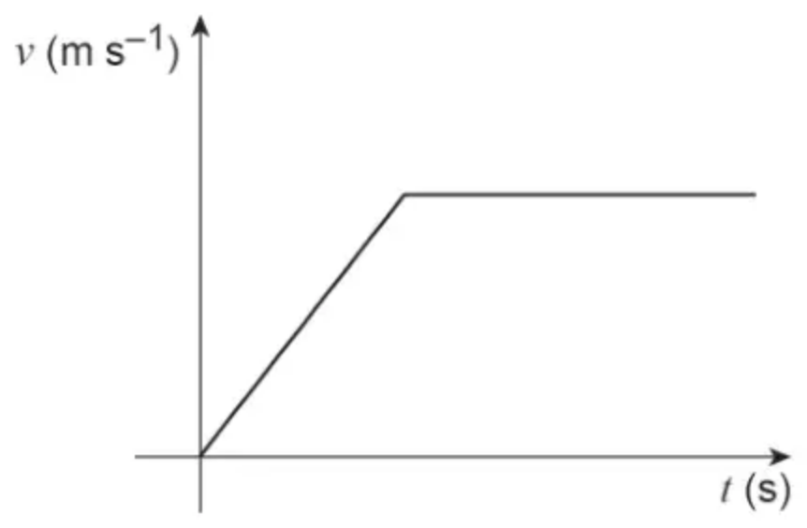
One of the following assumptions about the motion of the car is implied by the graph.
Identify this assumption. [1 mark]
Tick (✓) one box.
• The car never accelerates.
• The acceleration of the car is always positive.
• The acceleration of the car can change instantaneously.
• The acceleration of the car is never constant.
(Total 1 marks)
AQA June 2024 Paper 2 Q13
3. The graph shows displacement $s$ m against time $t$ s for a model of the motion of a bead moving along a straight wire. The points (0, 4), (2, 7), (5, 7) and (9, −7) are the endpoints of the line segments.
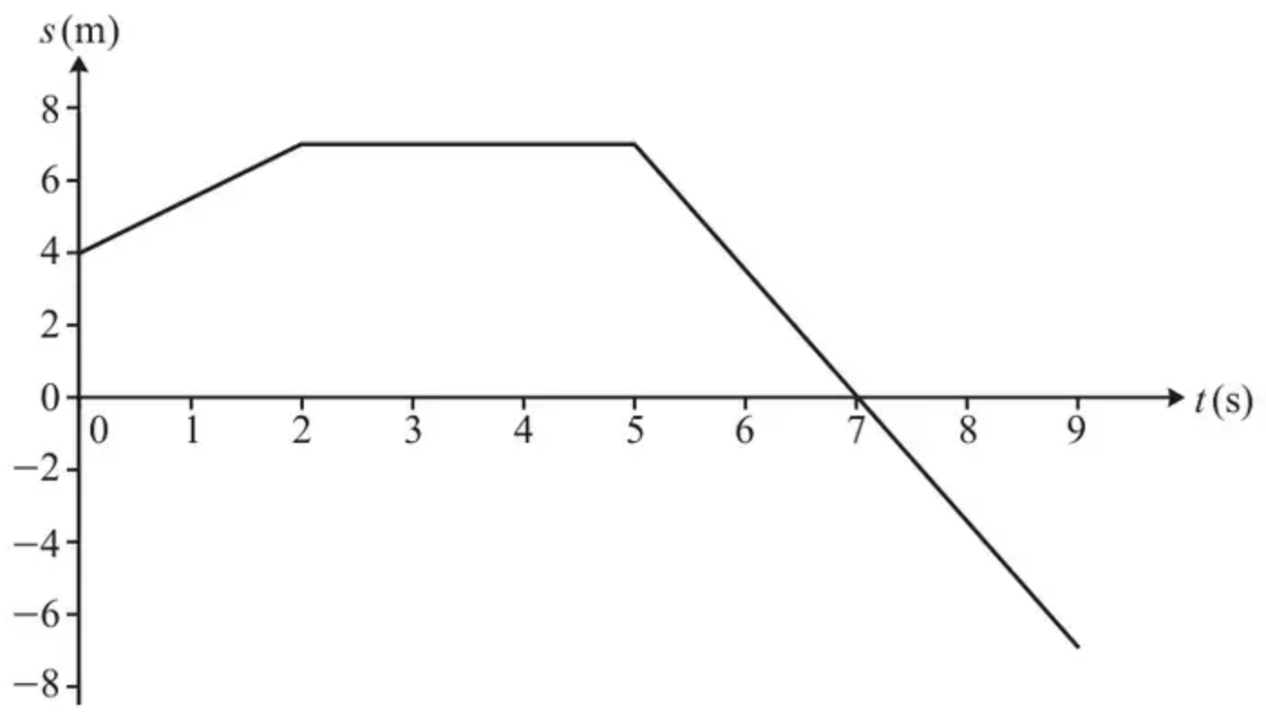
(a) Find an expression for the displacement of the bead for $0⩽t⩽2$. [2]
(b) Sketch the velocity-time graph for this model. [2]
(c) Explain why the model may not be suitable at $t=2$ and $t=5$. [1]
(Total 5 marks)
OCR MEI June 2023 Paper 1 Q5
4. A car, initially at rest, is driven along a straight horizontal road.
The graph below is a simple model of how the car’s velocity, $v$ metres per second, changes with respect to time, $t$ seconds.
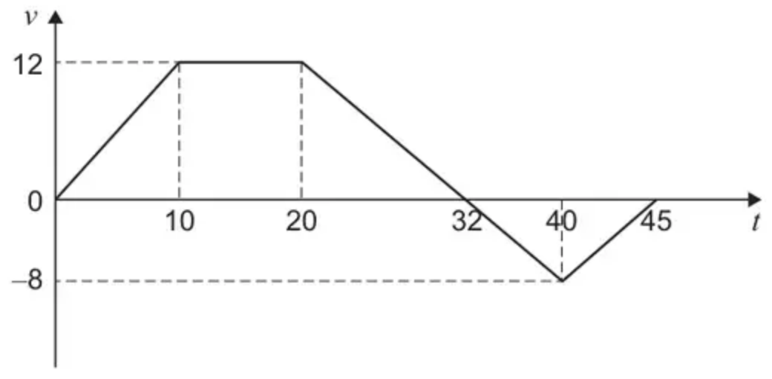
(a) Find the displacement of the car when $t=45$ [3 marks]
(b) Shona says:
“This model is too simple. It is unrealistic to assume that the car will instantaneously change its acceleration.”
On the axes below sketch a graph, for the first 10 seconds of the journey, which would represent a more realistic model. [2 marks]
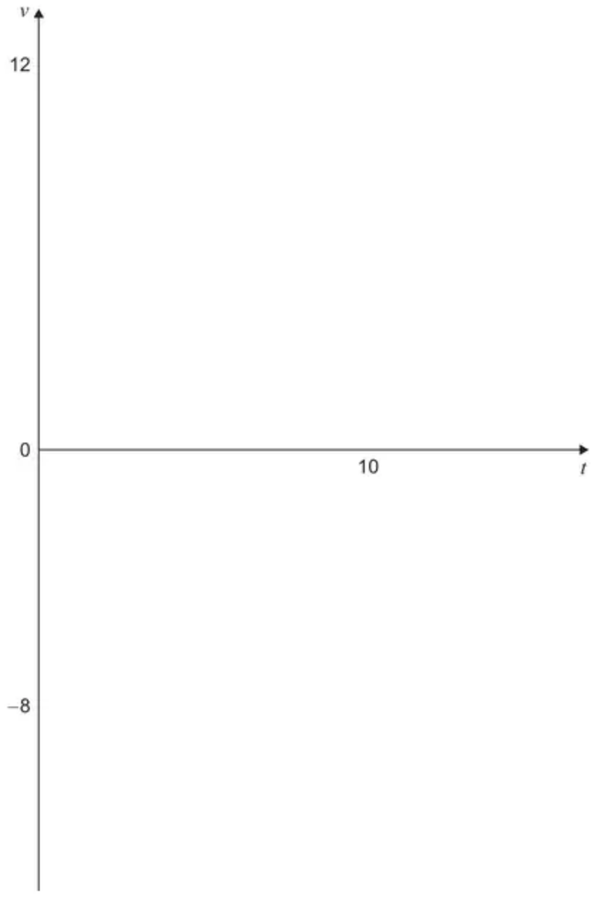
(Total 5 marks)
AQA June 2021 Paper 1 Q13
5. A child is running up and down a path. A simplified model of the child’s motion is as follows:
• he first runs north for 5 s at $4\text{m}{\text{s}}^{−1}$;
• he then suddenly stops and waits for 8 s;
• finally he runs in the opposite direction for 7 s at $3.5\text{m}{\text{s}}^{−1}$.
(a) Taking north to be the positive direction, sketch a velocity-time graph for this model of the child’s motion. [2]
Using this model,
(b) calculate the total distance travelled by the child, [2]
(c) find his final displacement from his original position. [1]
(Total 5 marks)
OCR MEI October 2020 Paper 1 Q5
6. A train travels along a straight horizontal track between two stations, $A$ and $B$.
In a model of the motion, the train starts from rest at $A$ and moves with constant acceleration 0.3 m s⁻² for 80 s.
The train then moves at constant velocity before it moves with a constant deceleration of 0.5 m s⁻², coming to rest at $B$.
(a) For this model of the motion of the train between $A$ and $B$,
(i) state the value of the constant velocity of the train,
(ii) state the time for which the train is decelerating,
(iii) sketch a velocity-time graph. (3)
The total distance between the two stations is 4800 m.
(b) Using the model, find the total time taken by the train to travel from $A$ to $B$. (3)
(c) Suggest one improvement that could be made to the model of the motion of the train from $A$ to $B$ in order to make the model more realistic. (1)
(Total 7 marks)
Edexcel June 2018 Mechanics Q7
Solutions
1.
Scheme | Marks | AO
Ticks correct box | B1 | 2.2a
 | (1 mark)

Typical solution
The particle was decelerating for $12⩽t⩽20$
2.
Scheme | Marks | AO
Ticks the 3rd box | B1 | 2.2a
 | (1 mark)

Typical solution
The acceleration of the car can change instantaneously
3.
Mark scheme (a)
Scheme | Marks | AO
gradient from (0, 4) to (2, 7) is 1.5  So $s=1.5t+4$ | M1  A1 | 3.3  3.3
 | [2]

Notes
M1: attempt to find the gradient – award if $\frac{3}{2}$ seen
A1: must be $s$ in terms of $t$
Mark scheme (b)
Scheme | Marks | AO
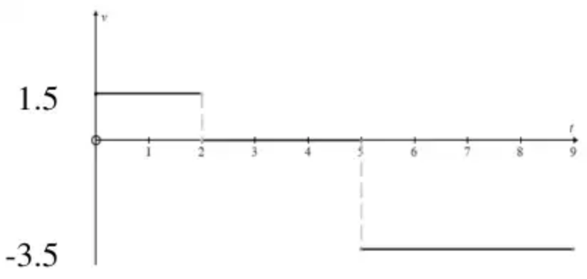 | B1*  B1 (dep) | 3.4  3.4
 | [2]

Notes
B1*: Three horizontal lines, above, on and below the $t$-axis. Also allow if the third line segment is above the first line segment because speed is given instead of velocity.
B1 (dep): their 1.5 and –3.5 seen and $t=2$ and $t=5$ clear
Mark scheme (c)
Scheme | Marks | AO
The changes in velocity are instantaneous. In reality, the velocity changes over a period of time | E1 | 3.5b
 | [1]

Notes
E1: Accept “suddenly stops” or similar. Also accept that the velocity at $t=2$ or $t=5$ is ambiguous
4.
Mark scheme (a)
Scheme | Marks | AO
Finds any area either above or below the axis | M1 | 3.1b
Obtains correct values of area above or area below the axis  PI | A1 | 1.1b
Obtains correct displacement condone missing units | A1 | 1.1b
 | (3)

Typical solution
$$\text{Area above}=(\frac{1}{2})(12)(10+32)=252$$
$$\text{Area below}=(\frac{1}{2})(13)(8)=52$$
$$r=252−52=200\text{m}$$
Mark scheme (b)
Scheme | Marks | AO
Sketches a curve at the end $t=0$ correctly | B1 | 3.5c
Sketches a curve at the end $t=10$ correctly | B1 | 3.5c
 | (2)
 | (5 marks)

Typical solution
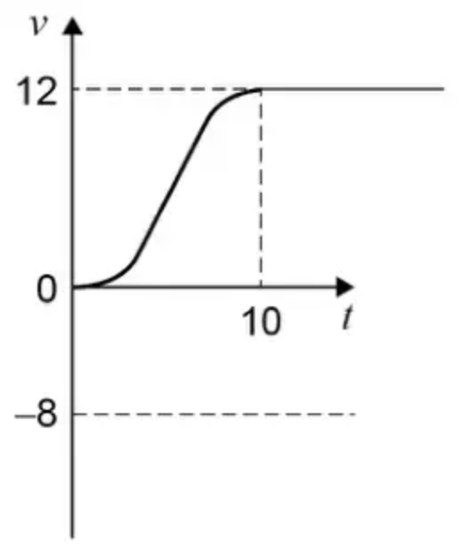
5.
Mark scheme (a)
Scheme | Marks | AO
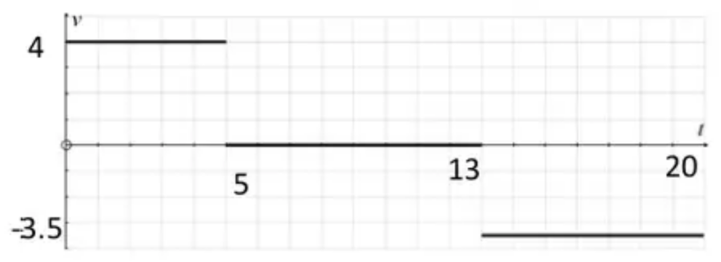 | B1  B1 | 1.1  1.1
 | [2]

Notes
B1: Graph from 3 horizontal line segments. Correct velocities labelled
Any lines joining the horizontal lines should be vertical
B1: Times seen – either $t$ = 5, 13, 20 or lengths of line segments 5, 8, 7 seen.
Mark scheme (b)
Scheme | Marks | AO
Distance $=(4×5)+(7×3.5)$ m | M1 | 1.1a
$=44.5$ | A1 | 1.1
 | [2]

Notes
M1: finding the area of at least one region from their graph oe
May work directly from the information in the question without reference to their graph
A1: cao
Mark scheme (c)
Scheme | Marks | AO
Displacement $=20−24.5=−4.5$ m | B1 | 1.1
 | [1]

Notes
B1: Allow for –4.5 m or for 4.5 m south
Do not allow -4.5 m south
6.
Mark scheme (a)
Scheme | Marks | AO
(i) 24 (m s⁻¹) | B1 | 1.1b
(ii) 48 (s) | B1 | 1.1b
(iii)  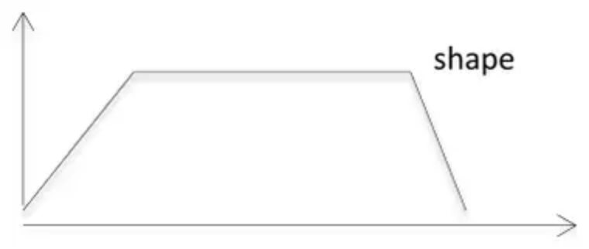 | B1 | 1.1b
 | (3)

Notes
(i) B1: 24 (m s⁻¹) Must be stated i.e. not just inserted on the graph
(ii) B1: 48 (s) (Allow −48 changed to 48) Must be stated i.e. not just inserted on the graph
(iii) B1: A trapezium starting at the origin and ending on the $t$-axis.
Mark scheme (b)
Scheme | Marks | AO
Equating area under graph to 4800 to give equation in one unknown | M1 | 3.1b
$\frac{1}{2}(T+T+80+48)×24=4800$ OR  $(\frac{1}{2}×80×24)+24T+(\frac{1}{2}×48×24)=4800$ oe | A1ft | 1.1b
$T=136$ so total time is 264 (s) | A1 | 1.1b
 | (3)

Notes
M1: Complete method to find area of trapezium using trapezium rule with correct structure or using two triangles and a rectangle and equate to 4800 to give equation in one unknown
N.B. $\frac{1}{2}(T+80+48)×24=4800$ is M0 (equivalent to using three triangles)
OR they may use suvat on one or more sections (must have $a=0$ for middle section) and equate total distance travelled to 4800 to give equation in one unknown
A1ft: For a correct equation in their unknown ft on their 24 and 48 (but must be positive times)
A1: For 264 (s)
Mark scheme (c)
Scheme | Marks | AO
Accept  Either: a smooth change from acceleration to constant velocity or from constant velocity to deceleration.  Or have train accelerating and/or decelerating at a variable rate  Do not accept e.g.  Comments on air resistance or resistive forces, straightness of track, horizontal track, friction, length of train, mass of train, not having train moving with constant velocity.  B0 if either an incorrect extra is included or an incorrect reason for a valid improvement is included.  N.B. Variable acceleration due to air resistance is B0 BUT  Variable acceleration due to variable air resistance is B1 | B1 | 3.5c
 | (1)
 | (7 marks)

Notes
B1: Either: Include time to change from constant accln to constant velocity and/or time to change from constant velocity to constant deceleration oe
Or: Have train accelerating and/or decelerating at a variable rate

