QQQ – Mechanics Year 1 – Chapter 9 – Time-Series Graphs (Version 1)
Total Marks: 23
(23 = Platinum, 21 = Gold, 18 = Silver, 16 = Bronze)
1. The displacement–time graph, Figure 1, shows the first 5 seconds of the motion of a car which starts from rest and travels 12 metres.
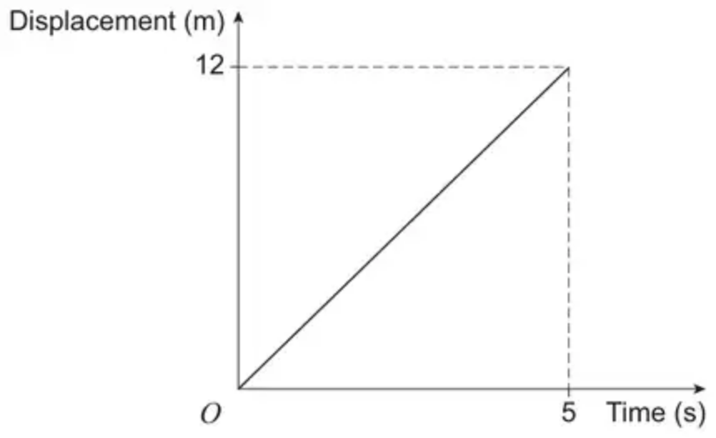
Figure 1
(a) Find the speed of the car. [1 mark]
(b) On Figure 2, draw a more realistic displacement–time graph to show the first 5 seconds of motion of the car. [1 mark]
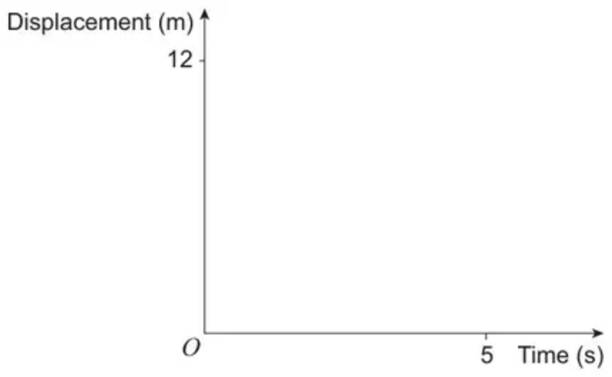
Figure 2
(Total 2 marks)
AQA June 2025 Paper 1 Q16
2. A car, initially at rest, moves with constant acceleration along a straight horizontal road.
One of the graphs below shows how the car’s velocity, $v$ m s⁻¹, changes over time, $t$ seconds.
Identify the correct graph.
Tick (✓) one box. [1 mark]
•
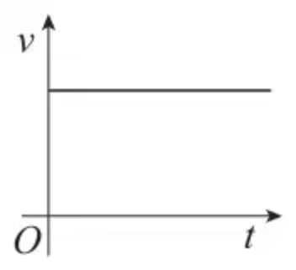
•
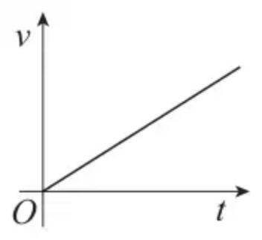
•
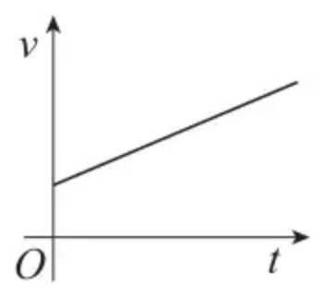
•
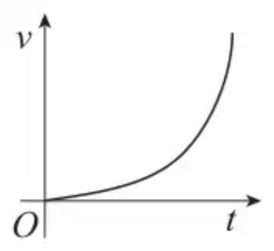
(Total 1 marks)
AQA June 2022 Paper 1 Q11
3. A particle moves along a straight line. The displacement $s$ m at time $t$ s is shown in the displacement-time graph below. The graph consists of straight line segments joining the points $(0,−2)$, $(10,5)$ and $(15,1)$.
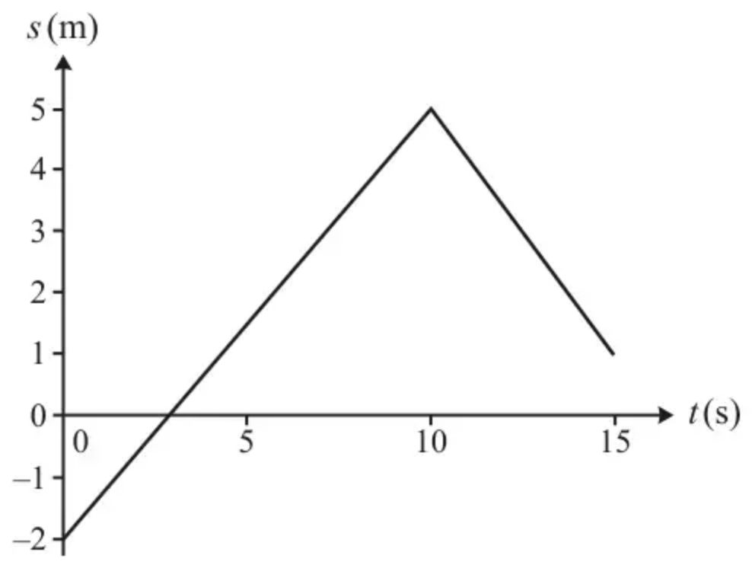
(a) Find the distance travelled by the particle in the first 15 s. [2]
(b) Calculate the velocity of the particle between $t=10$ and $t=15$. [2]
(Total 4 marks)
OCR MEI June 2022 Paper 1 Q1
4. A graph indicating how the velocity, $v$ m s⁻¹, of a particle changes with respect to time, $t$ seconds, is shown below.
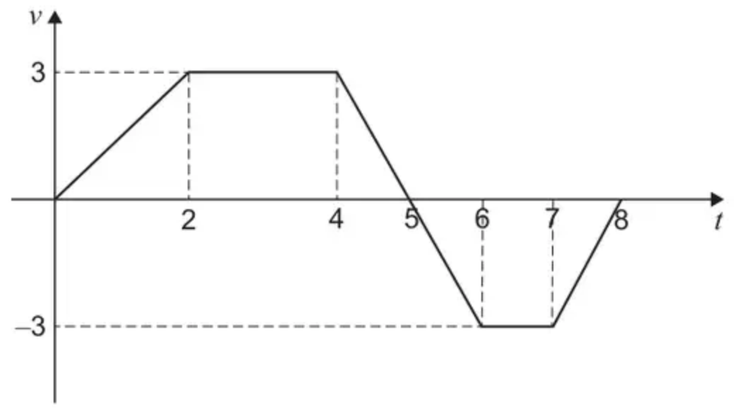
(a) Find the total distance travelled by the particle over the 8 second period shown. [3 marks]
(b) A student claims that
“The displacement of the particle is less than the distance travelled.”
State the range of values of $t$ for which this claim is true. [1 mark]
(Total 4 marks)
AQA June 2024 Paper 1 Q15
5.
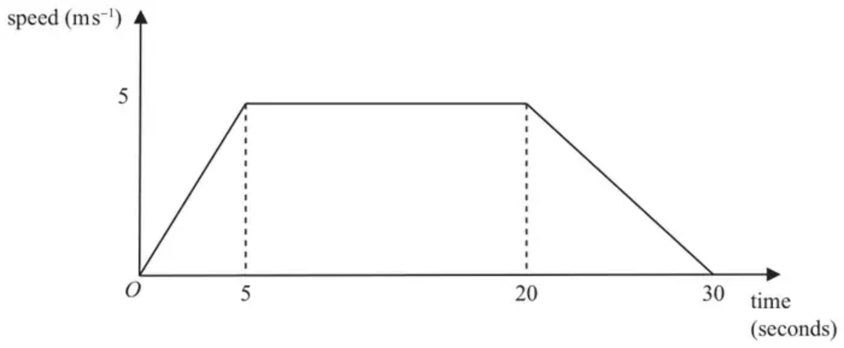
Figure 1
Figure 1 shows the speed-time graph for the journey of a car moving in a long queue of traffic on a straight horizontal road.
At time $t=0$, the car is at rest at the point $A$.
The car then accelerates uniformly for 5 seconds until it reaches a speed of $5\text{m}{\text{s}}^{−1}$
For the next 15 seconds the car travels at a constant speed of $5\text{m}{\text{s}}^{−1}$
The car then decelerates uniformly until it comes to rest at the point $B$.
The total journey time is 30 seconds.
(a) Find the distance $AB$. (3)
(b) Sketch a distance-time graph for the journey of the car from $A$ to $B$. (3)
(Total 6 marks)
Edexcel June 2024 Mechanics Q1
6.
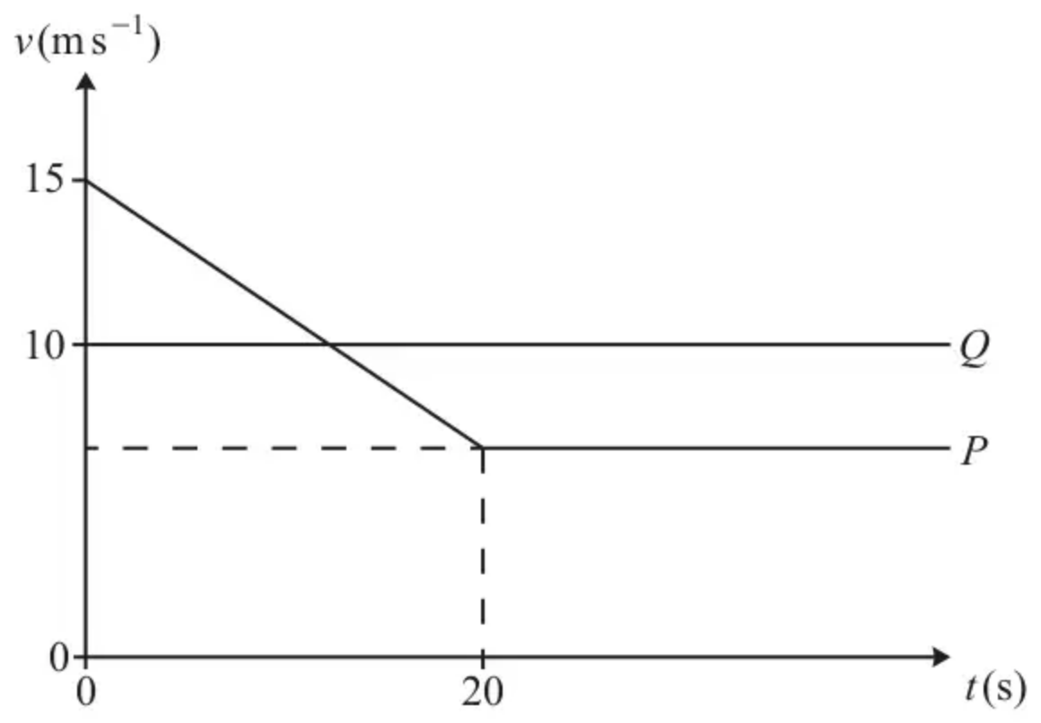
The velocity-time graph represents the motion of two cyclists $P$ and $Q$ who are travelling along a straight, horizontal road. At time $t=0$, the cyclists pass the same point on the road with $P$ cycling at $15\text{m}{\text{s}}^{−1}$ and $Q$ cycling at $10\text{m}{\text{s}}^{−1}$.
From time $t=0$, $P$ cycles with constant deceleration $0.4\text{m}{\text{s}}^{−2}$ for 20 seconds and $Q$ cycles at a constant velocity of $10\text{m}{\text{s}}^{−1}$. From $t=20$ onwards, $P$’s velocity remains constant.
(a) Find the value of $t$ when $P$ and $Q$ have the same velocity. [2]
(b) Determine the value of $t$ when $Q$ overtakes $P$. [4]
(Total 6 marks)
OCR A June 2025 Paper 2 Q10
Solutions
1.
Mark scheme (a)
Scheme | Marks | AO
Obtains 2.4 m s⁻¹  ACF  Condone missing units | B1 | 1.1b
 | (1)

Typical solution
2.4 m s⁻¹
Mark scheme (b)
Scheme | Marks | AO
Draws a graph which is convex at the origin and reaches or passes through approximately (5,12) | B1 | 3.5c
 | (1)
 | (2 marks)

Typical solution
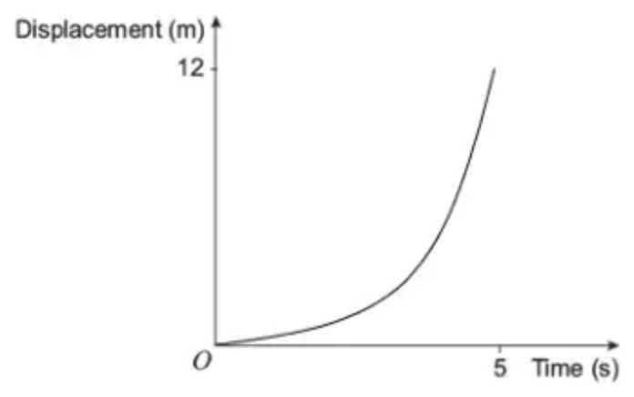
2.
Scheme | Marks | AO
Circles correct graph. | B1 | 2.2a
 | (1 mark)

Typical solution
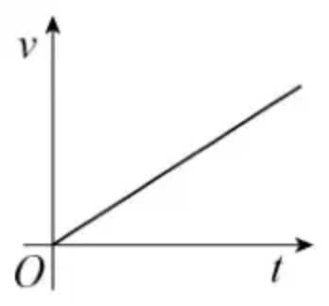
3.
Mark scheme (a)
Scheme | Marks | AO
Distance $2+5+4$ | M1 | 1.1a
$=11$ m | A1 | 1.1b
 | [2]

Notes
M1: adding distances in two or three sections
A1: cao
Mark scheme (b)
Scheme | Marks | AO
velocity $=\frac{5−1}{10−15}$ | M1 | 1.1a
$v=−0.8\text{m}{\text{s}}^{−1}$ | A1 | 1.1b
 | [2]

Notes
M1: Allow sign errors but not wrong way up. Soi
A1: Oe. Mark final answer
4.
Mark scheme (a)
Scheme | Marks | AO
Finds any area from the graph | M1 | 3.1a
Obtains a fully correct expression for total area above or below axis  PI by 4.5 | A1 | 1.1b
Obtains 16.5 m  Condone missing units | A1 | 1.1b
 | (3)

Typical solution
Area above axis = 10.5
Area below axis = 6
Total distance travelled = 16.5 m
Mark scheme (b)
Scheme | Marks | AO
Obtains $t>5$  Ignore any upper bound of inequality provided it is 8 or more  Do not accept $t⩾5$ | R1 | 2.2a
 | (1)
 | (4 marks)

Typical solution
$$t>5$$
5.
Mark scheme (a)
Scheme | Marks | AO
Complete method to find $AB$ | M1 | 3.1b
$=(\frac{1}{2}×5×5)+(5×15)+(\frac{1}{2}×5×10)$  or $=\frac{1}{2}(30+15)×5$  or $=(\frac{1}{2}×5×5)+\frac{1}{2}(25+15)×5$  or $=\frac{1}{2}(20+15)×5+(\frac{1}{2}×5×10)$  or $=(30×5)−(\frac{1}{2}×5×5)−(\frac{1}{2}×5×10)$ | A1 | 1.1b
$=112.5(\text{m})$ | A1 | 1.1b
 | (3)

Notes
M1 Complete method to find the total area under the graph, with the correct structure
triangle + rectangle + triangle
or trapezium
or triangle + trapezium
or trapezium + triangle
or rectangle – triangle – triangle
N.B. They may use suvat on one or more of the sections.
A1 Correct unsimplified expression for the distance $AB$
A1 Accept 110 or better
Mark scheme (b)
Scheme | Marks | AO
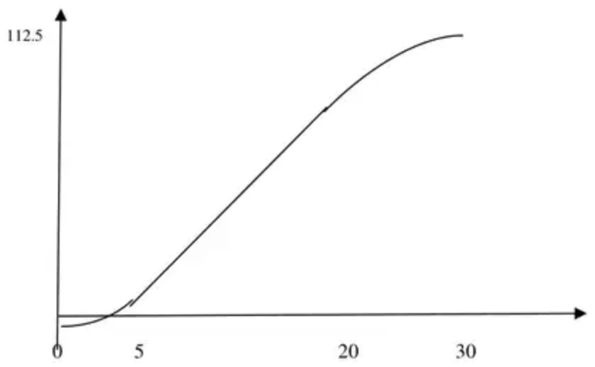 | B1  B1  B1 | 1.1b  1.1b  1.1b
 | (3)
 | (6 marks)

Notes
SC: If there is a single straight line with a positive gradient, allow B1B0B0, unless it’s absolutely clear that it is for the first section only.
If there are just two straight lines, both with positive gradient, allow B1B0B0.
B1 One section correct. Straight section should be straight with positive gradient..Curves should look like curves with first one having increasing gradient and second one decreasing gradient but staying non-negative.
B1 Two sections correct. Straight section should be straight with positive gradient Curves should look like curves with first one having increasing gradient and second one decreasing gradient but staying non-negative. Continuous graph but condone incorrect transition between sections.
B1 All three sections correct and 5, 20, 30 and their 112.5 shown. Straight section should be straight with positive gradient. Curves should look like curves with first one having increasing gradient and second one decreasing gradient but staying non-negative. Continuous graph but condone incorrect transition between sections.
N.B. Subtract 1 mark from any earned if there is a continuous vertical line at the end.
Ignore any figs when awarding the first two B marks except for the SC mentioned above.
6.
Mark scheme (a)
Scheme | Marks | AO
$(v_{P}=)15−0.4t$ | M1 | 3.4
$15−0.4t=10⇒t=12.5$ | A1 | 1.1
 | [2]

Notes
M1: Attempt to find a linear expression for the velocity of $P$ for $t<20$ soi
Condone $a=0.4$
May see $y=15−0.4x$
A1: Condone $x=12.5$
Mark scheme (b)
Scheme | Marks | AO
Speed of $P$ at $t=20$ is given by $15+(−0.4)(20)$ | M1 | 1.1
Distance travelled by $Q$ is given by $10t$ | B1 | 3.4
$10t=\frac{1}{2}(15+\text{‘}7\text{’})(20)+\text{‘}7\text{’}(t−20)$  $10t=\frac{1}{2}(15−\text{‘}7\text{’})(20)+\text{‘}7\text{’}t$  $10T+20(10)=\text{‘}7\text{’}T+\frac{1}{2}(15+\text{‘}7\text{’})(20)$ | A1FT | 3.4
$t=26.7$ | A1 | 1.1
 | [4]

Notes
M1: Attempt to find speed of $P$ at $t=20$
May be seen on the diagram but needs to be seen or used in (b)
If correct speed is 7
B1: Possibly seen in subsequent working oe
Condone $10x$
A1FT: Correct equation with their speed of $P$ at $t=20$
Condone any inequality rather than equation here
Condone $x$
Where $T$ is the time from 20s until $Q$ overtakes $P$
Condone $t$
A1: Allow 26.7 or better (26.6666…)
Condone exact value $\frac{80}{3}$ or $26\frac{2}{3}$

