QQQ – Mechanics Year 1 – Chapter 9 – SUVAT Equations (Version 2)
Total Marks: 23
(23 = Platinum, 21 = Gold, 18 = Silver, 16 = Bronze)
1. In this question use $g=9.8$ m s⁻²
A ball, initially at rest, is dropped from a height of 40 m above the ground.
Calculate the speed of the ball when it reaches the ground.
Circle your answer. [1 mark]
• $−28$ m s⁻¹
• 28 m s⁻¹
• $−780$ m s⁻¹
• 780 m s⁻¹
(Total 1 marks)
AQA June 2018 Paper 1 Q11
2. An object is moving in a straight line, with constant acceleration $a$ m s⁻², over a time period of $t$ seconds.
It has an initial velocity $u$ and final velocity $v$ as shown in the graph below.
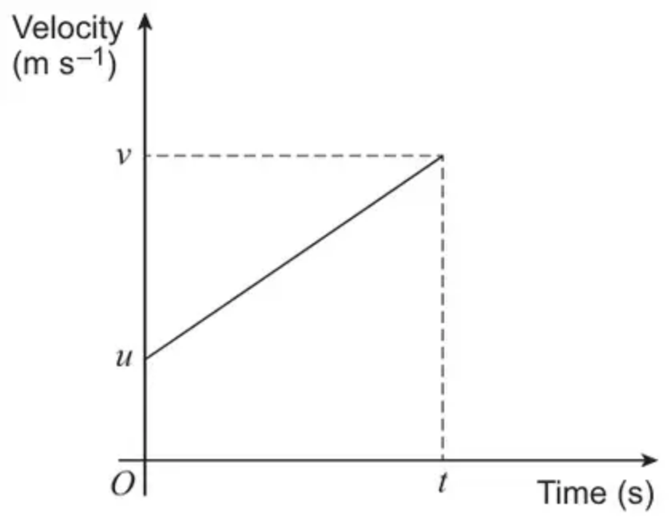
Use the graph to show that
$$v=u+at$$
[3 marks]
(Total 3 marks)
AQA June 2020 Paper 1 Q13
3. In this question use $g=10$ m s⁻²
A ball is thrown vertically upwards from a height of 1.8 metres above the ground.
The initial velocity of the ball is 12 m s⁻¹
The greatest height reached by the ball above the ground is $h$ metres.
Find the value of $h$ [3 marks]
(Total 3 marks)
AQA June 2025 Paper 1 Q18
4. A small ball $B$ is projected vertically upwards from a point $2\text{m}$ above horizontal ground. $B$ is projected with initial speed $3.5\text{m}{\text{s}}^{−1}$, and takes $t$ seconds to reach the ground.
Find the value of $t$. [3]
(Total 3 marks)
OCR A June 2022 Paper 2 Q10
5. A ball, initially at rest, is dropped from a vertical height of $h$ metres above the Earth’s surface.
After 4 seconds the ball’s height above the Earth’s surface is $0.2h$ metres.
(a) Assuming air resistance can be ignored, show that
$$h=10g$$
[3 marks]
(b) Assuming air resistance cannot be ignored, explain the effect that this would have on the value of $h$ in part (a). [1 mark]
(Total 4 marks)
AQA June 2023 Paper 1 Q14
6. A lorry is moving along a straight horizontal road with constant acceleration. The lorry passes a point $A$ with speed $u$ m s${}^{−1}$, $(u<34)$, and 10 seconds later passes a point $B$ with speed 34 m s${}^{−1}$. Given that $AB=240$ m, find
(a) the value of $u$, (3)
(b) the time taken for the lorry to move from $A$ to the mid-point of $AB$. (6)
(Total 9 marks)
Edexcel M1 June 2013 Q4
Solutions
1.
Scheme | Marks | AO
Circles correct answer | B1 | 1.1b
 | (1 mark)

Typical solution
28 m s⁻¹
Notes
(corrected from the printed mark scheme: the typical solution is printed as “$a=28$”; 28 is the speed, 28 m s⁻¹)
2.
Scheme | Marks | AO
Uses definition of acceleration | B1 | 1.2
Uses appropriate gradient formula OE | M1 | 1.1a
Substitutes $u$, $v$ and $t$ into gradient formula and rearranges to find given equation AG | R1 | 2.1
 | (3 marks)

Typical solution
Gradient of $v$–$t$ graph represents acceleration
$$a=\frac{v−u}{t}$$
$$⇒v=u+at$$
3.
Scheme | Marks | AO
Selects an appropriate equation of constant acceleration and substitutes $u=±12$, $a=±10$, $v=0$  Condone use of $g=9.8$ or 9.81 | M1 | 3.1b
Substitutes consistent correct values to obtain $s$ or $h$  Condone $h+1.8$ for $s$ | A1 | 1.1b
Obtains 9 | B1 | 3.2a
 | (3 marks)

Typical solution
$$u=12,a=−10,v=0$$
Using $v^{2}=u^{2}+2as$
$$0^{2}=12^{2}+2(−10)s$$
$$s=7.2$$
$$h=7.2+1.8=9$$
4.
Scheme | Marks | AO
 | M1 | 3.3
$−2=3.5t+\frac{1}{2}(−9.8)t^{2}(⇒4.9t^{2}−3.5t−2=0)$ | A1 | 1.1
$t=1.09$ | A1 | 1.1
 | [3]

Notes
M1: M1 for use of $s=ut+\frac{1}{2}at^{2}$ with $s=±2,u=±3.5$ and $a=±g$ and $t$ is the total time for the motion
A1: Correct equation – need not be simplified
Possible to consider for eg motion up and motion down. In this case: M1 for complete method to find relevant times. A1 All equations correct – need not be simplified
A1: BC (positive root only). $t=1.0890679…$
5.
Mark scheme (a)
Scheme | Marks | AO
Selects an appropriate equation of constant acceleration.  and  states $u=0$, $t=4$ and $a=g$  PI by correct substitution | M1 | 1.1a
Substitutes $s=0.8h$ | M1 | 1.1a
Completes reasoned argument to obtain given answer | R1 | 2.1
 | (3)

Typical solution
$$s=ut+\frac{1}{2}at^{2}$$
$u=0$, $t=4$ and $a=g$
$$0.8h=\frac{1}{2}g×4^{2}$$
$$0.8h=8g$$
$$h=10g$$
Mark scheme (b)
Scheme | Marks | AO
Explains that $h$ will be less | E1 | 3.5a
 | (1)
 | (4 marks)

Typical solution
Air resistance will cause $h$ to be lower
6.
Mark scheme (a)
Scheme | Marks
$240=\frac{1}{2}(u+34)10$ | M1 A1
$u=14$ | A1
 | (3)

Notes
First M1 for a complete method to produce an equation in $u$ only.
First A1 for a correct equation. ($u^{2}−48u+476=0$ oe is possible).
Second A1 for $u=14$.
Mark scheme (b)
Scheme | Marks
$34=14+10a⇒a=2$ | M1 A1
$120=14t+\frac{1}{2}×2×t^{2}$ | M1 A1
$t^{2}+14t−120=0$
Solving, $t=−20$ or 6 | DM1
$t=6$ | A1
 | (6)
 | (9 marks)

OR
$34=14+10a⇒a=2$ | M1 A1
$v^{2}=14^{2}+2×2×120⇒v=26$
AND $26=14+2t$ | M1 A1
$t=6$ | DM1 A1
 | (6)

Notes
EITHER
First M1 for an equation in $a$ only. (M0 if $v=34$ when $s=120$ is used)
First A1 for $a=2$. (This may have been found in part (a))
Second M1 for a 3-term quadratic equation in $t$ only, allow sign errors (must have found a value of $a$. (M0 if $v=34$ when $s=120$ is used)
Second A1 for a correct equation.
Third M1 dependent on previous M1 for solving for $t$.
Third A1 for $t=6$
OR
First M1 for an equation in $a$ only.
First A1 for $a=2$. (This may have been found in part (a))
Second M1 for a complete method to obtain an equation in $t$ only, allow sign errors. (must have found a value of $a$)
Second A1 for a correct equation.
Third M1 dependent on previous M1 for solving for $t$.
Third A1 for $t=6$

