QQQ – Further Statistics 2 – Chapter 3 – Continuous Distributions (Version 1)
Total Marks: 24
(24 = Platinum, 22 = Gold, 19 = Silver, 16 = Bronze)
1. The graph shows the probability density function $\text{f}(x)$ of the continuous random variable $X$
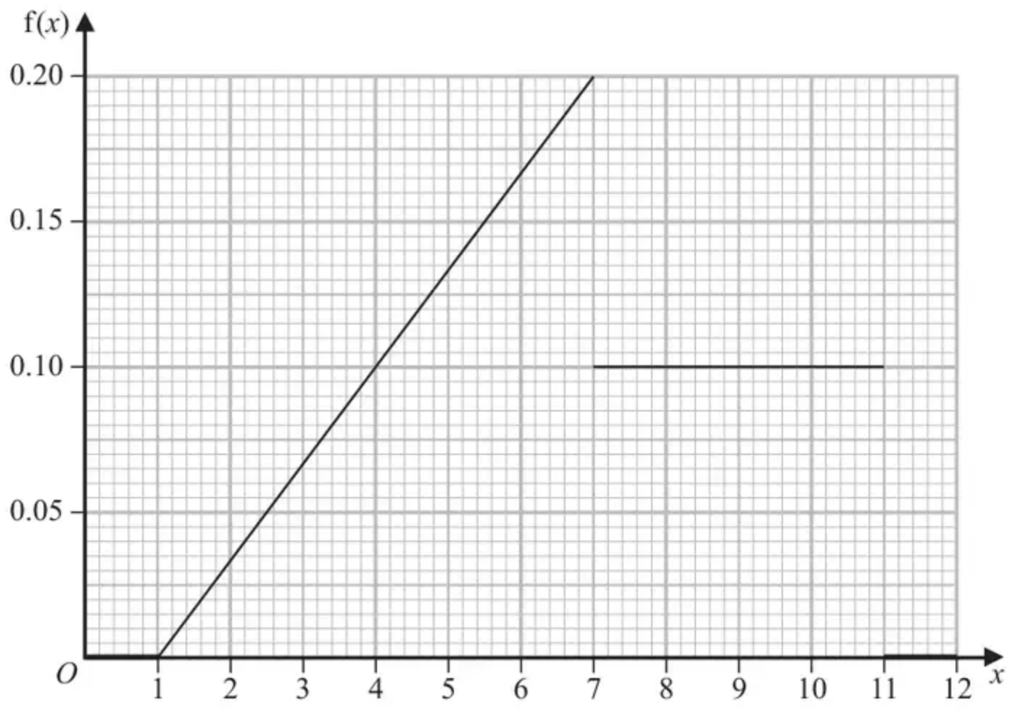
(a) Find $\text{P}(X<4)$ (2)
(b) Specify the cumulative distribution function of $X$ for $7⩽x⩽11$ (3)
(Total 5 marks)
Edexcel AS June 2022 Q2
2. The random variable $R$ has a continuous uniform distribution over the interval [5, 9]
(a) Specify fully the probability density function of $R$. (1)
(b) Find $\text{P}(7<R<10)$ (1)
The random variable $A$ is the area of a circle radius $R$ cm.
(c) Find $\text{E}(A)$ (4)
(Total 6 marks)
Edexcel S2 June 2016 Q3
3. A rectangle has a perimeter of 20 cm. The length, $X$ cm, of one side of this rectangle is uniformly distributed between 1 cm and 7 cm.
Find the probability that the length of the longer side of the rectangle is more than 6 cm long. (5)
(Total 5 marks)
Edexcel S2 June 2010 Q3
4. The continuous random variable $X$ has cumulative distribution function given by
$$\text{F}(x)=\{\begin{matrix}0 & x⩽0 \\ k(x^{3}−\frac{3}{8}x^{4}) & 0<x⩽2 \\ 1 & x>2\end{matrix}$$
where $k$ is a constant.
(a) Show that $k=\frac{1}{2}$ (1)
(b) Showing your working clearly, use calculus to find
(i) $\text{E}(X)$
(ii) the mode of $X$
(6)
(c) Describe, giving a reason, the skewness of the distribution of $X$ (1)
(Total 8 marks)
Edexcel A2 June 2019 Q4
Solutions
1.
Mark scheme (a)
Scheme | Marks | AO
$\text{P}(X<4)=\frac{(4−1)×0.1}{2}$ or $\int_{1}^{4}{}\frac{1}{30}(x−1)\text{d}x$ | M1 | 2.1
$=0.15$ | A1 | 1.1b
 | (2)

Notes
M1: Use of area of triangle or integration with limits to find required area
Condone $\frac{4×0.1}{2}$ or $\int_{1}^{4}{}\frac{1}{30}(x)\text{d}x$ for M1
A1: 0.15 oe
Mark scheme (b)
Scheme | Marks | AO
 | M1  M1 | 3.1a  1.1b
  $\frac{(7−1)×0.2}{2}+…$  $…0.1(x−7)$ | $\int_{1}^{7}{}\frac{1}{30}(x−1)\text{d}x+…$  $…\int_{7}^{x}{0.1}\text{d}t$ | $∫0.1\text{d}x$  $\text{F}(7)=0.1x+c$  or  $\text{F}(11)=0.1x+c$
$\text{F}(x)=0.1x−0.1$ [for $7⩽x⩽11$] | A1 | 1.1b
 | (3)
 | (5 marks)

Notes
M1: Complete method for finding the cdf including area from $1⩽x<7$
Condone one slip for the area from $1⩽x<7$
M1: Attempt at area from $7⩽x⩽11$
A1: $0.1x−0.1$
2.
Mark scheme (a)
Scheme | Marks
$\text{f}(r)=\{\begin{matrix}\frac{1}{4} & 5⩽r⩽9 \\ 0 & \text{otherwise}\end{matrix}$ | B1
 | (1)

Notes
B1: Allow $r<5$ and $r>9$ instead of 0 otherwise
Allow < instead of $⩽$ signs.
Any letter may be used - condone mixed letters
Must have f(r) – condone F(r)
Mark scheme (b)
Scheme | Marks
$\text{P}(7<R<10)=2×\frac{1}{4}$  $=\frac{1}{2}$ | B1
 | (1)

Notes
B1: oe
Mark scheme (c)
Scheme | Marks
$[\text{E}(A)=\text{E}(πR^{2})]$  $\text{E}(R^{2})=\text{Var}(R)+[\text{E}(R)]^{2}$ or $\int_{5}^{9}{}\frac{r^{2}}{4}\text{d}r$ | M1
$\text{E}(R)=7, \text{Var}(R)=\frac{4}{3}$ or ${[\frac{r^{3}}{12}]}_{5}^{9}$ | B1
$=50\frac{1}{3}$ | A1
$\text{E}(A)=50\frac{1}{3}π$ oe | A1
 | (4)
 | (6 marks)

Notes
M1: Using correct formula for $\text{E}(R^{2})$. This may be in any order or written in words
B1: Var $(R)=\frac{4}{3}$ or awrt 1.33 and $\text{E}(R)=7$ or ${[\frac{r^{3}}{12}]}_{5}^{9}$. These may be implied by a correct answer
A1: Allow awrt 50.3
A1: Allow exact multiple of $π$ eg $50.\dot{3}π$ or awrt 158
Do Not allow $50.3π$
NB If both $\text{E}(R)^{2}$ and $[\text{E}(R)]^{2}$ are both worked out and neither is selected they lose the final A marks. The best they can get is M1 B1 A1A0
3.
Scheme | Marks
Method 1  $\text{P}(X>6)=\frac{1}{6}$ | B1  M1
$\text{P}(X<4)=\frac{1}{2}$ | A1
$\text{total}=\frac{1}{6}+\frac{1}{2}=\frac{2}{3}$ | M1dep B  A1
 | (5)
 | (5 marks)

Notes
Method 2
Scheme | Marks
$\text{P}(4<X<6)=\frac{1}{3}$ | B1  M1  A1
$1−\frac{1}{3}=\frac{2}{3}$ | M1dep B  A1

Method 3
Scheme | Marks
$\text{P}(X>6)=\frac{1}{6}$ | B1  M1
$Y∼\text{U}[3,9]$ $\text{P}(Y>6)=\frac{1}{2}$ | A1
$\text{total}=\frac{1}{6}+\frac{1}{2}=\frac{2}{3}$ | M1dep B  A1

Methods 1 and 2
B1 for 6 and 4 (allow if seen on a diagram on $x$-axis)
M1 for $\text{P}(X>6)$ or $\text{P}(6<X<7)$; or $\text{P}(X<4)$ or $\text{P}(1<X<4)$ ; or $\text{P}(4<X<6)$ Allow $⩽$ and $⩾$ signs
A1 $\frac{1}{6}$; or $\frac{1}{2}$; $\frac{1}{3}$ must match the probability statement
M1 for adding their “$\text{P}(X>6)$” and their “$\text{P}(X<4)$” or 1 - their “$\text{P}(4<X<6)$” dep on getting first B mark
A1 cao $\frac{2}{3}$
Method 3 $Y∼\text{U}[3,9]$
B1 for 6 with U[1,7]and 6 with U[3,9]
M1 for $\text{P}(X>6)$ or $\text{P}(6<X<7)$ or $\text{P}(6<Y<9)$
A1 $\frac{1}{6}$; or $\frac{1}{2}$; must match the probability statement
M1 for adding their “$\text{P}(X>6)$” and their “$\text{P}(Y>6)$” dep on getting first B mark
A1 cao $\frac{2}{3}$
4.
Mark scheme (a)
Scheme | Marks | AO
$k(2^{3}−\frac{3}{8}2^{4})=1$  $2k=1$  $k=\frac{1}{2}$ * | B1* | 1.1b
Or $\frac{1}{2}(2^{3}−\frac{3}{8}2^{4})=1 ∴k=\frac{1}{2}$ * | (B1*)
 | (1)

Notes
B1*: substituting $x=2$ into $\text{F}(x)$ and equating to 1 leading to $k=\frac{1}{2}$ with no errors.
Minimum subst seen is $k(8−6)=1$ or $0.5(8−6)=1$
Mark scheme (b)
Scheme | Marks | AO
$\text{f}(x)=k[3x^{2}−\frac{3}{2}x^{3}]$ | M1 | 2.1
(i) $\int_{0}^{2}{x}\text{f}(x)\text{d}x=k\int_{0}^{2}{(3x^{3}−\frac{3}{2}x^{4})}\text{d}x$ | M1d | 1.1b
$={[\frac{3x^{4}}{8}−\frac{3x^{5}}{20}]}_{0}^{2}$
$=\frac{6}{5}$ or 1.2 | A1 | 1.1b
(ii) $3x−\frac{9x^{2}}{4}=0$ | M1d | 3.1a
$x(3−\frac{9x}{4})=0$ | M1d | 1.1b
$x=0$ or $\frac{4}{3}$ $∴$ mode $=\frac{4}{3}$ | A1 | 1.1b
 | (6)

Notes
M1: Realising they need to find the pdf and attempting to differentiate $k[x^{3}−\frac{3}{8}x^{4}]$ at least 1 correct term
(i) M1d: dep on 1st M1 Attempting to find $\int_{0}^{2}{x}\text{their}\text{f}(x))\text{d}x$ At least one correct term ft their pdf
A1: $\frac{6}{5}$ or 1.2 oe NB 1.2 with no working gains M0M0A0
(ii) M1d: dep on 1st M1 for realising they need to differentiate their pdf. At least one correct term but ft their pdf
M1d: Dep on 3rd M1. correct method for solving their differential of their pdf = 0 pdf must be of the form $ax^{2}+bx$
A1: $∴$ mode $=\frac{4}{3}$ only. They must eliminate 0
Mark scheme (c)
Scheme | Marks | AO
Mode > mean implies it is negative skew | B1ft | 2.4
 | (1)
 | (8 marks)

Notes
B1ft: ft their mode and mean or a correct sketch.

