QQQ – Further Statistics 2 – Chapter 1 – Linear Regression (Version 2)
Total Marks: 24
(24 = Platinum, 22 = Gold, 19 = Silver, 16 = Bronze)
1. Baako is investigating the times taken by children to run a 100 m race, $x$ seconds, and a 500 m race, $y$ seconds. For a sample of 20 children, Baako obtains the time taken by each child to run each race.
Here are Baako’s summary statistics.
$${\text{S}}_{xx}=314.55 {\text{S}}_{yy}=9026 {\text{S}}_{xy}=1610$$
$$\overset{ˉ}{x}=19.65 \overset{ˉ}{y}=108$$
(a) Calculate the product moment correlation coefficient between the times taken to run the 100 m race and the times taken to run the 500 m race. (2)
(b) Show that the equation of the regression line of $y$ on $x$ can be written as
$$y=5.12x+7.42$$
where the gradient and $y$ intercept are given to 3 significant figures. (3)
The child who completed the 100 m race in 20 seconds took 104 seconds to complete the 500 m race.
(c) Find the residual for this child. (1)
The table below shows the signs of the residuals for the 20 children in order of finishing time for the 100 m race.
Sign of residual | + | + | + | + | – | – | + | – | – | – | – | – | – | – | – | + | + | + | + | +

(d) Explain what the signs of the residuals show about the model’s predictions of the 500 m race times for the children who are fastest and slowest over the 100 m race. (1)
(Total 7 marks)
Edexcel A2 June 2023 Q1
2. Kwame is investigating a possible relationship between average March temperature, $t{}^{∘}\text{C}$, and tea yield, $y$ kg/hectare, for tea grown in a particular location.
He uses 30 years of past data to produce the following summary statistics for a linear regression model, with tea yield as the dependent variable.
$$\text{Residual Sum of Squares (RSS)}=1666567 {\text{S}}_{tt}=52.0 {\text{S}}_{yy}=1774155$$
$$\text{least squares regression line:} \text{gradient}=45.5 y\text{-intercept}=2080$$
(a) Use the regression model to predict the tea yield for an average March temperature of $20{}^{∘}\text{C}$ (1)
He also produces the following residual plot for the data.
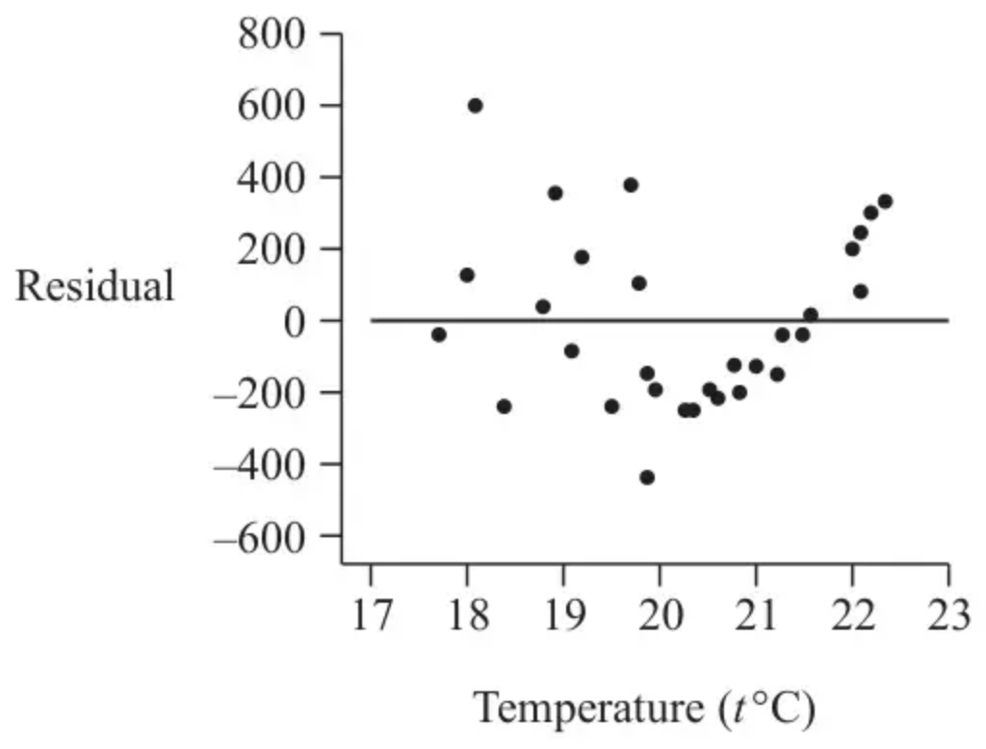
(b) Explain what you understand by the term residual. (1)
(c) Calculate the product moment correlation coefficient between $t$ and $y$ (2)
(d) Explain why the linear model may not be a good fit for the data
(i) with reference to your answer to part (c)
(ii) with reference to the residual plot.
(2)
Kwame also collects data on total March rainfall, $w$ mm, for each of these 30 years.
For a linear regression model of $w$ on $t$ the following summary statistic is found.
$$\text{Residual Sum of Squares (RSS)}=86754$$
Kwame concludes that since this model has a smaller RSS, there must be a stronger linear relationship between $w$ and $t$ than between $y$ and $t$ (where RSS = 1 666 567)
(e) State, giving a reason, whether or not you agree with the reasoning that led to Kwame’s conclusion. (1)
(Total 7 marks)
Edexcel A2 June 2022 Q1
3. A researcher is investigating the relationship between elevation, $x$ metres, and annual mean temperature, $t{}^{∘}\text{C}$.
From a random sample of 20 weather stations in Switzerland, the following results were obtained
$${\text{S}}_{xx}=8820655 {\text{S}}_{tt}=444.7 ∑x=28130 ∑t=94.62$$
The product moment correlation coefficient for these data is found to be $−0.959$
(a) Interpret the value of this correlation coefficient. (1)
(b) Show that the equation of the regression line of $t$ on $x$ can be written as
$$t=14.3−0.00681x$$
(4)
The random variable $W$ represents the elevations of the weather stations in kilometres.
(c) Write down the equation of the regression line of $t$ on $w$ for these 20 weather stations in the form $t=a+bw$ (1)
(d) Show that the residual sum of squares (RSS) for the model for $t$ and $x$ is 35.7 correct to one decimal place. (1)
One of the weather stations in the sample had a recorded elevation of 1100 metres and an annual mean temperature of $1.4{}^{∘}\text{C}$
(e)
(i) Calculate this weather station’s contribution to the residual sum of squares.
Give your answer as a percentage. (2)
(ii) Comment on the data for this weather station in light of your answer to part (e)(i). (1)
(Total 10 marks)
Edexcel A2 October 2021 Q4
Solutions
1.
Mark scheme (a)
Scheme | Marks | AO
$r=\frac{1610}{\sqrt{314.55×9026}}$ | M1 | 1.1b
$=0.9555…$ awrt 0.956 | A1 | 1.1b
 | (2)

Notes
M1: correct expression for $r$
A1: awrt 0.956
Mark scheme (b)
Scheme | Marks | AO
$b=\frac{1610}{314.55}$ | M1 | 2.1
$a=\overset{ˉ}{y}−b\overset{ˉ}{x}=108−\text{‘}b\text{’}×19.65$ | M1 | 1.1b
$y=5.12x+7.42$* | A1* | 1.1b
 | (3)

Notes
M1: correct expression for gradient, or correct formula stated with $b$ to more than 3.s.f
M1: correct expression, or correct formula stated with $a$ to more than 3.s.f
follow through their $b$
*A1: correct linear model with $\text{a}$ = awrt 7.42 and $\text{b}$ = awrt 5.12
Mark scheme (c)
Scheme | Marks | AO
Residual $=104−(5.12(20)+7.42)=$ awrt –5.8 | B1 | 3.4
 | (1)

Notes
B1: correct use of model awrt –5.8
Mark scheme (d)
Scheme | Marks | AO
Positive residuals show that the model underestimates the 500m race times of the fastest and slowest children. | B1 | 3.5a
 | (1)
 | (7 marks)

Notes
B1: correct contextual explanation mentioning positive residuals and underestimate o.e.
2.
Mark scheme (a)
Scheme | Marks | AO
$[20×45.5+2080]=2990$ [kg/ha] | B1 | 3.4
 | (1)

Notes
B1: cao
Mark scheme (b)
Scheme | Marks | AO
(A residual is the) difference between the observed value (oe) and the predicted value (oe) (of the dependent variable) | B1 | 1.2
 | (1)

Notes
B1: Correct definition. Allow equivalent wording.
Distance from regression line on its own is B0, but allow if vertical distance or $y$ is referenced
Mark scheme (c)
Scheme | Marks | AO
$1666567=1774155(1−r^{2})$ | M1 | 1.1b
$r=0.246…$ awrt 0.246 | A1 | 1.1b
 | (2)

Notes
M1: Use of correct expression for $r$ or $r^{2}$
Allow use of ${\text{S}}_{ty}=45.5×52.0[=2366]$
or RSS: $1774155−\frac{({\text{S}}_{ty})^{2}}{52}=1666567→[{\text{S}}_{ty}=2365.2…]$
and then $r=\frac{\text{awrt 2365 or awrt 2366}}{\sqrt{52.0×1774155}}$
A1: awrt 0.246 ($−0.246$ or $±0.246$ scores M1A0)
Mark scheme (d)
Scheme | Marks | AO
(i) Since $r$ is close to 0/weak correlation | B1 | 2.4
(ii) e.g. (For $t>20…$) the residuals do not appear randomly scattered about 0. | B1 | 3.5a
 | (2)

Notes
(i) B1: Correct explanation
(ii) B1: Correct evaluation of the fit of the model’s residuals (e.g. variance either side of $t=20$ does not appear to be the same)
‘residuals not randomly scattered’ on its own is B0.
Mark scheme (e)
Scheme | Marks | AO
Kwame’s conclusion cannot be supported using RSS since the two values of RSS do not have the same units. | B1 | 2.3
 | (1)
 | (7 marks)

Notes
B1: Correct assessment of the conclusion involving the units/size of the variables used to calculate the RSS
3.
Mark scheme (a)
Scheme | Marks | AO
As elevation increases, temperature decreases. | B1 | 3.4
 | (1)

Notes
B1: Correct contextual interpretation
Mark scheme (b)
Scheme | Marks | AO
${\text{S}}_{xt}=−0.959\sqrt{8820655×444.7}[=−60062.38727]$ | M1 | 2.1
$b=\frac{\text{‘}−60062…\text{’}}{8820655}[=−0.006809…]$ | M1 | 1.1b
$a=\frac{94.62}{20}−\text{‘}b\text{’}\frac{28130}{20}[=14.308…]$ | M1 | 1.1b
$t=14.3−0.00681x$ * | A1cso* | 2.2a
 | (4)

Notes
M1: Using pmcc to find ${\text{S}}_{xt}$
M1: Setting up linear model by attempting to find $b$
Note: Allow M2 for $b=r\sqrt{\frac{{\text{S}}_{tt}}{{\text{S}}_{xx}}}$
M1: Setting up linear model by attempting to find $a$
A1cso*: Correct model $t=14.3−0.00681x$ with $a$ = awrt 14.3 and $b$ = awrt $−0.00681$ dependent upon all previous M marks.
Mark scheme (c)
Scheme | Marks | AO
$[w=\frac{x}{1000}→] t=14.3−6.81w$ | B1 | 3.3
 | (1)

Notes
B1: Correct model
Mark scheme (d)
Scheme | Marks | AO
$444.7(1−(−0.959)^{2})$ or $444.7−\frac{(−60062…)^{2}}{8820655}$ [ = 35.7*] | B1cso* | 1.1b
 | (1)

Notes
B1cso*: Either correct expression
Mark scheme (e)
Scheme | Marks | AO
(i) (residual)² = $[1.4−(14.3−0.00681(1100))]^{2} [=29.2…]$ | M1 | 3.4
$[29.2…÷35.7×100\text{\%}]$ awrt 82% | A1 | 1.1b
 | (2)
(ii) (As the point representing this data contributes to the majority of the RSS), the point is possibly an outlier and should be investigated. | B1 | 3.5a
 | (1)
 | (10 marks)

Notes
M1: Using the model to evaluate the squared residual
A1: awrt 82%
B1: Evaluating the result obtained from the model to suggest that this point may be an outlier

