QQQ – Further Statistics 2 – Chapter 1 – Linear Regression (Version 1)
Total Marks: 25
(25 = Platinum, 23 = Gold, 20 = Silver, 17 = Bronze)
1. Below are 3 sketches from some students of the residuals from their linear regressions of $y$ on $x$.
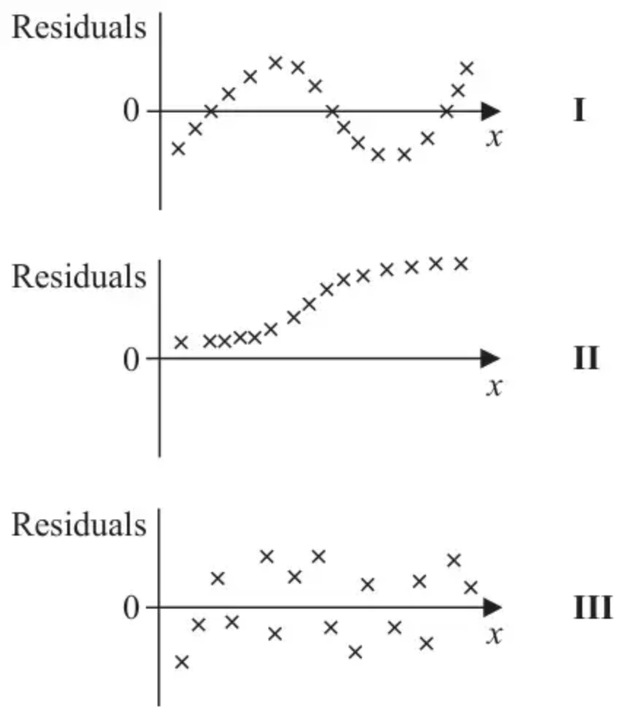
For each sketch you should state, giving your reason,
(i) whether or not the sketch is feasible
and if it is feasible
(ii) whether or not the sketch suggests a linear or a non-linear relationship between $y$ and $x$. (6)
(Total 6 marks)
Edexcel A2 October 2020 Q3
2. Two students are experimenting with some water in a plastic bottle. The bottle is filled with water and a hole is put in the bottom of the bottle. The students record the time, $t$ seconds, it takes for the water level to fall to each of 10 given values of the height, $h$ cm, above the hole.
Student $A$ models the data with an equation of the form $t=a+b\sqrt{h}$
The data is coded using $v=t−40$ and $w=\sqrt{h}$ and the following information is obtained.
$$∑v=626 ∑v^{2}=64678 ∑w=22.47 {\text{S}}_{ww}=4.52 {\text{S}}_{vw}=−338.83$$
(a) Find the equation of the regression line of $t$ on $\sqrt{h}$ in the form $t=a+b\sqrt{h}$ (4)
The time it takes the water level to fall to a height of 9 cm above the hole is 47 seconds.
(b) Calculate the residual for this data point.
Give your answer to 2 decimal places. (2)
Given that the residual sum of squares (RSS) for the model of $t$ on $\sqrt{h}$ is the same as the RSS for the model of $v$ on $w$,
(c) calculate the RSS for these 10 data points. (2)
Student $B$ models the data with an equation of the form $t=c+dh$
The regression line of $t$ on $h$ is calculated and the residual sum of squares (RSS) is found to be 980 to 3 significant figures.
(d) With reference to part (c) state, giving a reason, whether Student $B$’s model or Student $A$’s model is the more suitable for these data. (1)
(Total 9 marks)
Edexcel A2 June 2024 Q1
3. A medical researcher is exploring the relationship between the weight, $x$ kg, and the head circumference, $y$ cm, of newborn babies. A random sample of 15 newborn babies is taken and the data are summarised by the following statistics
$$∑x=50.46 ∑x^{2}=171.828 ∑y=518.9 ∑y^{2}=18004.47 {\text{S}}_{xy}=7.8284$$
(a) Show that, to 3 decimal places, ${\text{S}}_{xx}=2.081$ and ${\text{S}}_{yy}=53.989$ (3)
(b) Find the equation of the regression line of $y$ on $x$, giving your answer in the form $y=a+bx$ (3)
(c) Find the residual sum of squares (RSS) for these data. (1)
One of these 15 babies had a birth weight of 3.26 kg and a head circumference of 36.8 cm
(d) Find the residual for this baby. (2)
The researcher claims that this baby could be an outlier.
(e) Using your answers to part (c) and part (d), give a reason that might support this claim. (1)
(Total 10 marks)
Edexcel A2 June 2025 Q1
Solutions
1.
Scheme | Marks | AO
I (Is feasible as a residual plot but) probably a non-linear relationship | B1 | 2.2b
Since the residuals are not randomly scattered about zero | B1 | 2.4
II Impossible as a residual plot | B1 | 2.2a
Since the residuals do not sum to zero | B1 | 2.4
III (Is feasible as a residual plot) and probably a linear relationship | B1 | 2.2b
Since the points are randomly scattered about zero | B1 | 2.4
 | (6)
 | (6 marks)

Notes
I: 1st B1 for stating possibly non-linear (allow a suitable sketch)
2nd B1 for a suitable comment (e.g. follow a systematic pattern)
II: 1st B1 for stating not feasible as a residual plot
2nd B1 for a correct reason
III: 1st B1 for stating probably a linear relationship
2nd B1 for a suitable supporting reason
2.
Mark scheme (a)
Scheme | Marks | AO
$b=\frac{−338.83}{4.52}[=−74.96…]$ | M1 | 3.3
$a=\frac{626}{10}−\text{“}b\text{”}\frac{22.47}{10}[=231.04…]$ | M1 | 1.1b
$t−40=\text{“}231.04…\text{”}+(\text{“}−74.96…\text{”})\sqrt{h}$ | dM1 | 3.1a
$t=271.04…−74.96…\sqrt{h}$ | A1 | 1.1b
 | (4)

Notes
M1: For use of a correct model ie a correct expression for $b$
M1: For use of a correct model ie a correct expression (ft) for $a$
dM1: dep on both previous method marks for proceeding from an equation of the form $v=\text{“}a\text{”}+\text{“}b\text{”}w$ to a correct un-simplified model in terms of $h$ and $t$ ft their $a$ and $b$
A1: For a correct model $t=271.04…−74.96…\sqrt{h}$ with awrt 271 and awrt 75 (corrected from the printed mark scheme: the note prints 74.95…; $b=−74.96…$)
Mark scheme (b)
Scheme | Marks | AO
Residual $=47−(\text{“}271.04…\text{”}−\text{“}74.96…\text{”}×\sqrt{9})$ | M1 | 3.4
$=0.8466…$ | A1 | 1.1b
 | (2)

Notes
M1: For a correct method to find the residual. States $h=9$ and a correct expression to find the residual for their model of the form $t=a+b\sqrt{h}$ or 9 substituted into a correct expression. Must be subtracting the correct way round. Alternatively, may code the data to $v$ and $w$ and attempt $47−(\text{“}231.04…\text{”}−\text{“}74.96…\text{”}×3)$
A1: awrt 0.85 Allow answers in range awrt 0.84 to awrt 0.86 if working shown following a correct model in (a). If no working is shown then look for awrt 0.847
Mark scheme (c)
Scheme | Marks | AO
$\text{RSS}=[64678−\frac{626^{2}}{10}]−\frac{(−338.83)^{2}}{4.52} (=25490.4−\frac{(−338.83)^{2}}{4.52})$ | M1 | 1.1b
$=90.89…[{\text{s}}^{2}]$ | A1 | 1.1b
 | (2)

Notes
M1: For a correct expression for RSS. 25490.4 may be seen as $\frac{127452}{5}$
May also use $\text{RSS}={\text{S}}_{vv}(1−r^{2})=25490.4(1−\frac{(−338.83)^{2}}{4.52×25490.4})$
A1: awrt 90.9
Mark scheme (d)
Scheme | Marks | AO
Student $A$’s model as the sum of squares of the residuals is lower | B1 | 2.4
 | (1)
 | (9 marks)

Notes
B1: Explaining a reason for their conclusion that A is a more suitable model provided their positive RSS found in (c) is less than 980. e.g. RSS is smaller so model $A$
Condone references to the model being more accurate oe. Must be a comparison with $B$ or implied so do not accept statements such as “$A$ because it has a small RSS”
3.
Mark scheme (a)
Scheme | Marks | AO
${\text{S}}_{xx}=171.828−\frac{50.46^{2}}{15}$ or ${\text{S}}_{yy}=18004.47−\frac{518.9^{2}}{15}$ | M1 | 1.1b
$=2.08056=$2.081* (3dp) ; $=53.98933…=$53.989* (3dp) | A1*;  A1* | 1.1b(x2)
 | (3)

Notes
M1: for either correct expression
1st A1*: cso for 2.081 or better following a correct expression
2nd A1*: cso for 53.989 or better following a correct expression
Mark scheme (b)
Scheme | Marks | AO
$b=[\frac{{\text{S}}_{xy}}{{\text{S}}_{xx}}=]\frac{7.8284}{2.081}=(3.76…)$ | M1 | 1.1b
$a=\frac{518.9}{15}−b\frac{50.46}{15}=34.593…−\text{“}3.76…\text{”}×3.364(=21.9…)$ | M1 | 1.1b
Equation of line is: $y=21.9+3.76x$ | A1 | 1.1b
 | (3)

Notes
1st M1: for a correct numerical expression for gradient (or ft their ${\text{S}}_{xx}\text{≠}2.081$, ${\text{S}}_{xy}\text{≠}7.8284$)
2nd M1: for a correct expression for intercept (ft their $b$). May be implied by awrt 21.9
A1: for equation with $a$ = awrt 21.9 and $b$ = awrt 3.76
Note: A correct equation scores M1M1A1
Mark scheme (c)
Scheme | Marks | AO
$[\text{RSS}={\text{S}}_{yy}−\frac{({\text{S}}_{xy}{}^{2})}{{\text{S}}_{xx}}=]24.5397…$ = awrt 24.5 | B1 | 1.1b
 | (1)

Notes
B1: for awrt 24.5
Mark scheme (d)
Scheme | Marks | AO
$\hat{y}=\text{“}21.9\text{”}+\text{“}3.76\text{”}×3.26(=34.1576)$ | M1 | 3.4
[Residual $=y−\hat{y}=36.8−\text{“}34.15…\text{”}=2.6424$] = awrt 2.6 | A1 | 1.1b
 | (2)

Notes
M1: for an expression for $\hat{y}$ or the residual (ft their regression line equation). Implied by awrt 2.6
A1: for awrt 2.6 (exact figures give 2.5979…)
Mark scheme (e)
Scheme | Marks | AO
$\text{“}2.64…{\text{”}}^{2}≈7$ which is a high proportion of RSS (so this value may be an outlier) | B1 | 2.4
 | (1)
 | (10 marks)

Notes
B1: Dependent on $0.25<\frac{\text{“}2.6{\text{”}}^{2}}{\text{“}24.5\text{”}}<1$ for a suitable explanation based on their (d)² compared with their (c) or other suitable calculations which enable a comparison to be made.
e.g. this residual is 27.5% of the total which is a large proportion”.
References to size e.g. “large” requires quoting the numerical value as well.

