QQQ – Further Statistics 1 – Chapter 8 – Quality of Tests (Version 2)
Total Marks: 25
(25 = Platinum, 23 = Gold, 20 = Silver, 17 = Bronze)
1. The number of errors made by a secretary is modelled by a Poisson distribution with a mean of 2.4 per 100 words.
A 100-word piece of work completed by the secretary is selected at random.
(a) Find the probability that
(i) there are exactly 3 errors,
(ii) there are fewer than 2 errors. (2)
After a long holiday, a randomly selected piece of work containing 250 words completed by the secretary is examined to see if the rate of errors has changed.
(b) Stating your hypotheses clearly, and using a 5% level of significance, find the critical region for a suitable test. (4)
(c) Find $\text{P}(\text{Type I error})$ for the test in part (b) (1)
(Total 7 marks)
Edexcel A2 June 2024 Q2
2. A machine fills cartons with juice.
The amount of juice in a carton is normally distributed with mean $μ$ ml and standard deviation 8 ml.
A manager wants to test whether or not the amount of juice in the cartons, $X$ ml, is less than 330 ml. The manager takes a random sample of 25 cartons of juice and calculates the mean amount of juice $\overset{ˉ}{x}$ ml.
(a) Using a 5% level of significance, find the critical region of $\overset{‾}{X}$ for this test.
State your hypotheses clearly. (4)
The Director is concerned about the machine filling the cartons with more than 330 ml of juice as well as less than 330 ml of juice. The Director takes a sample of 55 cartons, records the mean amount of juice $\overset{ˉ}{y}$ ml and uses a test with a critical region of
$$\{\overset{‾}{Y}<328\}∪\{\overset{‾}{Y}>332\}$$
(b) Find $\text{P}(\text{Type I error})$ for the Director’s test. (2)
When $μ=325$ ml
(c) find $\text{P}(\text{Type II error})$ for the test in part (a) (2)
(Total 8 marks)
Edexcel A2 June 2023 Q5
3. The number of houses sold per week by a firm of estate agents follows a Poisson distribution with mean 2. The firm believes that the appointment of a new salesman will increase the number of houses sold. The firm tests its belief by recording the number of houses sold, $x$, in the week following the appointment. The firm sets up the hypotheses ${\text{H}}_{0}:λ=2$ and ${\text{H}}_{1}:λ>2$, where $λ$ is the mean number of houses sold per week, and rejects the null hypothesis if $x⩾3$
(a) Find the size of the test. (2)
(b) Show that the power function for this test is
$$1−\frac{1}{2}{\text{e}}^{−λ}(2+2λ+λ^{2})$$
(3)
The table below gives the values of the power function to 2 decimal places.
$λ$ | 2.5 | 3.0 | 3.5 | 4.0 | 5.0 | 7.0
Power | 0.46 | $r$ | 0.68 | $s$ | 0.88 | 0.97

Table 1
(c) Calculate the values of $r$ and $s$. (2)
(d) Draw a graph of the power function. (2)
(e) Find the range of values of $λ$ for which the power of this test is greater than 0.6 (1)
(Total 10 marks)
Edexcel S4 June 2013 (R) Q3
Solutions
1.
Mark scheme (a)
Scheme | Marks | AO
(i) 0.20901… awrt 0.209 | B1 | 3.4
(ii) 0.30844.. awrt 0.308 | B1 | 1.1b
 | (2)

Notes
1st B1 for awrt 0.209
2nd B1 for awrt 0.308
Mark scheme (b)
Scheme | Marks | AO
${\text{H}}_{0}:λ=2.4$ (or $μ=6$) ${\text{H}}_{1}:λ\text{≠}2.4$ (or $μ\text{≠}6$) | B1 | 2.5
[$E$ = no. of errors] $E∼\text{Po}(6)$ | M1 | 3.3
$\text{P}(E⩽1)=0.0174$ or $\text{P}(E⩽2)=0.0620$  and  $\text{P}(E⩽11)=0.980$ or $\text{P}(E⩾12)=0.0201$ | M1 | 3.4
Critical region: $E⩽1$ or $E⩾12$ | A1 | 1.1b
 | (4)

Notes
B1 for both hypotheses correct in terms of $λ$ or $μ$ (allow $λ=6$ etc)
1st M1 for selecting the correct model. Sight or use of $\text{Po}(6)$
2nd M1 for use of the correct model with two probs correct to 2.s.f. (accept $\text{P}(E⩾12)=0.02$)
Must see attempt at lower and upper limit. Probabilities may be seen in (c).
A1 for correct critical region (both parts). Allow $E⩽1$ and $E⩾12$ or $E⩽1,E⩾12$ etc
Writing CR as probability statements is A0
NB: Completely correct CR implies M1M1A1
SC: 1-tailed test
B0 as hypotheses are incorrect
M1 for sight or use of $\text{Po}(6)$
M1 (dep on ${\text{H}}_{1}$) for sight of $\text{P}(E⩽1)=0.0174$ or $\text{P}(E⩾11)=0.0426$, in line with their ${\text{H}}_{1}$
A1 for CR: $E⩽1$ or CR: $E⩾11$, in line with their hypotheses
Mark scheme (c)
Scheme | Marks | AO
[$\text{P}(\text{Type I error})=0.0174+0.0201=$] 0.0375  (Calc gives: 0.017351… + 0.0200919… = 0.037443…) | B1ft | 1.2
 | (1)
 | (7 marks)

Notes
B1ft for 0.0375 or 0.0374 or summing their two appropriate probs (ft their CR)
NB: If candidate uses a 1-tailed test, this mark cannot be gained
2.
Mark scheme (a)
Scheme | Marks | AO
${\text{H}}_{0}:μ=330 {\text{H}}_{1}:μ<330$ | B1 | 2.5
[$\overset{‾}{X}∼$] $\text{N}(330,{(\frac{8}{\sqrt{25}})}^{2})$ | M1 | 3.3
$\text{P}(\overset{‾}{X}<C)=0.05⇒\frac{C−330}{8\text{/}\sqrt{25}}=−1.6449$ | M1 | 3.4
So $C=327.368…$ and critical region is: $\overset{‾}{X}<$ awrt 327 | A1 | 1.1b
 | (4)

Notes
B1 for both hypotheses in terms of $μ$
1st M1 for stating or using the correct model – may be implied by use in later line.
Condone $X$ or any letter for $\overset{‾}{X}$
2nd M1 for a correct equation for $C$ Allow any $z$ value that satisfies $1.6<\text{∣}z\text{∣}<1.7$
If standardisation equation not seen, this mark may be implied by CV = awrt 327 or CR: <awrt 327
A1 for a correct CR allow just “< awrt 327” Condone e.g. $X<327$ rather than $\overset{‾}{X}<327$
Condone $⩽$
Mark scheme (b)
Scheme | Marks | AO
$\overset{‾}{Y}∼\text{N}(330,{(\frac{8}{\sqrt{55}})}^{2})$ and require $2×\text{P}(\overset{‾}{Y}<328)$ (o.e.) | M1 | 3.3
$=0.063732…$ awrt 0.0637 | A1 | 1.1b
 | (2)

Notes
M1 for sight of correct model and attempt at $\text{P}(\overset{‾}{Y}<328)$ (o.e.) Condone missing $2×$
A1 for awrt 0.0637 (correct answer scores 2 out of 2)
Mark scheme (c)
Scheme | Marks | AO
$\text{P}(\overset{‾}{X}>\text{“}327.368…\text{”}∣μ=325)$ or $1−\text{P}(\overset{‾}{X}<\text{“}327.368…\text{”}∣μ=325)$ | M1 | 3.4
$=0.0694233…$ awrt 0.0694 | A1 | 1.1b
 | (2)
 | (8 marks)

Notes
M1 for a correct (ft) statement may be implied by sight of e.g. $Z>\frac{\text{“}327.36…\text{”}−325}{8\text{/}5}=1.48..$
For $μ=325$ allow $\overset{‾}{X}∼\text{N}(325,…\text{.})$
Allow ft from a 2-tailed test in part (a)
A1 for awrt 0.0694 (correct answer scores 2 out of 2)
SC Sight of $\text{P}(328<\overset{‾}{X}<332∣μ=325)$ or $1−\text{P}(\overset{‾}{X}<328∪\overset{‾}{X}>332∣μ=325)$ scores M1A0
3.
Mark scheme (a)
Scheme | Marks
$X∼\text{Po}(2)$
Size $=\text{P}(X⩾3\text{/}λ=2)$
$=1−0.6767$ | M1
$=0.3233$ awrt 0.323 | A1
 | (2)

Notes
M1 for correct expression for size using Po(2)
Mark scheme (b)
Scheme | Marks
Power $=1−\text{P}(0)−\text{P}(1)−\text{P}(2)$ | M1
$=1−{\text{e}}^{−λ}−λ{\text{e}}^{−λ}−\frac{λ^{2}{\text{e}}^{−λ}}{2!}$ | A1
$=1−\frac{1}{2}{\text{e}}^{−λ}(2+2λ+λ^{2})$ | A1 cso
 | (3)

Notes
1st M1 for a correct expression in terms of probabilities. Allow $1−\text{P}(X⩽2)$ or $1−\text{P}(X<3)$
1st A1 for correct equation in $λ$
2nd A1 cso
Mark scheme (c)
Scheme | Marks
$r=0.58 s=0.76$ | B1, B1
 | (2)

Notes
SC if both correct but not to 2dp award B1B0
Mark scheme (d)
Scheme | Marks
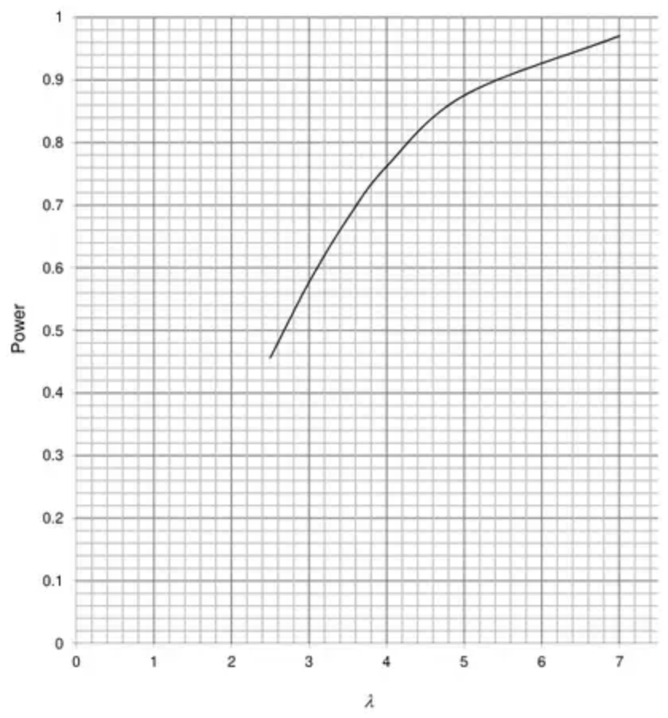 | B1ft points  B1ft curve
 | (2)

Notes
1st B1ft points
2nd B1ft curve (or straight lines) through points
Mark scheme (e)
Scheme | Marks
$λ>3.1$ allow numbers in range 3.1–3.2 | B1
 | (1)
 | (10 marks)

