QQQ – Further Pure 2 – Chapter 6 – Integration Techniques (Version 1)
Total Marks: 22
(22 = Platinum, 20 = Gold, 18 = Silver, 15 = Bronze)
1. A curve has equation
$$y=cosh⁡x, 1⩽x⩽ln⁡5$$
Find the exact length of this curve. Give your answer in terms of e. (5)
(Total 5 marks)
Edexcel FP3 June 2015 Q2
2.
$$I_{n}=\int_{0}^{2}{(})^{n}{\text{e}}^{4x}\text{d}x n⩾0$$
(a) Prove that for $n⩾1$
$$I_{n}=−a^{n−2}−\frac{n}{4}I_{n−1}$$
where $a$ is a constant to be determined. (4)
(b) Hence determine the exact value of
$$\int_{0}^{2}{(})^{2}{\text{e}}^{4x}\text{d}x$$
(3)
(Total 7 marks)
Edexcel A2 June 2023 Q8
3.
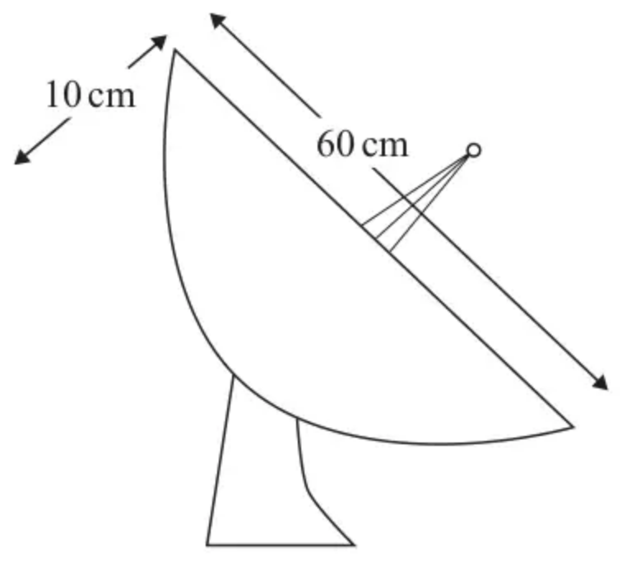
Figure 1
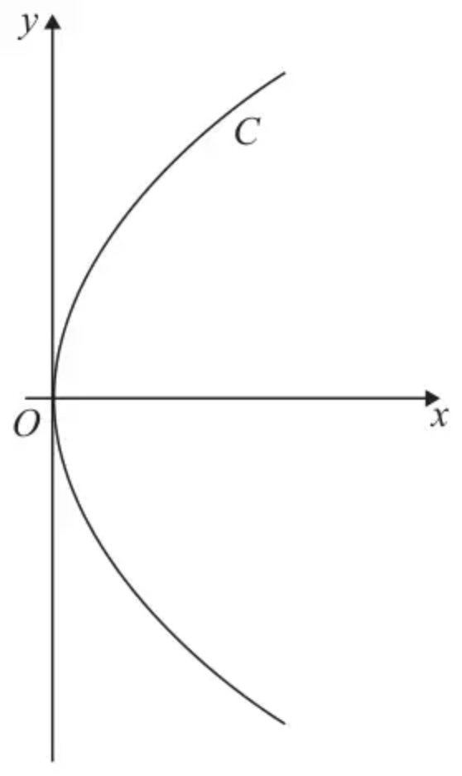
Figure 2
Figure 1 shows a satellite dish.
Figure 2 shows a sketch of the curve $C$ with equation
$$y^{2}=Ax 0⩽x⩽10$$
where $A$ is a positive constant.
The curved inner surface of the satellite dish is modelled by the surface of revolution formed by rotating curve $C$ through $π$ radians about the $x$-axis.
The inner surface of the satellite dish has
• a largest diameter of 60 cm
• a depth of 10 cm
as shown in Figure 1.
(a) Determine the value of $A$. (2)
(b) Using algebraic integration, determine, in cm${}^{2}$, the area of the curved inner surface of the satellite dish, according to the model. Give your answer to 2 significant figures. (7)
(c) State a limitation of the model. (1)
(Total 10 marks)
Edexcel A2 June 2025 Q8
Solutions
1.
Scheme | Marks
$y=cosh⁡x⇒\frac{\text{d}y}{\text{d}x}=sinh⁡x$ | B1
$∫\sqrt{(1+{(\frac{\text{d}y}{\text{d}x})}^{2})}\text{d}x=∫\sqrt{1+{sinh⁡}^{2}x}\text{d}x$ | M1
$=∫cosh⁡x\text{d}x$ or $∫\frac{e^{x}+e^{−x}}{2}\text{d}x$ | A1
$={[sinh⁡x]}_{1}^{ln⁡5}=sinh⁡(ln⁡5)−sinh⁡(1)$ | dM1
$=\frac{12}{5}−\frac{1}{2}(e−\frac{1}{e})$ | A1cso
 | (5)
 | (5 marks)

Notes
B1: Correct derivative
M1: Uses the correct formula with their $\frac{\text{d}y}{\text{d}x}$
A1: Correct integral (Condone omission of $\text{d}x$)
dM1: $∫cosh⁡x\text{d}x=sinh⁡x$ and correct use of the correct limits. Dependent on the first method mark.
A1cso: Or equivalent (must be in terms of e with no ln’s) Score when a correct answer is first seen and isw.
Alternative for first 2 marks
$y=\frac{e^{x}+e^{−x}}{2}⇒\frac{\text{d}y}{\text{d}x}=\frac{e^{x}−e^{−x}}{2}$ = B1
$∫\sqrt{(1+{(\frac{\text{d}y}{\text{d}x})}^{2})}\text{d}x=∫\sqrt{1+{(\frac{e^{x}−e^{−x}}{2})}^{2}}\text{d}x$ = M1
Then apply the scheme
Some equivalent final answers
$\frac{12}{5}−\frac{e}{2}+\frac{e^{−1}}{2}, 2.4−\frac{e−e^{−1}}{2}, \frac{12}{5}−\frac{e^{2}−1}{2e}, \frac{24e−5e^{2}+5}{10e}$
Special Case: $\frac{\text{d}y}{\text{d}x}=−sinh⁡x$ leads to a correct answer. This scores a maximum of 3/5 i.e. B0M1A1(recovery)dM1A0
2.
Mark scheme (a)
Scheme | Marks | AO
$$I_{n}=\int_{0}^{2}{(})^{n}{\text{e}}^{4x}\text{d}x=[(x−2)^{n}×A{\text{e}}^{4x}]_{0}^{2}−\int_{0}^{2}{n})^{n−1}×A{\text{e}}^{4x}\text{d}x$$  $$\{={[(x−2)^{n}×\frac{1}{4}{\text{e}}^{4x}]}_{0}^{2}−\int_{0}^{2}{n})^{n−1}×\frac{1}{4}{\text{e}}^{4x}\text{d}x\}$$ | M1 | 1.1b
$$=(0−A(−2)^{n})−A\int_{0}^{2}{(})^{n−1}{\text{e}}^{4x}\text{d}x$$  $$\{=(0−\frac{1}{4}(−2)^{n})−\frac{n}{4}\int_{0}^{2}{(})^{n−1}{\text{e}}^{4x}\text{d}x\}$$ | M1 | 1.1b
$$=−\frac{1}{(−2)^{2}}(−2)^{n}−\frac{n}{4}I_{n−1}$$ | M1 | 3.1a
$$I_{n}=−(−2)^{n−2}−\frac{n}{4}I_{n−1}$$ | A1 | 2.1
 | (4)

Notes
M1: Applies integration by parts to achieve the correct form
M1: Substitutes in the limits 0 and 2 and simplifies integral to match the form of $I_{n}$
M1: Writes 4 as $(−2)^{2}$ in the first terms (or correctly combines powers) and replaces integral by $I_{n−1}$
In the alternative award this M for a full process to rearrange to the form $I_{n+1}$ as well as the above constraints.
A1: Achieves the correct answer following correct working, cso. In the alternative a replacement of $n$ by $n−1$ must also occur. isw
Alternative (a)
Scheme | Marks | AO
$$I_{n}=\int_{0}^{2}{(})^{n}{\text{e}}^{4x}\text{d}x={[\frac{(x−2)^{n+1}}{n+1}×{\text{e}}^{4x}]}_{0}^{2}−\int_{0}^{2}{}\frac{(x−2)^{n+1}}{n+1}×A{\text{e}}^{4x}\text{d}x$$  $$\{={[\frac{(x−2)^{n+1}}{n+1}×{\text{e}}^{4x}]}_{0}^{2}−\int_{0}^{2}{}\frac{(x−2)^{n+1}}{n+1}×4{\text{e}}^{4x}\text{d}x\}$$ | M1 | 1.1b
$$=(0−\frac{(−2)^{n+1}}{n+1})−\frac{A}{n+1}\int_{0}^{2}{(})^{n+1}{\text{e}}^{4x}\text{d}x$$  $$\{=(0−\frac{(−2)^{n+1}}{n+1})−\frac{4}{n+1}\int_{0}^{2}{(})^{n+1}{\text{e}}^{4x}\text{d}x\}$$ | M1 | 1.1b
$$⇒(n+1)I_{n}=−(−2)^{n+1}−4I_{n+1}⇒I_{n+1}=−\frac{1}{(−2)^{2}}(−2)^{n+1}−\frac{n+1}{4}I_{n}$$ | M1 | 3.1a
$$⇒I_{n}=−(−2)^{n−2}−\frac{n}{4}I_{n−1}$$ | A1 | 2.1
 | (4)

Mark scheme (b)
Scheme | Marks | AO
$$I_{2}=\int_{0}^{2}{(})^{2}{\text{e}}^{4x}\text{d}x=−(−2)^{0}−\frac{2}{4}I_{1}=−1−\frac{1}{2}(−(−2)^{−1}−\frac{1}{4}I_{0})$$ | M1 | 2.1
$$=−1−\frac{1}{4}+\frac{1}{8}(\frac{1}{4}{\text{e}}^{8}−\frac{1}{4})$$ | M1 | 1.1b
$$=\frac{1}{32}{\text{e}}^{8}−\frac{41}{32}$$ | A1 | 1.1b
 | (3)
 | (7 marks)

Notes
M1: For a full process of reducing the integral to an expression in $I_{0}$
M1: Evaluates $I_{0}$ and substitutes into the expression.
A1: cso $\frac{1}{32}{\text{e}}^{8}−\frac{41}{32}$ or simplified equivalent.
Note: Candidates might use
M1: $I_{2}=\int_{0}^{2}{(})^{2}{\text{e}}^{4x}\text{d}x=−(−2)^{0}−\frac{2}{4}I_{1}=−1−\frac{1}{2}I_{1}$
M1: $I_{1}=\int_{0}^{2}{(}{\text{e}}^{4x}\text{d}x=−\frac{1}{16}{\text{e}}^{8}+\frac{9}{16}$ therefore $I_{2}=−1−\frac{1}{2}(−\frac{1}{16}{\text{e}}^{8}+\frac{9}{16})$
A1: cso $\frac{1}{32}{\text{e}}^{8}−\frac{41}{32}$ or simplified equivalent. isw
3.
Mark scheme (a)
Scheme | Marks | AO
$30^{2}=A(10)⇒A=…$ | M1 | 3.3
$A=90$ | A1 | 1.1b
 | (2)

Notes
M1: Uses the model $x=10$ and $y=30$ to find a value for $A$
A1: Correct value for $A$
Mark scheme (b)
Scheme | Marks | AO
$2y\frac{\text{d}y}{\text{d}x}=\text{their}90$ or $\frac{\text{d}y}{\text{d}x}=\frac{\sqrt{90}}{2}x^{−\frac{1}{2}}$ oe | B1ft | 3.4
$\text{SA}=2π∫y\sqrt{1+{(\frac{45}{y})}^{2}}\text{d}x$ | M1 | 3.4
$\text{SA}=2π∫y\sqrt{\frac{y^{2}+2025}{y^{2}}}\text{d}x=2π∫\sqrt{y^{2}+2025}\text{d}x=2π∫\sqrt{90x+2025}\text{d}x$ | M1 | 3.1a
$∫(αx+β)^{0.5}\text{d}x=K(αx+β)^{1.5}$ (NB $α$ may be 1 if they take the 90 out) | M1 | 1.1b
$∫(90x+2025)^{0.5}\text{d}x=\frac{(90x+2025)^{1.5}}{90×1.5}$ oe e.g. $\frac{3\sqrt{10}(x+22.5)^{1.5}}{1.5}$  FT is $\frac{\sqrt{A}(4x+A)^{1.5}}{12}=\frac{2\sqrt{A}{(x+\frac{A}{4})}^{1.5}}{3}$ with their $A$ | A1ft | 1.1b
Use of correct limits $x=0$ and $x=10$  $\{2π\}[\frac{(90(10)+2025)^{1.5}}{135}−\frac{(90(0)+2025)^{1.5}}{135}]$ | M1 | 3.4
SA = AWRT 3100 (cm${}^{2}$) | A1 | 1.1b
 | (7)

Notes
B1: Correct derivative.
M1: Uses the model, their $\frac{\text{d}y}{\text{d}x}$ (which must not be a constant) and the surface area of revolution formula $\text{SA}=2π∫y\sqrt{1+{(\frac{\text{d}y}{\text{d}x})}^{2}}\text{d}x$ to form an expression of the inner surface area. The $2π$ must be present either here or later, but may be missing in between. If never considers this mark and the final A will be lost but the in between marks may be gained. Must be integral with respect to $x$. Attempting to integrate wrt $y$ will likely gain no further marks in the question as they will not obtain correct forms.
M1: Uses correct algebra to manipulate their integral into the form $∫(αx+β)^{0.5}\text{d}x(α,β\text{≠}0)$
M1: Integrates to the correct form $∫(αx+β)^{0.5}\text{d}x=K(αx+β)^{1.5}$ (allow $β=0$ for this mark)
A1ft: Correct integration, follow through on their value of $A$ – not on incorrect manipulation.
M1: Use of correct limits $x=0$ and $x=10$ on an attempt at an integral, need not be correct but must have come from an attempt at $∫y\sqrt{1+{(\frac{\text{d}y}{\text{d}x})}^{2}}\text{d}x$
A1: Correct answer awrt 3100 (units not required).
Mark scheme (c)
Scheme | Marks | AO
Score for any reasonable comment about a limitation of the model.  Eg the dish will not be smooth, the curve may not be accurate, the measurements might not have been exact. | B1 | 3.5b
 | (1)
 | (10 marks)

Notes
B1: Any appropriate comment referencing the model. E.g. their may be imperfections in the dish, it may not be smooth. The answer must be referring to the model of the curve of the dish for the inner surface, not other features of the satellite.
Do not accept answer such as “there is an antenna” which do not in any way refer to the curve unless the specifically refer to how it might affect the inner surface.
Do not accept answer about the thickness of the dish – the model is specifically referring to the curved inner surface of the dish, so thickness is not relevant to this aspect of the model.

