QQQ – Further Pure 2 – Chapter 3 – Complex Numbers (Version 2)
Total Marks: 24
(24 = Platinum, 22 = Gold, 19 = Silver, 16 = Bronze)
1.
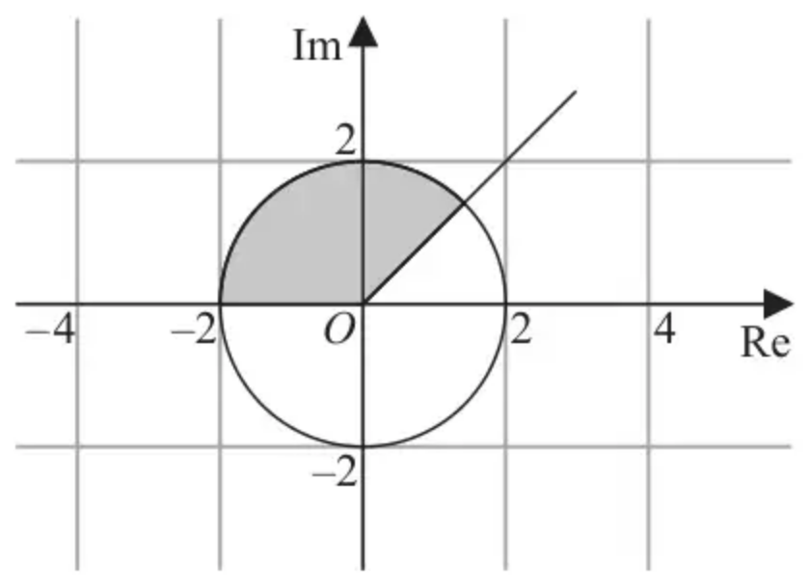
Figure 1
Figure 1 shows an Argand diagram.
The set of points, $A$, that lies within the shaded region, including its boundaries, is defined by
$$A=\{z:p⩽arg⁡(z)⩽q\}∩\{z:\text{∣}z\text{∣}⩽r\}$$
where $p$, $q$ and $r$ are positive constants.
(a) Write down the values of $p$, $q$ and $r$. (2)
Given that $w=−2\sqrt{3}+2\text{i}$ and $z∈A$,
(b) find the maximum value of $\text{∣}w−z{\text{∣}}^{2}$ giving your answer in an exact simplified form. (4)
(Total 6 marks)
Edexcel AS October 2020 Q5
2. A transformation $T$ from the $z$-plane to the $w$-plane is given by
$$w=\frac{z+2\text{i}}{\text{i}z} z\text{≠}0$$
The transformation maps points on the real axis in the $z$-plane onto a line in the $w$-plane.
Find an equation of this line. (4)
(Total 4 marks)
Edexcel FP2 June 2013 (R) Q1
3.
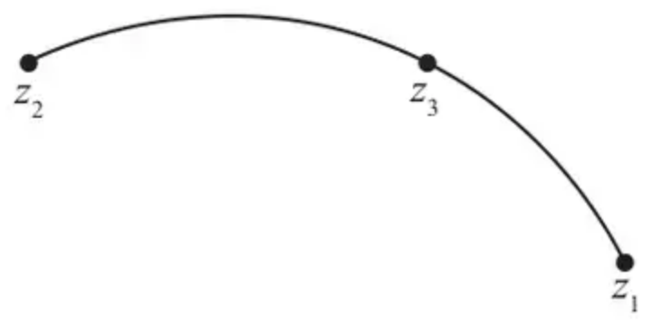
Figure 1
Figure 1 shows a locus in the complex plane.
The locus is an arc of a circle from the point represented by $z_{1}=3+2\text{i}$ to the point represented by $z_{2}=a+4\text{i}$, where $a$ is a constant, $a\text{≠}1$
Given that
• the point $z_{3}=1+4\text{i}$ also lies on the locus
• the centre of the circle has real part equal to $−1$
(a) determine the value of $a$. (2)
(b) Hence determine a complex equation for the locus, giving any angles in the equation as positive values. (3)
(Total 5 marks)
Edexcel A2 June 2023 Q9
4.
(i) A circle $C$ in the complex plane is defined by the locus of points satisfying
$$\text{∣}z−3\text{i∣}=2\text{∣}z\text{∣}$$
(a) Determine a Cartesian equation for $C$, giving your answer in simplest form. (3)
(b) On an Argand diagram, shade the region defined by
$$\{z∈\text{C}:\text{∣}z−3\text{i∣}>2\text{∣}z\text{∣}\}$$
(2)
(ii) The transformation $T$ from the $z$-plane to the $w$-plane is given by
$$w=z^{3}$$
(a) Describe the geometric effect of $T$. (2)
The region $R$ in the $z$-plane is given by
$$\{z∈\text{C}:0<arg⁡z<\frac{π}{4}\}$$
(b) On a different Argand diagram, sketch the image of $R$ under $T$. (2)
(Total 9 marks)
Edexcel A2 June 2024 Q5
Solutions
1.
Mark scheme (a)
Scheme | Marks | AO
$p=\frac{π}{4}$ and $q=π$ or $\frac{π}{4}⩽arg⁡z⩽π$ | B1 | 1.1b
$r=2$ or $\text{∣}z\text{∣}⩽2$ | B1 | 1.1b
 | (2)

Notes
B1: Correct values or correct loci
B1: Correct value or correct loci
Mark scheme (b)
Scheme | Marks | AO
Position for $z$ is at intersection in quadrant 1 | B1 | 3.1a
Angle between $y=x$ and “$OW$” is $\frac{π}{3}+\frac{π}{4}$ | B1 | 2.2a
$d^{2}=4^{2}+2^{2}−2×4×2cos⁡(\frac{π}{3}+\frac{π}{4})$ | M1 | 1.1b
$=20−4\sqrt{2}+4\sqrt{6}$ | A1 | 2.2a
 | (4)
 | (6 marks)

Notes
B1: Realises that the position for $z$ is at the intersection in quadrant 1 and makes progress in finding the distance
B1: Deduces from the information given that the angle between $y=x$ and “$OW$” is $π\text{/}4+π\text{/}3$
M1: Correct use of the cosine rule in order to find the required length²
A1: Deduces the required value in a simplified and exact form
Alternative for (b)
Scheme | Marks | AO
Position for $z$ is at intersection in quadrant 1 | B1 | 3.1a
$y=x$ intersects $x^{2}+y^{2}=4$ at $(\sqrt{2},\sqrt{2})$ | B1 | 2.2a
$d^{2}={(\text{“}\sqrt{2}\text{”}+2\sqrt{3})}^{2}+{(\text{“}\sqrt{2}\text{”}−2)}^{2}$ | M1 | 1.1b
$=20−4\sqrt{2}+4\sqrt{6}$ | A1 | 2.2a
 | (4)

B1: Realises that the position for $z$ is at the intersection in quadrant 1 and makes progress in finding the distance
B1: Deduces from the information given the correct coordinates for $z$
M1: Correct use of Pythagoras in order to find the required length²
A1: Deduces the required value in a simplified and exact form
2.
Scheme | Marks
$z=x w=\frac{x+2\text{i}}{\text{i}x}$ | M1A1
$w=\frac{1}{\text{i}}+\frac{2\text{i}}{\text{i}x}$
$u+\text{i}v=−\text{i}+\frac{2}{x}$
$(u=\frac{2}{x}) v=−1$ | M1
$∴w$ is on the line $v+1=0$ | A1
 | (4 marks)

Notes
M1 for replacing at least one $z$ with $x$ to obtain (ie show an appreciation that $y=0$)
A1 $w=\frac{x+2\text{i}}{\text{i}x}$
M1 for writing $w$ as $u+\text{i}v$ and equating real or imaginary parts to obtain either $u$ or $v$ in terms of $x$ or just a number
A1 for giving the equation of the line $v+1=0$ oe must be in terms of $v$
Q1 – Alternative 1
Scheme | Marks
$w=\frac{x+\text{i}y+2\text{i}}{\text{i}(x+\text{i}y)}$ Replacing $z$ with $x+\text{i}y$
$w=\frac{x+\text{i}y+2\text{i}}{−y+\text{i}x}×\frac{−y−\text{i}x}{−y−\text{i}x}$
$w=\frac{(x+\text{i}(y+2))(−y−\text{i}x)}{y^{2}+x^{2}}$
$w=\frac{2x−\text{i}(x^{2}+y^{2}+2y)}{y^{2}+x^{2}}$
$w=\frac{2x−\text{i}x^{2}}{x^{2}}=\frac{2}{x}−\text{i}$ Using $y=0$. This is where the first M1 may be awarded. A1 if correct even if expression is unsimplified but denominator must be real | M1A1
$v=−1$ M1, A1 as in main scheme | M1A1

Q1 – Alternative 2
Scheme | Marks
$z=\frac{2\text{i}}{\text{i}w−1}$ Writing the transformation as a function of $w$
$z=\frac{2\text{i}}{\text{i}(u+\text{i}v)−1}$
$z=\frac{2\text{i}}{(−v−1)+\text{i}u}×\frac{(−v−1)−\text{i}u}{(−v−1)−\text{i}u}$
$z=\frac{2u+2\text{i}(−v−1)}{(−v−1)^{2}+u^{2}}=\frac{2u}{(−v−1)^{2}+u^{2}}+\text{i}(\frac{2(−v−1)}{(−v−1)^{2}+u^{2}})$
$(\frac{2(−v−1)}{(v−1)^{2}+u^{2}})=0$ or simply $−2(v+1)=0$ Using $y=0$. This is where the first M1 may be awarded. A1 if correct even if expression is unsimplified but denominator must be real | M1A1
$v=−1$ M1, A1 as in main mark scheme above | M1A1

3.
Mark scheme (a)
Scheme | Marks | AO
Centre lies on perpendicular bisector of $z_{2}$ and $z_{3}$, which is vertical as same imaginary components. Hence $\frac{a+1}{2}=−1⇒a=…$  Or  $(a−(−1))^{2}+(4−b)^{2}=(1−(−1))^{2}+(4−b)^{2}⇒a=…$  $(a−(−1))^{2}=(1−(−1))^{2}⇒a=…$  Or  $−1−a=1−(−1)⇒a=…$ | M1 | 1.1b
$a=−3$ | A1 | 2.2a
 | (2)

Notes
M: Forms a correct strategy to find the value of $a$, see scheme for various approaches
A1: Correct value
Alternative
Scheme | Marks | AO
$(x−(−1))^{2}+(y−b)^{2}=r^{2}$  $\begin{matrix} & (1+1)^{2}+(4−b)^{2}=r^{2} \\ & (3+1)^{2}+(2−b)^{2}=r^{2}\end{matrix}\}⇒4+(4−b)^{2}=16+(2−b)^{2}⇒b=…\{0\}$  $r^{2}=4+(4−\text{“}0\text{”})^{2}=…\{20\}$  $(a+1)^{2}+(4−\text{“}0\text{”})^{2}=\text{“}20\text{”}⇒a=…$ | M1 | 1.1b
$a=−3$ only the other root must be rejected | A1 | 2.2a
 | (2)

Mark scheme (b)
Scheme | Marks | AO
Equation has form $arg⁡(\frac{z−z_{1}}{z−z_{2}})=θ$ | B1 | 1.2
$$arg⁡(\frac{1+4\text{i}−(3+2\text{i})}{1+4\text{i}−(\text{“}−3\text{”}+4\text{i})})=arg⁡(−2+2\text{i})−arg⁡(4)=…(=\frac{3π}{4})$$  Or  $$arg⁡(\frac{1+4\text{i}−3−2\text{i}}{1+4\text{i}−a−4\text{i}})=arg⁡(\frac{−2+2\text{i}}{4})=arg⁡(−\frac{1}{2}+\frac{1}{2}\text{i})=\frac{3π}{4}$$  or  $$\vec{z_{3}z_{2}}=(\begin{matrix}−4 \\ 0\end{matrix})\text{and}\vec{z_{3}z_{1}}=(\begin{matrix}2 \\ −2\end{matrix})$$  $$cos⁡θ=\frac{(\begin{matrix}−4 \\ 0\end{matrix})∙(\begin{matrix}2 \\ −2\end{matrix})}{4\sqrt{2^{2}+(−2)^{2}}}⇒θ=…$$  Or  $$cos⁡θ=\frac{4^{2}+8−40}{2×4×\sqrt{8}}⇒θ=…$$  or  Using trigonometry  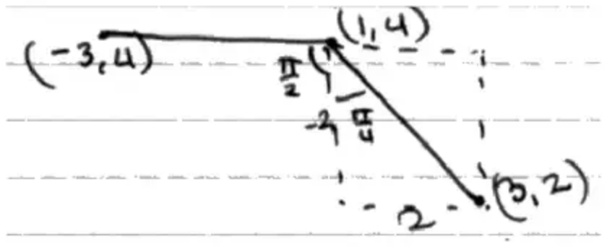 | M1 | 3.1a
Equation is $arg⁡(\frac{z−3−2\text{i}}{z+3−4\text{i}})=\frac{3π}{4}$ o.e.e.  Equation is $arg⁡(z−3−2\text{i})−arg⁡(z+3−4\text{i})=\frac{3π}{4}$ o.e.e. | A1 | 2.1
 | (3)
 | (5 marks)

Notes
B1: Recalls the correct form for the equation of an arc, with any angle or $θ$. Look for the correct form, so allow if $z_{1}$ and $z_{2}$ are the other way round.
M1: Any correct full method to find the value of $θ$, see scheme for various approaches
A1: Correct equation.
Correct answer implies full marks
4.
Mark scheme (i)(a)
Scheme | Marks | AO
$\text{∣}x+(y−3)\text{i∣}=2\text{∣}x+y\text{i∣}⇒x^{2}+(y−3)^{2}=4(x^{2}+y^{2})$ | M1 | 3.1a
$⇒x^{2}+y^{2}−6y+9=4x^{2}+4y^{2}⇒x^{2}+y^{2}+2y−3=0$ in any order | M1  A1 | 1.1b  1.1b
 | (3)

Notes
M1: Substitutes $z=x+y\text{i}$ into the equation and applies the modulus to obtain an equation with no i's. Must have dealt with the i${}^{2}$ correctly. Condone not squaring the 2.
M1: Expands and gathers terms. Must have an $x^{2}$ and $y^{2}$ after simplifying so that it is an equation of a circle.
A1: Cancels common factor 3 to obtain the equation shown. ISW if they make errors trying to complete the square.
Note: Any letters may be used not just $x$ and $y$
Alt (a)
Scheme | Marks | AO
Points are twice as far from 3i as from 0 so i and −3i are diametrically opposite points. | M1 | 3.1a
So radius is $\frac{\text{∣i}−(−3\text{i})\text{∣}}{2}=2$ and centre is $\frac{\text{i}−3\text{i}}{2}=−\text{i}$ | M1 | 1.1b
Hence equation is $x^{2}+(y+1)^{2}=4$ | A1 | 1.1b
 | (3)

M1: Identifies two diametrically opposite points on the circle by understanding the geometry of the situation.
M1: Finds the radius and centre of the circle from their points, dotted or solid line
A1: Correct equation need not expand, but should be in simplest form.
Mark scheme (i)(b)
Scheme | Marks | AO
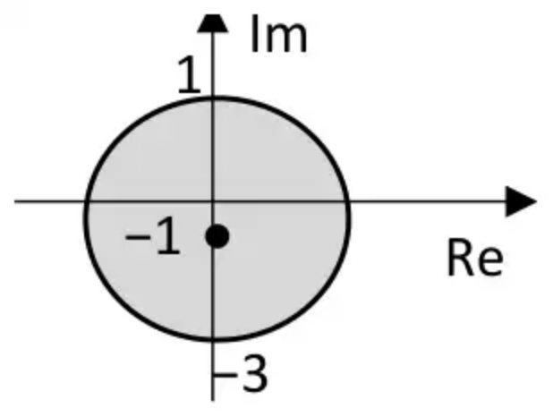
Circle drawn with the inside shaded | M1 | 2.2a
Correct circle drawn for their equation. Implied by the position of the centre and radius. Inside shaded. | A1ft | 3.1a
 | (2)

Notes
M1: Circle drawn anywhere and the inside shaded
A1ft: Correct circle drawn for their equation. Implied by the position of the centre and radius. Inside shaded.
Mark scheme (ii)(a)
Scheme | Marks | AO
A point $z$ is mapped to a point with 3 times the argument…  Rotate every point by 2 times the argument | B1 | 2.4
… and with modulus as the modulus of the cube of $z$. | B1 | 2.5
 | (2)

Notes
B1: Identifies that the argument triples in size.
B1: Identifies that the modulus scales according to the modulus of $z$ cubed.
Mark scheme (ii)(b)
Scheme | Marks | AO
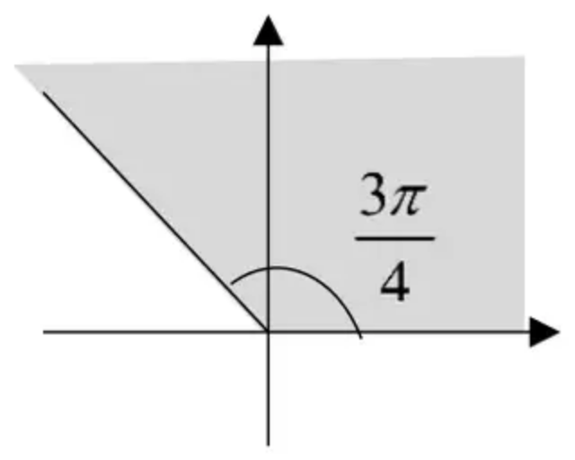
Sector from $O$ along the real axis, indicated by some shading, in an anticlockwise direction | M1 | 1.1b
Correct sector, angle must be stated or implied by the diagram | A1 | 2.2a
 | (2)
 | (9 marks)

Notes
M1: A sector centre $O$ and starting along the real axis and in an anticlockwise direction. Must be some shading to represent the region, dotted or solid line
A1: Correct sector shaded and the angle stated or implied

