QQQ – Further Pure 2 – Chapter 3 – Complex Numbers (Version 1)
Total Marks: 22
(22 = Platinum, 20 = Gold, 18 = Silver, 15 = Bronze)
1. Sketch on an Argand diagram the region defined by
$$\{z∈\text{C}:−\frac{π}{4}<arg⁡(z+2)<\frac{π}{4}\}∩\{z∈\text{C}:−1<\text{Re}(z)⩽1\}$$
On your sketch
• shade the part of the diagram that is included in the region
• use solid lines to show the parts of the boundary that are included in the region
• use dashed lines to show the parts of the boundary that are not included in the region
(4)
(Total 4 marks)
Edexcel AS June 2022 Q1
2. A complex number $z=x+\text{i}y$ is represented by the point $P$ in an Argand diagram.
Given that
$$\text{∣}z−3\text{∣}=4\text{∣}z+1\text{∣}$$
(a) show that the locus of $P$ has equation
$$15x^{2}+15y^{2}+38x+7=0$$
(2)
(b) Hence find the maximum value of $\text{∣}z\text{∣}$ (3)
(Total 5 marks)
Edexcel A2 June 2019 Q1
3. A complex number $z$ is represented by the point $P$ on an Argand diagram.
Given that
$$arg⁡(\frac{z−4−\text{i}}{z−2−7\text{i}})=\frac{π}{2}$$
(a) sketch the locus of $P$ as $z$ varies, (2)
(b) determine the exact maximum possible value of $\text{∣}z\text{∣}$ (5)
(Total 7 marks)
Edexcel AS June 2023 Q3
4. A transformation from the $z$-plane to the $w$-plane is given by
$$w=\frac{3\text{i}z−2}{z+\text{i}} z\text{≠}−\text{i}$$
(a) Show that the circle $C$ with equation $\text{∣}z+\text{i∣}=1$ in the $z$-plane is mapped to a circle $D$ in the $w$-plane, giving a Cartesian equation for $D$. (4)
(b) Sketch $C$ and $D$ on Argand diagrams. (2)
(Total 6 marks)
Edexcel A2 June 2019 Q7
Solutions
1.
Scheme | Marks | AO
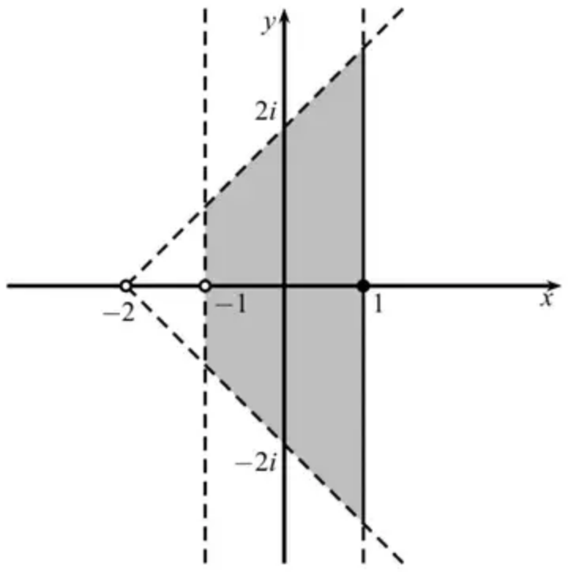  Sector from ±2 or ±2i | M1 | 1.1b
Strip about either axis | M1 | 1.1b
Correct strip and sector | A1 | 3.1a
Fully correct | A1 | 2.5
 | (4)
 | (4 marks)

Notes
M1: Draws or identifies a sector, or relevant part thereof, spanning from either ±2 or ±2i.
M1: Either a vertical or horizontal strip drawn or identified, with lines either imaginary or real axis.
A1: Correct sector and strip – so starting sector from −2 on negative real axis, with vertical strip about imaginary axis approximately halfway on real axis between start of sector and $O$. Sector at $±45^{∘}$ (do not worry about the boundary lines for this mark). The strip must be roughly even spaced either side of the imaginary axis, and the sector roughly symmetric in the real axis (allow small tolerance, but A0 if clearly not symmetric)
A1: Inside strip and sector shaded, with correct boundary lines.
2.
Mark scheme (a)
Scheme | Marks | AO
$(x−3)^{2}+y^{2}=16((x+1)^{2}+y^{2})$ | M1 | 1.1b
$x^{2}−6x+9+y^{2}=16x^{2}+32x+16+16y^{2}$  $15x^{2}+15y^{2}+38x+7=0$ * | A1* | 2.1
 | (2)

Notes
M1: Obtains an equation in terms of $x$ and $y$ using the given information. Allow if the 4 is not squared, but i² must have been dealt with correctly (ie positive $y^{2}$ terms). Condone invisible brackets for the M mark.
A1*: Expands and simplifies and obtains a circle equation correctly. Accept terms in different order but must include =0. No errors seen, so bracketing errors in solution are A0.
Mark scheme (b)
Scheme | Marks | AO
$15x^{2}+15y^{2}+38x+7=15{(x±\frac{19}{15})}^{2}−…+15y^{2}+7=0$ | M1 | 2.1
Centre is $(−\frac{\text{“}19\text{”}}{15},0)$ and radius is $\sqrt{{(\frac{\text{“}19\text{”}}{15})}^{2}−\frac{7}{15}}(=\frac{16}{15})$ | M1 | 2.2a
$max⁡\text{∣}z\text{∣}=\frac{16}{15}+\frac{19}{15}=\frac{7}{3}$ | A1 | 3.1a
 | (3)
 | (5 marks)

Notes
M1: Completes the square on the $x$ term achieving $A{(x±\frac{19}{15})}^{2}−B$, or uses other appropriate method in order to attempt the radius and/or centre of the circle. Award if correct $x$ coordinate of centre or radius is found.
M1: Deduces both centre and radius for their completed square form, either seen used in work clearly as centre and radius, stated or labelled on a diagram, not just embedded within the equation. This is implied by the correct calculation being carried out for their centre and radius.
A1cso: Realises the need to add distance of centre from origin to radius to achieve the correct answer. Must come from correct work.
Note that completing the square as ${(x−\frac{19}{15})}^{2}−…$ can score a maximum M1M1A0
(corrected from the printed mark scheme: the centre is printed as $(−\frac{\text{“}19\text{”}}{5},0)$)
3.
Mark scheme (a)
Scheme | Marks | AO
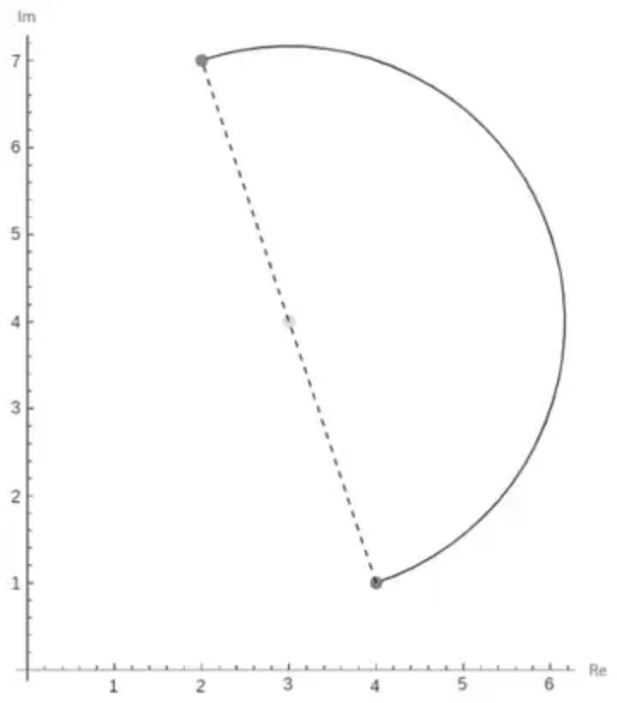  Draws part of a circle with end points (4, 1) and (2, 7), | M1 | 1.1b
A semi-circle with end points (4, 1) and (2, 7) to the right | A1 | 1.1b
 | (2)

Notes
M1: See scheme
A1: See scheme
Mark scheme (b)
Scheme | Marks | AO
Centre (3, 4) | B1 | 2.2a
Finds the radius using Pythagoras $r=\sqrt{(4−\text{“}3\text{”})^{2}+(1−\text{“}4\text{”})^{2}}$ or  $r=\sqrt{(2−\text{“}3\text{”})^{2}+(7−\text{“}4\text{”})^{2}}$ or $r=\frac{1}{2}\sqrt{(4−2)^{2}+(1−7)^{2}}$ | M1 | 1.1b
Finds the distance from the origin to their centre using Pythagoras  $d=\sqrt{(\text{“}3\text{”}−0)^{2}+(\text{“}4\text{”}−0)^{2}}$ | M1 | 1.1b
Adds this distance to their radius | dM1 | 3.1a
$\text{∣}z\text{∣}=5+\sqrt{10}$ | A1 | 1.1b
 | (5)
 | (7 marks)

Notes
B1: Deduces the correct centre coordinates.
M1: Uses Pythagoras and their centre coordinates to find the radius
$r=\sqrt{(4−\text{“their centre}x\text{”})^{2}+(1−\text{“their centre}y\text{”})^{2}}$ or
$r=\sqrt{(2−\text{“their centre}x\text{”})^{2}+(7−\text{“their centre}y\text{”})^{2}}$ or
half of the diameter $r=\frac{1}{2}\sqrt{(4−2)^{2}+(1−7)^{2}}$
M1: Finds the distance from their centre to the origin
dM1: Dependent on previous method mark. A complete method to find the maximum value of $\text{∣}z\text{∣}$ Adds the distance to the centre to their radius
A1: $\text{∣}z\text{∣}=5+\sqrt{10}$
4.
Mark scheme (a)
Scheme | Marks | AO
$w=\frac{3\text{i}z−2}{z+\text{i}}⇒z=\frac{2+w\text{i}}{3\text{i}−w}$ | M1 | 2.1
$\text{∣}z+\text{i∣}=1⇒∣\frac{2+w\text{i}}{3\text{i}−w}+\text{i}∣=1$ | M1 | 2.1
$∣\frac{2+w\text{i}−3−\text{i}w}{3\text{i}−w}∣=1⇒∣\frac{1}{w−3\text{i}}∣=1$ | A1 | 1.1b
$\text{∣}w−3\text{i∣}=1⇒u^{2}+(v−3)^{2}=1$ | A1 | 2.2a
 | (4)

Notes
M1: Attempts to solve the problem by attempting to make $z$ the subject of the formula
M1: Uses the given locus to obtain an equation in $w$
A1: Obtains a correct simplified equation in terms of $w$
A1: Deduces the correct form of the equation (allow $x$, $y$ or $u$, $v$ etc.)
Alt 1 (a)
Scheme | Marks | AO
$w=\frac{3\text{i}z−2}{z+\text{i}}⇒w(z+\text{i})=3\text{i}(z+\text{i})+3−2$  Attempts to isolate $z+\text{i}$ terms | M1 | 2.1
$(z+\text{i})(w−3\text{i})=1⇒\text{∣}(z+\text{i})(w−3\text{i})\text{∣}=1⇒\text{∣}(w−3\text{i})\text{∣}=1$  Gathers $z+\text{i}$ terms and applies $\text{∣}(z+\text{i})\text{∣}=1$ | M1 | 2.1
As main scheme | A1 | 1.1b
As main scheme | A1 | 2.2a

Alt 2 (a)
Scheme | Marks | AO
$w=\frac{3\text{i}z−2}{z+\text{i}}⇒z=\frac{2+w\text{i}}{3\text{i}−w}$ as main scheme | M1 | 2.1
$x+y\text{i}=\frac{2−v+u\text{i}}{−u−(v−3)\text{i}}×\frac{−u+(v−3)\text{i}}{−u+(v−3)\text{i}}=…=\frac{u−(u^{2}+v^{2}−5v+6)\text{i}}{u^{2}+(v−3)^{2}}$  $⇒{(\frac{u}{u^{2}+(v−3)^{2}})}^{2}+{(\frac{−(u^{2}+v^{2}−5v+6)}{u^{2}+(v−3)^{2}}+1)}^{2}=1$  Applies Cartesian coordinates to both sides, extracts $x$ and $y$ terms and attempts to apply $x^{2}+(y+1)^{2}=1$ | M1 | 2.1
${(\frac{u}{u^{2}+(v−3)^{2}})}^{2}+{(\frac{3−v}{u^{2}+(v−3)^{2}})}^{2}=1$  Correct expression with $y+1$ term combined and simplified. | A1 | 1.1b
$⇒u^{2}+(v−3)^{2}=1$ | A1 | 2.2a

Alt 3 (a)
Scheme | Marks | AO
$u+\text{i}v=\frac{3\text{i}(x+\text{i}y)−2}{x+\text{i}y+\text{i}}×\frac{x−(y+1)\text{i}}{x−(y+1)\text{i}}=\frac{\text{f}(x,y)+\text{g}(x,y)\text{i}}{x^{2}+(y+1)^{2}}$  Applies Cartesian coordinates to expression and use complex conjugate of denominator to reach Cartesian form. | M1 | 2.1
$x^{2}+(y+1)^{2}=1⇒u+\text{i}v=x+(3x^{2}+3y^{2}+5y+2)\text{i}$  $⇒u=x$ and $v=3x^{2}+3(y+1)^{2}−y−1=a+by$  Uses $x^{2}+(y+1)^{2}=1$ in their equation and extract $u$ and $v$ as linear terms in $x$ and $y$ | M1 | 2.1
$u=x$ and $v=2−y$  Correct $u$ and $v$ | A1 | 1.1b
$⇒u^{2}+(2−v+1)^{2}=1⇒u^{2}+(v−3)^{2}=1$  Uses $x^{2}+(y+1)^{2}=1$ again to find correct equation. | A1 | 2.2a

Note that there may be attempts via identifying images of points on a diameter. If seen, send to review.
Mark scheme (b)
Scheme | Marks | AO
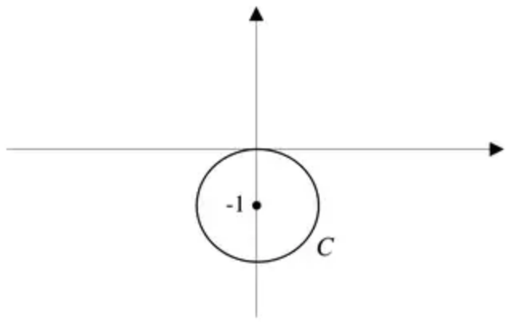 | B1 | 1.1b
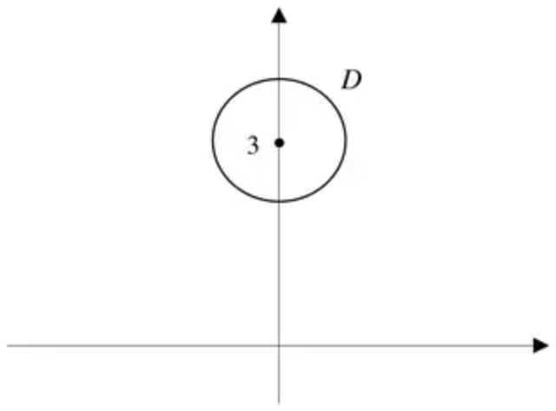 | B1ft | 1.1b
 | (2)
 | (6 marks)

Notes
B1: The circle $C$ correctly positioned, passing through the origin coordinates of centre labelled. Accept as coordinates or marked on axes.
B1ft: Their $D$ correctly positioned with the centre correctly labelled (accept as coordinates or marked on axes).
Accept both drawn on the same diagram.
Allow S.C. B1B0 for two circles in correct respective positions but with no labelling.

