QQQ – Further Pure 1 – Chapter 8 – Numerical Methods (Version 1)
Total Marks: 25
(25 = Platinum, 23 = Gold, 20 = Silver, 17 = Bronze)
1.
$$\frac{\text{d}y}{\text{d}x}=y{\text{e}}^{x^{2}}\text{.}$$
It is given that $y=0.2$ at $x=0$.
(a) Use the approximation $\frac{y_{1}−y_{0}}{h}≈{(\frac{\text{d}y}{\text{d}x})}_{0}$, with $h=0.1$, to obtain an estimate of the value of $y$ at $x=0.1$. (2)
(b) Use your answer to part (a) and the approximation $\frac{y_{2}−y_{0}}{2h}≈{(\frac{\text{d}y}{\text{d}x})}_{1}$, with $h=0.1$, to obtain an estimate of the value of $y$ at $x=0.2$.
Gives your answer to 4 decimal places. (3)
(Total 5 marks)
Edexcel FP2 June 2007 Q9
2.
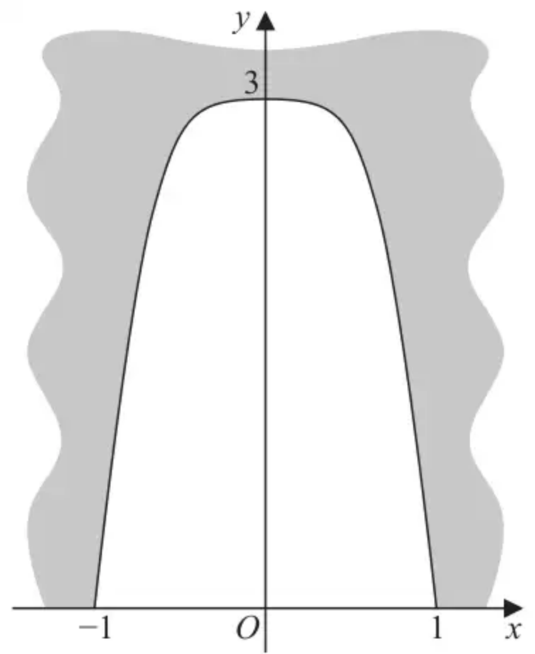
Figure 1
Figure 1 shows a sketch of the vertical cross-section of the entrance to a tunnel. The width at the base of the tunnel entrance is 2 metres and its maximum height is 3 metres.
The shape of the cross-section can be modelled by the curve with equation $y=\text{f}(x)$ where
$$\text{f}(x)=3cos⁡(\frac{π}{2}x^{2}) x∈[−1,1]$$
A wooden door of uniform thickness 85 mm is to be made to seal the tunnel entrance.
Use Simpson’s rule with 6 intervals to estimate the volume of wood required for this door, giving your answer in m³ to 4 significant figures.
(6)
(Total 6 marks)
Edexcel A2 October 2020 Q2
3. A population of deer was introduced onto an island.
The number of deer, $P$, on the island at time $t$ years following their introduction is modelled by the differential equation
$$\frac{\text{d}P}{\text{d}t}=\frac{P}{5000}(1000−\frac{P(t+1)}{6t+5}) t>0$$
It was estimated that there were 540 deer on the island six months after they were introduced.
Use two applications of the approximation formula ${(\frac{\text{d}y}{\text{d}x})}_{n}≈\frac{y_{n+1}−y_{n}}{h}$ to estimate the number of deer on the island 10 months after they were introduced.
(7)
(Total 7 marks)
Edexcel AS June 2022 Q2
4. The variables $x$ and $y$ satisfy the differential equation
$$\frac{{\text{d}}^{2}y}{\text{d}x^{2}}=2y^{2}−x−1$$
where $\frac{\text{d}y}{\text{d}x}=3$ and $y=0$ at $x=0$
Use the approximations
$${(\frac{{\text{d}}^{2}y}{\text{d}x^{2}})}_{n}≈\frac{(y_{n+1}−2y_{n}+y_{n−1})}{h^{2}} \text{and} {(\frac{\text{d}y}{\text{d}x})}_{n}≈\frac{(y_{n+1}−y_{n−1})}{2h}$$
with $h=0.1$ to find an estimate for the value of $y$ at $x=0.2$
(7)
(Total 7 marks)
Edexcel AS October 2020 Q1
Solutions
1.
Mark scheme (a)
Scheme | Marks
$\frac{y_{1}−0.2}{0.1}≈{(\frac{\text{d}y}{\text{d}x})}_{0}=0.2×{\text{e}}^{0}(=0.2)$ | M1
$y_{1}≈0.22$ | A1
 | (2)

Mark scheme (b)
Scheme | Marks
${(\frac{\text{d}y}{\text{d}x})}_{1}≈0.22×{\text{e}}^{0.01}≈0.2222…$ | B1
$\frac{y_{2}−0.2}{0.2}≈0.2222…$ | M1
$y_{2}≈0.2444$ cao | A1
 | (3)
 | (5 marks)

2.
Scheme | Marks | AO
Step $\frac{1}{3}$ | B1 | 1.1b
 | M1 | 3.4
   | $y_{0}$ | $y_{1}$ | $y_{2}$ | $y_{3}$ | $y_{4}$ | $y_{5}$ | $y_{6}$
  $x$ | $−1$ | $−\frac{2}{3}$ | $−\frac{1}{3}$ | $0$ | $\frac{1}{3}$ | $\frac{2}{3}$ | $1$
  $y$ | 0 | 2.2981 | 2.9544 | 3 | 2.9544 | 2.2981 | 0
$y_{0}+4y_{1}+2y_{2}+4y_{3}+2y_{4}+4y_{5}+y_{6}$ $=\text{“}42.203\text{”}$  $\{0+4(2.2981+3+2.2981)+2(2.9544+2.9544)+0\}$ | M1 | 1.1b
$=42.203(=24cos⁡(\frac{2π}{9})+12cos⁡(\frac{π}{18})+12)$ | A1 | 1.1b
So volume required is approx. $\frac{85}{1000}×\frac{\frac{1}{3}}{3}×\text{“}42.203\text{”}$ | M1 | 3.1a
$=$ awrt $0.3986{\text{m}}^{3}$ | A1 | 3.2a
 | (6)
 | (6 marks)

Notes
B1: Correct strip width for the method chosen $\frac{1}{3}$ for the interval $[−1,1]$
M1: Uses the model to find the appropriate values for the method. May use that the function is even to only work out half of them, so may be implied by use in the formula. At least two correct values to 4 s.f. needed for the method.
M1: Applies the “bracket” of Simpson’s rule, “$y_{0}+4y_{1}+2y_{2}+4y_{3}+2y_{4}+4y_{5}+y_{6}$”. Coefficients must be correct.
A1: Correct value for the “bracket”. If not explicitly seen, may be implied by awrt 4.689 as a value for the cross section area following correct values.
M1: Correct full method to find the volume. E.g. multiplies their bracket by their $\frac{h}{3}$ and by 0.085.
Accept an attempt in any consistent units, so e.g. in mm³ ie $85×\frac{\frac{1}{3}}{3}×\text{“}42.203\text{”}×1000^{2}$
A1: Correct answer in m³.
Alternative interval [0,1]
Scheme | Marks | AO
step $\frac{1}{6}$ and the answer is doubled later | B1 | 1.1b
 | M1 | 3.4
   | $y_{0}$ | $y_{1}$ | $y_{2}$ | $y_{3}$ | $y_{4}$ | $y_{5}$ | $y_{6}$
  $x$ | $0$ | $\frac{1}{6}$ | $\frac{1}{3}$ | $\frac{1}{2}$ | $\frac{2}{3}$ | $\frac{5}{6}$ | $1$
  $y$ | 3 | 2.9971 | 2.9544 | 2.7716 | 2.2981 | 1.3852 | 0
$y_{0}+4y_{1}+2y_{2}+4y_{3}+2y_{4}+4y_{5}+y_{6}$ $=\text{“}42.1206\text{”}$  $\{3+4(2.9971+2.7716+1.3852)+2(2.9544+2.2981)+0\}$ | M1 | 1.1b
Awrt 42.121 | A1 | 1.1b
So volume required is approx. $\frac{85}{1000}×\frac{\frac{1}{6}}{3}×\text{“}42.1206\text{”}×2$ | M1 | 3.1a
$=$ awrt $0.3978{\text{m}}^{3}$ | A1 | 3.2a
 | (6)

B1: Correct strip width for the method chosen $\frac{1}{6}$ for the interval $[0,1]$ and later doubled.
M1: Uses the model to find the appropriate values for the method. May use that the function is even to only work out half of them, so may be implied by use in the formula. At least two correct values to 4 s.f. needed for the method.
M1: Applies the “bracket” of Simpson’s rule, “$y_{0}+4y_{1}+2y_{2}+4y_{3}+2y_{4}+4y_{5}+y_{6}$”. Coefficients must be correct.
A1: Correct value for the “bracket”. If not explicitly seen, may be implied by awrt 4.680 as a value for the cross section area following correct values.
M1: Correct full method to find the volume. E.g. multiplies their bracket by their $\frac{h}{3}$ and by 0.085.
Accept an attempt in any consistent units, so e.g. in mm³ ie $85×\frac{\frac{1}{6}}{3}×\text{“}42.1206\text{”}×1000^{2}×2$ (corrected from the printed mark scheme, which has “42.203” here)
A1: Correct answer in m³.
Using 6 ordinates
Max score B0 M1 M0 A0 M0 A0
 | $y_{0}$ | $y_{1}$ | $y_{2}$ | $y_{3}$ | $y_{4}$ | $y_{5}$
$x$ | -1 | -0.6 | -0.2 | 0.2 | 0.6 | 1
$y$ | 0 | 2.53298 | 2.9941 | 2.9941 | 2.53298 | 0

B0: Incorrect strip width
M1: Uses the model to find the appropriate values for the method. At least two correct values to 4 s.f. needed for the method.
3.
Scheme | Marks | AO
$t_{0}=\frac{1}{2}$ and steps are 2 months, so $h=\frac{1}{6} (t_{1}=\frac{2}{3},t_{2}=\frac{5}{6})$ | B1 | 3.3
${(\frac{\text{d}P}{\text{d}t})}_{0}=\frac{540}{5000}(1000−\frac{540×(\frac{1}{2}+1)}{6×\frac{1}{2}+5})=…(97.065=\frac{19413}{200})$ | M1 | 3.4
So when $t=\frac{2}{3}$, $P_{1}=540+\frac{\text{’}1\text{’}}{6}×\text{’}97.065\text{’}=…$  Or starts with $\text{’}97.065\text{’}=\frac{y_{1}−540}{\frac{1}{6}}$ and rearranges to find $P_{1}=…$ | M1 | 1.1b
$=\frac{222471}{400}=556.1775$ | A1 | 1.1b
${(\frac{\text{d}P}{\text{d}t})}_{1}=\frac{\text{’}556.1775\text{’}}{5000}(1000−\frac{\text{’}556.1775\text{’}×(\frac{2}{3}+1)}{6×\frac{2}{3}+5})=…(99.778…)$ | M1 | 3.4
So when $t=\frac{5}{6}$, $P_{2}=\text{’}556.1775\text{’}+\frac{1}{6}×\text{’}99.778…\text{’}=…(572.807…)$ | M1 | 1.1b
So there are estimated to be 572 or 573 deer after 10 months. | A1 | 3.2a
 | (7)
 | (7 marks)

Notes
B1: Uses the given information to set up correct parameters for the model, $t_{0}=\frac{1}{2}$, $(t_{1}=\frac{2}{3},t_{2}=\frac{5}{6})$ and $h=\frac{1}{6}$ seen or implied.
M1: Uses $P_{0}=540$ and their value for $t_{0}$ in the given equation to find a value for ${(\frac{\text{d}P}{\text{d}t})}_{0}$
M1: Applies the approximation formula with 540, their $h$ and their ${(\frac{\text{d}P}{\text{d}t})}_{0}$ to find a value for $P_{1}$
A1: Correct approximation $P$ at $t=\frac{2}{3}$. Accept awrt 556.2
M1: Uses $t_{1}=t_{0}+h$ and their $P_{1}$ in the given equation to find a value for ${(\frac{\text{d}P}{\text{d}t})}_{1}$.
M1: Uses the approximation a second time with their $h$, their $P_{1}$ and their ${(\frac{\text{d}P}{\text{d}t})}_{1}$. to find a value for $P_{2}$
A1: Correct answer. Accept either 572 or 573.
Useful table of values for reference
$n$ | $P_{n}$ | $t$ | $\frac{\text{d}P}{\text{d}t}$ | $h\frac{\text{d}P}{\text{d}t}$
0 | 540 | $\frac{1}{2}$ | 97.065 | 16.1775
1 | 556.1775 | $\frac{2}{3}$ | 99.77870698 | 16.6297845
2 | 572.807 | $\frac{5}{6}$

Note use of $t_{0}=6$ and $h=2$ leads to ${(\frac{\text{d}P}{\text{d}t})}_{0}=\frac{100494}{1025}=98.04… P_{1}=736.08… {(\frac{\text{d}P}{\text{d}t})}_{1}=128.8…$
$P_{2}=993.7…$ which scores a maximum of B0 M1 M1 A0 M1 M1 A0
4.
Scheme | Marks | AO
$\frac{{\text{d}}^{2}y}{\text{d}x^{2}}=2y^{2}−x−1⇒{(\frac{{\text{d}}^{2}y}{\text{d}x^{2}})}_{0}=0−0−1=−1$ | B1 | 1.1b
${(\frac{\text{d}y}{\text{d}x})}_{0}=3⇒\frac{(y_{1}−y_{−1})}{0.2}≈3$ | B1 | 1.1b
${(\frac{{\text{d}}^{2}y}{\text{d}x^{2}})}_{0}≈\frac{(y_{1}−2y_{0}+y_{−1})}{h^{2}}⇒\frac{y_{1}−2(0)+y_{−1}}{0.01}≈−1$ | M1 | 1.1b
$y_{1}≈\frac{1}{2}(0.6−0.01)=0.295$ | dM1 | 2.1
$\frac{{\text{d}}^{2}y}{\text{d}x^{2}}=2y^{2}−x−1⇒{(\frac{{\text{d}}^{2}y}{\text{d}x^{2}})}_{1}=2(0.295)^{2}−0.1−1=−0.92595$ | dM1 | 1.1b
${(\frac{{\text{d}}^{2}y}{\text{d}x^{2}})}_{1}≈\frac{(y_{2}−2y_{1}+y_{0})}{h^{2}}⇒\frac{y_{2}−2(0.295)+0}{0.01}≈−0.92595⇒y_{2}=…$ | dM1 | 2.1
$y_{2}≈2(0.295)−0.92595×0.01=0.581(3\text{s.f.})$ | A1 | 1.1b
 | (7)
 | (7 marks)

Notes
B1: Correct value for the second derivative using the differential equation
B1: Correct equation in terms of $y_{1}$ and $y_{−1}$ using the first order approximation
M1: Uses the second order approximation to obtain another equation in terms of $y_{1}$ and $y_{−1}$
M1: Uses their two equations in $y_{1}$ and $y_{−1}$ and solves together to find $y$ at $x=0.1$.
M1: Uses the differential equation with their $y$ at $x=0.1$ and $x=0.1$ to find a value for the second derivative at $x=0.1$
M1: Completes the process by using the second order approximation and their second derivative to obtain a value for $y_{2}$
A1: Correct value for $y$ at $x=0.2$
Note that all method marks are dependent

