QQQ – Further Pure 1 – Chapter 4 – Inequalities (Version 2)
Total Marks: 24
(24 = Platinum, 22 = Gold, 19 = Silver, 16 = Bronze)
1. Use algebra to determine the values of $x$ for which
$$∣x^{2}−2x∣⩽x$$
(4)
(Total 4 marks)
Edexcel A2 June 2024 Q2
2. A student was set the following problem.
Use algebra to find the set of values of $x$ for which
$\frac{x}{x−24}>\frac{1}{x+11}$

The student’s attempt at a solution is written below.
$x(x−24)(x+11)^{2}>(x+11)(x−24)^{2}$
$x(x−24)(x+11)^{2}−(x+11)(x−24)^{2}>0$
$(x−24)(x+11)[x(x+11)−x−24]>0$ | Line 3
$(x−24)(x+11)[x^{2}+10x−24]>0$
$(x−24)(x+11)(x+12)(x−2)>0$
$x=24,x=−11,x=−12,x=2$
$\{x∈\text{R}:−12<x<−11\}∪\{x∈\text{R}:2<x<24\}$ | Line 7

There are errors in the student’s solution.
(a) Identify the error made
(i) in line 3
(ii) in line 7 (2)
(b) Find a correct solution to this problem. (4)
(Total 6 marks)
Edexcel AS June 2019 Q2
3.
In this question you must show all stages of your working.
Solutions relying entirely on calculator technology are not acceptable.
Use algebra to determine the values of $x$ for which
$$\frac{x^{2}−4}{\text{∣}x−5\text{∣}}>4x+8$$
(6)
(Total 6 marks)
Edexcel A2 June 2025 Q3
4.
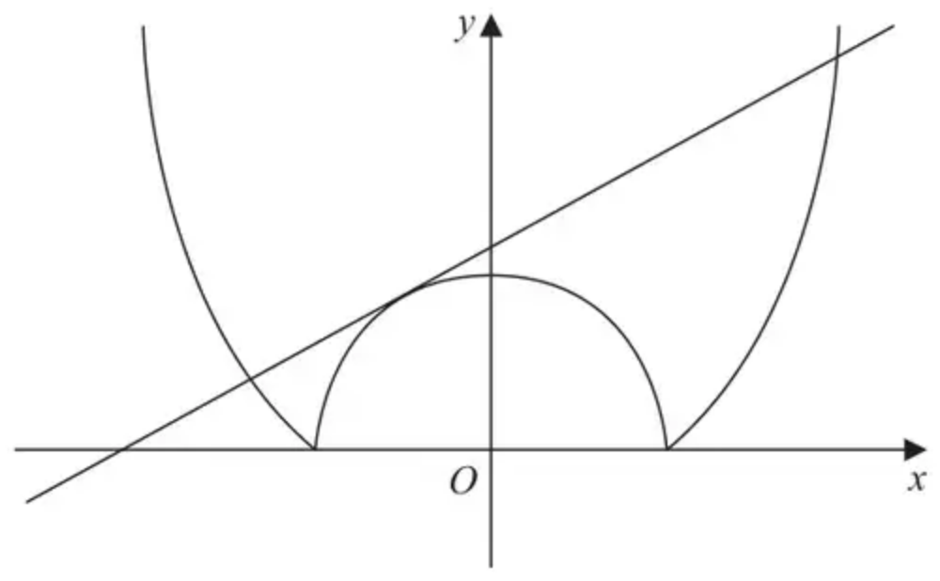
Figure 1
Figure 1 shows a sketch of the curve with equation $y=∣x^{2}−8∣$ and a sketch of the straight line with equation $y=mx+c$, where $m$ and $c$ are positive constants.
The equation
$$∣x^{2}−8∣=mx+c$$
has exactly 3 roots, as shown in Figure 1.
(a) Show that
$$m^{2}−4c+32=0$$
(2)
Given that $c=3m$
(b) determine the value of $m$ and the value of $c$ (3)
(c) Hence solve
$$∣x^{2}−8∣⩾mx+c$$
(3)
(Total 8 marks)
Edexcel A2 June 2022 Q7
Solutions
1.
Scheme | Marks | AO
A complete method to form equations in an attempt to find the critical values  Method 1  Uses $x^{2}−2x=x⇒x^{2}−3x=0$ and $x^{2}−2x=−x⇒x^{2}−x=0$  Method 2  Squares both sides  ${(x^{2}−2x)}^{2}=x^{2}⇒x^{4}−4x^{3}+3x^{2}=0$ | M1 | 1.1b
Solves their equations to find at least all the non-zero the critical values | dM1 | 3.1a
$x=0,1,3$ | A1 | 1.1b
$x=0,1⩽x⩽3$ | A1 | 2.2a
 | (4)
 | (4 marks)

Notes
M1: A complete method to form equations/an equation that will give all the critical values. For method 1, both equations must be attempted. Allow with inequalities in place of equals throughout and do not be concerned if the inequalities are correct or not. This is for the method to find an equation or equations for the CVs.
dM1: Dependent on the previous method mark. Solve their equation(s) to find at least all the non-zero critical values. If using method 1 both equations must be solved, in method 2 the quadratic after factoring out or dividing by $x^{2}$ must be solved. Allow for attempts by dividing through by $x$ or $x^{2}$.
A1: Correct critical values, including 0 (although this may be later rejected), seen stated or used in the solution. Must have come from correct work.
A1: Deduces the correct range following correct work. Both parts must clearly be identified for the answer (e.g. underlined during working if not on the final line).
Accept alternative notation, e.g. set or interval notation. In words “and” or “or” may be used, but if using mathematical notation, must use union and not intersection.
E.g. $\{0\}∪\{x:1⩽x⩽3\}$ or $[0]∪[1,3]$ (if intervals given, must be square brackets not round) are acceptable answers.
2.
Mark scheme (a)
Scheme | Marks | AO
(a)(i) Line 3: Allow any of either  • bracketing error  • $−24$ should be $24$ in the square brackets  • $x(x+11)−x−24$ should be $x(x+11)−(x−24)$  • $x(x+11)−x−24$ should be $x(x+11)−x+24$ | B1 | 2.3
(a)(ii) Line 7: Allow any of either  • should be $\{x∈\text{R}:x<−12\text{or}−11<x<2\text{or}x>24\}$  • they have found the regions where the inequality is $<0$  • they have reversed the inequality | B1 | 2.3
 | (2)

Notes
(a)(i)
B1: See scheme
Note: Give B0 for contradictory reasons
(a)(ii) Way 1
B1: See scheme
Note: Give B0 for contradictory reasons
Note: Allow “Should be $x<−12,−11<x<2,x>24$”
Note: Do not allow
• “Should be $x<−12∩−11<x<2∩x>24$”
• They have found where $x<0$ and not where $x>0$
• “There should be 3 inequalities and not 2 inequalities”
• “The sign is the wrong way around”
Mark scheme (b)
Scheme | Marks | AO
Way 1  $(x−24)(x+11)[x(x+11)−(x−24)]>0$  $(x−24)(x+11)[x^{2}+10x+24]>0$ | M1 | 1.1b
$(x−24)(x+11)(x+6)(x+4)>0$  Critical values $x=−11,−6,−4,24$ | A1 | 1.1b
$\{x∈\text{R}:x<−11\}∪\{x∈\text{R}:−6<x<−4\}∪\{x∈\text{R}:x>24\}$ | M1  A1 | 2.2a  2.5
 | (4)
 | (6 marks)

Notes
Way 1
M1: Uses brackets {to correct the error made on line 3}, forms a 3TQ and uses a correct method of solving a 3TQ to give $x=…$
A1: All four correct critical values for $x$
M1: Deduces that the 2 “outsides” and the “middle interval” are required
A1: Exactly 3 correct intervals. Their answer must be given in set notation. Accept equivalent set notation. E.g. Allow
• $\{x∈\text{R}:x<−11\text{or}−6<x<−4\text{or}x>24\}$
• $\{x<−11\text{or}−6<x<−4\text{or}x>24\}$
• $\{x<−11∪−6<x<−4∪x>24\}$
• $\text{R}−([−11,−6]∪[−4,24])$
Note: Give final A0 for $\{x∈\text{R}:x<−11\}∩\{x∈\text{R}:−6<x<−4\}∩\{x∈\text{R}:x>24\}$
Note: Allow A1 for $\{x∈\text{R}:x<−11,−6<x<−4,x>24\}$
(b) Way 2
Scheme | Marks | AO
$\frac{x}{x−24}>\frac{1}{x+11}⇒\frac{x}{x−24}−\frac{1}{x+11}>0⇒\frac{x(x+11)−(x−24)}{(x−24)(x+11)}>0$ | M1 | 1.1b
$⇒\frac{x^{2}+10x+24}{(x−24)(x+11)}>0⇒\frac{(x+6)(x+4)}{(x−24)(x+11)}>0$  Critical values $x=−11,−6,−4,24$ | A1 | 1.1b
$\{x∈\text{R}:x<−11\}∪\{x∈\text{R}:−6<x<−4\}∪\{x∈\text{R}:x>24\}$ | M1  A1 | 2.2a  2.5
 | (4)

M1: Gathers terms on one side and puts over a common denominator. Simplifies the numerator to $x(x+11)−(x−24)$ {and thereby corrects the error made in line 3}, forms a 3TQ and uses a correct method of solving a 3TQ to give $x=…$
A1: See Way 1
M1: See Way 1
A1: See Way 1
(b) Way 3
Scheme | Marks | AO
Considering $x<−11$  $\frac{x}{x−24}>\frac{1}{x+11}⇒x^{2}+11x>x−24⇒x^{2}+10x+24>0$  gives $x<−6$ or $x>−4$. Hence $x<−11$ | M1 | 1.1b
Considering $−11<x<24$  $\frac{x}{x−24}>\frac{1}{x+11}⇒x^{2}+11x<x−24⇒x^{2}+10x+24<0$  gives $−6<x<−4$. Hence $−6<x<−4$  Considering $x>24$  $\frac{x}{x−24}>\frac{1}{x+11}⇒x^{2}+11x>x−24⇒x^{2}+10x+24>0$  gives $x<−6$ or $x>−4$. Hence $x>24$ | A1 | 1.1b
Overall, $\{x∈\text{R}:x<−11\}∪\{x∈\text{R}:−6<x<−4\}∪\{x∈\text{R}:x>24\}$ | M1  A1 | 2.2a  2.5
 | (4)

M1: Considers each of the intervals $x<−11,−11<x<24,x>24$ separately and evaluates which parts (if any) of these regions satisfy the original inequality
A1: Obtains a correct inequality statement for each of the intervals $x<−11,−11<x<24,x>24$
M1: See Way 1
A1: See Way 1
3.
Scheme | Marks | AO
$x=5$ or $x\text{≠}5$ | B1 | 2.2a
$\{x>5\}$  $x^{2}−4=(8+4x)(x−5)⇒3x^{2}−12x−36=0⇒x=…$  or  $\{x<5\}$  $x^{2}−4=(8+4x)(5−x)⇒5x^{2}−12x−44=0⇒x=…$ | M1 | 1.1b
$\{x>5\}$  $x^{2}−4=(8+4x)(x−5)⇒3x^{2}−12x−36=0⇒x=…$  And  $\{x<5\}$  $x^{2}−4=(8+4x)(5−x)⇒5x^{2}−12x−44=0⇒x=…$ | M1 | 3.1a
Any 2 of: $x=−2,\frac{22}{5},6$ | A1 | 1.1b
$x<−2,\frac{22}{5}<x<5,5<x<6$ o.e. | A1  A1 | 1.1b  3.2a
 | (6)
 | (6 marks)

Notes
B1: Deduces that $x=5$ is a critical value. May be seen stated or as part of their final answer $x\text{≠}5$
M1: Attempts to find the critical values by solving a quadratic equation for $x>5$ or for $x<5$
M1: A complete method to find all the critical values by solving two quadratic equations. E.g. considers both $x>5$ and $x<5$
A1: Obtains any 2 correct critical values as long as one of the previous method marks has been scored
A1: Obtains any 2 correct regions. Note that $\frac{22}{5}<x<6,x\text{≠}5$ counts as 2 correct regions.
A1: Obtains the fully correct regions with no extras. Note that $x<−2,\frac{22}{5}<x<6,x\text{≠}5$ is also fully correct. If uses set notation it must be correct, or, $∪$ not $∩$ isw
Alternative 1 by squaring:
Scheme | Marks | AO
$x=5$ or $x\text{≠}5$ | B1 | 2.2a
$\frac{x^{2}−4}{\text{∣}x−5\text{∣}}=4x+8⇒\frac{x^{4}−8x^{2}+16}{x^{2}−10x+25}=16x^{2}+64x+64$  $x^{4}−8x^{2}+16=(16x^{2}+64x+64)(x^{2}−10x+25)$ | M1 | 3.1a
$15x^{4}−96x^{3}−168x^{2}+960x+1584=0⇒x=…$ | M1 | 1.1b
Any 2 of: $x=−2,\frac{22}{5},6$ | A1 | 1.1b
$x<−2,\frac{22}{5}<x<5,5<x<6$ o.e. | A1  A1 | 1.1b  3.2a

B1: Deduces that $x=5$ is a critical value. May be seen stated or as part of their final answer $x\text{≠}5$
M1: Attempts to find square both sides and multiples up or vice versa in order to obtain a quartic equation that will give the critical values
M1: A complete method to find all four of the critical values by solving a quartic equation may use a calculator
A1: Obtains any 2 correct critical values, as long as they have scored at least one of the previous method marks. May be seen as an inequality.
A1: Obtains any 2 correct regions. Note that $\frac{22}{5}<x<6,x\text{≠}5$ counts as 2 correct regions.
A1: Obtains the fully correct regions with no extras. Note that $x<−2,\frac{22}{5}<x<6,x\text{≠}5$ is also fully correct. If uses set notation it must be correct, or, $∪$ not $∩$ isw
Alternative 2
Scheme | Marks | AO
$x=5$ | B1 | 2.2a
$(x^{2}−4)(x−5)=(8+4x)(x−5)^{2}⇒(x−5)(3x^{2}−12x−36)=0⇒x=…$  or  $\frac{(x^{2}−4)−(4x+8)(x−5)}{x−5}=\frac{3x^{2}−12x−36}{x−5}=0⇒x=…$  OR  $(x^{2}−4)(5−x)=(8+4x)(5−x)^{2}⇒(5−x)(5x^{2}−12x−44)⇒x=…$  or  $\frac{(x^{2}−4)−(4x+8)(5−x)}{5−x}=\frac{5x^{2}−12x−44}{5−x}=0⇒x=…$ | M1 | 3.1a
$(x^{2}−4)(x−5)=(8+4x)(x−5)^{2}⇒(x−5)(3x^{2}−12x−36)=0⇒x=…$  or  $\frac{(x^{2}−4)−(4x+8)(x−5)}{x−5}=\frac{3x^{2}−12x−36}{x−5}=0⇒x=…$  AND  $(x^{2}−4)(5−x)=(8+4x)(5−x)^{2}⇒(5−x)(5x^{2}−12x−44)=0⇒$  or  $\frac{(x^{2}−4)−(4x+8)(5−x)}{5−x}=\frac{5x^{2}−12x−44}{5−x}=0⇒x=…$ | M1 | 1.1b
Any 2 of: $x=−2,\frac{22}{5},6$ | A1 | 1.1b
$x<−2,\frac{22}{5}<x<5,5<x<6$ o.e. | A1  A1 | 1.1b  3.2a

B1: Deduces that $x=5$ is a critical value. May be seen stated or as part of their final answer $x\text{≠}5$
M1: Either attempts to multiply both sides by $(x−5)^{2}$ or $(5−x)^{2}$ and solves to find the critical values. Or collects onto one side with a denominator of $x−5$ or $5−x$, uses a common denominator to combine and then finds the critical values may use a calculator
M1: Attempts to multiply both sides by $(x−5)^{2}$ and $(5−x)^{2}$ and solves to find the critical values. may use a calculator Or collects onto one side with a denominator of $x−5$ and $5−x$, uses a common denominator to combine and then finds the critical values
A1: Obtains any 2 correct critical values, as long as they have scored one of the previous method marks and using a correct equation
A1: Obtains any 2 correct regions. Note that $\frac{22}{5}<x<6,x\text{≠}5$ counts as 2 correct regions.
A1: Obtains the fully correct regions with no extras. Note that $x<−2,\frac{22}{5}<x<6,x\text{≠}5$ is also fully correct
4.
Mark scheme (a)
Scheme | Marks | AO
Considers $x^{2}−8=−(mx+c)⇒x^{2}+mx−8+c=0$ and sets the discriminant $=0$ $\{m^{2}−4(−8+c)=0\}$ | M1 | 3.1a
$m^{2}−4c+32=0∗$ | A1* | 2.1
 | (2)

Notes
If both case are attempted mark for the correct one.
M1: Considers $x^{2}−8=−(mx+c)$ collects terms, finds the discriminant and sets $=0$. Must see a correct equation (without modulus) initially, though allow if subsequent slips rearranging occur.
A1*: Correct result with no incorrect working seen.
Mark scheme (b)
Scheme | Marks | AO
$c=3m⇒m^{2}−4[3m]+32=0⇒m=…(4,8)$ or $⇒{(\frac{c}{3})}^{2}−4c+32=0⇒c=…(12,24)$ | M1 | 3.1a
$m=\text{“}4\text{”}⇒c=…$ or $c=\text{“}12\text{”}⇒m=…$ | M1 | 1.1b
Deduces that $m=4$ and $c=12$ and no other values for $m$ and $c$ | A1 | 2.2a
 | (3)

Notes
M1: Substitutes $c=3m$ into the equation (or their equation as long as it came from an attempt at using the correct equation in (a)) and solves the resulting 3TQ to find a value for $m$ or $c$.
M1: Finds the corresponding value of $c$ (or $m$) or solved the other 3TQ to get values for $c$ (or $m$)
A1: Deduces the correct values for $m$ and $c$. If two sets of values are stated this mark is not achieved until the extra set $m=8$ and $c=24$ are rejected (correct reason for rejection is not needed).
Mark scheme (c)
Scheme | Marks | AO
Solves $x^{2}−8=\text{‘}m\text{’}x+\text{‘}c\text{’}$ and $x^{2}−8=−(\text{‘}m\text{’}x+\text{‘}c\text{’})$  $x^{2}−8=4x+12$ and $x^{2}−8=−(4x+12)$ | M1 | 2.1
$x=2±\sqrt{24}$ o.e. and $x=−2$  (follow through $m=8,c=24⇒x=4±4\sqrt{3},x=−4$) | A1ft | 1.1b
$x⩽2−2\sqrt{6},x⩾2+2\sqrt{6},x=−2$ (oe notation) | A1 | 2.2a
 | (3)
 | (8 marks)

Notes
M1: Correct method to find all the critical values (so solves both equations). Allow if both cases are included and more than three critical values are found. Allow if relevant work was seen in (b).
A1ft: Correct three critical values only. May be implied by their final answer. Follow through on $m=8$ and $c=24$ only. Allow if the $−2$ was seen in (b).
A1cao: Deduces the correct region. Accept any correct notation. Accept with “and” or “or”, but not with $∧$

