QQQ – Further Mechanics 2 – Chapter 3 – Further Centres of Mass (Version 2)
Total Marks: 23
(23 = Platinum, 21 = Gold, 18 = Silver, 16 = Bronze)
1.
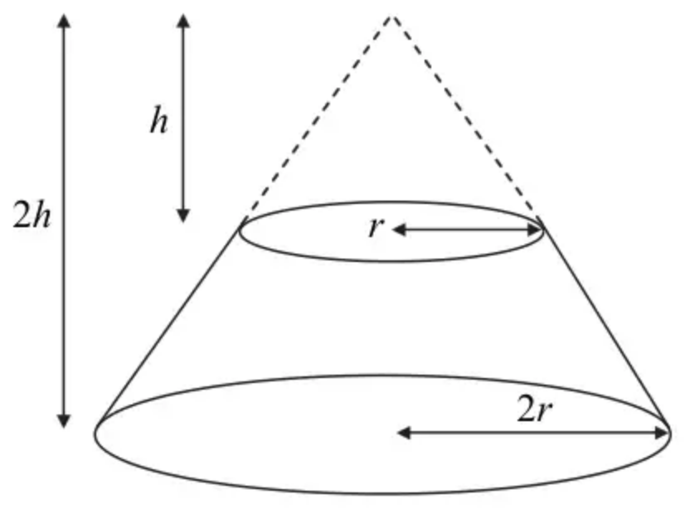
Figure 1
A uniform solid $S$ is formed by taking a uniform solid right circular cone, of base radius $2r$ and height $2h$, and removing the cone, with base radius $r$ and height $h$, which has the same vertex as the original cone, as shown in Figure 1.
(a) Show that the distance of the centre of mass of $S$ from its larger plane face is $\frac{11}{28}h$. (5)
The solid $S$ lies with its larger plane face on a rough table which is inclined at an angle $θ^{∘}$ to the horizontal. The table is sufficiently rough to prevent $S$ from slipping. Given that $h=2r$,
(b) find the greatest value of $θ$ for which $S$ does not topple. (3)
(Total 8 marks)
Edexcel M3 January 2008 Q3
2.
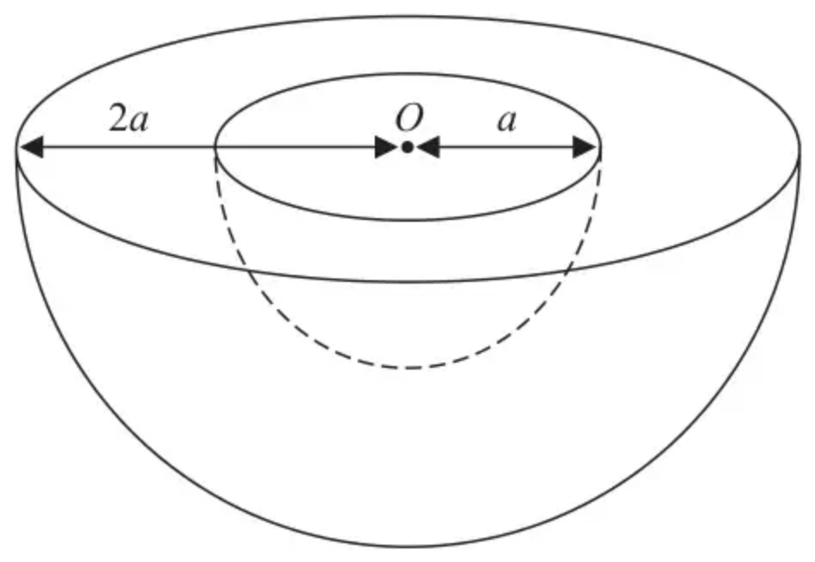
Figure 2
A uniform solid hemisphere $H$ has radius $2a$. A solid hemisphere of radius $a$ is removed from the hemisphere $H$ to form a bowl. The plane faces of the hemispheres coincide and the centres of the two hemispheres coincide at the point $O$, as shown in Figure 2.
The centre of mass of the bowl is at the point $G$.
(a) Show that $OG=\frac{45a}{56}$ (4)
Figure 3 below shows a cross-section of the bowl which is resting in equilibrium with a point $P$ on its curved surface in contact with a rough plane. The plane is inclined to the horizontal at an angle $α$ and is sufficiently rough to prevent the bowl from slipping. The line $OG$ is horizontal and the points $O$, $G$ and $P$ lie in a vertical plane which passes through a line of greatest slope of the inclined plane.
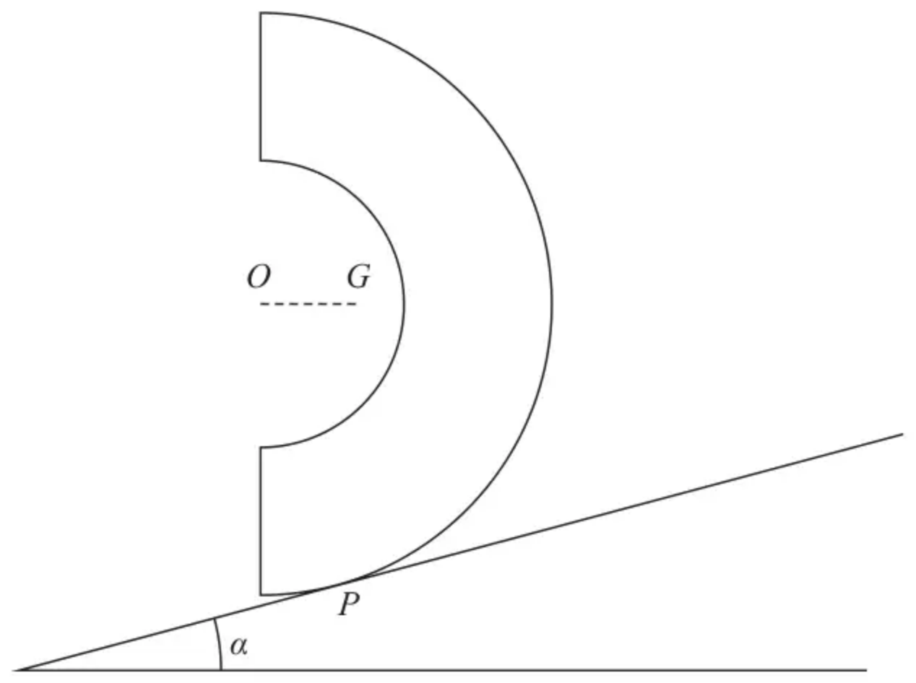
Figure 3
(b) Find the size of $α$, giving your answer in degrees to 3 significant figures. (2)
(Total 6 marks)
Edexcel A2 October 2021 Q3
3. [In this question, you may assume that the centre of mass of a circular arc, radius $r$, with angle at centre $2α$, is a distance $\frac{rsin⁡α}{α}$ from the centre.]
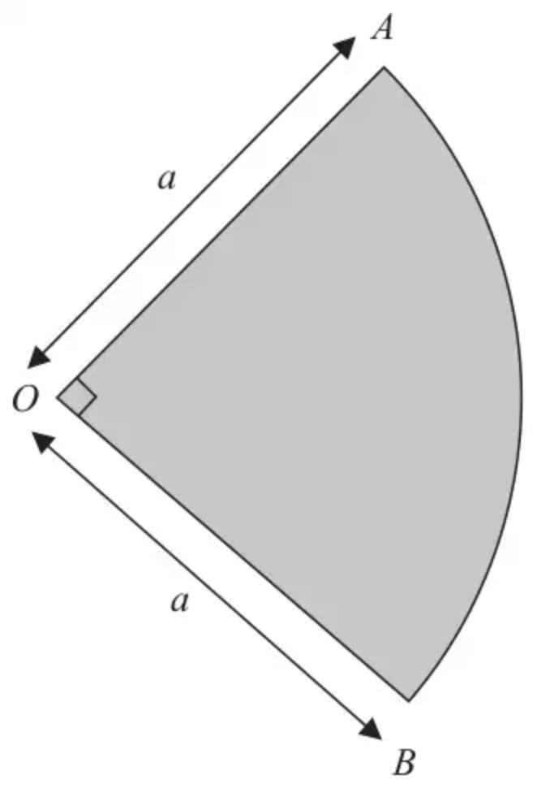
Figure 5
A thin non-uniform metal plate is in the shape of a sector $OAB$ of a circle with centre $O$ and radius $a$. The angle $AOB=\frac{π}{2}$, as shown in Figure 5.
The plate is modelled as a non-uniform lamina.
The mass per unit area of the lamina, at any point $P$ of the lamina, is modelled as $k(OP)^{2}$, where $k=\frac{4λ}{πa^{4}}$ and $λ$ is a constant.
Using the model,
(a) find the mass of the plate in terms of $λ$, (5)
(b) find, in terms of $a$, the distance of the centre of mass of the plate from $O$. (4)
(Total 9 marks)
Edexcel A2 October 2021 Q7
Solutions
1.
Mark scheme (a)
Scheme | Marks
Vol.: (accept ratios 8 : 1 : 7) C of M: (or equivalent) | B1  B1, B1
   | Large cone | small cone | $S$
  Vol. | $\frac{1}{3}π(2r)^{2}(2h)$ | $\frac{1}{3}πr^{2}h$ | $\frac{7}{3}πr^{2}h$
  C of M | $\frac{1}{2}h$, | $\frac{5}{4}h$ | $\overset{ˉ}{x}$
$\frac{8}{3}πr^{2}h\text{.}\frac{1}{2}h−\frac{1}{3}πr^{2}h\text{.}\frac{5}{4}h=\frac{7}{3}πr^{2}h\text{.}\overset{ˉ}{x}$ or equivalent | M1
$→\overset{ˉ}{x}=\frac{11}{28}h$ * | A1
 | (5)

Notes
Centres of mass may be measured from another point (e.g. centre of small circle, or vertex). The Method mark will then require a complete method (Moments and subtraction) to give required value for $\overset{ˉ}{x}$). However B marks can be awarded for correct values if the candidate makes the working clear.
Mark scheme (b)
Scheme | Marks
$tan⁡θ=\frac{2r}{\overset{ˉ}{x}}=\frac{2r}{\frac{11}{28}h},=\frac{2r}{\frac{11}{14}r}=\frac{28}{11}$ | M1, A1
$θ≈68.6^{∘}$ or 1.20 radians | A1
 | (3)
 | (8 marks)

Notes
(Special case – obtains complement by using $tan⁡θ=\frac{\overset{ˉ}{x}}{2r}$ giving 21.4${}^{∘}$ or .374 radians M1A0A0)
(Corrected from the printed mark scheme: the special case is printed as $tan⁡θ=\frac{2r}{\overset{ˉ}{x}}$.)
2.
Mark scheme (a)
Scheme | Marks | AO
Mass ratios: $\frac{2}{3}π(2a)^{3},\frac{2}{3}πa^{3},\frac{2}{3}π(2a)^{3}−\frac{2}{3}πa^{3} (8,1,7)$ | B1 | 1.2
Distances: $\frac{3}{8}(2a),\frac{3}{8}a,\overset{ˉ}{x}$ | B1 | 1.2
$(\frac{2}{3}π(2a)^{3}−\frac{2}{3}πa^{3})\overset{ˉ}{x}=\frac{2}{3}π(2a)^{3}×\frac{3}{8}(2a)−\frac{2}{3}πa^{3}×\frac{3}{8}a$ | M1 | 3.1a
$\overset{ˉ}{x}=\frac{45a}{56}$ * | A1* | 2.2a
 | (4)

Notes
B1: Correct unsimplified (8, 1, 7)
B1: Correct unsimplified but distances could be measured from a parallel axis
M1: All terms needed and must be dimensionally correct
A1*: Correct answer correctly derived
Mark scheme (b)
Scheme | Marks | AO
Use of appropriate trig ratio e.g. $sin⁡α=\frac{\frac{45a}{56}}{2a}$ | M1 | 3.1a
$α=23.7^{∘}$ (3 sf) | A1 | 1.1b
 | (2)
 | (6 marks)

Notes
M1: Must be using an appropriate trig ratio
A1: Cao to 3SF
3.
Mark scheme (a)
Scheme | Marks | AO
Use of an appropriate element (quarter of a circle) | M1 | 2.1
$δA≃\frac{1}{2}πxδx$ | A1 | 1.1b
$δm≃\frac{1}{2}πxδx×\frac{4λ}{πa^{4}}x^{2} (=\frac{2λ}{a^{4}}x^{3}δx)$ | A1 | 3.4
$M=\int_{0}^{a}{}\frac{2λ}{a^{4}}x^{3}\text{d}x$ | M1 | 2.1
$M=\frac{1}{2}λ$ | A1 | 1.1b
 | (5)

Notes
M1: Use of an appropriate element (may be implied)
A1: Correct expression for area of element (may be implied)
A1: Use of proportionality model to obtain mass of element (may be implied)
M1: Integrating with correct limits
A1: cao
Mark scheme (b)
Scheme | Marks | AO
Use of “$\overset{ˉ}{x}=\frac{1}{M}∫x\text{d}m$” | M1 | 3.4
$=\frac{1}{M}\int_{0}^{a}{(\frac{2\sqrt{2}x}{π})}\frac{2λ}{a^{4}}x^{3}\text{d}x$ | A1 | 1.1b
Substitute for $M$, integrate and sub. in limits | M1 | 3.4
$\overset{ˉ}{x}=\frac{8\sqrt{2}a}{5π}$ | A1 | 1.1b
 | (4)
 | (9 marks)

Notes
M1: Use the model and correct method
A1: Correct integral
M1: Use the model to complete the equation
A1: cao

