QQQ – Further Mechanics 2 – Chapter 3 – Further Centres of Mass (Version 1)
Total Marks: 24
(24 = Platinum, 22 = Gold, 19 = Silver, 16 = Bronze)
1. A uniform solid is formed by rotating the region enclosed between the curve with equation $y=\sqrt{x}$, the $x$-axis and the line $x=4$, through one complete revolution about the $x$-axis. Find the distance of the centre of mass of the solid from the origin $O$. (5)
(Total 5 marks)
Edexcel M3 June 2006 Q1
2.
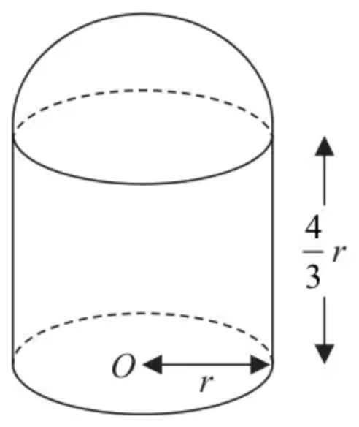
Figure 3
A uniform solid cylinder of base radius $r$ and height $\frac{4}{3}r$ has the same density as a uniform solid hemisphere of radius $r$. The plane face of the hemisphere is joined to a plane face of the cylinder to form the composite solid $S$ shown in Figure 3. The point $O$ is the centre of the plane face of $S$.
(a) Show that the distance from $O$ to the centre of mass of $S$ is $\frac{73}{72}r$ (4)
The solid $S$ is placed with its plane face on a rough horizontal plane. The coefficient of friction between $S$ and the plane is $μ$. A horizontal force $P$ is applied to the highest point of $S$. The magnitude of $P$ is gradually increased.
(b) Find the range of values of $μ$ for which $S$ will slide before it starts to tilt. (5)
(Total 9 marks)
Edexcel A2 October 2020 Q4
3.
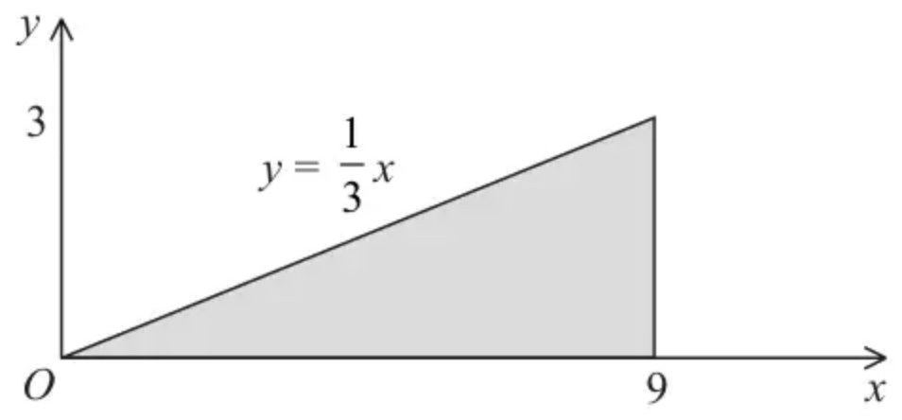
Figure 4
The shaded region shown in Figure 4 is bounded by the $x$-axis, the line with equation $x=9$ and the line with equation $y=\frac{1}{3}x$. This shaded region is rotated through $360^{∘}$ about the $x$-axis to form a solid of revolution. This solid of revolution is used to model a solid right circular cone of height 9 cm and base radius 3 cm.
The cone is non-uniform and the mass per unit volume of the cone at the point $(x,y,z)$ is $λx{\text{kg cm}}^{−3}$, where $0⩽x⩽9$ and $λ$ is constant.
(a) Find the distance of the centre of mass of the cone from its vertex. (6)
A toy is made by joining the circular plane face of the cone to the circular plane face of a uniform solid hemisphere of radius 3 cm, so that the centres of the two plane surfaces coincide.
The weight of the cone is $W$ newtons and the weight of the hemisphere is $kW$ newtons.
When the toy is placed on a smooth horizontal plane with any point of the curved surface of the hemisphere in contact with the plane, the toy will remain at rest.
(b) Find the value of $k$ (4)
(Total 10 marks)
Edexcel A2 June 2022 Q6
Solutions
1.
Scheme | Marks
Use of $(π)∫y^{2}\text{d}x×\overset{ˉ}{x}=(π)∫xy^{2}\text{d}x$ | M1
$∫x\text{d}x×\overset{ˉ}{x}=∫x^{2}\text{d}x$
${[\frac{1}{2}x^{2}]}_{…}^{…}×\overset{ˉ}{x}={[\frac{1}{3}x^{3}]}_{…}^{…}$ | A1 = A1
Using limits 0 and 4 $\frac{16}{2}×\overset{ˉ}{x}=\frac{64}{3}$ | M1
$\overset{ˉ}{x}=\frac{8}{3}$ | A1
 | (5)
 | (5 marks)

2.
Mark scheme (a)
Scheme | Marks | AO
$\frac{4}{3}πr^{3}×\frac{2}{3}r+\frac{2}{3}πr^{3}×(\frac{4}{3}r+\frac{3}{8}r)=(\frac{4}{3}+\frac{2}{3})πr^{3}×d$ | M1 | 2.1
$(\frac{8}{9}r+\frac{8}{9}r+\frac{1}{4}r=2d)$  $(\frac{73}{36}r=2d)$ | A1  A1 | 1.1b  1.1b
$⇒d=\frac{73}{72}r$ * | A1* | 2.2a
 | (4)

Notes
M1: Moments equation. Dimensionally correct.
A1: Unsimplified equation with at most one slip
A1: Correct unsimplified equation
A1*: Obtain given result from correct working.
Mark scheme (b)
Scheme | Marks | AO
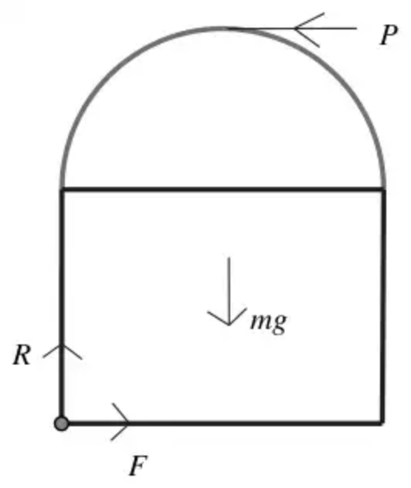
Resolving: $↔F=P$, $↕R=Mg$, $Fmax⁡=μR=μMg$ | M1 | 1.1b
Slides if $P>μMg$ | A1 | 1.2
Moments: $\frac{7}{3}rP=rMg$ Tilts if $P>\frac{3}{7}Mg$ | B1 | 1.1b
Comparison of restrictions to determine values of $μ$ | M1 | 3.1a
Slides first if $μMg<\frac{3}{7}Mg, (0<)μ<\frac{3}{7}$ | A1 | 2.2a
 | (5)
 | (9 marks)

Notes
M1: Resolve and use $F=μR$ to find values of $P$ for sliding
A1: Use the model to form the correct inequality
B1: Correct inequality for tilting
M1: Correct comparison of when it tilts and when it slides
A1: Correct conclusion
3.
Mark scheme (a)
Scheme | Marks | AO
Mass of cone $=\int_{0}^{9}{π}y^{2}λx\text{d}x=πλ\int_{0}^{9}{}\frac{x^{3}}{9}\text{d}x$ | M1 | 3.4
$=πλ{[\frac{x^{4}}{36}]}_{0}^{9} (=\frac{729πλ}{4}(\text{kg}))$ | A1 | 1.1b
Moments: $\int_{0}^{9}{π}y^{2}λx×x\text{d}x=πλ\int_{0}^{9}{}\frac{x^{4}}{9}\text{d}x$ | M1 | 3.4
$=\frac{πλ}{45}{[x^{5}]}_{0}^{9} (=\frac{πλ}{5}×9^{4})$ | A1 | 1.1b
$⇒d=\frac{\frac{πλ}{5}×9^{4}}{\frac{πλ}{4}×9^{3}}$ | DM1 | 2.1
$d=\frac{36}{5}=7.2(\text{cm})$ | A1 | 1.1b
 | (6)

Notes
NB: Some candidates are confusing the mass and the volume. For the first M1A1:
- If they have a correct method for the mass and they tell you that this is mass, award the marks.
- If they have a correct method for the mass say nothing, but use it correctly, award the marks.
- If they have a correct method for the mass, say nothing, and use it as the moment, then M0 because this implies that they do not think it is the mass.
M1: Use the model to find the mass of the cone. Allow without limits.
A1: Correct integration. Correct limits seen or implied
Substitution not required.
Allow 2/2 if π not seen and consistent with (b) if attempted
M1: Use the model to find the moment of the cone (usual rules for integration)
Allow without limits
A1: Correct integration. Correct limits seen or implied
Substitution not required.
Allow 2/2 if π not seen and consistent with (a)
M1: Complete method to find the distance of the centre of mass from the vertex. A complete method requires the two preceding M marks.
They need to get as far as a value for $d$.
If they have a method that comes directly to this stage you might not see the $λ$ or $π$
A1: Correct only
If all you see is $⇒d=\frac{9^{5}}{45}÷\frac{9^{4}}{36}$ or even $⇒d=\frac{9}{5}×4$ then award 6/6
Allow 6/6 if π not seen throughout but otherwise correct
Mark scheme (b)
Scheme | Marks | AO
Remains at rest $⇒$ centre of mass at centre of plane surface | B1 | 2.1
Moments about diameter of plane surface: | M1 | 3.1b
$(9−d)W\{=(9−\frac{36}{5})W\}=\frac{3}{8}×3×kW$ | A1ft | 1.1b
$k=\frac{8}{5}$ | A1 | 1.1b
 | (4)
 | (10 marks)

Notes
B1: Correct deduction for location of c of m
Stated or implied by their moments equation
M1: Moments about diameter of plane face(s)
M0 if the moments equation contradicts the centre of mass being on the interface
M0 if using volume in place of mass
A1ft: Correct unsimplified equation. Follow their 7.2
Alternative moments equations:
Using vertex: $W\overset{ˉ}{x}+kW(9+\frac{3}{8}×3)=(W+kW)×9$
Using base: $W(12−\overset{ˉ}{x})+kW(3−3×\frac{3}{8})=(W+kW)3$
If they are working with the axis at an angle they will possibly have trig terms which should cancel.
A1: Correct only

