QQQ – Further Mechanics 2 – Chapter 2 – Centres of Mass of Plane Figures (Version 2)
Total Marks: 24
(24 = Platinum, 22 = Gold, 19 = Silver, 16 = Bronze)
1. Three particles of masses $4m$, $2m$ and $km$ are placed at the points with coordinates $(−3,−1)$, $(6,1)$ and $(−1,5)$ respectively.
Given that the centre of mass of the three particles is at the point with coordinates $(\overset{ˉ}{x},\overset{ˉ}{y})$
(a) show that $\overset{ˉ}{x}=\frac{−k}{k+6}$ (3)
(b) find $\overset{ˉ}{y}$ in terms of $k$. (2)
Given that the centre of mass of the three particles lies on the line with equation $y=2x+3$
(c) find the value of $k$. (2)
A fourth particle is placed at the point with coordinates $(λ,4)$.
Given that the centre of mass of the four particles also lies on the line with equation $y=2x+3$
(d) find the value of $λ$. (2)
(Total 9 marks)
Edexcel AS June 2023 Q1
2.
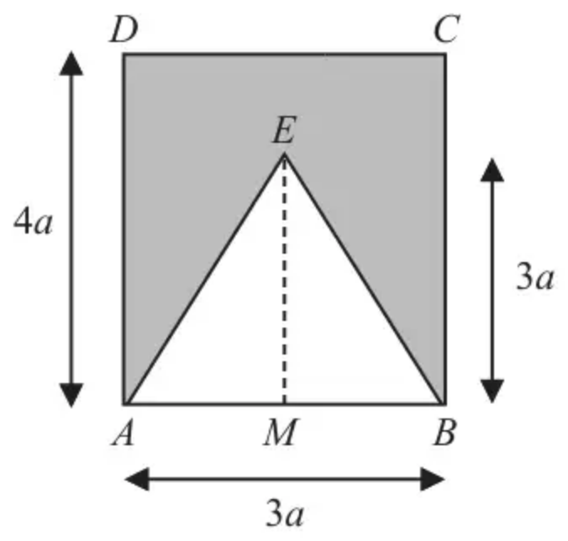
Figure 1
A uniform plane lamina, shown shaded in Figure 1, is formed by removing an isosceles triangle $ABE$ from a rectangle $ABCD$.
• The midpoint of $AB$ is $M$
• $AB=3a$
• $AD=4a$
• $EM=3a$
• $AE=EB$
(a) Show that the distance of the centre of mass of the lamina from $AB$ is $\frac{13a}{5}$ (5)
The lamina is suspended by a string attached to the lamina at $D$.
The lamina hangs freely in equilibrium.
(b) Find, to the nearest degree, the angle between $AD$ and the vertical. (3)
(Total 8 marks)
Edexcel AS June 2025 Q1
3.
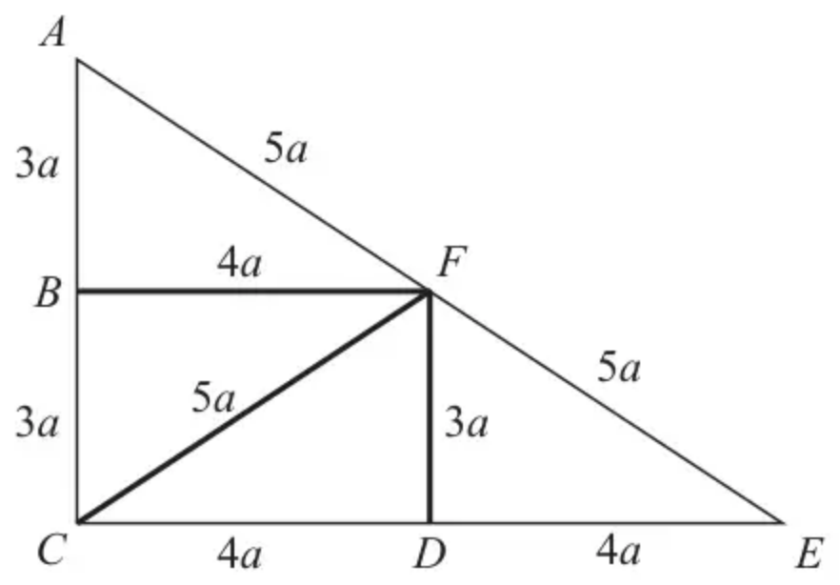
Figure 1
Nine uniform rods are joined together to form the rigid framework $ABCDEFA$, with $AB=BC=DF=3a$, $BF=CD=DE=4a$ and $AF=FE=CF=5a$, as shown in Figure 1. All nine rods lie in the same plane.
The mass per unit length of each of the rods $BF$, $CF$ and $DF$ is twice the mass per unit length of each of the other six rods.
(a) Find the distance of the centre of mass of the framework from $AC$ (4)
The mass of the framework is $M$. A particle of mass $kM$ is attached to the framework at $E$ to form a loaded framework.
When the loaded framework is freely suspended from $F$, it hangs in equilibrium with $CE$ horizontal.
(b) Find the exact value of $k$ (3)
(Total 7 marks)
Edexcel A2 June 2022 Q3
Solutions
1.
Mark scheme (a)
Scheme | Marks | AO
Moments about $y$ axis: | M1 | 2.1
$km×−1+4m×−3+2m×6=(k+6)m×\overset{ˉ}{x}$ | A1 | 1.1b
$⇒\overset{ˉ}{x}=\frac{−k}{k+6}$ * | A1* | 1.1b
 | (3)

Notes
M1: Moments about $y$ axis (or a parallel axis). All terms required. Dimensionally consistent. Condone sign errors.
A1: Correct unsimplified equation
A1*: Obtain given answer from full and correct working
Accept with $6+k$
Mark scheme (b)
Scheme | Marks | AO
Moments about $x$ axis: $(km×5+4m×−1+2m×1=(k+6)m×\overset{ˉ}{y})$ | M1 | 3.1a
$⇒\overset{ˉ}{y}=\frac{5k−2}{k+6}$ | A1 | 1.1b
 | (2)

Notes
M1: Moments about $x$ axis (or a parallel axis). All terms required. Dimensionally consistent. Condone sign errors.
A1: Correct unsimplified expression for $\overset{ˉ}{y}$.
Any equivalent simplified form
The first 5 marks are available for a combined equation in vector form
Mark scheme (c)
Scheme | Marks | AO
$\overset{ˉ}{y}=2\overset{ˉ}{x}+3⇒\frac{5k−2}{k+6}=\frac{−2k}{k+6}+3$ $(5k−2=−2k+(3k+18))$ | M1 | 1.1b
$⇒k=5$ | A1 | 1.1b
 | (2)

Notes
M1: Correct use of their $\overset{ˉ}{y}$ and given $\overset{ˉ}{x}$ to find $k$.
A1: Correct only
Mark scheme (d)
Scheme | Marks | AO
$4=2λ+3⇒$ | M1 | 3.4
$λ=\frac{1}{2}$ | A1 | 1.1b
 | (2)
 | (9 marks)

Notes
M1: Use the model to obtain $λ=…$ or $x=…$
If working from the beginning and the new particle has mass $M$ then $\frac{23+4M}{11+M}=2(\frac{−5+λM}{11+M})+3$
A1: Accept $x=\frac{1}{2}$
2.
Mark scheme (a)
Scheme | Marks | AO
$ABCD$ $ABE$ lamina
$12a^{2}$ $\frac{9a^{2}}{2}$ $\frac{15a^{2}}{2}$ | B1 | 1.2
$2a$ $a$ $\overset{ˉ}{x}$ | B1 | 1.2
Moments about $AB$ | M1 | 2.1
$(12a^{2}×2a)−(\frac{9a^{2}}{2}×a)=\frac{15a^{2}}{2}\overset{ˉ}{x}$ | A1 | 1.1b
$\overset{ˉ}{x}=\frac{13a}{5}$ * | A1* | 2.2a
 | (5)

Notes
B1: Any equivalent ratios
B1: Or correct distances from a parallel axis
M1: Or moments about a parallel axis
A1: Correct unsimplified equation for their axis
A1*: Correct given answer correctly obtained. Condone $\frac{13}{5}a$
Mark scheme (b)
Scheme | Marks | AO
Use of trigonometry to find a relevant angle | M1 | 3.1a
$tan⁡α=\frac{\frac{3a}{2}}{4a−\frac{13a}{5}}$ | A1 | 1.1b
$α=47^{∘}$ or $133^{∘}$ (nearest degree) | A1 | 1.1b
 | (3)
 | (8 marks)

Notes
M1: A complete method to obtain angle with e.g. vertical or horizontal
A1: Correct unsimplified equation (or its reciprocal)
A1: cao
3.
Mark scheme (a)
Scheme | Marks | AO
Moments about $AC$: | M1 | 3.1a
  rod | $CD$ | $DE$ | $EF$ | $FA$ | $AB$ | $BC$ | $BF$ | $DF$ | $CF$
  Mass ratio | 4 | 4 | 5 | 5 | 3 | 3 | 8 | 6 | 10
  From $AC$ | $2a$ | $6a$ | $6a$ | $2a$ | 0 | 0 | $2a$ | $4a$ | $2a$
$8a×4a+2×3a×4a+2×5a×2a+10a×4a+2×4a×2a=48a\overset{ˉ}{x}$ | A1  A1 | 1.1b  1.1b
$(132a=48\overset{ˉ}{x})⇒\overset{ˉ}{x}=\frac{11}{4}a$ | A1 | 1.1b
 | (4)

Notes
M1: Dimensionally correct equation for moments about $AC$ or a parallel axis. All terms needed and horizontal distances
Must be using the mass ratio. Allow slips, but not consistently density and not consistently lengths. Condone without $a$
A1: One side of the equation correct
A1: Both sides of the equation correct
A1: Or equivalent single term
Condone if $a$ is missing in the working and appears at the end
Mark scheme (b)
Scheme | Marks | AO
Moments about $F$: | M1 | 3.1a
$Mg(4a−\overset{ˉ}{x})=kMg×4a$ | A1ft | 1.1b
$⇒k=\frac{5}{16}$ | A1 | 1.1b
 | (3)
 | (7 marks)

Notes
M1: Dimensionally correct moments equation. Accept any complete alternative method using $M$ and $kM$ to obtain an equation in $k$ only.
Condone if g and / or M cancelled throughout
Condone incorrect distances
Condone if use $M=48$ throughout
A1ft: Correct unsimplified equation (accept without $g$ and/or $M$) Correct mass and distance combination for their $\overset{ˉ}{x}$
A1: Or 0.3125 Condone 0.31 or 0.313
Alternative
Scheme | Marks | AO
Moments about $C$: | M1
$4a(M+kM)=M\overset{ˉ}{x}+8akM$ | A1ft
$⇒k=\frac{5}{16}$ | A1 | 1.1b
 | (3)

