QQQ – Further Mechanics 2 – Chapter 2 – Centres of Mass of Plane Figures (Version 1)
Total Marks: 24
(24 = Platinum, 22 = Gold, 19 = Silver, 16 = Bronze)
1. Three particles of masses $3m$, $4m$ and $km$ are positioned at the points with coordinates $(2a,3a)$, $(a,5a)$ and $(2μa,μa)$ respectively, where $k$ and $μ$ are constants.
The centre of mass of the three particles is at the point with coordinates $(2a,4a)$.
Find
(i) the value of $k$
(ii) the value of $μ$ (6)
(Total 6 marks)
Edexcel A2 June 2023 Q1
2.
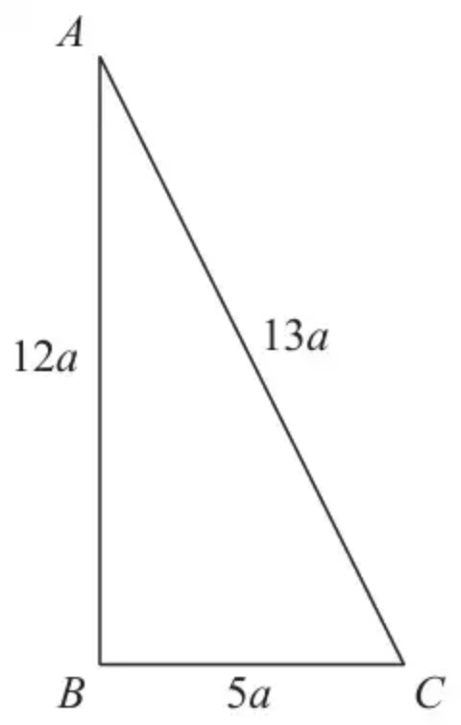
Figure 1
A thin uniform rod, of total length $30a$ and mass $M$, is bent to form a frame. The frame is in the shape of a triangle $ABC$, where $AB=12a$, $BC=5a$ and $CA=13a$, as shown in Figure 1.
(a) Show that the centre of mass of the frame is $\frac{3}{2}a$ from $AB$. (4)
The frame is freely suspended from $A$. A horizontal force of magnitude $kMg$, where $k$ is a constant, is applied to the frame at $B$. The line of action of the force lies in the vertical plane containing the frame. The frame hangs in equilibrium with $AB$ vertical.
(b) Find the value of $k$. (3)
(Total 7 marks)
Edexcel AS June 2018 Q1
3.
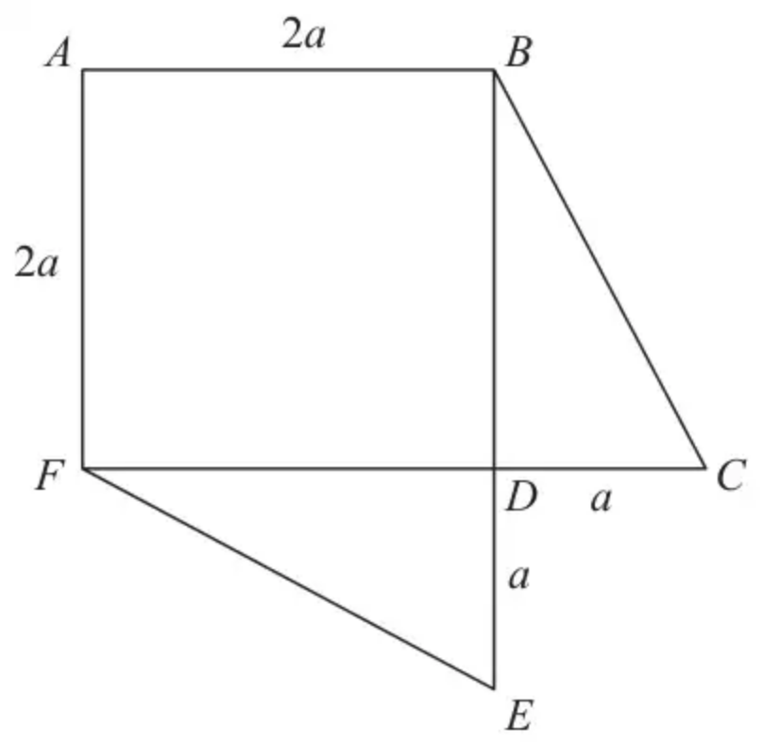
Figure 2
The lamina $L$, shown in Figure 2, consists of a uniform square lamina $ABDF$ and two uniform triangular laminas $BDC$ and $FDE$. The square has sides of length $2a$. The two triangles are identical.
The straight lines $BDE$ and $FDC$ are perpendicular with $BD=DF=2a$ and $DC=DE=a$.
The mass per unit of area of the square is $M$.
The mass per unit area of each triangle is $3M$.
The centre of mass of $L$ is at the point $G$.
(a) Without doing any calculations, explain why $G$ lies on $AD$. (1)
(b) Show that the distance of $G$ from $D$ is $\frac{\sqrt{2}}{2}a$ (7)
The lamina $L$ is freely suspended from $B$ and hangs in equilibrium.
(c) Find the size of the angle between $BE$ and the downward vertical. (3)
(Total 11 marks)
Edexcel AS June 2018 Q3
Solutions
1.
Scheme | Marks | AO
Moments about $y$-axis | M1 | 3.1a
$2a(7+k)=3×2a+4×a+k×2μa$  $(14+2k=10+2μk)$ | A1 | 1.1b
Moments about $x$-axis | M1 | 3.1a
$4a(7+k)=3×3a+4×5a+k×μa$  $(28+4k=29+μk)$ | A1 | 1.1b
Obtain $k=1$ or $μ=3$ | A1 | 2.2a
Obtain $k=1$ and $μ=3$ | A1 | 2.2a
 | (6)
 | (6 marks)

Notes
M1: Dimensionally correct equation with all terms. Allow with $\overset{ˉ}{x}$ in place of $2a$
A1: Correct unsimplified equation.
M1: Dimensionally correct equation with all terms. Allow with $\overset{ˉ}{y}$ in place of $4a$
A1: Correct unsimplified equation.
These two equations can be combined as a single vector equation.
A1: One correct value.
A1: Both correct values.
2.
Mark scheme (a)
Scheme | Marks | AO
Complete strategy to find $d$ | M1 | 3.1b
$\frac{5}{30}M×\frac{5}{2}a+\frac{13}{30}M×\frac{5}{2}a=M×d$ | A1 | 1.1b
$(\frac{25}{2}a+\frac{65}{2}a=30d)$ | A1 | 1.1b
$90a=60d⇒d=\frac{3}{2}a$ * | A1* | 2.1
 | (4)

Notes
M1: Complete strategy to find $d$ e.g. moments about $AB$ or a parallel axis. Needs all relevant terms. Must be dimensionally correct.
Condone sign errors. $M$'s might cancel from the start.
A1: Unsimplified equation with at most one error
A1: Correct unsimplified equation
A1*: Obtain the given answer from a convincing argument
Mark scheme (b)
Scheme | Marks | AO
Complete strategy to find $k$, e.g. by use of a moments equation | M1 | 3.1b
$Mg×\frac{3}{2}a=kMg×12a$ | A1 | 1.1b
$k=\frac{1}{8}$ | A1 | 1.1b
 | (3)
 | (7 marks)

Notes
M1: Complete strategy to find $k$ e.g. moments about $A$.
Needs all relevant terms. Must be dimensionally correct.
Condone sign errors. Condone if $a$, $M$, $g$ missing throughout
A1: Correct unsimplified equation in $k$
A1: Correct answer – any equivalent form
Alternative (b)
Scheme | Marks | AO
Moments equation | M1
$12a×kM=\frac{13}{30}M×2.5a+\frac{5}{30}M×2.5a$ | A1
$12k=\frac{45}{30}$, $k=\frac{1}{8}$ | A1
 | (3)

3.
Mark scheme (a)
Scheme | Marks | AO
$L$ is symmetrical about $AD$ | B1 | 2.4
 | (1)

Notes
B1: Any equivalent statement about the symmetry
Mark scheme (b)
Scheme | Marks | AO
 | $ABDF$ | $BCD$ | $DEF$ | $L$
Mass ratio | $4a^{2}×M$ | $a^{2}×3M$ | $a^{2}×3M$ | $10a^{2}×M$
C of M from $BE$ | $−a$ | $+\frac{a}{3}$ | $−\frac{2a}{3}$ | $x$

Mass ratios | B1 | 1.2
Distances from $BE$ | B1 | 1.2
Moments equation | M1 | 2.1
$−a×4a^{2}M+\frac{a}{3}×3a^{2}M−\frac{2a}{3}×3a^{2}M=10a^{2}M×x$  $(−4a+a−2a=10x)$ | A1 | 1.1b
$x=−\frac{5a}{10}=−\frac{a}{2}$ | A1 | 1.1b
Use symmetry and Pythagoras | M1 | 1.1a
Distance from $D=\sqrt{\frac{a^{2}}{4}+\frac{a^{2}}{4}}=\frac{\sqrt{2}}{2}a$ * | A1* | 2.2a
 | (7)

Notes
B1: Correct mass ratios
B1: Distance ratios from any horizontal or vertical axis
M1: Moments equation for complete lamina about any horizontal or vertical axis. Must be dimensionally correct
A1: Correct unsimplified equation for their axes
A1: Correct horizontal or vertical distance from $D$
M1: Use of Pythagoras with their distance
A1*: Obtain given answer from correct working.
Mark scheme (c)
Scheme | Marks | AO
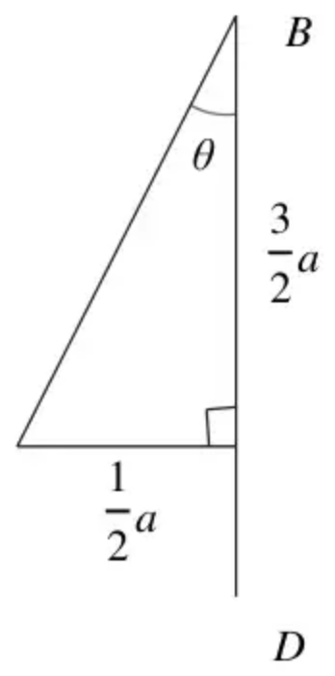
Trig ratio of a relevant angle | M1 | 1.2
$tan⁡θ=\frac{1}{3}$ or $cos⁡θ=\frac{\frac{10}{4}a^{2}+4a^{2}−\frac{2}{4}a^{2}}{2×\frac{\sqrt{10}}{2}a×2a}=\frac{6}{2\sqrt{10}}$ | A1ft | 1.1b
$θ=18.4^{∘}$ | A1 | 1.1b
 | (3)
 | (11 marks)

Notes
M1: Trig ratio of $θ$ or $90^{∘}−θ$ or equivalent
A1ft: Correct unsimplified expression using their $\frac{a}{2}$
A1: Correct angle. Accept 0.322 radians

