QQQ – Further Mechanics 2 – Chapter 1 – Circular Motion (Version 2)
Total Marks: 25
(25 = Platinum, 23 = Gold, 20 = Silver, 17 = Bronze)
1.
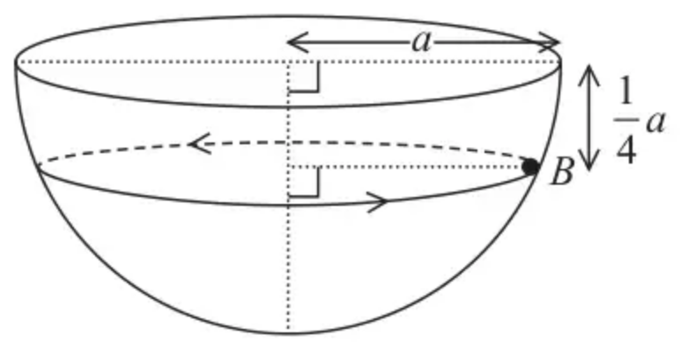
Figure 1
A hemispherical shell of radius $a$ is fixed with its rim uppermost and horizontal. A small bead, $B$, is moving with constant angular speed, $ω$, in a horizontal circle on the smooth inner surface of the shell. The centre of the path of $B$ is at a distance $\frac{1}{4}a$ vertically below the level of the rim of the hemisphere, as shown in Figure 1.
Find the magnitude of $ω$, giving your answer in terms of $a$ and $g$. (6)
(Total 6 marks)
Edexcel A2 June 2019 Q1
2. A rough disc rotates about its centre in a horizontal plane with constant angular speed 80 revolutions per minute. A particle $P$ lies on the disc at a distance 8 cm from the centre of the disc. The coefficient of friction between $P$ and the disc is $μ$. Given that $P$ remains at rest relative to the disc, find the least possible value of $μ$. (7)
(Total 7 marks)
Edexcel M3 January 2009 Q3
3. A fixed smooth sphere has centre $O$ and radius $a$. A particle $P$ is placed on the surface of the sphere at the point $A$, where $OA$ makes an angle $α$ with the upward vertical through $O$. The particle is released from rest at $A$. When $OP$ makes an angle $θ$ to the upward vertical through $O$, $P$ is on the surface of the sphere and the speed of $P$ is $v$.
Given that $cos⁡α=\frac{3}{5}$
(a) show that
$$v^{2}=\frac{2ga}{5}(3−5cos⁡θ)$$
(4)
(b) find the speed of $P$ at the instant when it loses contact with the sphere. (8)
(Total 12 marks)
Edexcel M3 June 2012 Q5
Solutions
1.
Scheme | Marks | AO
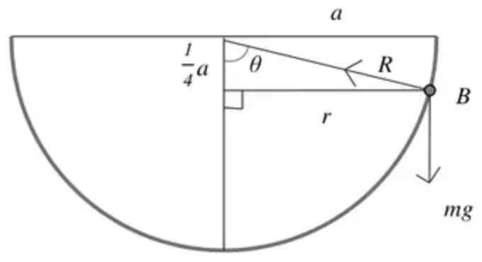
$↕Rcos⁡θ=mg$ | M1 | 3.1b
$↔Rsin⁡θ=mrω^{2}$ | M1 | 3.3
 | A1 | 1.1b
$tan⁡θ=\frac{r}{a\text{/}4} (tan⁡θ=\sqrt{15})$ | B1 | 1.1b
Complete strategy to find $ω$ | M1 | 3.1b
$tan⁡θ=\frac{mrω^{2}}{mg}=\frac{4r}{a}, ⇒ω^{2}=\frac{4g}{a}, ω=2\sqrt{\frac{g}{a}}$ | A1 | 1.1b
 | (6)
 | (6 marks)

Notes
Check their diagram to see where they have put $θ$
Check the working carefully, particularly the value of $r$: some errors in the working can lead to a fortuitously correct answer
M1: Resolve vertically. Must be dimensionally correct.
M1: Resolve horizontally and form equation for circular motion. Must be dimensionally correct.
A1: Correct pair of equations for their unknowns (any $r$)
B1: Correct trig ratio(s) seen or implied. Allow for $r=\frac{\sqrt{15}}{4}a$
M1: Complete strategy to form and solve a set of equations with $r\text{≠}a$ to find $ω$. For solving their 2 equations – not dependent
A1: Eliminate additional variables to obtain $ω$. Accept equivalent exact forms.
If $R$ does not act through the centre of the hemisphere then the maximum available is M1M1A0B0M0A0: 2/6
Alternative
Scheme | Marks | AO
$↕Rcos⁡θ=mg$ | M1 | 3.1b
$↔Rsin⁡θ=masin⁡θω^{2}$ | M1 | 3.3
 | A1 | 1.1b
$cos⁡θ=\frac{1}{4}$ | B1 | 1.1b
Complete strategy to find $ω$ | M1 | 3.1b
$⇒R=4mg, 4mg=maω^{2} ⇒ ω=2\sqrt{\frac{g}{a}}$ | A1 | 1.1b

2.
Scheme | Marks
$ω=\frac{80×2π}{60}$ rad s${}^{−1}$ $(=\frac{8π}{3}≈8.377…)$  Accept $v=\frac{16π}{75}≈0.67$ ms${}^{−1}$ as equivalent | B1
$(↑)$ $R=mg$ | B1
For least value of $μ$ $(←)$ $μmg=mrω^{2}$ | M1 A1=A1
$μ=\frac{0.08}{9.8}×{(\frac{8π}{3})}^{2}≈0.57$ accept 0.573 | M1 A1
 | (7)
 | (7 marks)

3.
Mark scheme (a)
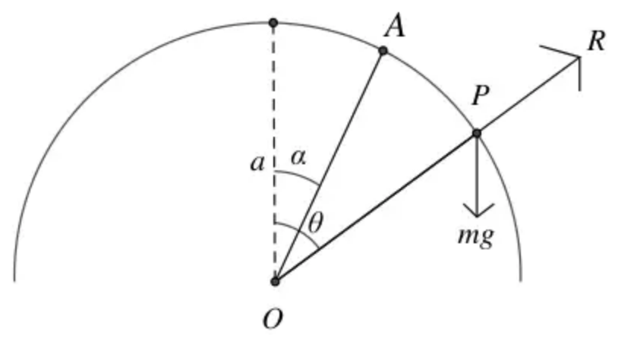
Scheme | Marks
Conservation of energy : Loss in GPE = gain in KE | M1
$mga(cos⁡α−cos⁡θ)=\frac{1}{2}mv^{2}$ | A2,1,0
Substitute for $cos⁡α$ and rearrange to given answer: | A1
$v^{2}=\frac{2mga}{m}(\frac{3}{5}−cos⁡θ)=\frac{2ga}{5}(3−5cos⁡θ)$ *
 | (4)

Mark scheme (b)
Scheme | Marks
Considering the acceleration towards the centre of the hemisphere: | M1
$mgcos⁡θ−R=\frac{mv^{2}}{a}$ | A2,1,0
Substitute for $v^{2}$ to form expression for $R$: | DM1
$R=mgcos⁡θ−\frac{mv^{2}}{a}=mg(3cos⁡θ−2cos⁡α)(=mg(3cos⁡θ−\frac{6}{5}))$ | A1
Loses contact with the surface when $R=0$ | M1
$cos⁡θ=\frac{2}{5}$ | A1
$v^{2}=\frac{2ga}{5},v=\sqrt{\frac{2ga}{5}}$ | A1
 | (8)
 | (12 marks)

Alt:
$R=0⇒mgcos⁡θ=\frac{mv^{2}}{a}$ | DM1
$cos⁡θ=\frac{v^{2}}{ga}$ | A1
Substitute in given (a) $v^{2}=\frac{2ga}{5}(3−5\frac{v^{2}}{ga})$ | M1
$v^{2}=\frac{6ga}{5}−2v^{2},3v^{2}=\frac{6ga}{5}$ | A1
$v=\sqrt{\frac{2ga}{5}}$ | A1

