QQQ – Further Mechanics 2 – Chapter 1 – Circular Motion (Version 1)
Total Marks: 24
(24 = Platinum, 22 = Gold, 19 = Silver, 16 = Bronze)
1.
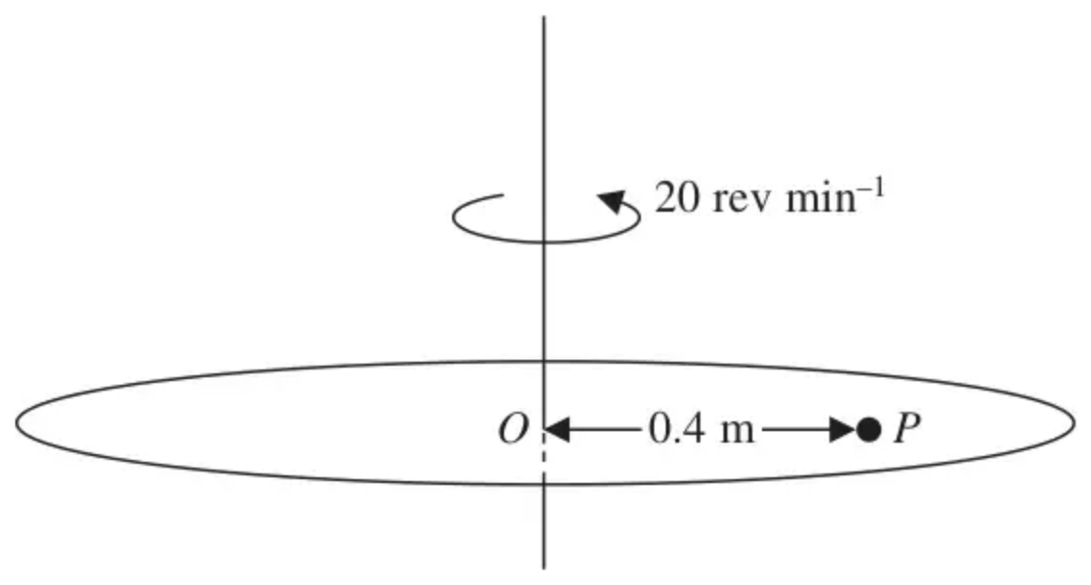
Figure 1
A rough disc is rotating in a horizontal plane with constant angular speed 20 revolutions per minute about a fixed vertical axis through its centre $O$. A particle $P$ rests on the disc at a distance 0.4 m from $O$, as shown in Figure 1. The coefficient of friction between $P$ and the disc is $μ$. The particle $P$ is on the point of slipping.
Find the value of $μ$. (6)
(Total 6 marks)
Edexcel M3 June 2013 Q1
2. A car moves round a bend which is banked at a constant angle of $θ^{∘}$ to the horizontal.
When the car is travelling at a constant speed of $80{\text{km h}}^{−1}$ there is no sideways frictional force on the car. The car is modelled as a particle moving in a horizontal circle of radius $500\text{m}$.
(a) Find the value of $θ$. (7)
(b) Identify one limitation of this model. (1)
The speed of the car is increased so that it is now travelling at a constant speed of $90{\text{km h}}^{−1}$
The car is still modelled as a particle moving in a horizontal circle of radius $500\text{m}$.
(c) Describe the extra force that will now be acting on the car, stating the direction of this force. (1)
(Total 9 marks)
Edexcel AS June 2018 Q2
3.
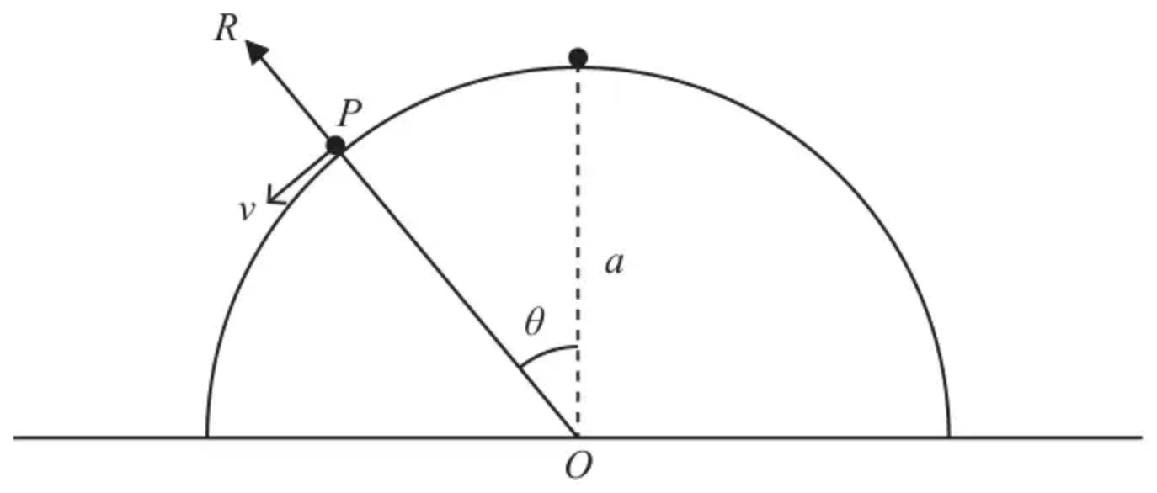
Figure 2
A smooth hemisphere of radius $a$ is fixed on a horizontal surface with its plane face in contact with the surface. The centre of the plane face of the hemisphere is $O$.
A particle $P$ of mass $M$ is disturbed from rest at the highest point of the hemisphere.
When $P$ is still on the surface of the hemisphere and the radius from $O$ to $P$ is at an angle $θ$ to the vertical,
• the speed of $P$ is $v$
• the normal reaction between the hemisphere and the particle is $R$, as shown in Figure 2.
(a) Show that $R=Mg(3cos⁡θ−2)$ (6)
(b) Find, in terms of $a$ and $g$, the speed of the particle at the instant when the particle leaves the surface of the hemisphere. (3)
(Total 9 marks)
Edexcel A2 June 2023 Q4
Solutions
1.
Scheme | Marks
R$(↑)$ $R=mg$
$F=μmg$ | B1
20 revs per min $=\frac{20}{60}×2π$ rad s${}^{−1}$ $(=\frac{2}{3}π{\text{rad s}}^{−1})$ | M1A1
R$(→)$ $μmg=m×0.4×{(\frac{2}{3}π)}^{2}$ | M1A1ft
$μ=\frac{0.4×4π^{2}}{9g}$
$μ=0.18$ or 0.179 | A1
 | (6 marks)

Notes
B1 for resolving vertically and using $F=μR$ to obtain $F=μmg$. This may not be seen explicitly, but give B1 when seen used in an equation.
M1 for attempting to change revs per minute to rad s${}^{−1}$, must see $(2)π$. (Can use 60 or 60${}^{2}$)
A1 for $\frac{20}{60}×2π$ (rad s${}^{−1}$) oe
M1 for NL2 horizontally along the radius - acceleration in either form for this mark, $F$ or $μmg$ or $μm$ all allowed. $r$ to be 0.4 now or later. This is not dependent on the previous M mark.
A1ft for $μmg=m×0.4×{(\frac{2}{3}π)}^{2}$ follow through on their $ω$
A1cso for $μ=0.18$ or 0.179, must be 2 or 3 sf.
NB: Use of $⩽$: is allowed, provided used correctly, until the final statement, which must be $μ=…$
2.
Mark scheme (a)
Scheme | Marks | AO
Complete strategy to find value of $θ$ | M1 | 3.1b
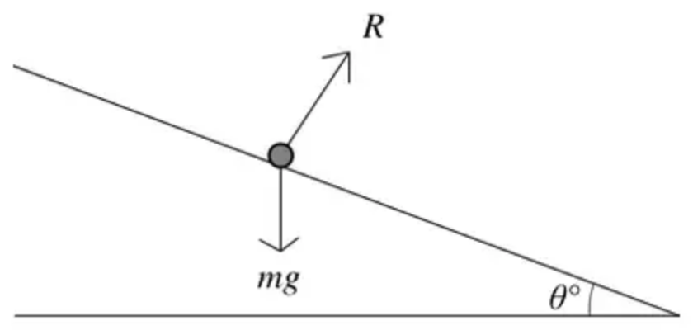
Resolve vertically | M1 | 3.1b
$Rcos⁡θ^{∘}=mg$ | A1 | 1.1b
Resolve horizontally | M1 | 3.1b
$Rsin⁡θ^{∘}=\frac{mv^{2}}{r}$ | A1 | 1.1b
$v=80{\text{km h}}^{−1}=\frac{80×1000}{60^{2}}{\text{m s}}^{−1}$ | B1 | 1.2
Solve simultaneous equations and substitute $v$ in correct units to obtain $θ$:  $tan⁡θ^{∘}=\frac{v^{2}}{rg}=\frac{640000}{36^{2}×500×9.8}$, $θ=5.8$ | A1 | 2.2a
 | (7)

Notes
M1: Complete strategy involving resolving in perpendicular directions, change of units and solution of simultaneous equations
M1: Complete strategy to form one equation involving $θ$ e.g. resolve vertically. Condone sin/cos confusion
A1: Or equivalent
M1: Complete strategy to form a second equation involving $θ$ e.g. resolve horizontally. Condone sin/cos confusion
A1: Correct unsimplified – need not substitute for $v$ or $r$
B1: Correct conversion ${\text{km h}}^{−1}$ to ${\text{m s}}^{−1}$ (22.2)
A1: Accept 5.8 or 5.75 (follows use of 9.8)
Mark scheme (b)
Scheme | Marks | AO
All weight acting at a single point | B1 | 3.5b
 | (1)

Notes
B1: Any appropriate comment
e.g. Only one point of contact with the road
The centre of mass of the car is on the road.
Mark scheme (c)
Scheme | Marks | AO
Friction acting down the slope | B1 | 2.2a
 | (1)
 | (9 marks)

Notes
B1: Need to include the direction
3.
Mark scheme (a)
Scheme | Marks | AO
Conservation of energy: | M1 | 3.1a
$\frac{1}{2}Mv^{2}=Mga(1−cos⁡θ)$ | A1 | 1.1b
Equation of motion: | M1 | 3.1a
$\frac{Mv^{2}}{a}=Mgcos⁡θ−R$ | A1 | 1.1b
Solve for $R$: | DM1 | 2.1
$R=Mgcos⁡θ−\frac{Mv^{2}}{a}=Mgcos⁡θ−2Mg(1−cos⁡θ)$  $=3Mgcos⁡θ−2Mg=Mg(3cos⁡θ−2)$ * | A1* | 2.2a
 | (6)

Notes
M1: Dimensionally correct equation. All relevant terms. Condone sign error(s) and sin/cos confusion.
A1: Correct unsimplified equation.
M1: Dimensionally correct equation. All relevant terms. Condone sign error(s) and sin/cos confusion.
A1: Correct unsimplified equation.
If they have more than 2 equations, mark the correct equations. If they go on to use an incorrect equation then DM0.
DM1: Complete method to obtain expression for $R$
A1*: Obtain given answer from full and correct working.
Mark scheme (b)
Scheme | Marks | AO
$R=0⇒cos⁡θ=\frac{2}{3}$ | B1 | 1.1b
$v^{2}=2ga(1−cos⁡θ)$ | M1 | 3.1a
$v^{2}=\frac{2}{3}ga, v=\sqrt{\frac{2ga}{3}}$ | A1 | 1.1b
 | (3)
 | (9 marks)

Notes
B1: Seen or implied.
M1: Complete method to obtain $v$ or $v^{2}$
A1: Any equivalent form.
Allow $0.82\sqrt{ga}$ or better.

