QQQ – Further Mechanics 1 – Chapter 5 – Collisions in Two Dimensions (Version 2)
Total Marks: 25
(25 = Platinum, 23 = Gold, 20 = Silver, 17 = Bronze)
1. Two small smooth spheres $A$ and $B$ have equal radii. The mass of $A$ is $2m$ kg and the mass of $B$ is $m$ kg. The spheres are moving on a smooth horizontal plane and they collide. Immediately before the collision the velocity of $A$ is $(2\text{i}−2\text{j})$ m s${}^{−1}$ and the velocity of $B$ is $(−3\text{i}−\text{j})$ m s${}^{−1}$. Immediately after the collision the velocity of $A$ is $(\text{i}−3\text{j})$ m s${}^{−1}$.
Find the speed of $B$ immediately after the collision. (5)
(Total 5 marks)
Edexcel M4 June 2008 Q2
2. [In this question, $\text{i}$ and $\text{j}$ are perpendicular unit vectors in a horizontal plane.]
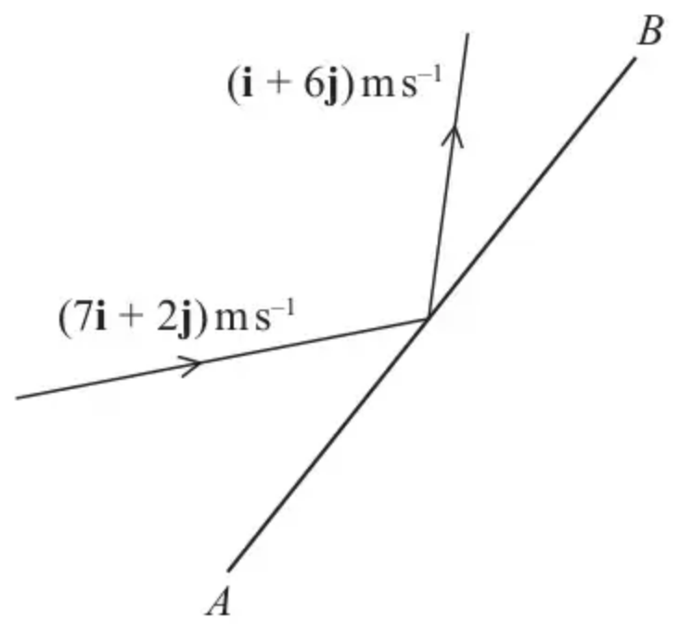
Figure 1
Figure 1 represents the plan view of part of a smooth horizontal floor, where $AB$ represents a fixed smooth vertical wall.
A small ball of mass 0.5 kg is moving on the floor when it strikes the wall.
Immediately before the impact the velocity of the ball is $(7\text{i}+2\text{j}){\text{m s}}^{−1}$.
Immediately after the impact the velocity of the ball is $(\text{i}+6\text{j}){\text{m s}}^{−1}$.
The coefficient of restitution between the ball and the wall is $e$.
(a) Show that $AB$ is parallel to $(2\text{i}+3\text{j})$. (4)
(b) Find the value of $e$. (5)
(Total 9 marks)
Edexcel A2 October 2020 Q4
3.
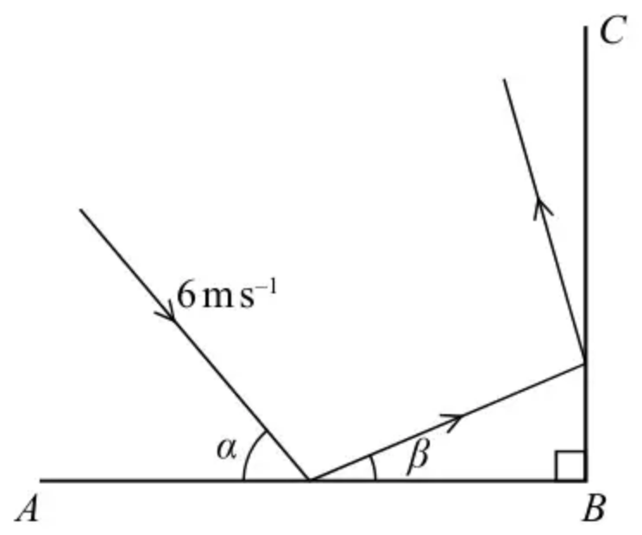
Figure 2
Figure 2 represents the plan view of part of a horizontal floor, where $AB$ and $BC$ are fixed vertical walls with $AB$ perpendicular to $BC$.
A small ball is projected along the floor towards $AB$ with speed $6{\text{m s}}^{−1}$ on a path that makes an angle $α$ with $AB$, where $tan⁡α=\frac{4}{3}$. The ball hits $AB$ and then hits $BC$.
Immediately after hitting $AB$, the ball is moving at an angle $β$ to $AB$, where $tan⁡β=\frac{1}{3}$
The coefficient of restitution between the ball and $AB$ is $e$.
The coefficient of restitution between the ball and $BC$ is $\frac{1}{2}$
By modelling the ball as a particle and the floor and walls as being smooth,
(a) show that the value of $e=\frac{1}{4}$ (5)
(b) find the speed of the ball immediately after it hits $BC$. (4)
(c) Suggest two ways in which the model could be refined to make it more realistic. (2)
(Total 11 marks)
Edexcel A2 June 2019 Q2
Solutions
1.
Scheme | Marks
$2m(2\text{i}−2\text{j})+m(−3\text{i}−\text{j})=2m(\text{i}−3\text{j})+m\text{v}$ | M1 A1
$(\text{i}−5\text{j})=(2\text{i}−6\text{j})+\text{v}$
$(−\text{i}+\text{j})=\text{v}$ | A1
$\text{∣}\text{v}\text{∣}=\sqrt{(−1)^{2}+1^{2}}=\sqrt{2}$ m s${}^{−1}$ cwo | DM1 A1
 | (5 marks)

2.
Mark scheme (a)
Scheme | Marks | AO
Use of $\text{I}=m\text{v}−m\text{u}$ or $\text{v}−\text{u}$ | M1 | 2.1
$\text{I}=0.5((\text{i}+6\text{j})−(7\text{i}+2\text{j}))$ $(=(−3\text{i}+2\text{j}))$ | A1 | 1.1b
Use of scalar product $(−3\text{i}+2\text{j})\text{.}(2\text{i}+3\text{j})=−6+6=0$ | M1 | 1.1b
Hence impulse perpendicular to $(2\text{i}+3\text{j})$, so $AB$ must be parallel to $(2\text{i}+3\text{j})$. * | A1* | 2.2a
 | (4)

Notes
Correction: In Alternative (a) 2 the ratio is $b=\frac{3}{2}a$ (corrected from the printed mark scheme: $b=\frac{2}{3}a$).
M1: Must be finding the difference between two momenta or two velocities
A1: Correct unsimplified equation for the impulse or for change in velocity
M1: Use of scalar product or equivalent. In the alt method allow full marks if $\sqrt{13}$ not used.
A1*: Reach given conclusion from correct working
If working with angles, score
M1 for correct method to find components parallel to the wall
A1 for $\sqrt{53}cos⁡40.36.{\text{.}}^{∘}$ and $\sqrt{37}cos⁡24.23.{\text{.}}^{∘}$
M1 for comparing the two values
A0 because the work has involved decimal approximations (since working towards an exact given answer).
Alternative: Could use $etan⁡24.2.{\text{.}}^{∘}=tan⁡40.36.{\text{.}}^{∘}$
Alternative (a)
Scheme | Marks | AO
Components of velocities parallel to $(2\text{i}+3\text{j})$: | M1 | 2.1
$(\frac{1}{\sqrt{13}})(7\text{i}+2\text{j})\text{.}(2\text{i}+3\text{j})=(\frac{1}{\sqrt{13}})(14+6)$  $(\frac{1}{\sqrt{13}})(\text{i}+6\text{j})\text{.}(2\text{i}+3\text{j})=(\frac{1}{\sqrt{13}})(2+18)$ | A1 | 1.1b
Simplify and compare values | M1 | 1.1b
Hence component of velocity parallel to $(2\text{i}+3\text{j})$ is unchanged, so $AB$ must be parallel to $(2\text{i}+3\text{j})$. * | A1* | 2.2a
 | (4)

Alternative (a) 2
Scheme | Marks | AO
Use conservation of velocity parallel to $a\text{i}+b\text{j}$ | M1 | 2.1
$(7\text{i}+2\text{j})\text{.}(a\text{i}+b\text{j})=(\text{i}+6\text{j})\text{.}(a\text{i}+b\text{j})$  $(⇒7a+2b=a+6b)$ | A1 | 1.1b
Find ratio of $a$ and $b$ to obtain direction: $(b=\frac{3}{2}a)$ | M1 | 1.1b
Hence $AB$ must be parallel to $(2\text{i}+3\text{j})$. * | A1* | 2.2a
 | (4)

Mark scheme (b)
Scheme | Marks | AO
Use scalar product to find components of velocities perpendicular to the wall | M1 | 3.1b
$(\frac{1}{\sqrt{13}})(−3\text{i}+2\text{j})\text{.}(7\text{i}+2\text{j})=(\frac{1}{\sqrt{13}})(−21+4)(=\frac{−17}{\sqrt{13}})$  $(\frac{1}{\sqrt{13}})(−3\text{i}+2\text{j})\text{.}(\text{i}+6\text{j})=(\frac{1}{\sqrt{13}})(−3+12)(=\frac{9}{\sqrt{13}})$ | A1  A1 | 1.1b  1.1b
Use of impact law | M1 | 3.4
$e=\frac{9}{17}$ | A1 | 1.1b
 | (5)
 | (9 marks)

Notes
M1: Condone if not using a unit vector
A1 A1: One correct value
Second correct values
If working with angles, score M1A1A1 for $\sqrt{53}sin⁡40.36.{\text{.}}^{∘}$ and $\sqrt{37}sin⁡24.23..{\text{.}}^{∘}$
M1: Use their components the right way round in the impact law. Condone sign error.
A1: 0.53 or better (0.52941……)
3.
Mark scheme (a)
Scheme | Marks | AO
After hit $AB$: $→6cos⁡α(=vcos⁡β)(=3.6)$ | B1 | 3.1b
Use of impact law: | M1 | 3.4
$↑6esin⁡α(=vsin⁡β)(=\frac{24e}{5})(=4.8e)$ | A1 | 1.1b
$tan⁡β=\frac{1}{3}=\frac{6esin⁡α}{6cos⁡α}(=\frac{24e}{5}÷\frac{18}{5})$ | M1 | 2.1
$e=\frac{18}{3×24}=\frac{1}{4}$ * | A1* | 2.2a
 | (5)

Notes
B1: Use model to find component parallel to the wall
M1: Use model and impact law perpendicular to the wall
A1: Correct perpendicular component
M1: Use $\frac{1}{3}$ and their components to form equation in $e$ $(v=\frac{6\sqrt{10}}{5}=3.79)$
A1*: Correct answer from correct exact working
If only see $etan⁡α=tan⁡β$ with no explanation of where it comes from then score 0/5
Mark scheme (b)
Scheme | Marks | AO
After hit $BC$: $↑\frac{6}{5}$ | B1 | 1.1b
$→\frac{1}{2}×\frac{18}{5}(=\frac{9}{5})$ | B1 | 3.4
Speed $=\frac{3}{5}\sqrt{2^{2}+3^{2}}$ | M1 | 1.1b
$=\frac{3\sqrt{13}}{5}({\text{m s}}^{−1})$ | A1 | 1.1b
 | (4)

Notes
B1: First component correct
B1: Second component correct
Alternative: B1 for speed of impact with $BC=3.79…$
B1 for path on leaving $BC$ at $56.3…^{∘}$ to $BC$
M1: Use Pythagoras’ theorem or trigonometry to find the speed
A1: Any equivalent form. 2.2 or better $(2.1633…)$
Mark scheme (c)
Scheme | Marks | AO
An appropriate refinement | B1 | 3.5c
A second independent appropriate refinement and no incorrect refinements | B1 | 3.5c
 | (2)
 | (11 marks)

Notes
B1 B1: Two independent refinements relating to the modelling e.g.
• Include friction between the floor and the ball
• Include friction between the ball and the walls
• Give the ball dimensions.
• Consider air resistance
• Spin / rotation
Do not accept comments about mass / gravity / levels / perpendicularity

