QQQ – Further Mechanics 1 – Chapter 5 – Collisions in Two Dimensions (Version 1)
Total Marks: 25
(25 = Platinum, 23 = Gold, 20 = Silver, 17 = Bronze)
1.
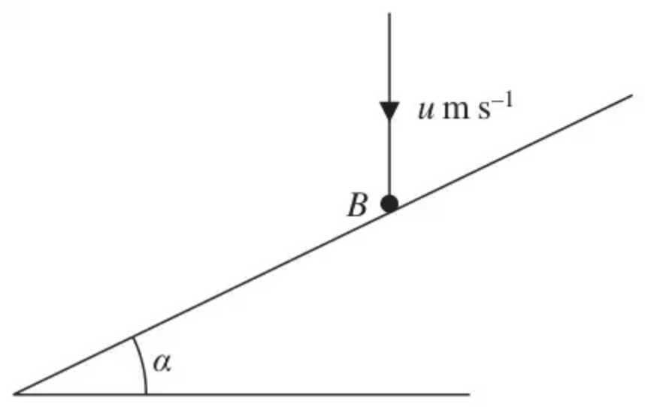
Figure 1
A smooth fixed plane is inclined at an angle $α$ to the horizontal. A smooth ball $B$ falls vertically and hits the plane. Immediately before the impact the speed of $B$ is $u$ m s${}^{−1}$, as shown in Figure 1. Immediately after the impact the direction of motion of $B$ is horizontal. The coefficient of restitution between $B$ and the plane is $\frac{1}{3}$.
Find the size of angle $α$. (6)
(Total 6 marks)
Edexcel M4 June 2013 (R) Q2
2.
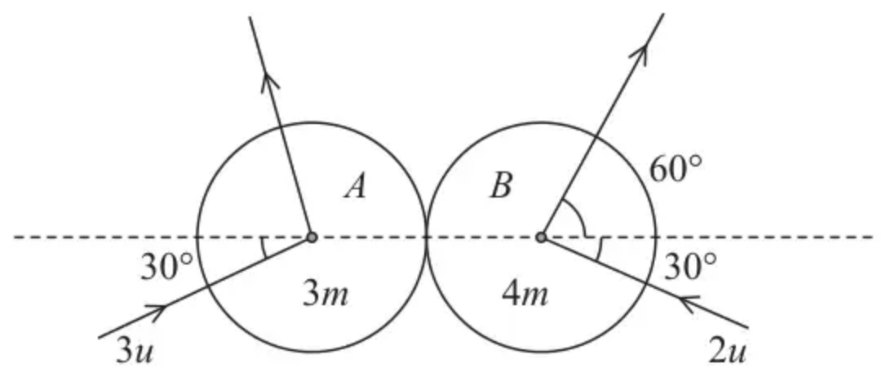
Figure 3
Two smooth uniform spheres, $A$ and $B$, have equal radii. The mass of $A$ is $3m$ and the mass of $B$ is $4m$. The spheres are moving on a smooth horizontal plane when they collide obliquely. Immediately before they collide, $A$ is moving with speed $3u$ at $30^{∘}$ to the line of centres of the spheres and $B$ is moving with speed $2u$ at $30^{∘}$ to the line of centres of the spheres. The direction of motion of $B$ is turned through an angle of $90^{∘}$ by the collision, as shown in Figure 3.
(i) Find the size of the angle through which the direction of motion of $A$ is turned as a result of the collision.
(ii) Find, in terms of $m$ and $u$, the magnitude of the impulse received by $B$ in the collision. (9)
(Total 9 marks)
Edexcel A2 June 2022 Q4
3.
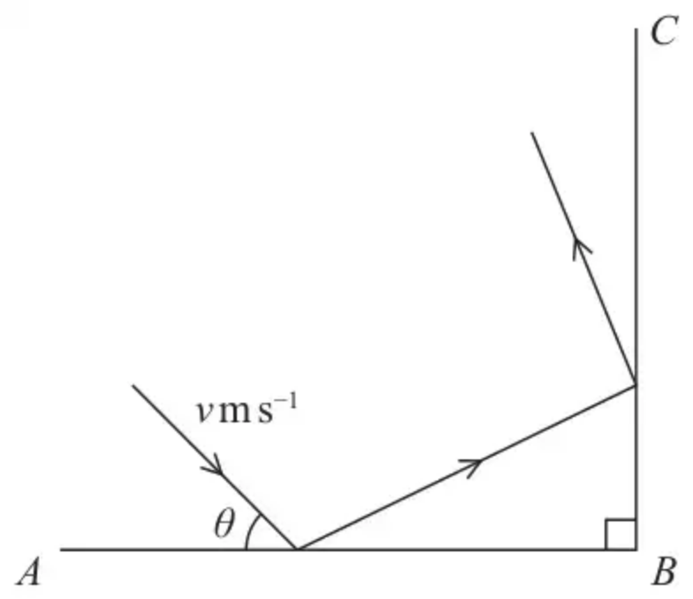
Figure 1
Figure 1 represents the plan view of part of a horizontal floor, where $AB$ and $BC$ represent fixed vertical walls, with $AB$ perpendicular to $BC$.
A small ball is projected along the floor towards the wall $AB$. Immediately before hitting the wall $AB$ the ball is moving with speed $v{\text{m s}}^{−1}$ at an angle $θ$ to $AB$.
The ball hits the wall $AB$ and then hits the wall $BC$.
The coefficient of restitution between the ball and the wall $AB$ is $\frac{1}{3}$
The coefficient of restitution between the ball and the wall $BC$ is $e$.
The floor and the walls are modelled as being smooth.
The ball is modelled as a particle.
The ball loses half of its kinetic energy in the impact with the wall $AB$.
(a) Find the exact value of $cos⁡θ$. (5)
The ball loses half of its remaining kinetic energy in the impact with the wall $BC$.
(b) Find the exact value of $e$. (5)
(Total 10 marks)
Edexcel A2 October 2021 Q5
Solutions
1.
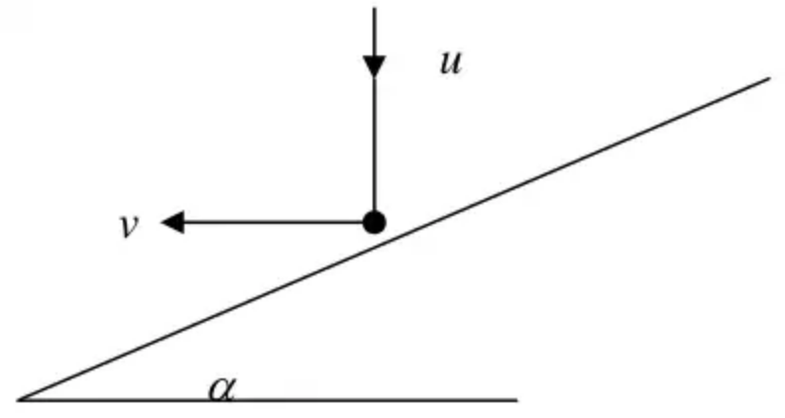
Scheme | Marks
CLM: $usin⁡α=vcos⁡α$ | M1 A1
Impact: $\frac{1}{3}ucos⁡α=vsin⁡α$ | M1 A1
$\frac{1}{3}×\frac{1}{tan⁡α}=tan⁡α$ | M1
$tan⁡α=\frac{1}{\sqrt{3}}$
$α=30^{∘}(\text{or}\frac{π}{6}\text{or}0.52\text{rad})$ | A1
 | (6)
 | (6 marks)

Notes
M1 A1 Must be in correct direction but condone trig confusion
M1 A1 Condone consistent trig confusion
2.
Mark scheme (i)
Scheme | Marks | AO
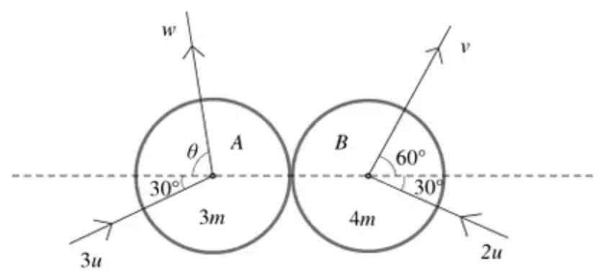
Parallel to line of centres: | M1 | 3.1b
$9mucos⁡30^{∘}−8mucos⁡30^{∘}=4mvcos⁡60^{∘}−3mwcos⁡θ$  $(ucos⁡30^{∘}=2v−3wcos⁡θ)$ $(ucos⁡30^{∘}=2v−3w_{x})$ | A1 | 1.1b
$↕A:(w_{y}=)wsin⁡θ=3usin⁡30^{∘}(=\frac{3u}{2})$  $↕B:vsin⁡60^{∘}=2usin⁡30^{∘}(=u)$ $(v=\frac{2u}{\sqrt{3}})$ | B1  B1 | 3.4  3.4
$(w_{x}=)wcos⁡θ=\frac{1}{3}(2v−ucos⁡30^{∘})=\frac{5u\sqrt{3}}{18}$  $(w_{y}=)wsin⁡θ=\frac{3u}{2}$  $(⇒tan⁡θ=\frac{9\sqrt{3}}{5},θ=72.2^{∘})$ | M1 | 1.1b
Direction deflected by $77.8^{∘}$ ($78^{∘}$ or better) | A1 | 2.2a

Notes
M1: Use of CLM parallel to the line of centres.
Need all 4 terms. Dimensionally correct. Condone sign errors and sin/cos confusion.
A1: Correct unsimplified equation. Allow e.g. $w_{x}$ in place of $wcos⁡θ$ and $v_{x}$ in place of $vcos⁡60^{∘}$.
Allow if they have divided through by a common factor e.g. $m$
NB there is no mark for the correct use of the impact law because the candidates are not required to find the coefficient of restitution. They might however find it as part of an alternative method. In this case, the M marks below are for a complete correct method to achieve the required result. Ignore work to find $e$ if it is not used.
B1 B1: No change perpendicular to line of centres for one sphere. Allow e.g. $w_{y}$ in place of $wsin⁡θ$.
Check the diagrams – the vertical components are often shown there.
No change perpendicular to line of centres for both spheres
M1: Use scalar product or solve simultaneous equations to find $θ$ for a relevant angle using their $w_{x}$
They need to get as far as $θ=$ a numerical value for a relevant angle
A1: $78^{∘}$ or better
Mark scheme (ii)
Scheme | Marks | AO
Magnitude of impulse | M1 | 3.1b
$=4m(vcos⁡60^{∘}−(−2ucos⁡30^{∘}))$ | A1 | 1.1b
$=4m(\frac{1}{2}×\frac{u}{sin⁡60^{∘}}−(−2u\frac{\sqrt{3}}{2}))=\frac{16\sqrt{3}}{3}mu$ | A1 | 2.2a
OR: magnitude $=3m(3ucos⁡30^{∘}+wcos⁡θ)$
$=3m(+\frac{5u\sqrt{3}}{18}−(−\frac{3u\sqrt{3}}{2}))=\frac{16\sqrt{3}}{3}mu$
 | (9)
 | (9 marks)

Notes
M1: Use of $I=mv−mu$ in direction of line of centres. Condone subtraction in either order
Allow M1 if they think that they have subtracted but they have not actually taken account of the change of direction.
Allow M1 if they go direct to the correct expression with a + without telling you that they have taken account of the change in direction
Allow M1 if they go straight to an unsimplified expression in surds using values already found earlier.
A1: Correct unsimplified expression.
Allow the negative of this
A1: Any equivalent simplified form. Must be positive. Condone if they change sign at the very end without explaining why. Accept $9.2(376…)mu$ (2 sf or better)
NB You might see candidates using the right angle and matrix multiplication to rotate the initial velocity of $B$ to find the correct components of the velocity of $B$ after impact.
3.
Mark scheme (a)
Scheme | Marks | AO
Use the model to find components of velocity after first impact:  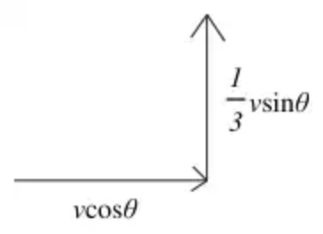 | B1  B1 | 1.1b  3.4
Kinetic energy: $\frac{1}{2}×\frac{1}{2}mv^{2}=\frac{1}{2}m(v^{2}{cos⁡}^{2}θ+\frac{1}{9}v^{2}{sin⁡}^{2}θ)$ | M1 | 3.1b
$\frac{1}{2}=\frac{1}{9}+\frac{8}{9}{cos⁡}^{2}θ$ | M1 | 1.1b
$\frac{7}{16}={cos⁡}^{2}θ, cos⁡θ=\frac{\sqrt{7}}{4}$ | A1 | 1.1b
 | (5)

Notes
B1 B1: Parallel component correct
Perpendicular component correct Check the diagram
M1: Equation for KE in $v,θ$. Dimensionally correct. Includes all components. Condone $\frac{1}{2}$ used on wrong side
M1: Form and solve equation in $cos⁡θ$
A1: Or exact equivalent
Alternative (a)
Scheme | Marks | AO
Working with initial velocity $\text{v}=x\text{i}−y\text{j}$, after impact $\text{v}=x\text{i}+\frac{1}{3}y\text{j}$ | B1  B1 | 1.1b  3.4
KE: $\frac{1}{2}×\frac{1}{2}m(x^{2}+y^{2})=\frac{1}{2}m(x^{2}+\frac{1}{9}y^{2})$ | M1 | 3.1b
$y^{2}=\frac{9}{7}x^{2}, \frac{y}{x}=tan⁡θ=\frac{3}{\sqrt{7}}$ | M1 | 1.1b
$cos⁡θ=\frac{\sqrt{7}}{4}$ | A1 | 1.1b
 | (5)

Mark scheme (b)
Scheme | Marks | AO
Use the model to find components of velocity after second impact:  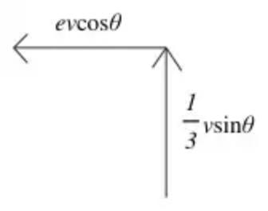 | B1  B1 | 1.1b  3.4
Kinetic energy: $\frac{1}{4}×\frac{1}{2}mv^{2}=\frac{1}{2}m(e^{2}v^{2}{cos⁡}^{2}θ+\frac{1}{9}v^{2}{sin⁡}^{2}θ)$  or $\frac{1}{2}×\frac{1}{2}m(v^{2}{cos⁡}^{2}θ+\frac{1}{9}v^{2}{sin⁡}^{2}θ)=\frac{1}{2}m(e^{2}v^{2}{cos⁡}^{2}θ+\frac{1}{9}v^{2}{sin⁡}^{2}θ)$ | M1 | 3.1b
$\frac{1}{4}=\frac{7}{16}e^{2}+\frac{1}{9}×\frac{9}{16}$ | M1 | 1.1b
$⇒e^{2}=\frac{3}{7}, e=\sqrt{\frac{3}{7}}$ | A1 | 1.1b
 | (5)
 | (10 marks)

Notes
B1 B1: Parallel component correct
Perpendicular component correct
M1: Equation for KE in $x,y$. Dimensionally correct. Includes all components. Condone $\frac{1}{2}$ used on wrong side
M1: Use their $cos⁡θ$ to form and solve equation in $e$
A1: Or exact equivalent
Alternative (b)
Scheme | Marks | AO
After second impact $\text{v}=−ex\text{i}+\frac{1}{3}y\text{j}$ | B1  B1 | 1.1b  3.4
KE: $\frac{1}{4}×\frac{1}{2}m(x^{2}+y^{2})=\frac{1}{2}m(e^{2}x^{2}+\frac{1}{9}y^{2})$ | M1 | 3.1b
$4e^{2}x^{2}+\frac{4}{9}y^{2}=x^{2}+y^{2}, 4e^{2}=1+\frac{5}{9}{(\frac{y}{x})}^{2}$ | M1 | 1.1b
$⇒e^{2}=\frac{3}{7}, e=\sqrt{\frac{3}{7}}$ | A1 | 1.1b
 | (5)

