QQQ – Further Mechanics 1 – Chapter 4 – Collisions in One Dimension (Version 1)
Total Marks: 25
(25 = Platinum, 23 = Gold, 20 = Silver, 17 = Bronze)
1. A small ball of mass 0.3 kg is released from rest from a point 3.6 m above horizontal ground. The ball falls freely under gravity, hits the ground and rebounds vertically upwards.
In the first impact with the ground, the ball receives an impulse of magnitude 4.2 N s.
The ball is modelled as a particle.
(a) Find the speed of the ball immediately after it first hits the ground. (5)
(b) Find the kinetic energy lost by the ball as a result of the impact with the ground. (3)
(Total 8 marks)
Edexcel AS June 2018 Q1
2. A particle $A$ has mass $2m$ and a particle $B$ has mass $3m$. The particles are moving in opposite directions along the same straight line and collide directly.
Immediately before the collision, the speed of $A$ is $2u$ and the speed of $B$ is $u$.
Immediately after the collision, the speed of $A$ is $0.5u$ and the speed of $B$ is $w$.
Given that the direction of motion of each particle is reversed by the collision,
(a) find $w$ in terms of $u$ (3)
(b) find the coefficient of restitution between the particles, (3)
(c) find, in terms of $m$ and $u$, the magnitude of the impulse received by $A$ in the collision. (3)
(Total 9 marks)
Edexcel AS June 2024 Q1
3.
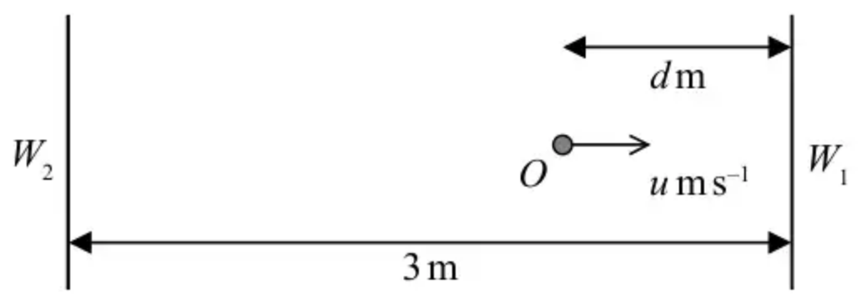
Figure 1
Figure 1 represents the plan of part of a smooth horizontal floor, where $W_{1}$ and $W_{2}$ are two fixed parallel vertical walls. The walls are 3 metres apart.
A particle lies at rest at a point $O$ on the floor between the two walls, where the point $O$ is $d$ metres, $0<d⩽3$, from $W_{1}$
At time $t=0$, the particle is projected from $O$ towards $W_{1}$ with speed $u{\text{m s}}^{−1}$ in a direction perpendicular to the walls.
The coefficient of restitution between the particle and each wall is $\frac{2}{3}$
The particle returns to $O$ at time $t=T$ seconds, having bounced off each wall once.
(a) Show that $T=\frac{45−5d}{4u}$ (6)
The value of $u$ is fixed, the particle still hits each wall once but the value of $d$ can now vary.
(b) Find the least possible value of $T$, giving your answer in terms of $u$. You must give a reason for your answer. (2)
(Total 8 marks)
Edexcel A2 June 2019 Q1
Solutions
1.
Mark scheme (a)
Scheme | Marks | AO
Speed just before impact: $v^{2}=u^{2}+2as=2×9.8×3.6(=70.56)$ | M1 | 3.4
$v=8.4({\text{m s}}^{−1})$ | A1 | 1.1b
Use of $I=mv−mu$: $4.2=0.3(w−(−8.4))$ | M1 | 3.1b
Follow their 8.4 | A1ft | 1.1b
$w=5.6({\text{m s}}^{−1})$ | A1 | 1.1b
 | (5)

Notes
M1: Use the model and suvat or energy to find speed before impact
A1: Correct answer. Accept $\sqrt{70.56}$, $\sqrt{7.2g}$
M1: A complete strategy to find $w$: Use the model and impulse-momentum equation using given impulse and their speed of impact. Must be using a difference in velocities. Be vigilant for sign fudges that make the original equation incorrect.
A1ft: Correct unsimplified equation using their speed
A1: Correct positive answer
Mark scheme (b)
Scheme | Marks | AO
KE lost $=\frac{1}{2}m(v^{2}−w^{2})$ | M1 | 3.3
$=\frac{0.3}{2}(8.4^{2}−5.6^{2})$ Follow their 8.4 and 5.6 | A1ft | 1.1b
$=5.88(\text{J})$ | A1 | 1.1b
 | (3)
 | (8 marks)

Notes
M1: Correct method to find the KE lost in the impact. Need to be using speeds immediately before and immediately after impact.
A1ft: Correct expression for their speeds. Accept subtraction either way round
A1: Correct solution only. Accept 5.9
2.
Mark scheme (a)
Scheme | Marks | AO
Use of CLM: | M1 | 3.1a
$2m×2u−3mu=−2m×0.5u+3mw$  OR: $(I=)2m(0.5u−−2u)=3m(w−−u)$ | A1 | 1.1b
$w=\frac{2u}{3}$ accept $0.67u$ or better | A1 | 1.1b
 | (3)

Notes
M1: Use of CLM, with correct no. of terms, condone consistent extra $g$’s, sign errors, cancelled $m$’s, to produce an equation in ($m$), $u$ and $w$ only.
OR:
Use of two imp-mom equations, with $I$ then eliminated, to produce an equation in ($m$), $u$ and $w$ only, condone consistent extra $g$’s, sign errors, cancelled $m$’s.
N.B. Allow the use of another letter for $w$ in the working.
A1: Correct equation in ($m$), $u$ and their $w$ only.
A1: Cao. Must see $w=ku$
Mark scheme (b)
Scheme | Marks | AO
Use of NEL | M1 | 3.4
$e=\frac{0.5u+\frac{2u}{3}}{2u+u}$ | A1ft | 1.1b
$\frac{7}{18}$ accept 0.39 or better | A1 | 1.1b
 | (3)

Notes
M1: Use of NEL, must be the right way up with the ‘correct’ terms but condone sign errors.
Allow without the $u$’s
A1ft: Correct unsimplified expression, ft on their $w$
A1: cao
Mark scheme (c)
Scheme | Marks | AO
Use of impulse-momentum principle for $A$ or $B$ | M1 | 3.1a
$±2m(0.5u−−2u)$ OR $±3m(\frac{2u}{3}−−u)$ | A1 | 1.1b
$5mu$ | A1 | 1.1b
 | (3)
 | (9 marks)

Notes
M1: Correct structure but condone sign errors (M0 if $g$ included or $m$’s missing)
Can score this mark if they use $m$ for the mass with a ‘correct’ pair of velocities.
A1: Correct equation
A1: cao
3.
Mark scheme (a)
Scheme | Marks | AO
Speed after first impact $=\frac{2}{3}u$ | B1 | 3.4
Speed after second impact $=\frac{4}{9}u$ | B1 | 3.4
Correct method for total time | M1 | 2.1
$T=\frac{d}{u}+\frac{3}{\frac{2}{3}u}+\frac{3−d}{\frac{4}{9}u}$ | A1ft  A1ft | 1.1b  1.1b
$=\frac{4d+18+27−9d}{4u}=\frac{45−5d}{4u}$ * | A1* | 2.2a
 | (6)

Notes
B1: Correct use of impact law, seen or implied. Allow +/-
B1: Correct use of impact law a second time, seen or implied. Allow +/-
M1: Use of $t=\frac{d}{v}$ or equivalent for at least 2 of the 3 parts added
A1ft: Unsimplified expression for $T$ with all 3 terms and at most one error. Follow their speeds.
A1ft: Correct unsimplified expression for $T$. Follow their speeds
A1*: Obtain given answer from correct working
Mark scheme (b)
Scheme | Marks | AO
• Least $T$ when $d$ is maximum  • Furthest distance at highest speed  • Highest average speed  • Sketch graph of function | B1 | 2.4
i.e. $d=3$, least $T=\frac{30}{4u}=\frac{15}{2u}$ | B1 | 2.2a
 | (2)
 | (8 marks)

Notes
B1: Correct reasoning
B1: Correct answer only. Any equivalent form. $(\frac{7.5}{u})$

