QQQ – Further Mechanics 1 – Chapter 3 – Elastic Strings, Springs & Hooke's Law (Version 2)
Total Marks: 25
(25 = Platinum, 23 = Gold, 20 = Silver, 17 = Bronze)
1. A particle of mass 0.8 kg is attached to one end of a light elastic string of natural length 0.6 m. The other end of the string is attached to a fixed point $A$. The particle is released from rest at $A$ and comes to instantaneous rest 1.1 m below $A$.
Find the modulus of elasticity of the string. (4)
(Total 4 marks)
Edexcel M3 January 2012 Q1
2. A light elastic string has natural length 8 m and modulus of elasticity 80 N. The ends of the string are attached to fixed points $P$ and $Q$ which are on the same horizontal level and 12 m apart. A particle is attached to the mid-point of the string and hangs in equilibrium at a point 4.5 m below $PQ$.
(a) Calculate the weight of the particle. (6)
(b) Calculate the elastic energy in the string when the particle is in this position. (3)
(Total 9 marks)
Edexcel M3 June 2009 Q1
3. A spring of natural length $a$ has one end attached to a fixed point $A$. The other end of the spring is attached to a package $P$ of mass $m$.
The package $P$ is held at rest at the point $B$, which is vertically below $A$ such that $AB=3a$.
After being released from rest at $B$, the package $P$ first comes to instantaneous rest at $A$.
Air resistance is modelled as being negligible.
By modelling the spring as being light and modelling $P$ as a particle,
(a) show that the modulus of elasticity of the spring is $2mg$ (5)
(b)
(i) Show that $P$ attains its maximum speed when the extension of the spring is $\frac{1}{2}a$
(ii) Use the principle of conservation of mechanical energy to find the maximum speed, giving your answer in terms of $a$ and $g$.
(6)
In reality, the spring is not light.
(c) State one way in which this would affect your energy equation in part (b). (1)
(Total 12 marks)
Edexcel A2 June 2022 Q7
Solutions
1.
Scheme | Marks
EPE $=\frac{λ×0.5^{2}}{1.2}$ | B1
GPE lost = EPE gained | M1 (used)
$0.8×9.8×1.1=\frac{λ×0.5^{2}}{1.2}$ | A1ft
$λ=41.4$ N or 41 N | A1
 | (4 marks)

2.
Mark scheme (a)
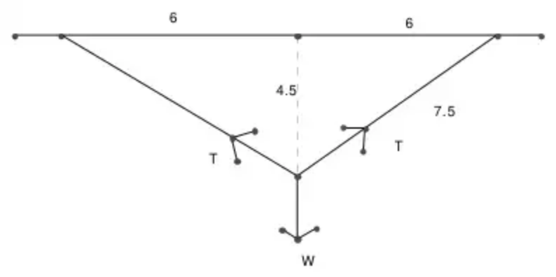
Scheme | Marks
Resolving vertically: $2Tcos⁡θ=W$ | M1A2,1,0
Hooke’s Law: $T=\frac{80×3.5}{4}$ | M1A1
$W=84$N | A1

Mark scheme (b)
Scheme | Marks
EPE $=2×\frac{80×3.5^{2}}{2×4},=245$ (or awrt 245)  (alternative $\frac{80×7^{2}}{16}=245$) | M1A1ft,A1
 | (9 marks)

3.
Mark scheme (a)
Scheme | Marks | AO
EPE at $A=\frac{λa^{2}}{2a}$ or EPE at $B=\frac{λ(2a)^{2}}{2a}$ | M1 | 2.1
Form work-energy equation: | M1 | 3.3
$\frac{λa^{2}}{2a}+mg×3a=\frac{λ(2a)^{2}}{2a}$ $(\frac{λa}{2}+3mga=2λa)$ | A1  A1 | 1.1b  1.1b
$3mg=\frac{3λ}{2}⇒λ=2mg$ * | A1* | 2.2a
 | (5)

Notes
M1: Correct method for EPE seen or implied
Need something of the form $\frac{1}{2}kx^{2}$ where $k=\frac{λ}{a}$
Must be using the formula for EPE correctly at least once
M1: Require all terms. Dimensionally correct. Condone their EPE. Condone sign errors
A1 A1: Unsimplified equation with at most one error. A repeated error in EPE formula is one error
Correct unsimplified equation.
A1*: Obtain given answer from correct working
Mark scheme (b)
Scheme | Marks | AO
Extension at equilibrium: | M1 | 2.1
$\frac{2mgx}{a}=mg⇒x=\frac{a}{2}$ * | A1* | 1.1b
Use work-energy equation to find max speed: | M1 | 3.4
$\frac{2mgx^{2}}{2a}+mg×(2a−x)+\frac{1}{2}mV^{2}=\frac{2mg(2a)^{2}}{2a}$  $(\frac{ag}{4}+\frac{3ag}{2}+\frac{1}{2}V^{2}=4ag)$ | A1  A1 | 1.1b  1.1b
$V=3\sqrt{\frac{ag}{2}}$ | A1 | 2.2a
 | (6)

Notes
M1: Use correct method for tension to find the extension at equilibrium. Need to see the formula for tension used.
Allow verification with an appropriate conclusion
If they use SHM they must use $F=ma$ to prove that $P$ is moving with SHM, otherwise 0/2.
A1*: Correct answer from correct work
Allow verification with an appropriate conclusion
M1: Use given $x$ to form work-energy equation. Need all terms, and dimensionally correct. Condone sign errors.
Accept with values of $λ$ and $x$ not substituted
A1 A1: Unsimplified equation with at most one error. Need given $λ$ and given $x$ substituted at some point. A repeated error in the formula for EPE is one error.
Correct unsimplified equation with given $λ$ and given $x$ substituted at some point
A1: Use correct method for tension to find the extension at equilibrium. Any equivalent form. $2.1\sqrt{ag}$ or better
Alternative for the first M1A1
Scheme | Marks | AO
Use the work-energy equation to obtain $\frac{\text{d}V^{2}}{\text{d}x}$ and set the derivative equal to zero | M1
$\frac{1}{a}×2x−1=0⇒x=\frac{a}{2}$ | A1

Alt: M1: Or an equivalent method for finding the turning point of a quadratic
Alt: A1*: Correct answer from correct work
Mark scheme (c)
Scheme | Marks | AO
e.g. for B1  Need to include the GPE of the spring  The extension of the spring at equilibrium will be different  The spring will have KE  You would need to include the KE of the spring in the energy equation  You would need to include the GPE of the spring in the energy equation  The GPE of the system changes  It would take work to raise the spring so the package would have less KE  If the spring has mass then GPE of the spring would need to be included | B1 | 3.5b
 | (1)
 | (12 marks)

Notes
B1: Any valid response.
B0 if answer includes an additional incorrect factor. Must be specific e.g. not just “the GPE changes”, but the GPE of the system changes is OK.
Must relate to an effect on the energy equation
E.g. for B0
The extension changes
$AB$ will increase
The tension/energy/GPE/work done etc would increase
The KE/GPE/EPE/acceleration/extension/velocity changes
The mass of the spring would drag down and the EPE would change
The EPE/KE/GPE etc would be variable
There would be tension in the spring as well
It has weight
The velocity would decrease as energy is converted

