QQQ – Further Mechanics 1 – Chapter 3 – Elastic Strings, Springs & Hooke's Law (Version 1)
Total Marks: 23
(23 = Platinum, 21 = Gold, 18 = Silver, 16 = Bronze)
1. A light elastic string of natural length 0.4 m has one end $A$ attached to a fixed point. The other end of the string is attached to a particle $P$ of mass 2 kg. When $P$ hangs in equilibrium vertically below $A$, the length of the string is 0.56 m.
(a) Find the modulus of elasticity of the string. (3)
A horizontal force is applied to $P$ so that it is held in equilibrium with the string making an angle $θ$ with the downward vertical. The length of the string is now 0.72 m.
(b) Find the angle $θ$. (3)
(Total 6 marks)
Edexcel M3 January 2008 Q1
2.
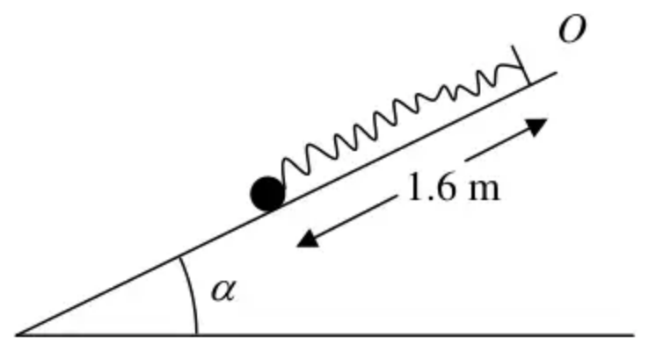
Figure 1
A particle of mass 0.8 kg is attached to one end of a light elastic spring, of natural length 2 m and modulus of elasticity 20 N. The other end of the spring is attached to a fixed point $O$ on a smooth plane which is inclined at an angle $α$ to the horizontal, where $tan⁡α=\frac{3}{4}$. The particle is held on the plane at a point which is 1.6 m down a line of greatest slope of the plane from $O$, as shown in Figure 1. The particle is then released from rest.
Find the initial acceleration of the particle. (6)
(Total 6 marks)
Edexcel M3 June 2005 Q1
3. A light elastic string with natural length $l$ and modulus of elasticity $kmg$ has one end attached to a fixed point $A$ on a rough inclined plane. The other end of the string is attached to a package of mass $m$.
The plane is inclined at an angle $θ$ to the horizontal, where $tan⁡θ=\frac{5}{12}$
The package is initially held at $A$. The package is then projected with speed $\sqrt{6gl}$ up a line of greatest slope of the plane and first comes to rest at the point $B$, where $AB=3l$.
The coefficient of friction between the package and the plane is $\frac{1}{4}$
By modelling the package as a particle,
(a) show that $k=\frac{15}{26}$ (6)
(b) find the acceleration of the package at the instant it starts to move back down the plane from the point $B$. (5)
(Total 11 marks)
Edexcel A2 October 2020 Q6
Solutions
1.
Mark scheme (a)
Scheme | Marks
$T$ or $\frac{λ×e}{l}=mg$ (even $T=m$ is M1, A0, A0 sp case) | M1
$\frac{λ×0.16}{0.4}=2g$ | A1
$⇒λ=\overset{‾}{49\text{N}}$ or 5g | A1
 | (3)

Mark scheme (b)
Scheme | Marks
R($↑$) $Tcos⁡θ=mg$ or $cos⁡θ=\frac{mg}{T}$ | M1
$49.\frac{0.32}{0.4}\text{.}cos⁡θ=19.6$ or $4g\text{.}cos⁡θ=2g$ or $2mg\text{.}cos⁡θ=mg$ (ft on their $λ$) | A1ft
$⇒cos⁡θ=\frac{1}{2}⇒θ=60^{∘}$ (or $\frac{π}{3}$ radians) | A1
 | (3)
 | (6 marks)

Notes
Special case $Tsin⁡θ=mg$ giving $θ=30$ is M1 A0 A0 unless there is evidence that they think $θ$ is with horizontal – then M1 A1 A0
2.
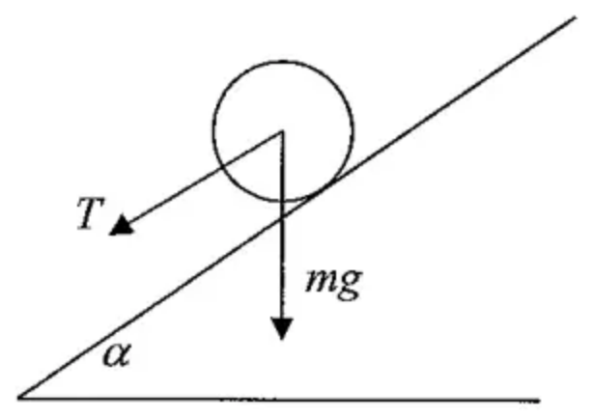
Scheme | Marks
HL $T=\frac{20×0.4}{2}(=4)$ accept $−4$ | M1 A1
$mgsin⁡α+T=ma$ | M1 A1
$0.8g×0.6+4=0.8a$ | M1
$a=10.88≈10.9({\text{m s}}^{−2})$ accept 11 | A1
 | (6 marks)

Notes
The scheme brackets the last two M1 marks: the M1 for $0.8g×0.6+4=0.8a$ depends on the previous M1.
3.
Mark scheme (a)
Scheme | Marks | AO
Work done against friction $=3l×μmgcos⁡θ(=\frac{9mgl}{13})$  Gain in EPE $=\frac{kmg×4l^{2}}{2l}(=2kmgl)$  Gain in GPE $=mg×3lsin⁡θ(=\frac{15mgl}{13})$ | B1  B1  B1 | 3.4  3.4  3.4
Work energy equation: | M1 | 2.1
$\frac{1}{2}m×6gl=\frac{9mgl}{13}+2kmgl+\frac{15mgl}{13}$ | A1 | 1.1b
$2k=3−\frac{24}{13}=\frac{15}{13}$, $k=\frac{15}{26}$ * | A1* | 2.2a
 | (6)

Notes
B1 B1 B1: Use model to obtain one correct term
Use model to obtain two correct terms
Use model to obtain three correct terms
M1: Work-energy equation. Need all terms and no extras. Dimensionally correct. Condone sign errors and sin/cos confusion.
A1: Correct unsimplified equation
A1*: Obtain given result from correct working
NB: The use of suvat equations is not a valid alternative method because the acceleration is not constant
Mark scheme (b)
Scheme | Marks | AO
Tension in the string at $B$: $\frac{\frac{15}{26}mg×2l}{l}(=\frac{15mg}{13})$ | B1 | 3.1a
Equation of motion: tension + component of weight − friction $=ma$ | M1 | 3.3
$\frac{15mg}{13}+mgsin⁡θ−\frac{1}{4}mgcos⁡θ=ma$  $(mg(\frac{15}{13}+\frac{5}{13}−\frac{3}{13})=ma)$ | A1  A1 | 1.1b  1.1b
$a=\frac{17g}{13}$ | A1 | 1.1b
 | (5)
 | (11 marks)

Notes
B1: Correct unsimplified expression for the tension in the string
M1: Equation of motion. Need all terms and no extras. Condone sign errors and sin/cos confusion Allow with $T$ or their $T$
A1 A1: Unsimplified equation with at most one error
Correct unsimplified equation
A1: Exact answer or accept 12.8 or 13 $({\text{m s}}^{−2})$

