QQQ – Further Mechanics 1 – Chapter 2 – Work, Energy & Power (Version 1)
Total Marks: 22
(22 = Platinum, 20 = Gold, 18 = Silver, 15 = Bronze)
1. A parcel of mass 2.5 kg is moving in a straight line on a smooth horizontal floor. Initially the parcel is moving with speed 8 m s${}^{−1}$. The parcel is brought to rest in a distance of 20 m by a constant horizontal force of magnitude $R$ newtons. Modelling the parcel as a particle, find
(a) the kinetic energy lost by the parcel in coming to rest, (2)
(b) the value of $R$. (3)
(Total 5 marks)
Edexcel M2 January 2008 Q1
2. A car of mass 1000 kg moves along a straight horizontal road at a constant speed $U{\text{m s}}^{−1}$. The engine of the car is working at a rate of 20 kW.
The total resistance to the motion of the car is modelled as a constant force of magnitude 1600 N.
Using the model,
(a) find the value of $U$. (3)
Later on, the car moves down a straight road which is inclined to the horizontal at an angle $α$, where $sin⁡α=\frac{1}{49}$
The total resistance to the motion of the car is again modelled as a constant force of magnitude 1600 N.
At the instant when the engine of the car is working at a rate of 20 kW and the speed of the car is $8{\text{m s}}^{−1}$, the acceleration of the car is $a{\text{m s}}^{−2}$
Using the model,
(b) find the value of $a$. (4)
(c) State one improvement to the model that would make it more realistic. (1)
(Total 8 marks)
Edexcel AS June 2025 Q1
3.
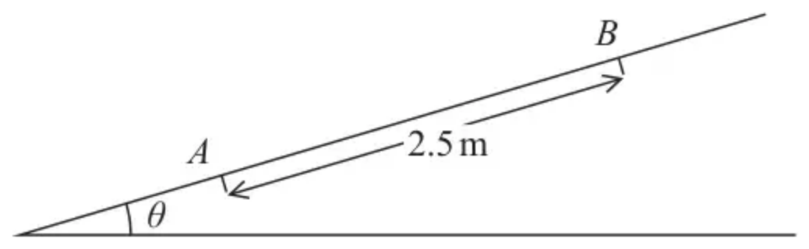
Figure 1
Figure 1 shows a ramp inclined at an angle $θ$ to the horizontal, where $sin⁡θ=\frac{2}{7}$
A parcel of mass 4 kg is projected, with speed $5{\text{m s}}^{−1}$, from a point $A$ on the ramp.
The parcel moves up a line of greatest slope of the ramp and first comes to instantaneous rest at the point $B$, where $AB=2.5$ m.
The parcel is modelled as a particle.
The total resistance to the motion of the parcel from non-gravitational forces is modelled as a constant force of magnitude $R$ newtons.
(a) Use the work-energy principle to show that $R=8.8$ (4)
After coming to instantaneous rest at $B$, the parcel slides back down the ramp. The total resistance to the motion of the particle is modelled as a constant force of magnitude 8.8 N.
(b) Find the speed of the parcel at the instant it returns to $A$. (3)
(c) Suggest two improvements that could be made to the model. (2)
(Total 9 marks)
Edexcel AS June 2018 Q2
Solutions
1.
Mark scheme (a)
Scheme | Marks
KE lost is $\frac{1}{2}×2.5×8^{2}=80$ (J) | M1 A1
 | (2)

Mark scheme (b)
Scheme | Marks
Work energy $80=R×20$ ft their (a) | M1 A1 ft
$R=4$ | A1
 | (3)
 | (5 marks)

Alternative to (b)
$0^{2}=8^{2}−2×a×20⇒a=(−)1.6$
N2L $R=2.5×1.6$ ft their $a$ | M1 A1ft
$=4$ | A1

(3)
2.
Mark scheme (a)
Scheme | Marks | AO
Equation of motion | M1 | 3.4
$\frac{20000}{U}−1600=0$ | A1 | 1.1b
$U=12.5$ | A1 | 1.1b
 | (3)

Notes
M1: Allow $F−1600=0$ or $F=1600$
A1: Correct equation in $U$ only.
A1: Allow 13
N.B. A correct answer only, with no working, can score all 3 marks.
Mark scheme (b)
Scheme | Marks | AO
$\frac{20000}{8}=F$, the driving force | B1 | 3.3
Equation of motion | M1 | 3.1b
$F+1000gsin⁡α−1600=1000a$ | A1 | 1.1b
$a=1.1$ | A1 | 1.1b
 | (4)

Notes
B1: Seen or implied. Allow 20 instead of 20000.
B0 if they use $\frac{20000}{8}$ as the resultant force not the driving force.
M1: Correct no. of terms, condone sign errors and sin/cos confusion.
A1: Correct equation.
A1: cao
Mark scheme (c)
Scheme | Marks | AO
E.g. Make the resistance dependent on the speed.  Make the resistance variable (not constant) | B1 | 3.5c
B0: Anything which is not related to the model i.e. to the total resistance being constant.
e.g. Model the road as rough, include friction, include air resistance, unevenness of the road, more accurate value of $g$, make air resistance dependent on the speed.
N.B. If there is more than one answer, penalise incorrect extras once e.g. one correct, one incorrect is B0.
 | (1)
 | (8 marks)

Notes
B1: Accept ‘make resistance non-constant’ oe
3.
Mark scheme (a)
Scheme | Marks | AO
Work-energy equation: KE lost = PE gained + Work Done | M1 | 2.1
$\frac{1}{2}×4×5^{2}−4×g×2.5×sin⁡θ=2.5R$ | A1 | 1.1b
$\frac{1}{2}×4×5^{2}−4×g×2.5×\frac{2}{7}=2.5R$ | A1 | 1.1b
$2.5R=22⇒R=8.8$ * | A1* | 1.1b
 | (4)

Notes
M1: A complete method to obtain $R$. The question requires the use of work-energy. Need to consider all three terms with no duplication. Condone sign error and sin/cos confusion.
A1: Unsimplified equation with at most one error
A1: Correct unsimplified
A1*: Correct answer with sufficient working shown to justify given answer
Mark scheme (b)
Scheme | Marks | AO
Work-energy equation: KE after = initial KE – 2 (Work Done) | M1 | 3.3
$\frac{1}{2}×4×v^{2}=\frac{1}{2}×4×25−2×8.8×2.5$ | A1 | 1.1b
$⇒2v^{2}=6,v=1.7({\text{m s}}^{−1})$ | A1 | 1.1b
 | (3)

Notes
M1: Work-energy equation considering $A→A$ or $B→A$. Requires all relevant terms with no duplication. Condone sign errors and sin/cos confusion
A1: Correct unsimplified equation
A1: Accept 1.7 or 1.73 (answer depends on use of g). Not $\sqrt{3}$
Alternative (b)
Scheme | Marks | AO
Work-energy equation: KE at $A$ = PE lost – Work Done | M1
$\frac{1}{2}×4×v^{2}=4×9.8×\frac{2}{7}×2.5−8.8×2.5$ | A1
$⇒2v^{2}=6,v=1.7({\text{m s}}^{−1})$ | A1
 | (3)

(corrected from the printed mark scheme: “KE at $B$”, but the kinetic energy found is at $A$; the parcel is at rest at $B$)
Alternative (b)
Scheme | Marks | AO
Equation of motion and suvat: $4gsin⁡θ−8.8=4a (a=0.6)$ | M1
$v^{2}=2×a×2.5$ | A1
$v=1.7({\text{m s}}^{−1})$ | A1
 | (3)

M1: Complete method to find $v$ or $v^{2}$.
A1: Correct unsimplified expression for $v$ or $v^{2}$.
A1: Accept 1.7 or 1.73 (answer depends on use of g)
Mark scheme (c)
Scheme | Marks | AO
A valid improvement | B1 | 3.5c
A second valid, distinct, improvement | B1 | 3.5c
 | (2)
 | (9 marks)

Notes
B1: it has assumed a constant resistance - have variable resistance
-have air resistance proportional to speed ……
B1: Do not model the parcel as a particle
- so can consider the possibility that the parcel rotates as it moves up/down the slope
- consider the dimensions of the parcel
The comments need to relate to the 2 modelling assumptions in the question. Air resistance and friction are already included in "non-gravitational forces".

