QQQ – Decision 2 – Chapter 8 – Decision Analysis (Version 2)
Total Marks: 26
(26 = Platinum, 23 = Gold, 21 = Silver, 18 = Bronze)
1. The table below shows the transport options, usual travel times, possible delay times and corresponding probabilities of delay for a journey. All times are in minutes.
Transport option | Usual travel time | Possible delay time | Probability of delay
Car | 52 | 10 | 0.10
25 | 0.02
Train | 45 | 15 | 0.05
25 | 0.03
Coach | 55 | 5 | 0.05
15 | 0.01

(a) Draw a decision tree to model the transport options and the possible outcomes. (5)
(b) State the minimum expected travel time and the corresponding transport option indicated by the decision tree. (2)
(Total 7 marks)
Edexcel A2 June 2022 Q3
2. Jenny can choose one of three options, A, B or C, when playing a game. The profit, in pounds, associated with each outcome and their corresponding probabilities are shown on the decision tree in Figure 1.
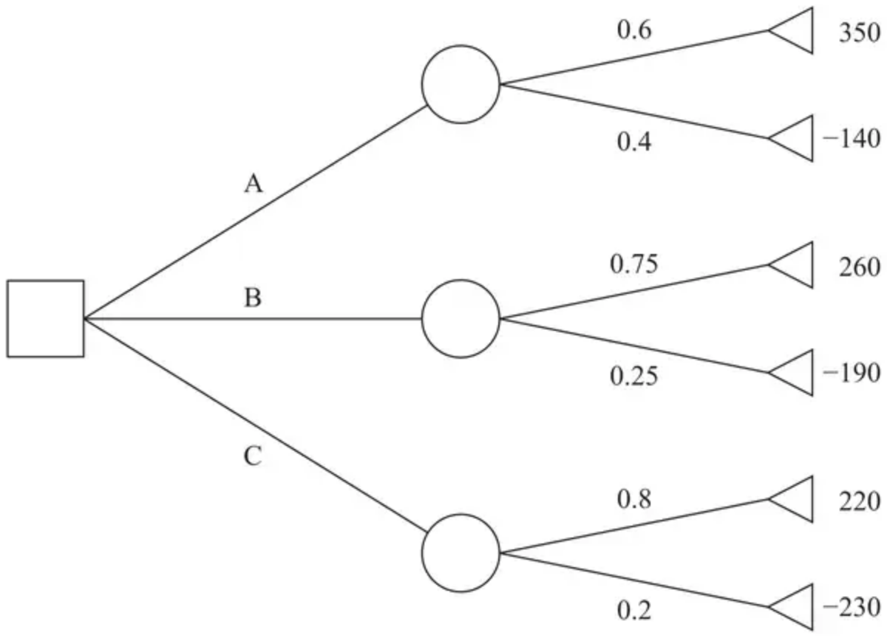
Figure 1
(a) Calculate the optimal EMV to determine Jenny’s best course of action. You must make your working clear. (3)
For a profit of £$x$, Jenny’s utility is given by $1−{\text{e}}^{−\frac{x}{400}}$
(b) Using expected utility as the criterion for the best course of action, determine what Jenny should do now to maximise her profit. You must make your working clear. (4)
(Total 7 marks)
Edexcel A2 October 2020 Q2
3. Aisha is deciding whether or not to play a game.
The game involves rolling three fair six-sided dice, which have faces numbered from 1 to 6
If the total score on the three dice is 16 or more then she wins a prize. If the total score is 15 or less then she loses and will have to pay the person running the game £3
(a) Given that the prize is £15
(i) draw a decision tree to model Aisha’s possible decisions and the possible outcomes
(ii) determine Aisha’s optimal EMV and state the optimal strategy indicated by the decision tree. (6)
The utility function of the game to Aisha is $\text{u}(m)=1−{\text{e}}^{−\frac{m}{500}}$ where $m$ is the amount of money that Aisha has available. Given that Aisha has exactly £3 and that the prize is now £$x$
(b) find the expected utility to Aisha of playing the game in the form
$$\frac{a}{b}(1−{\text{e}}^{−\frac{(x+c)}{500}})$$
where $a$, $b$ and $c$ are integers to be found. (2)
Aisha decides to use the expected utilities to determine whether she should play the game or not.
(c) Find the minimum prize for which Aisha would consider playing the game. (4)
(Total 12 marks)
Edexcel A2 June 2019 Q7
Solutions
1.
Mark scheme (a)
Scheme | Marks | AO
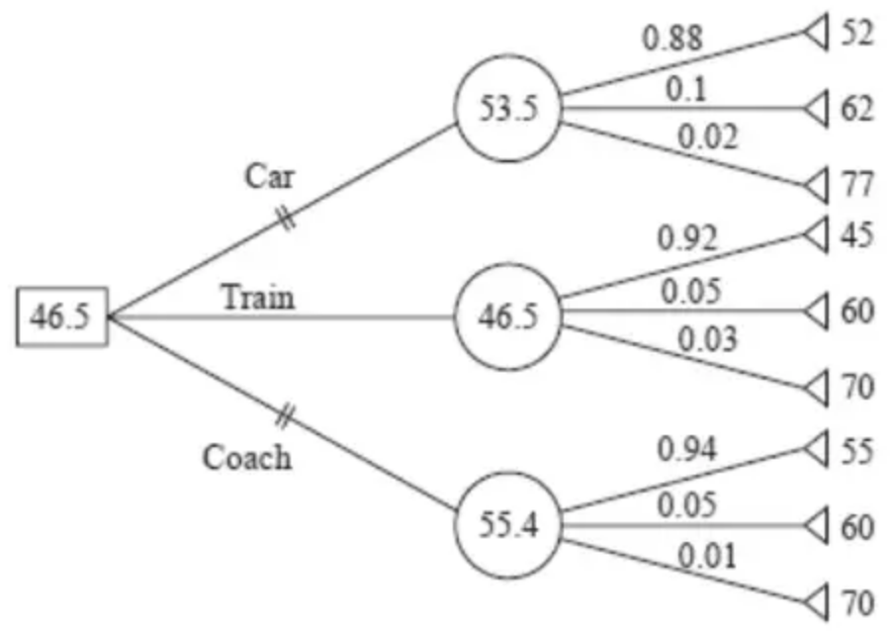 | M1  A1  M1  M1  A1 | 3.3  1.1b  3.4  3.4  1.1b
 | (5)

Notes
M1: tree diagram with at least nine end pay-offs, one decision node and at least three chance nodes used correctly
A1: correct structure of tree diagram with each arc labelled correctly (including probabilities)
M1: at least three end-pay offs consistent with their stated probabilities (eg time 52 with probability 0.88); all nine attempted
M1: chance nodes attempted with their probabilities. Must be filled in on their diagram.
A1: cao for chance and decision nodes completed correctly
Mark scheme (b)
Scheme | Marks | AO
Minimum expected travel time is 46.5 minutes  Transport option is Train | B1ft  B1 | 3.4  2.2a
 | (2)
 | (7 marks)

Notes
B1ft: correct travel time from their completed tree diagram (dependent on all method marks earned in (a))
B1: deduction of correct transport option (dependent on all method marks earned in (a)) including double line through inferior options in (a) (condone cross or single line here)
2.
Mark scheme (a)
Scheme | Marks | AO
EMV for A is $0.6(350)+0.4(−140)=154$  EMV for B is $0.75(260)+0.25(−190)=147.5$  EMV for C is $0.8(220)+0.2(−230)=130$ | M1  A1 | 3.4  1.1b
The optimal EMV is £154, which makes option A the best choice using the EMV criterion | A1 | 2.2a
 | (3)

Notes
M1: Correct method for calculation EMV for either A, B or C
A1: Correct values of EMV for A, B and C
A1: Correct deduction of optimal EMV (dependent on all three correct EMVs)
Mark scheme (b)
Scheme | Marks | AO
$u(350)=0.5831379803…,u(−140)=−0.4190675486…$  $u(260)=0.4779542232…,u(−190)=−0.6080141975…$  $u(220)=0.4230501896…,u(−230)=−0.7771305269…$ | M1 | 3.4
Calculate all three expected utilities:  A is $0.6(0.583…)+0.4(−0.419…)=0.1822557…$  B is $0.75(0.477…)+0.25(−0.608…)=0.2064621…$  C is $0.8(0.423…)+0.2(−0.777…)=0.1830140…$ | DM1  A1 | 1.1b  1.1b
The optimal expected utility is 0.206 utils, which makes option B the best choice using expected utility as the criterion | A1 | 2.2a
 | (4)
 | (7 marks)

Notes
M1: Uses the correct utility function to replace each pay-off with the corresponding utility
DM1: Calculate all three expected utilities using correct probability values from (a)
A1: At least 2 expected utilities correct (correct to at least 2 decimal places)
A1: Correct deduction of optimal expected utility
3.
Mark scheme (a)
Scheme | Marks | AO
(i)  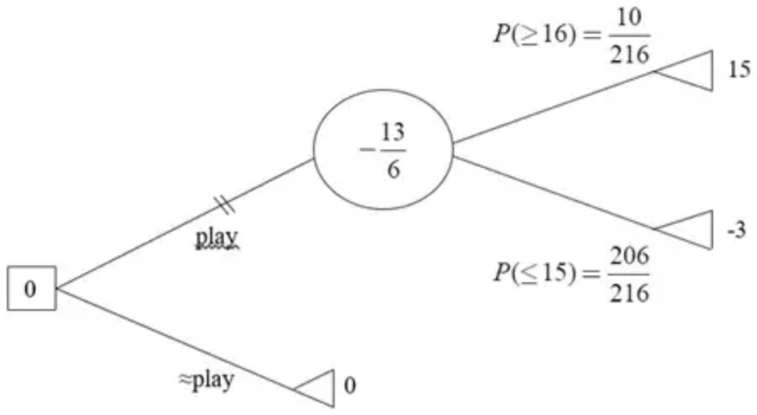 | 1M1  1B1  1A1  2M1  2A1 | 3.3  1.1b  1.1b  3.4  1.1b
(ii) Optimum EMV is (£)0 and Aisha should not play the game | 1B1ft | 3.2a
 | (6)

Notes
(a)(i) 1M1: tree diagram with at least three end pay-offs, one (rectangular) decision node and one (circular) chance node
1B1: Correct probability for rolling 16 or more (accept equivalent fractions)
1A1: Correct structure of tree diagram with each arc labelled correctly. The following must be seen for this mark:
• Probabilities on branches leading from chance node. Probabilities may not be correct but must sum to 1
• ‘Play’ and ‘Not Play’ (o.e.) labelled correctly. (If one branch is labelled correctly then condone lack of label on the other branch).
• Pay offs: 15, –3, 0 placed at tree ends (do not condone ‘3’ for ‘–3’)
2M1: Correct chance node. ft from their probabilities: $15p−3(1−p)$ where $p$ is their probability for rolling 16 or more. If given as a decimal allow for correct (or truncated) to 2dp
2A1: CAO (must be exact) for chance and decision node including double line through inferior option
Note must see 0 at the decision node for this mark.
(ii) 1B1ft: correct optimal EMV (clearly indicated) and analysis in context.
So: If their EMV for playing game < 0 then ‘Optimum EMV = 0, together with corresponding conclusion: ‘Aisha should not play’ o.e. would earn B1.
Whereas, if their EMV for playing game > 0 then ‘Optimum EMV = their EMV of playing game’ together with corresponding conclusion: ‘Aisha should play’ o.e. would earn B1. (Corrected from the printed mark scheme, which has ‘should play’ and ‘should not play’ the wrong way round in these two sentences.)
BUT If their EMV for playing game does not ft from their probabilities then B0.
Mark scheme (b)
Scheme | Marks | AO
Expected utility is $\frac{10}{216}(1−{\text{e}}^{−\frac{(x+3)}{500}})$ | 1M1  1A1 | 3.4  2.2a
 | (2)

Notes
1M1: $p(1−{\text{e}}^{−\frac{(x+3)}{500}})$ with their $p$ from (a)
Note: isw after a correct expression for M mark. May see:
$p(1−{\text{e}}^{−\frac{(x+3)}{500}})+(1−p)(1−{\text{e}}^{−\frac{(−3+3)}{500}})$ o.e.
1A1: CAO for expected utility. Must be of the correct form as is specified in the question. So: $\frac{10}{216}(1−{\text{e}}^{−\frac{(x+3)}{500}})$ but allow fractions equivalent to $\frac{10}{216}$
Mark scheme (c)
Scheme | Marks | AO
If Aisha doesn’t play she will have $3⇒1−{\text{e}}^{−\frac{3}{500}}$ | 1B1 | 3.1a
For the prize to be worthwhile $\frac{10}{216}(1−{\text{e}}^{−\frac{(x+3)}{500}})>1−{\text{e}}^{−\frac{3}{500}}$ | 1M1 | 1.1b
Correct order of operations and use of logs to find $x$ | 2dM1 | 1.1b
$x>66.178…$ so (minimum prize amount should be) £66.18 | 1A1 | 3.2a
 | (4)
 | (12 marks)

Notes
1B1: CAO. May be in decimal form: 0.00598…. May be embedded in inequality/equation.
Note: Look out for missing minus sign in the power if stated exactly.
Note: Do not award this mark if seen in only part (b).
1M1: Sets up an inequality or equation with their expected utility of playing the game (from part b).
2dM1: Solving for $x$ (dependent on previous M mark). Requires correct order of operations and log work.
For example,
May see: ${\text{e}}^{−\frac{(x+3)}{500}}\text{□}1−\text{‘}p\text{’}(1−{\text{e}}^{−\frac{(3)}{500}})$ o.e. [Isolates exponential term]
Or ${\text{e}}^{−\frac{(x+3)}{500}}\text{□}0.870…$
Followed by: $\frac{(x+3)}{500}\text{□}−ln⁡(1−\text{‘}p\text{’}(1−{\text{e}}^{−\frac{(3)}{500}}))$ o.e. [Applies logs correctly]
Or $\frac{(x+3)}{500}\text{□}0.138…$
Where $\text{□}$ is any inequality or equals sign.
Note: May not get to $x=…$
Note: Can be implied by correct answer
1A1: CAO with units
Note: For this mark, condone ‘£66.18’ or ‘$x=$ £66.18’ or ‘$x⩾$ £66.18’, but not ‘$x>$ £66.18’.

