QQQ – Decision 2 – Chapter 8 – Decision Analysis (Version 1)
Total Marks: 25
(25 = Platinum, 23 = Gold, 20 = Silver, 17 = Bronze)
1. Ravi can choose one of three options, A, B or C, when playing a game. The profit, in pounds, associated with each outcome, and the corresponding probabilities, are shown in the decision tree in Figure 1.
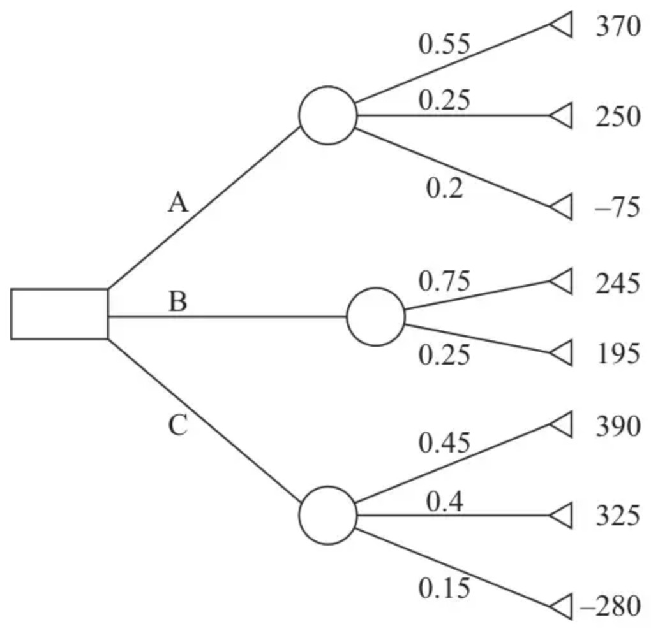
Figure 1
Calculate the optimal EMV to determine Ravi’s best course of action. You must make your working clear. (3)
(Total 3 marks)
Edexcel A2 June 2025 Q1
2. An outdoor theatre is holding a summer gala performance. The theatre owner must decide whether to take out insurance against rain for this performance.
The theatre owner estimates that
• on a fine day, the total profit will be £15 000
• on a wet day, the total loss will be £20 000
Insurance against rain costs £2 000. If the performance must be cancelled due to rain, then the theatre owner will receive £16 000 from the insurer. If the performance is not cancelled due to rain, then the theatre owner will receive nothing from the insurer.
The probability of rain on the day of the gala performance is 0.2
Draw a decision tree and hence determine whether the theatre owner should take out the insurance against rain for this performance. (5)
(Total 5 marks)
Edexcel A2 June 2023 Q2
3. Alka is considering paying £5 to play a game. The game involves rolling two fair six-sided dice. If the sum of the numbers on the two dice is at least 8, she receives £10, otherwise she loses and receives nothing.
If Alka loses, she can pay a further £5 to roll the dice again. If both dice show the same number then she receives £35, otherwise she loses and receives nothing.
(i) Draw a decision tree to model Alka’s possible decisions and the possible outcomes.
(ii) Determine Alka’s optimal EMV and state the optimal strategy indicated by the decision tree. (7)
(Total 7 marks)
Edexcel A2 October 2021 Q2
4. Sebastien needs to make a journey. He can choose between travelling by plane, by train or by coach.
Sebastien knows the exact costs of all three travel options, but he also wants to account for his travel time, including any possible delays.
The cost of Sebastien’s time is £50 per hour.
The table below shows the costs, the journey times (without delays), and the corresponding probabilities of delays, for each travel option.
 | Cost of travel option | Journey time (in hours) without delays | Probability of a 1-hour delay | Probability of a 2-hour delay | Probability of a 3-hour delay | Probability of a 24-hour delay
Plane | £200 | 3 | 0.09 | 0.05 | 0 | 0.03
Train | £130 | 5 | 0.07 | 0.03 | 0 | 0
Coach | £70 | 6 | 0.15 | 0.1 | 0.05 | 0

(a) By drawing a decision tree, evaluate the EMV of the total cost of Sebastien’s journey for each node of your tree. (6)
(b) Hence state the travel option that minimises the EMV of the total cost of Sebastien’s journey. (1)
(c) A cube root utility function is applied to the total costs of each option. Determine the travel option with the best expected utility and state the corresponding value. (3)
(Total 10 marks)
Edexcel A2 June 2024 Q5
Solutions
1.
Scheme | Marks | AO
EMV for A is $0.55(370)+0.25(250)+0.2(−75)=251$  EMV for B is $0.75(245)+0.25(195)=232.5$  EMV for C is $0.45(390)+0.4(325)+0.15(−280)=263.5$ | M1  A1 | 3.4  1.1b
The optimal EMV is £263.50, which makes option C the best choice (using the EMV criterion) | A1 | 2.2a
 | (3)
 | (3 marks)

Notes
Note: Working (or values) may be seen on the diagram as well as on the lined page. If both seen, the answers on the lined page take precedent. Completion of the diagram is not necessary.
M1: Correct method for calculation EMV for either A, B or C
A1: Correct values of EMV for A, B and C
A1: Correct deduction of optimal EMV (dependent on all three correct EMVs) C must be clearly identified in some way, either stated or indicated with e.g. an arrow. If all working is shown on the diagram with 263.50 written in the decision node, they must still indicate C in some way.
2.
Scheme | Marks | AO
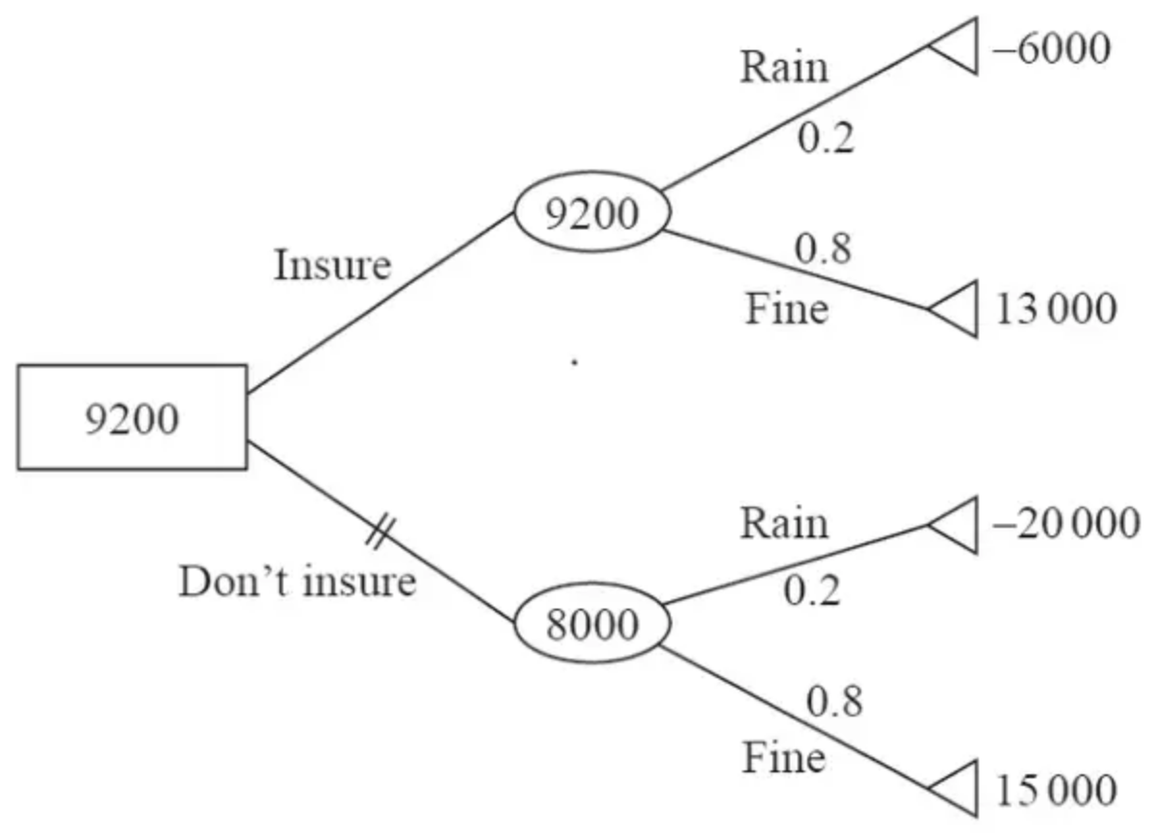 | M1  A1  A1  M1 | 3.3  1.1b  3.4  3.4
The theatre owner should take out the insurance | A1 | 1.1b
 | (5)
 | (5 marks)

Notes
M1: tree diagram with at least four end pay-offs, one decision node and two chance nodes used correctly (may not have all shapes drawn e.g. no triangles on end pay-offs)
A1: correct structure of tree diagram with each arc labelled correctly with word and associated probabilities (condone incorrect shapes for decision and chance nodes)
A1: at least three end pay-offs correct including triangles; all four attempted (not dependent on previous A mark so M1 A0 A1 is possible)
M1: both chance nodes completed with at least one value correct. Must be filled in on their diagram.
A1: cao for chance and decision nodes (all three correctly filled in on diagram) + clear conclusion ‘insure’ including double line through the inferior option.
3.
Scheme | Marks | AO
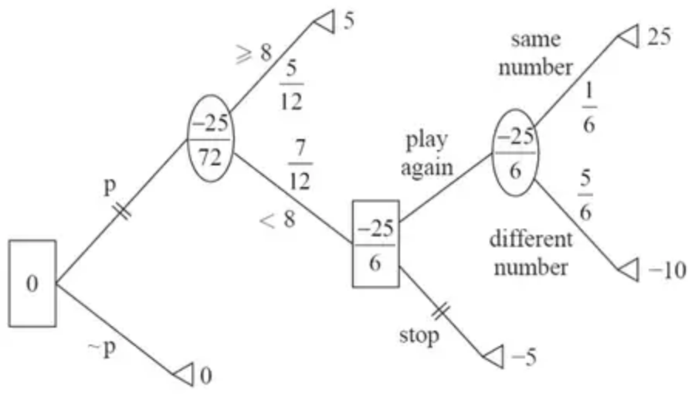 | M1  B1  A1  M1  M1  A1 | 3.3  1.1b  1.1b  3.4  3.4  1.1b
EMV is £0 and Alka should not play the game | B1 | 3.2a
 | (7)
 | (7 marks)

Notes
M1: Tree diagram with at least five end pay-offs, two decision nodes and two chance nodes
B1: Correct probabilities for rolling an 8 or more and obtaining the same number on both dice
A1: Correct structure for the tree diagram with each arc labelled correctly (including probabilities)
M1: At least three end-pay offs consistent with their stated probabilities; all five attempted
M1: Chance nodes attempted with their probabilities
A1: cao for chance and decision nodes including double line through inferior option
B1: Correct EMV and analysis in context
4.
Mark scheme (a)
Scheme | Marks | AO
Note arcs must show delay time and probability  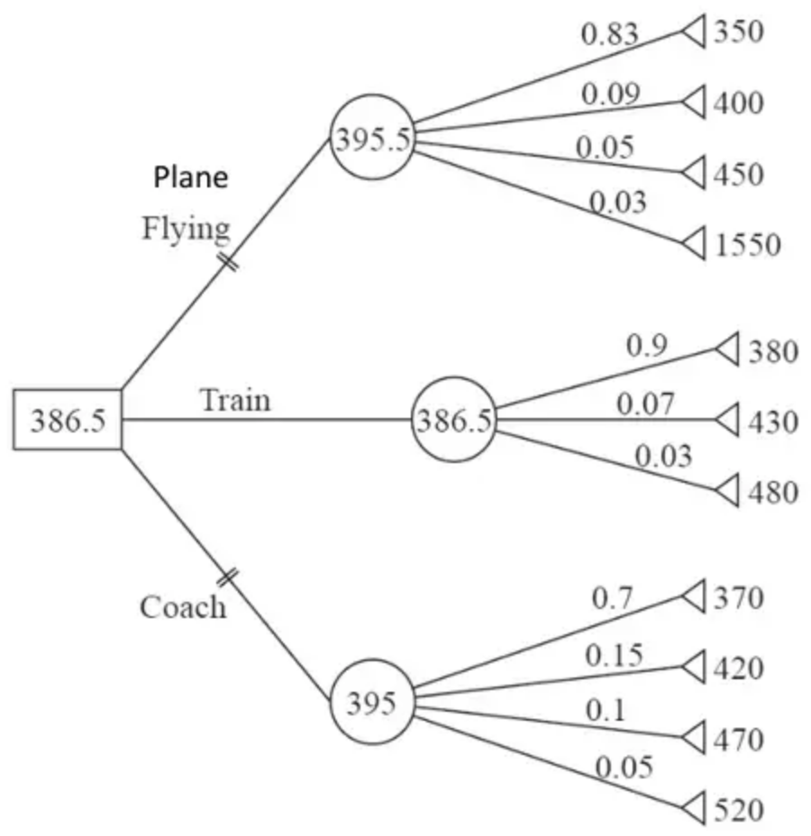 | M1  A1  M1  A1  M1  A1 | 3.3  1.1b  3.4  1.1b  3.4  1.1b
 | (6)

Notes
(a) Condone additional arcs seen with 0 probability (plane 3 hours, train 3 and 24 hours, coach 24 hours)
M1: tree diagram with at least eight end pay-offs, one decision node and three chance nodes (condone missing triangles from end pay offs and incorrect shapes for decision and chance nodes)
A1: correct structure of tree diagram with the non-zero probability 11 arcs labelled correctly (including probabilities)
M1: at least three end-pay offs consistent with their stated probabilities (must include ticket price, cost for travel time and cost for delay – may be implied by correct values); at least eight attempted
A1: all eleven end-pay offs correct including triangles and no incorrect extra (condone if not fully simplified) (values may be negative as costs)
M1: all three chance nodes attempted with their probabilities
A1: CAO for chance and decision nodes including double line through inferior options – must have the correct shapes
Mark scheme (b)
Scheme | Marks | AO
Travel option is Train | dB1 | 2.2a
 | (1)

Notes
dB1: deduction of correct travel option (dependent on all method marks earned in (a))
Mark scheme (c)
Scheme | Marks | AO
Utility values are 7.2427…, 7.2820…, 7.3282… | M1  A1 | 1.1b  1.1b
Therefore, the travel option with the best expected utility is Plane | A1 | 2.2a
 | (3)
 | (10 marks)

Notes
M1: At least one (of the three) utility values correct (FT their end pay offs)
A1: At least two correct
A1: Correct travel option (Plane) together with all three correct values (to at least 3 sf – rounded or truncated)

