QQQ – Decision 2 – Chapter 6 – Game Theory (Version 2)
Total Marks: 22
(22 = Platinum, 20 = Gold, 18 = Silver, 15 = Bronze)
1. Anna (A) and Roland (R) play a two-person zero-sum game which is represented by the following pay-off matrix for Anna.
 | R plays 1 | R plays 2 | R plays 3
A plays 1 | 6 | −2 | −3
A plays 2 | −3 | 1 | 2
A plays 3 | 5 | 4 | −1

Formulate the game as a linear programming problem for player R. Write the constraints as inequalities. Define your variables clearly. (8)
(Total 8 marks)
Edexcel D2 June 2007 Q6
2. A two-person zero-sum game is represented by the following pay-off matrix for player $A$.
 | $B$ plays X | $B$ plays Y
$A$ plays Q | $2$ | $−2$
$A$ plays R | $−1$ | $5$
$A$ plays S | $3$ | $4$
$A$ plays T | $0$ | $2$

(a)
(i) Show that this game is stable.
(ii) State the value of this game to player $B$. (3)
Option S is removed from player $A$’s choices and the reduced game, with option S removed, is no longer stable.
(b) Write down the reduced pay-off matrix for player $B$. (1)
Let $B$ play option X with probability $p$ and option Y with probability $1−p$.
(c) Use a graphical method to find the optimal value of $p$ and hence find the best strategy for player $B$ in the reduced game. (6)
(d)
(i) Find the value of the reduced game to player $A$.
(ii) State which option player $A$ should never play in the reduced game.
(iii) Hence find the best strategy for player $A$ in the reduced game. (4)
(Total 14 marks)
Edexcel AS June 2023 Q3
Solutions
1.
Scheme | Marks
Alt 1
Game from R’s point of view.  Add 7 | B1, B1
   | A1 | A2 | A3
  $R_{1}$ | −6 | 3 | −5
  $R_{2}$ | 2 | −1 | −4
  $R_{3}$ | 3 | −2 | 1
   | A1 | A2 | A3
  $R_{1}$ | 1 | 10 | 2
  $R_{2}$ | 9 | 6 | 3
  $R_{3}$ | 10 | 5 | 8
Let R play 1 with probability ${\text{P}}_{1}$, 2 with probability ${\text{P}}_{2}$, 3 with probability ${\text{P}}_{3}$  V = value of the game | B1
Maximise $\text{P}=\text{V}$ | B1
Subject to $\text{V}−{\text{P}}_{1}−9{\text{P}}_{2}−10{\text{P}}_{3}⩽0$ | M1 A1ft
$\text{V}−10{\text{P}}_{1}−6{\text{P}}_{2}−5{\text{P}}_{3}⩽0$ | A1ft
$\text{V}−2{\text{P}}_{1}−3{\text{P}}_{2}−8{\text{P}}_{3}⩽0$ | A1ft
${\text{P}}_{1}+{\text{P}}_{2}+{\text{P}}_{3}⩽1$ accept =  $\text{V},{\text{P}}_{1},{\text{P}}_{2},{\text{P}}_{3}⩾0$ | A1
 | (8 marks)

Notes
Alt 2
Add 4 to all entries | B1
   | $R_{1}$ | $R_{2}$ | $R_{3}$
  A1 | 10 | 2 | 1
  A2 | 1 | 5 | 6
  A3 | 9 | 8 | 3
Let R play 1 with probability ${\text{P}}_{1}$, 2 with probability ${\text{P}}_{2}$, 3 with probability ${\text{P}}_{3}$; let V = value of game. | B1
Let $x_{1}=\frac{{\text{P}}_{1}}{\text{V}},x_{2}=\frac{{\text{P}}_{2}}{\text{V}},x_{3}=\frac{{\text{P}}_{3}}{\text{V}}$ | B1
Maximise $\text{P}=x_{1}+x_{2}+x_{3}$ | B1
Subject to $10x_{1}+2x_{2}+x_{3}⩽1$ | M1 A1ft
$x_{1}+5x_{2}+6x_{3}⩽1$ | A1ft
$9x_{1}+8x_{2}+3x_{3}⩽1$  $x_{1},x_{2},x_{3}⩾0$ accept ${\text{P}}_{i}⩾0$ | A1

The codes listed for Alt 1 add up to 9, but the question total is 8 marks.
2.
Mark scheme (a)
Scheme | Marks | AO
(i) Row minima: $−2,−1,3,0$ max is 3  Column maxima: 3, 5 min is 3 | M1 | 1.1b
Row(maximin) $=$ Col(minimax) which are both 3 therefore game is stable | A1 | 2.4
(ii) Value of the game to player $B$ is $−3$ | A1 | 2.2a
 | (3)

Notes
M1: finding row minimums and column maximums – condone one error
A1: row maximin 3 = col minimax 3 (so stable) – dependent on all 6 correct values – as a minimum must see the two 3’s explicitly being considered
A1: cao ($−3$) – ‘lose 3’ is A0
Mark scheme (b)
Scheme | Marks | AO
$(\begin{matrix}−2 & 1 & 0 \\ 2 & −5 & −2\end{matrix})$ | B1 | 1.1b
 | (1)

Notes
B1: cao (must be the reduced game so with option S removed)
Mark scheme (c)
Scheme | Marks | AO
If $A$ plays option Q, $B$’s gains are $−2p+2(1−p)=2−4p$  If $A$ plays option R, $B$’s gains are $p+(−5)(1−p)=−5+6p$  If $A$ plays option T, $B$’s gains are $(−2)(1−p)=−2+2p$ | M1  A1 | 1.1b  1.1b
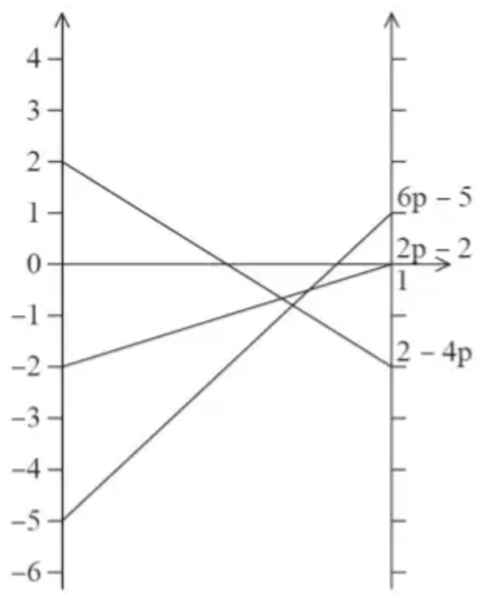 | M1  A1 | 1.1b  1.1b
$2−4p=−5+6p⇒p=7\text{/}10$ | A1 | 1.1b
$B$ should play option X with probability 7/10 and option Y with probability 3/10 | A1ft | 3.2a
 | (6)

Notes
In (c) if the candidate includes option S (and so has four expressions and lines) then this can score the first 3 marks only in this part
M1: setting up three expressions in terms of $p$
A1: all three expressions correctly simplified
M1: at least two lines correctly drawn for their expressions – if values on at least one vertical axis not given then lines must be in the right position relative to each other
A1: completely correct graph with clear indication of the correct intersection points at the ends where $p=0$ and $p=1$ (so if no scaling on the vertical axis assume that 1 line = 1 unit (unless other suitable scaling is clear), and lines must not extend past $p<0$ and/or $p>1$)
A1: using the graph (with 3 lines) to obtain the correct probability expressions leading to the correct value of $p$
A1ft: interpret their value of $p$ in the context of the question – must refer to ‘play’ and the associated probabilities (but do not need to explicitly use the word ‘probability’)
Mark scheme (d)
Scheme | Marks | AO
(i) $6(\frac{7}{10})−5=−4\text{/}5⇒$ value of the game to player $A$ is 4/5 | B1 | 3.1a
(ii) Player $A$ should never play option T | B1 | 2.2a
(iii) If $A$ plays their option Q with probability $q$ and their option R with probability $1−q$ then $2q+(−1)(1−q)=\frac{4}{5}$ | M1 | 3.1b
$q=\frac{3}{5}⇒$ $A$ should play option Q with probability 3/5 and option R with probability 2/5 (play S and T never) | A1 | 3.2a
 | (4)
 | (14 marks)

Notes
(d)(i) B1: cao ($\frac{4}{5}$ or 0.8)
(d)(ii) B1: cao (option T)
(d)(iii) M1: Setting up a linear equation with their V($A$) from (d)(i) wither either of the two correct expressions $2q+(−1)(1−q)$ or $−2q+5(1−q)$ or setting up the correct equation $−2q+5(1−q)=2q+(−1)(1−q)$ (or $2q−5(1−q)=−2q+(1−q)$)
A1: interpret the correct value of $q$ in the context of the question – must refer to ‘play’ and the associated probabilities (but do not need to explicitly use the word ‘probability’)
(corrected from the printed mark scheme: the printed line in (d)(i) reads “6 7/10 −5 = −4/5”, with the bracket/multiplication between 6 and 7/10 missing)

