QQQ – Decision 2 – Chapter 6 – Game Theory (Version 1)
Total Marks: 24
(24 = Platinum, 22 = Gold, 19 = Silver, 16 = Bronze)
1. Layla and Mohsin play a zero-sum game represented by the following pay-off matrix for Layla.
 | Mohsin plays X | Mohsin plays Y | Mohsin plays Z
Layla plays P | $1$ | $−2$ | $2$
Layla plays Q | $−4$ | $3$ | $−5$
Layla plays R | $−1$ | $1$ | $−3$

(a)
(i) Find the play-safe strategies for each player.
(ii) State, giving a reason, whether there is a stable solution to this game. (3)
(b) Option R is now removed from Layla’s choices.
(i) For each of Mohsin’s three options, find the expected pay-off to Layla when she plays options P and Q equally often. (1)
(ii) Use a graphical method to determine Layla’s optimal mixed strategy. You should define any variables you use. (7)
(Total 11 marks)
Edexcel AS June 2025 Q3
2. A two-person zero-sum game is represented by the following pay-off matrix for player A.
 | B plays 1 | B plays 2 | B plays 3 | B plays 4
A plays 1 | −3 | 2 | 5 | −1
A plays 2 | −5 | 3 | 1 | −1
A plays 3 | −2 | 5 | 4 | 2
A plays 4 | 2 | −3 | −1 | 4

(a) Identify the play safe strategies for each player. (3)
(b) State, giving a reason, whether there is a stable solution to this game. (1)
(c) Explain why the game above can be reduced to the following 3×3 game.
−3 | 2 | 5
−2 | 5 | 4
2 | −3 | −1

(2)
(d) Formulate the 3×3 game as a linear programming problem for player A, defining your variables clearly and writing the constraints as inequalities. (7)
(Total 13 marks)
Edexcel D2 June 2018 Q2
Solutions
1.
Mark scheme (a)
Scheme | Marks | AO
(i) Row minima: $−2,−5,−3$ maximum is $−2$  Column maxima: $1,3,2$ minimum is $1$  Layla’s play-safe is play P and Mohsin’s play-safe is play X. | M1  A1 | 1.1b  1.1b
(ii) The game is not stable because  Row(maximin) $(−2)\text{≠}$ Column(minimax) $(1)$ | B1 | 2.4
 | (3)

Notes
aiM1: Finding row minimums and column maximums - condone one error.
aiA1: Correct play-safes stated for both players (P and X not values)
aiiB1: Row maximin $(−2)\text{≠}$ column minimax $(1)$ (must be clearly identified)
Mark scheme (b)
Scheme | Marks | AO
(i) If Mohsin plays X, Layla’s expected pay-off  $=0.5×1+0.5×(−4)=−1.5$  If Mohsin plays Y, Layla’s expected pay-off  $=0.5×(−2)+0.5×3=0.5$  If Mohsin plays Z, Layla’s expected pay-off  $=0.5×2+0.5×(−5)=−1.5$ | B1 | 1.1b
 | (1)
(ii) Let Layla play P with probability $p$ and play Q with probability $(1−p)$ | B1 | 3.3
If Mohsin plays X, Layla’s expected win $=p−4(1−p)=5p−4$  If Mohsin plays Y, Layla’s expected win $=−2p+3(1−p)=−5p+3$  If Mohsin plays Z, Layla’s expected win $=2p−5(1−p)=7p−5$ | M1  A1 | 1.1b  1.1b
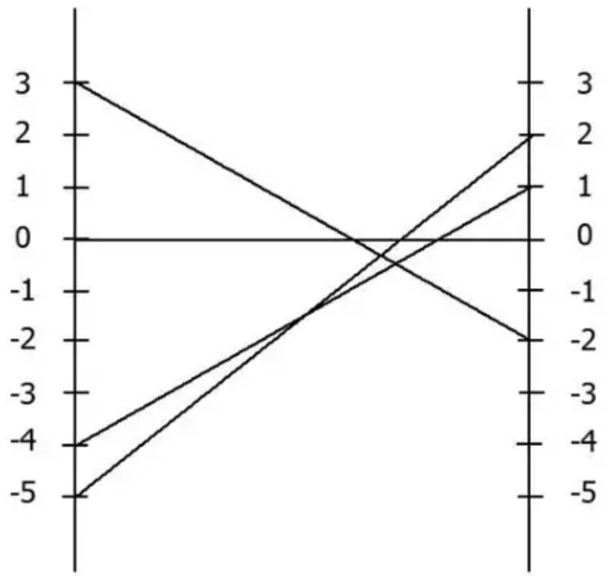 | M1  A1 | 1.1b  1.1b
$−5p+3=5p−4⇒p=\frac{7}{10}$ | A1 | 1.1b
Layla should play P with probability $7\text{/}10$ and play Q with probability $3\text{/}10$ | A1ft | 3.2a
 | (7)
 | (11 marks)

Notes
bi1B1: Correct calculations, allow one slip.
bii1B1: Defining variable $p$
bii1M1: Setting up three expressions in terms of $p$
bii 1A1: All three expressions correct. (must be fully simplified)
bii 2M1: Axes correct, at least one line correctly drawn for their expressions. Horizontally the graph must be drawn between 0 and 1 only
bii 2A1: Correct graph.
bii 3A1: Using the graph to obtain the correct probability expressions leading to the correct value of $p$
bii4A1ft: Interpret their value of $p$ in the context of the question.
2.
Mark scheme (a)
Scheme | Marks
Row minimum {–3, –5, –2, –3} Row maximin = –2 | M1
Column maximum {2,5,5,4} Column minimax = 2 | A1
So play safe for player A is 3 and play safe for player B is 1 | A1
 | (3)

Notes
a1M1: Clear attempt to find the Row maximin and Column minimax (either the Row minimums or Column maximums correct or at least six (of the eight) values stated correctly) – if they reduce the game to the given 3 by 3 matrix then they need five of the six values correct – working must be done in (a) – if correct play-safes for both players stated with no working then M1 only
a1A1: Correct Row maximin and Column minimax (dependent on all row mins and column maxs correct) – stated or clearly shown
a2A1: Correct play safes (A(3) and B(1)) for both players – not dependent on previous A mark
Mark scheme (b)
Scheme | Marks
$2\text{≠}−2$ so game is not stable | B1
 | (1)

Notes
b1B1: CAO (dependent on the first two marks in (a) or complete method seen in (b)) – states $2\text{≠}−2$ or row(maximin) $\text{≠}$ col(minimax) as long as 2 and –2 are clearly identified + conclusion (not stable)
Mark scheme (c)
Scheme | Marks
Column 1 dominates column 4 because –3 < –1, –5 < –1, –2 < 2 and 2 < 4 (so remove column 4) | B1
Row 3 dominates row 2 because –2 > –5, 5 > 3, 4 > 1 (and 2 > –1) (so remove row 2) | B1
 | (2)

Notes
c1B1: Either correct domination stated for both rows and columns or one correct with correct justification
c2B1: CSO (correct domination and full justification) – for justification the minimum we will accept is that all values in C4 > C1 (although the C1 could be implied) and that all values in R3 > R2 (again R2 could be implied) – note strict inequalities
Mark scheme (d)
Scheme | Marks
e.g. add at least 3 to each element e.g. $(\begin{matrix}1 & 6 & 9 \\ 2 & 9 & 8 \\ 6 & 1 & 3\end{matrix})$, $(\begin{matrix}0 & 5 & 8 \\ 1 & 8 & 7 \\ 5 & 0 & 2\end{matrix})$, etc. | B1
Let $p_{1},p_{3},p_{4}$ be the probability of (A) playing 1, 3, 4 respectively (where $p_{1},p_{3},p_{4}⩾0$) | B1
Let $V=$ value of the game (to player A) | B1
Maximise $(P=)V$ | B1
Subject to:  e.g.  $$\begin{matrix}V−p_{1}−2p_{3}−6p_{4} & ⩽0 & V−p_{3}−5p_{4} & ⩽0 \\ V−6p_{1}−9p_{3}−p_{4} & ⩽0 & V−5p_{1}−8p_{3} & ⩽0 \\ V−9p_{1}−8p_{3}−3p_{4} & ⩽0 & V−8p_{1}−7p_{3}−2p_{4} & ⩽0 \\ p_{1}+p_{3}+p_{4} & ⩽1 & p_{1}+p_{3}+p_{4} & ⩽1\end{matrix}$$ | M1  A1  A1
 | (7)
 | 13 marks

Notes
d1B1: Making all terms non-negative (any addition of at least 3 is acceptable) – must be shown (not just stated as a method), all values correct – could be implied in constraints
d2B1: Defining probability variables (allow throughout if defined using 1, 2 and 3 rather than 1, 3 and 4)
d3B1: Defining $V$
d4B1: Maximising + function/expression
d1M1: At least three inequalities (of the four) using column values in $(V)$, $p_{1},p_{3},p_{4}$ (or equations using slack variables e.g. $V−p_{1}−2p_{3}−6p_{4}+r=0$ but must be + $r$), all probability terms in the first three constraints having correct signs for their coefficients, must be $V⩽…$
d1A1: The three inequalities in $V,p_{1},p_{3},p_{4}$ CAO (must be expressed as inequalities)
d2A1: Probability sum inequality correct
If defining for the original 4 by 4 game (they would need to add at least 5) then first five marks available only in (d)

