QQQ – Decision 2 – Chapter 5 – Dynamic Programming (Version 2)
Total Marks: 24
(24 = Platinum, 22 = Gold, 19 = Silver, 16 = Bronze)
1. A factory can process up to five units of carrots each month.
Each unit can be sold fresh or frozen or canned.
The profits, in £100s, for the number of units sold, are shown in the table.
The total monthly profit is to be maximised.
Number of units | 0 | 1 | 2 | 3 | 4 | 5
Fresh | 0 | 45 | 85 | 120 | 150 | 175
Frozen | 0 | 45 | 70 | 100 | 120 | 130
Canned | 0 | 35 | 75 | 125 | 155 | 195

Use dynamic programming to determine how many of the five units should be sold fresh, frozen and canned in order to maximise the monthly profit. State the maximum monthly profit. (12)
(Total 12 marks)
Edexcel D2 June 2013 (R) Q8
2.
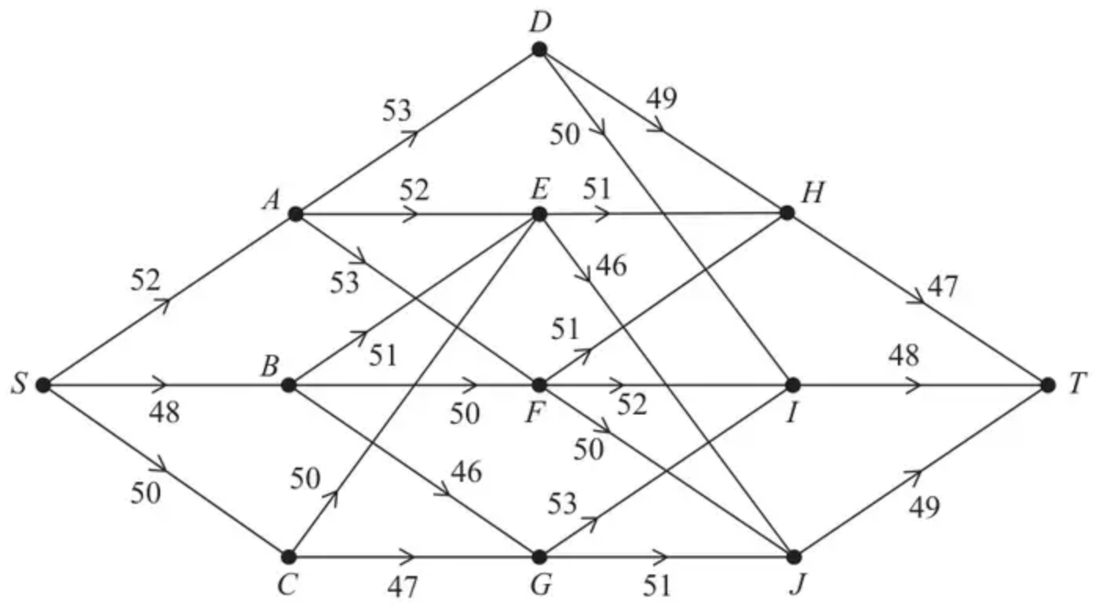
Figure 3
The staged, directed network in Figure 3 represents a series of roads connecting 12 towns, $S$, $A$, $B$, $C$, $D$, $E$, $F$, $G$, $H$, $I$, $J$ and $T$. The number on each arc shows the distance between these towns, in miles.
Bradley is planning a four-day cycle ride from $S$ to $T$.
He plans to leave his home at $S$. On the first night he will stay at $A$, $B$ or $C$, on the second night he will stay at $D$, $E$, $F$ or $G$, on the third night he will stay at $H$, $I$ or $J$, and he will arrive at his friend’s house at $T$ on the fourth day.
Bradley decides that the maximum distance he will cycle on any one day should be as small as possible.
(a) Write down the type of dynamic programming problem that Bradley needs to solve. (1)
(b) Use dynamic programming to complete the table below. (9)
Stage | State | Action | Destination | Value

(c) Hence write down the possible routes that Bradley could take. (2)
(Total 12 marks)
Edexcel A2 October 2021 Q6
Solutions
1.
Stage | State | Action | Dest. | Value | Marks
Fresh | 0 | 0 | 0 | 0
 | 1 | 1 | 0 | 45
 | 2 | 2 | 0 | 85 | 1M1 1A1  (stage 1)
 | 3 | 3 | 0 | 120
 | 4 | 4 | 0 | 150
 | 5 | 5 | 0 | 175
Frozen | 0 | 0 | 0 | 0
 | 1 | 1 | 0 | 45 + 0 = 45*
 |  | 0 | 1 | 0 + 45 = 45*
 | 2 | 2 | 0 | 70 + 0 = 70
 |  | 1 | 1 | 45 + 45 = 90* | 2M1 2A1  (1st 4 states of stage 2)
 |  | 0 | 2 | 0 + 85 = 85
 | 3 | 3 | 0 | 100 + 0 = 100
 |  | 2 | 1 | 70 + 45 = 115
 |  | 1 | 2 | 45 + 85 = 130* | 3A1  (state 3)
 |  | 0 | 3 | 0 + 120 = 120
 | 4 | 4 | 0 | 120 + 0 = 120
 |  | 3 | 1 | 100 + 45 = 145
 |  | 2 | 2 | 70 + 85 = 155 | 3M1 4A1
 |  | 1 | 3 | 45 + 120 = 165* | (Last 2 states of stage 2)
 |  | 0 | 4 | 0 + 150 = 150
 | 5 | 5 | 0 | 130 + 0 = 130
 |  | 4 | 1 | 120 + 45 = 165
 |  | 3 | 2 | 100 + 85 = 185
 |  | 2 | 3 | 70 + 120 = 190 | 5A1
 |  | 1 | 4 | 45 + 150 = 195* | (state 5)
 |  | 0 | 5 | 0 + 175 = 175
Canned | 5 | 5 | 0 | 195 + 0 = 195
 |  | 4 | 1 | 155 + 45 = 200
 |  | 3 | 2 | 125 + 90 = 215* | 4M1 6A1ft
 |  | 2 | 3 | 75 + 130 = 205 | (3rd stage)
 |  | 1 | 4 | 35 + 165 = 200
 |  | 0 | 5 | 0 + 195 = 195

Scheme | Marks
Fresh = 1, Frozen = 1, Canned = 3 | 5M1
Monthly income = £21 500 | 7A1ft
 | 12 marks

Notes
• ALL M marks – Must bring earlier optimal results into calculations. Must have necessary right ‘ingredients’ (profit values from the table) at least once per stage.
• Penalise inconsistency/errors with the state/destination columns with the first two A marks earned only.
• Penalise empty/errors in stage column with first A mark earned only.
1M1: First stage completed (bod something in each cell). Condone missing state 0 for this mark. Must have columns for stage, state, value and one of either action or destination.
1A1: CAO for first stage – condone missing * in this stage.
2M1: Second stage – states 0, 1 and 2 complete (bod something in each cell). Condone missing state 0 for this mark.
2A1: States 0, 1 and 2 correct for second stage. Penalise * errors only twice in the question on the first occurrences.
3A1: State 3 correct for second stage. Penalise * errors only twice in the question.
3M1: Second stage – states 3 and 4 complete (bod something in each cell).
4A1: State 4 correct for second stage. Penalise * errors only twice in the question.
5A1: State 5 correct for second stage. Penalise * errors only twice in the question.
4M1: Third stage complete (bod something in each cell).
6A1ft: Third stage correct (ft from previous stage). Penalise * errors only twice in the question.
5M1: For Fresh = 1, Frozen = 1, Canned = 3 – dependent on all previous M marks having been awarded.
7A1ft: Income correct for their table. Must have earned the first 4 M marks only (not dependent on 5M1).
2.
Mark scheme (a)
Scheme | Marks | AO
Minimax | B1 | 1.2
 | (1)

Notes
B1: cao
Mark scheme (b)
Scheme | Marks | AO
 | B1 | 3.1a
  Stage | State | Action | Destination | Value
  1 | H | HT | T | 47*
   | I | IT | T | 48*
   | J | JT | T | 49*
 | M1  A1  A1 | 3.1a  1.1b  1.1b
  Stage | State | Action | Destination | Value
  2 | D | DH | H | Max(49, 47) = 49*
   |  | DI | I | Max(50, 48) = 50
   | E | EH | H | Max (51, 47) = 51
   |  | EJ | J | Max (46, 49) = 49*
   | F | FH | H | Max (51, 47) = 51
   |  | FI | I | Max (52, 48) = 52
   |  | FJ | J | Max (50, 49) = 50*
   | G | GI | I | Max (53, 48) = 53
   |  | GJ | J | Max (51, 49) = 51*
 | M1  A1ft  A1 | 1.1b  1.1b  1.1b
  Stage | State | Action | Destination | Value
  3 | A | AD | D | Max(53, 49) = 53
   |  | AE | E | Max(52, 49) = 52*
   |  | AF | F | Max (53, 50) = 53
   | B | BE | E | Max(51, 49) = 51
   |  | BF | F | Max(50, 50) = 50*
   |  | BG | G | Max(46, 51) = 51
   | C | CE | E | Max(50, 49) = 50*
   |  | CG | G | Max(47, 51) = 51
 | M1  A1ft | 1.1b  1.1b
  Stage | State | Action | Destination | Value
  4 | S | SA | A | Max(52, 52) = 52
   |  | SB | B | Max(48, 50) = 50*
   |  | SC | C | Max(50, 50) = 50*
 | (9)

Notes
Throughout (b):
• Condone lack of destination column and/or reversed stage numbers throughout
• Only penalise incorrect result in value – ie ignore working values
• Penalise absence of state or action column with first two A marks earned only
• Penalise empty/errors in stage column with first A mark earned only
• If maximin, minimum, maximum, etc. then only the B mark and M marks can be awarded in (b) (so 4 out of 9 maximum) and one B mark can be awarded in (c) following through a correct route from their table
M marks in (b) - must bring earlier optimal results into calculations at least once
B1: Stage 1 correct
M1: Stage 2 completed with 4 states and at least 9 rows. Bod if something in each cell
A1: Any two states in Stage 2 correct
A1: cao all 4 states correct in Stage 2 (no extra rows)
M1: Stage 3 completed with 3 states and at least 8 rows. Bod if something in each cell
A1ft: cao any 2 states correct in Stage 3 on the follow through
A1: cao all 3 states in Stage 3 (no extra rows)
M1: Stage 4 completed with 1 state and at least 3 rows. Bod if something in each cell
A1ft: cao for Stage 4 following through their * values (no extra rows)
Mark scheme (c)
Scheme | Marks | AO
Route 1: S – B – F – J – T  Route 2: S – C – E – J – T | B1ft  B1 | 2.2a  2.2a
 | (2)
 | (12 marks)

Notes
B1ft: One correct route (dependent on first B mark and all M marks in (b)) following through their least values (oe) at each stage in (b)
B1: Both routes correct (dependent on first B mark and all M marks in (b))

