QQQ – Decision 2 – Chapter 5 – Dynamic Programming (Version 1)
Total Marks: 26
(26 = Platinum, 23 = Gold, 21 = Silver, 18 = Bronze)
1.
(a) State Bellman’s principle of optimality. (1)
(b) Explain what is meant by a minimax route. (1)
(c) Describe a practical problem that would require a minimax route as its solution. (2)
(Total 4 marks)
Edexcel D2 June 2006 Q1
2.
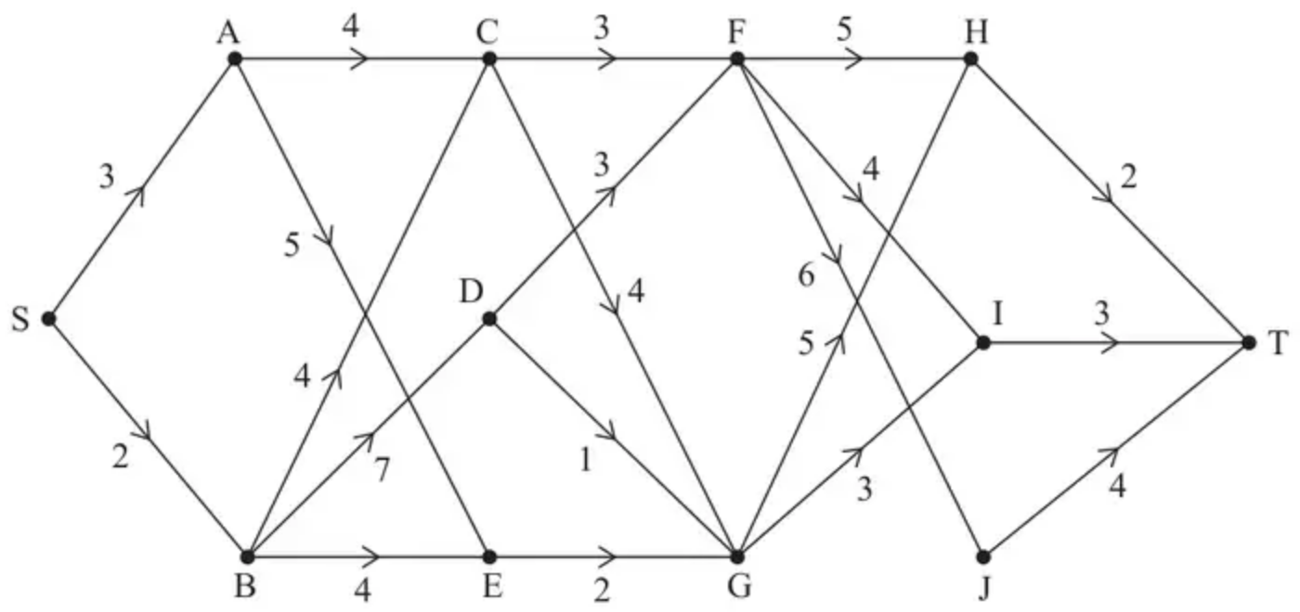
Figure 2
The staged, directed network in Figure 2 represents the roads that connect 12 towns, S, A, B, C, D, E, F, G, H, I, J and T. The number on each arc shows the time, in hours, it takes to drive between these towns.
Elena plans to drive from S to T. She must arrive at T by 9 pm.
(a) By completing the table in the answer book, use dynamic programming to find the latest time that Elena can start her journey from S to arrive at T by 9 pm. (9)
[The table in the answer book has columns headed Stage, State, Action, Destination and Value.]
(b) Hence write down the route that Elena should take. (1)
(Total 10 marks)
Edexcel A2 June 2024 Q6
3. A manufacturer can export five batches of footwear each year. Each exported batch contains just one type of footwear. The types of footwear are trainers, sandals or high heels.
The table below shows the profit, in £1000s, for the number of batches of each type of footwear.
Number of batches | 0 | 1 | 2 | 3 | 4 | 5
Trainers | 0 | 50 | 90 | 170 | 225 | 295
Sandals | 0 | 70 | 110 | 165 | 245 | 300
High heels | 0 | 75 | 115 | $x$ | 235 | 305

The total annual profit is to be maximised.
(a) Use dynamic programming to determine the two possible values of the maximum total annual profit, giving one of these values in terms of $x$. (10)
Given that the maximum total annual profit is £320 000
(b) advise the manufacturer on the possible ways in which the five batches should be allocated. (2)
(Total 12 marks)
Edexcel A2 October 2020 Q7
Solutions
1.
Mark scheme (a)
Scheme | Marks
Any part of an optimal path is itself optimal | B1
 | (1)

Notes
B1 cao (“port”, “section”, OK; “arc”, “stage”, activity”, “event”, not)
Mark scheme (b)
Scheme | Marks
The route chosen such that the maximum arc length is as small as possible | B1
 | (1)

Notes
B1 cao (not min of max rate, not minimize largest arc)
Mark scheme (c)
Scheme | Marks
e.g. Maximising freight by minimising fuel needed when planning multiple stage light aircraft journey | B2, 1, 0
 | (2)
 | (4 marks)

Notes
B2 cao
B1 cloze “Bod” gets B1
2.
Mark scheme (a)
Scheme | Marks | AO
 | B1 | 3.1a
  Stage | State | Action | Dest | Value
  1 | H | HT | T | 2*
   | I | IT | T | 3*
   | J | JT | T | 4*
 | M1  A1 | 3.1a  1.1b
  Stage | State | Action | Dest | Value
  2 | F | FH | H | 5 + 2 = 7*
   |  | FI | I | 4 + 3 = 7*
   |  | FJ | J | 6 + 4 = 10
   | G | GH | H | 5 + 2 = 7
   |  | GI | I | 3 + 3 = 6*
 | M1  A1 | 1.1b  1.1b
  Stage | State | Action | Dest | Value
  3 | C | CF | F | 3 + 7 = 10*
   |  | CG | G | 4 + 6 = 10*
   | D | DF | F | 3 + 7 = 10
   |  | DG | G | 1 + 6 = 7*
   | E | EG | G | 2 + 6 = 8*
 | M1  A1ft  A1 | 1.1b  1.1b  1.1b
  Stage | State | Action | Dest | Value
  4 | A | AC | C | 4 + 10 = 14
   |  | AE | E | 5 + 8 = 13*
   | B | BC | C | 4 + 10 = 14
   |  | BD | D | 7 + 7 = 14
   |  | BE | E | 4 + 8 = 12*
  5 | S | SA | A | 3 + 13 = 16
   |  | SB | B | 2 + 12 = 14*
Latest time that Elena can start her journey is 7 am | A1 | 3.2a
 | (9)

Notes
All M marks – must bring earlier optimal results into calculations. Ignore extra rows. Penalise lack of * only once per question.
B1: CAO for first stage
M1: Second stage completed. At least 4 rows, something in each cell.
A1: CAO for second stage exactly 5 rows
M1: Third stage completed. At least 4 rows, something in each cell.
A1: CAO for third stage exactly 5 rows
M1: Fourth stage completed. 5 rows, something in each cell.
A1ft: correct ft their optimal values from third stage
A1: CAO for fifth stage
A1: Correct latest start time in context (e.g. 7 am, 07:00, etc.)
Special Case – Maximin or Minimax
Stage | State | Action | Dest | Value | Value
1 | H | HT | T | 2* | 2*
 | I | IT | T | 3* | 3*
 | J | JT | T | 4* | 4*
2 | F | FH | H | Min (5, 2) = 2 | Max (5, 2) = 5
 |  | FI | I | Min (4, 3) = 3 | Max (4, 3) = 4*
 |  | FJ | J | Min (6, 4) = 4* | Max (6, 4) = 6
 | G | GH | H | Min (5, 2) = 2 | Max (5, 2) = 5*
 |  | GI | I | Min (3, 3) = 3* | Max (3, 3) = 3
3 | C | CF | F | Min (3, 4) = 3* | Max (3, 4) = 4*
 |  | CG | G | Min (4, 3) = 3* | Max (4, 5) = 5
 | D | DF | F | Min (3, 4) = 3* | Max (3, 4) = 4*
 |  | DG | G | Min (1, 3) = 1 | Max (1, 5) = 5
 | E | EG | G | Min (2, 3) = 2* | Max (2, 5) = 5*
4 | A | AC | C | Min (4, 3) = 3* | Max (4, 4) = 4*
 |  | AE | E | Min (5, 2) = 2 | Max (5, 5) = 5
 | B | BC | C | Min (4, 3) = 3* | Max (4, 4) = 4*
 |  | BD | D | Min (7, 3) = 3* | Max (7, 4) = 7
 |  | BE | E | Min (4, 2) = 2 | Max (4, 5) = 5
5 | S | SA | A | Min (3, 3) = 3* | Max (3, 4) = 4*
 |  | SB | B | Min (2, 3) = 2 | Max (2, 4) = 4*

B1 M1 A0 M1 A0 M1 A0 A0 A0 B0 - Max 4/10
Mark scheme (b)
Scheme | Marks | AO
Route: SBEGIT | B1 | 2.2a
 | (1)
 | (10 marks)

Notes
B1: Correct route (dependent on all previous M marks)
3.
Mark scheme (a)
Scheme | Marks | AO
 | B1 | 3.1a
  Stage | State | Action | Dest. | Value
  Trainers | 0 | 0 | 0 | 0
   | 1 | 1 | 0 | 50
   | 2 | 2 | 0 | 90
   | 3 | 3 | 0 | 170
   | 4 | 4 | 0 | 225
   | 5 | 5 | 0 | 295
 | M1  A1  A1 | 3.1a  1.1b  1.1b
  Stage | State | Action | Dest. | Value
  Sandals | 0 | 0 | 0 | 0
   | 1 | 1 | 0 | 70 + 0 = 70*
   |  | 0 | 1 | 0 + 50 = 50
   | 2 | 2 | 0 | 110 + 0 = 110
   |  | 1 | 1 | 70 + 50 = 120*
   |  | 0 | 2 | 0 + 90 = 90
   | 3 | 3 | 0 | 165 + 0 = 165
   |  | 2 | 1 | 110 + 50 = 160
   |  | 1 | 2 | 70 + 90 = 160
   |  | 0 | 3 | 0 + 170 = 170*
 | M1  A1  A1 | 1.1b  1.1b  1.1b
  Stage | State | Action | Dest. | Value
   | 4 | 4 | 0 | 245 + 0 = 245*
   |  | 3 | 1 | 165 + 50 = 215
   |  | 2 | 2 | 110 + 90 = 200
   |  | 1 | 3 | 70 + 170 = 240
   |  | 0 | 4 | 0 + 225 = 225
   | 5 | 5 | 0 | 300 + 0 = 300*
   |  | 4 | 1 | 245 + 50 = 295
   |  | 3 | 2 | 165 + 90 = 255
   |  | 2 | 3 | 110 + 170 = 280
   |  | 1 | 4 | 70 + 225 = 295
   |  | 0 | 5 | 0 + 295 = 295
 | M1  A1ft | 1.1b  1.1b
  Stage | State | Action | Dest. | Value
  High heels | 5 | 5 | 0 | 305 + 0 = 305
   |  | 4 | 1 | 235 + 70 = 305
   |  | 3 | 2 | $x+120$
   |  | 2 | 3 | 115 + 170 = 285
   |  | 1 | 4 | 75 + 245 = 320
   |  | 0 | 5 | 0 + 300 = 300
320 and $x+120$ | A1ft | 1.1b
 | (10)

Notes
B1: CAO for the first stage (all six rows) – entries in all columns must be correct – candidates may start with state 5 (rather than state 0) which is fine
M1: Second stage – my states 1, 2 and 3 (so at least 9 rows in the first half of the second stage or at least 20 non-zero rows). Value column must be complete with at least one value correct for each state – ignore entries in all other columns
A1: Value column for states 1, 2 and 3 correct for the second stage – ignore entries in all other columns and condone additional rows
A1: CAO for states 0, 1, 2 and 3 of the second stage (no additional rows for these four states) – entries in all columns must be correct
M1: Second stage – my states 4 and 5 (so at least 11 rows in the second half of the second stage or at least 20 non-zero rows). Value column must be complete with at least one value correct for each state – ignore entries in all other columns
A1: Value column for states 4 and 5 correct for the second stage – ignore entries in all other columns and condone additional rows
A1: CAO for states 4 and 5 of the second stage (no additional rows for these two states) - entries in all columns must be correct
M1: At least 6 rows for the third stage. Value column must be complete with at least 3 values correct – ignore entries in all other columns
A1ft: CAO for third stage correct (no additional rows for this stage) - entries in all columns must be correct
A1ft: Must have earned all previous M marks from their completed dynamic programming but ft their result
Mark scheme (b)
Scheme | Marks | AO
Trainers: 0 Sandals: 4 High heels: 1 | B1 | 1.1b
Trainers: 1 Sandals: 1 High heels: 3 | B1 | 2.2a
 | (2)
 | (12 marks)

Notes
B1: One correct allocation (dependent on first three M marks in (a))
B1: For both correct (dependent on first three M marks in (a))

