QQQ – Decision 2 – Chapter 4 – Flows in Networks 2 (Version 2)
Total Marks: 24
(24 = Platinum, 22 = Gold, 19 = Silver, 16 = Bronze)
1.
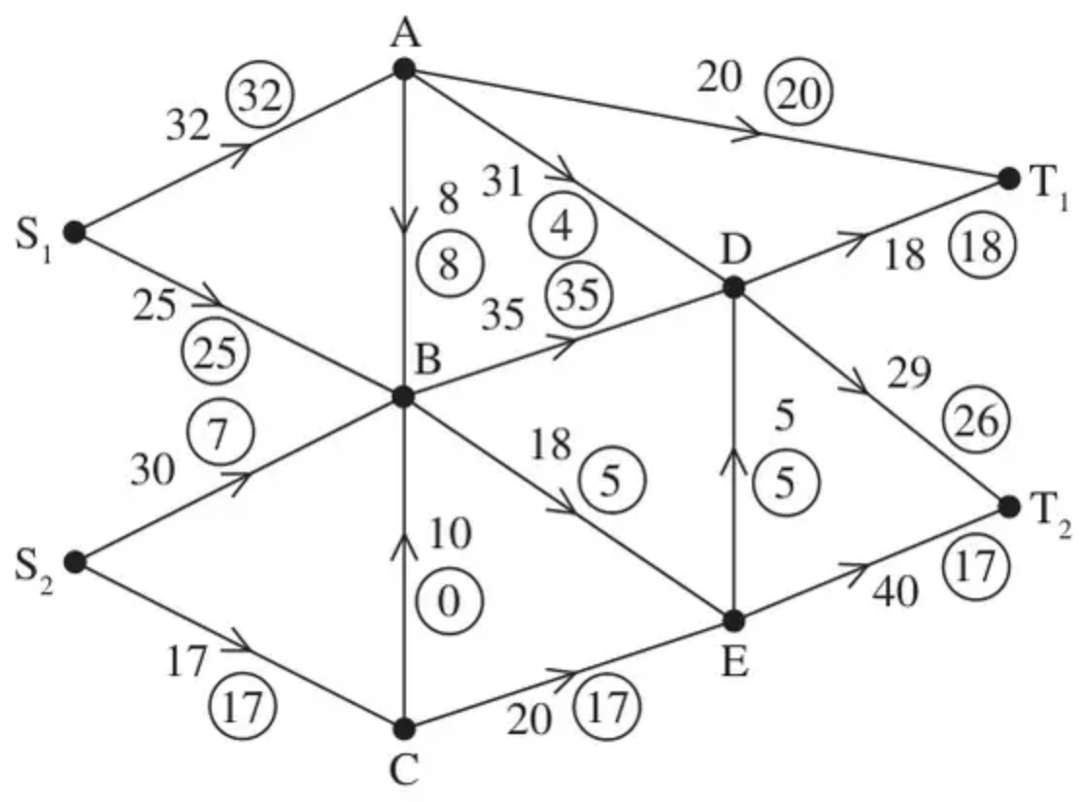
Figure 1
Figure 1 shows a capacitated, directed network. The number on each arc represents the capacity of that arc. The numbers in circles represent an initial flow.
(a) (3)
(i) Add a supersource, S, and a supersink, T, and corresponding arcs to Diagrams 1 and 2, in the answer book.
(ii) Enter the flow value and appropriate capacity on each of the arcs you have added to Diagram 1.
(b) Complete the initialisation of the labelling procedure on Diagram 2 by entering values along the new arcs from S and T, and along AB, AD and DT${}_{2}$. (2)
(c) Hence use the labelling procedure to find a maximum flow through the network. You must list each flow-augmenting route you use, together with its flow. (4)
(d) Draw a maximal flow pattern on Diagram 3 in the answer book. (2)
(e) Prove that your flow is maximal. (2)
(Total 13 marks)
Edexcel D2 June 2014 (R) Q5
2.
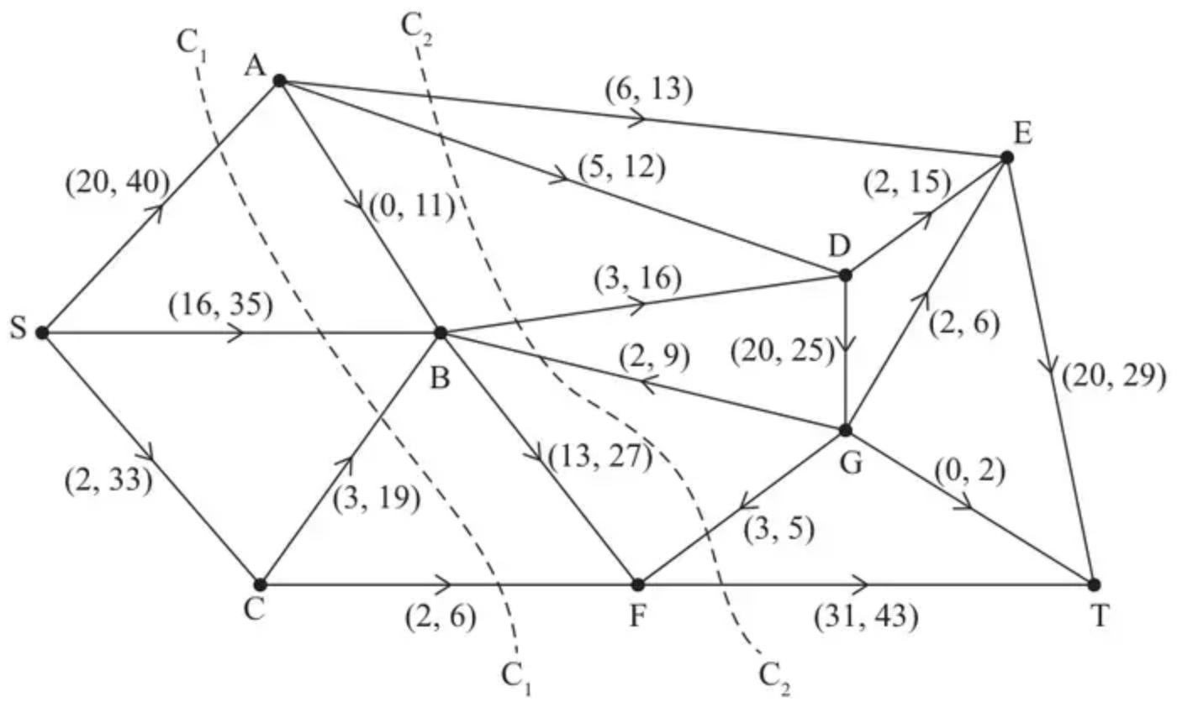
Figure 2
Figure 2 shows a capacitated, directed network. The network represents a system of pipes through which fluid can flow.
The weights on the arcs show the lower and upper capacities for the corresponding pipes, in litres per second.
(a) Calculate the capacity of
(i) cut $C_{1}$
(ii) cut $C_{2}$ (2)
(b) Using only the capacities of cuts $C_{1}$ and $C_{2}$, state what can be deduced about the maximum flow through the system. (1)
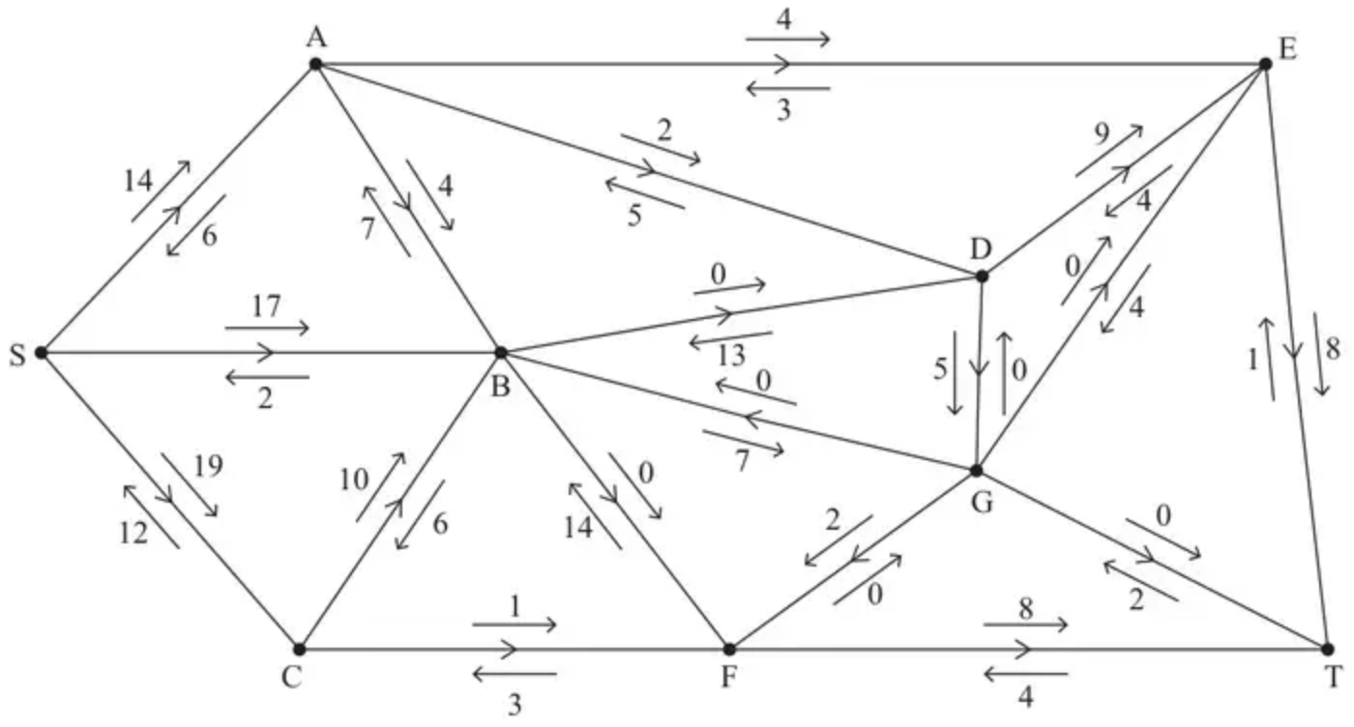
Figure 3
A scientist monitors the system of pipes in which a fluid now flows from the source, S, to the sink, T.
The scientist initialises the labelling procedure for this system. The excess and potential backflows for this are shown on the arrows either side of each arc in Figure 3.
(c) State the value of the initial flow. (1)
(d) Use the labelling procedure to find a maximum flow through the network. You must list each flow-augmenting route you use, together with its flow. (3)
(e) Use your answer to part (d) to find a maximum flow pattern for this system of pipes and draw it on Diagram 1 in the answer book. (1)
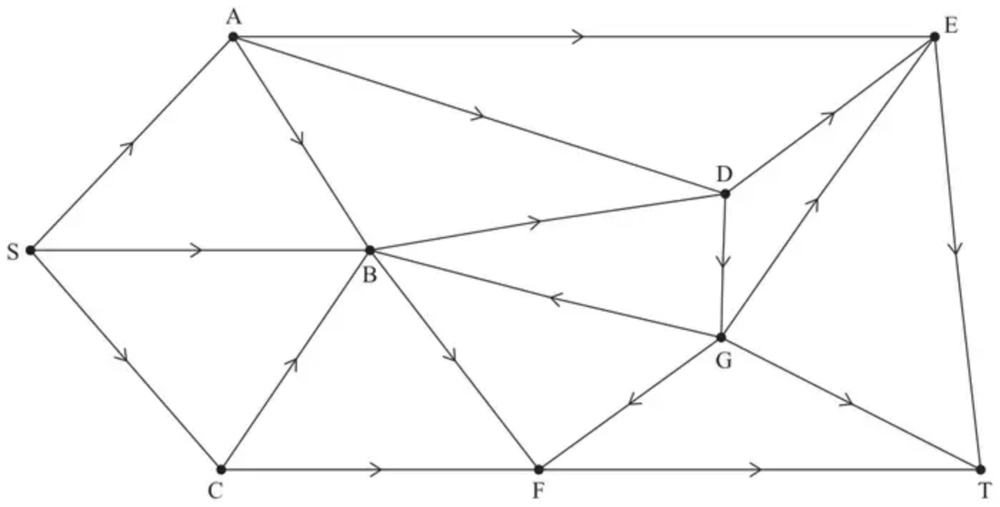
Diagram 1
(f) Prove that the answer to part (e) is optimal. (3)
(Total 11 marks)
Edexcel A2 June 2025 Q4
Solutions
1.
Mark scheme (a)
Scheme | Marks
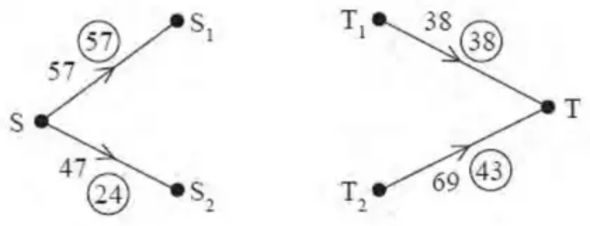 | M1 A1 A1
 | (3)

Notes
a1M1: Four arcs added, SS${}_{1}$, SS${}_{2}$, T${}_{1}$T, T${}_{2}$T and 2 numbers on each.
a1A1: CAO for arcs
a2A1: CAO for flow values and capacities
Mark scheme (b)
Scheme | Marks
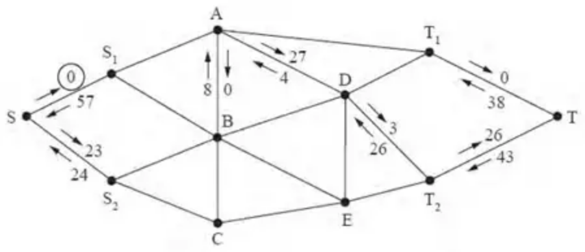 | M1 A1
 | (2)

Notes
b1M1: Two numbers on each arc and at least three arcs or six numbers correct.
b1A1: CAO do give bod since they might well cross these numbers out.
Mark scheme (c)
Scheme | Marks
E.g.  SS${}_{2}$BET${}_{2}$T – 13  SS${}_{2}$BADT${}_{2}$T – 3  SS${}_{2}$BADET${}_{2}$T – 5 | M1 A1  A1  A1
 | (4)

Notes
c1M1: One valid flow augmenting route found and a value stated.
c1A1: Flow increased by at least 3.
c2A1: A second correct flow route of value at least 5 and value correct.
c3A1: CSO Flow increased by 21 and no more.
Mark scheme (d)
Scheme | Marks
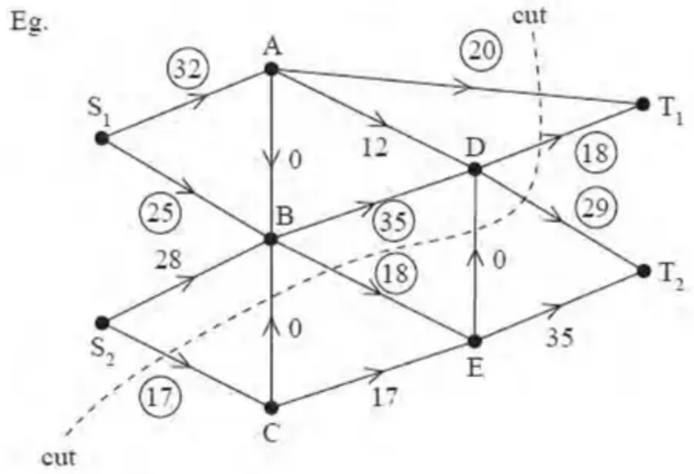 | M1 A1
 | (2)

Notes
d1M1: Consistent flow pattern $⩾$ 84 (check each node). One number only per arc. No unnumbered arcs.
d1A1: CAO, showing flow of 102, must follow from their routes.
Mark scheme (e)
Scheme | Marks
The cut through AT${}_{1}$, DT${}_{1}$, DT${}_{2}$, DE, BE, CB and S${}_{2}$C has value 102 | DB1
Value of the flow is 102 so by max flow – min cut theorem flow is maximal | DB1
 | (2)
 | 13 marks

Notes
e1DB1: Must have attempted (d) - at least one number on all but one arc, and made an attempt at a cut, either drawn or stated.
e2DB1: CSO - (d) fully correct (showing a correct flow of 102) and a correct cut. Must refer to max flow-min cut theorem – all four words.
2.
Mark scheme (a)
Scheme | Marks | AO
$C_{1}(=40+35+19+6)=100$ | B1 | 1.1b
$C_{2}(=13+12+16−2−3+43)=79$ | B1 | 1.1b
 | (2)

Notes
B1: CAO
B1: CAO
Mark scheme (b)
Scheme | Marks | AO
Deduces the maximum possible flow is $⩽79$ litres per second | B1ft | 2.2a
 | (1)

Notes
B1ft: deduced from their least value given in (a) - must include ‘less than or equal to’ (oe)
Mark scheme (c)
Scheme | Marks | AO
Initial flow = 58 | B1 | 1.1b
 | (1)

Notes
B1: CAO
Mark scheme (d)
Scheme | Marks | AO
e.g. SAET – 4, SADET – 2, SBGFT – 2, SCFT – 1 | M1  A1  A1 | 1.1b  1.1b  1.1b
 | (3)

Notes
M1: One flow augmenting route found from S to T
A1: Two correct routes + flow values
A1: CSO – increasing the flow by 9
Note possible flow augmenting routes are only _ADET + 2 _AET + 4 _BGFT + 2 _CFT + 1 where _ represents either S, SB, SC or SCB
(SADGFT + 2 is also valid but this prevents DET being increased)
Mark scheme (e)
Scheme | Marks | AO
e.g.  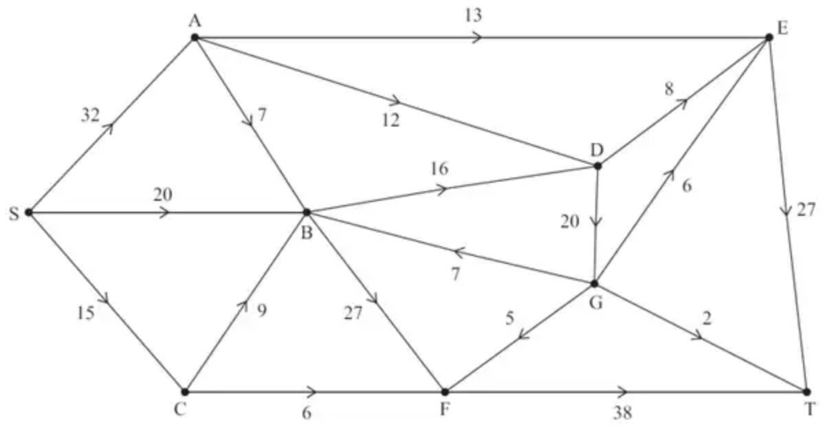 | B1 | 2.2a
 | (1)

Notes
B1: CAO – one number only per arc (only SA, SB, SC, AB and CB can vary depending on their flow augmenting routes)
Mark scheme (f)
Scheme | Marks | AO
Use of max-flow min-cut theorem  Identification of cut through AE, AD, BD, DG, GE, GT, GF, BF and CF  Value of flow = 67  Therefore it follows that flow is maximal | M1  A1  A1 | 2.1  3.1a  2.2a
 | (3)
 | (11 marks)

Notes
M1: Construct argument based on max-flow min-cut theorem (e.g. attempt to find a cut through saturated arcs) (A valid cut through saturated arcs must either be listed or drawn)
May be drawn on either diagram or listed as arcs or set notation {S, A, B, C, G}{D, E, F, T}
A1: Use appropriate process of finding a minimum cut: cut + value correct and value of flow stated
A1: Correct deduction that the flow is maximal – must see all 4 words max flow min cut and conclusion - dependent on previous A mark

