QQQ – Decision 2 – Chapter 4 – Flows in Networks 2 (Version 1)
Total Marks: 24
(24 = Platinum, 22 = Gold, 19 = Silver, 16 = Bronze)
1.
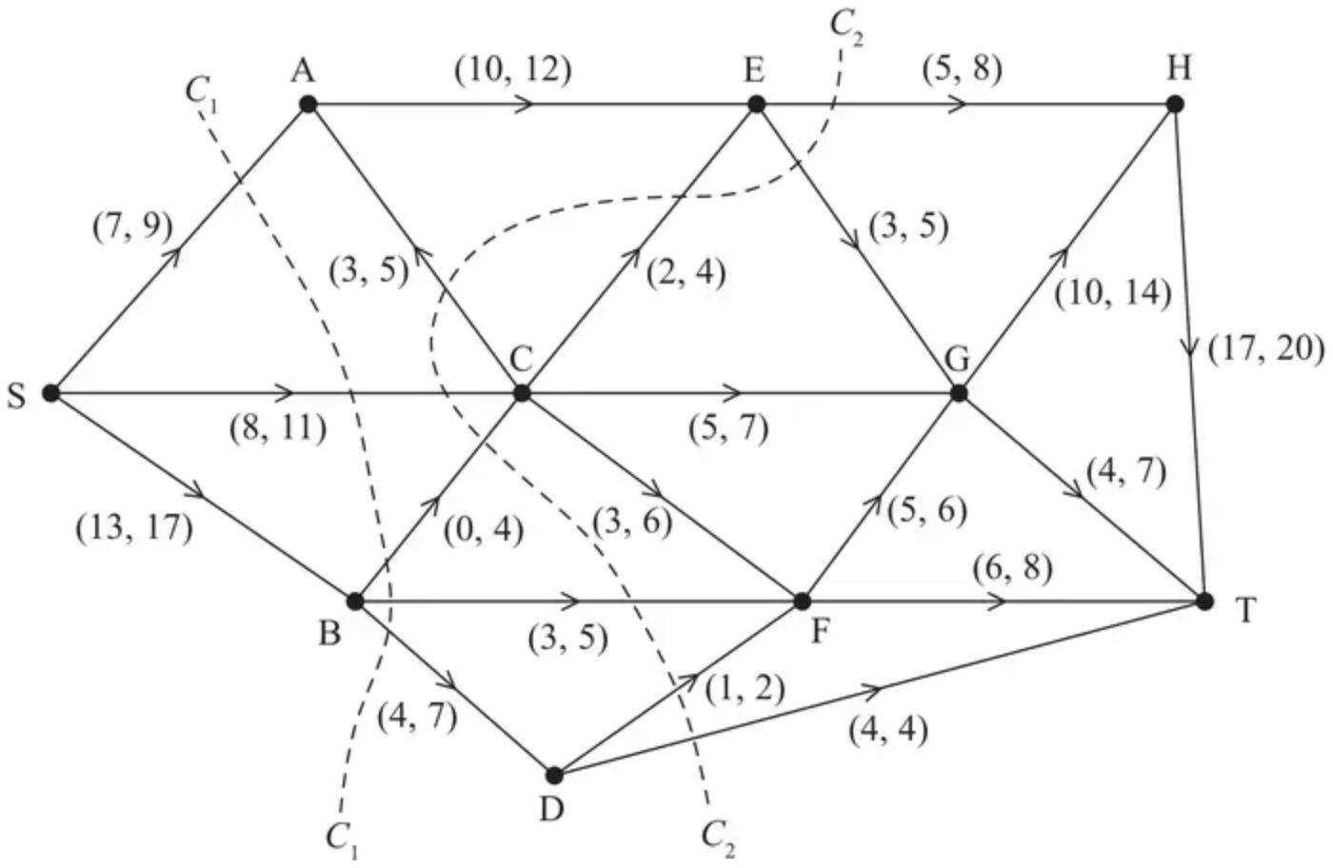
Figure 2
Figure 2 shows a capacitated, directed network. The network represents a system of pipes through which fluid flows from a source, S, to a sink, T.
The numbers $(l,u)$ on each arc represent, in litres per second, the lower capacity, $l$, and the upper capacity, $u$, of the corresponding pipe.
Two cuts $C_{1}$ and $C_{2}$ are shown.
(a) Find the capacity of
(i) cut $C_{1}$
(ii) cut $C_{2}$ (2)
(b) Explain why the arcs AE and CE cannot be at their upper capacities simultaneously. (1)
(c) Explain why a flow of 31 litres per second through the system is not possible. (1)
(d) Hence determine a minimum feasible flow and a maximum feasible flow through the system. You must draw these feasible flows on the diagrams below and give reasons to justify your answer. You should not apply the labelling procedure to find these flows. (4)
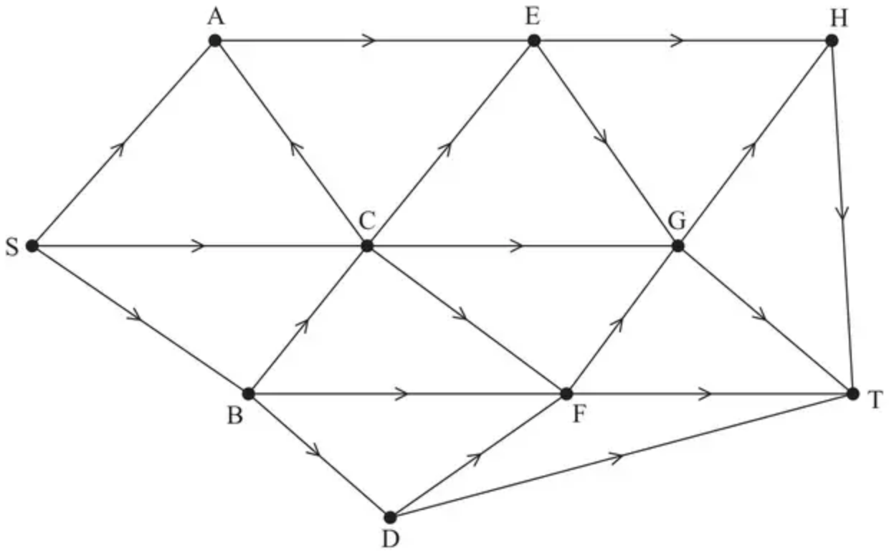
Minimum feasible flow
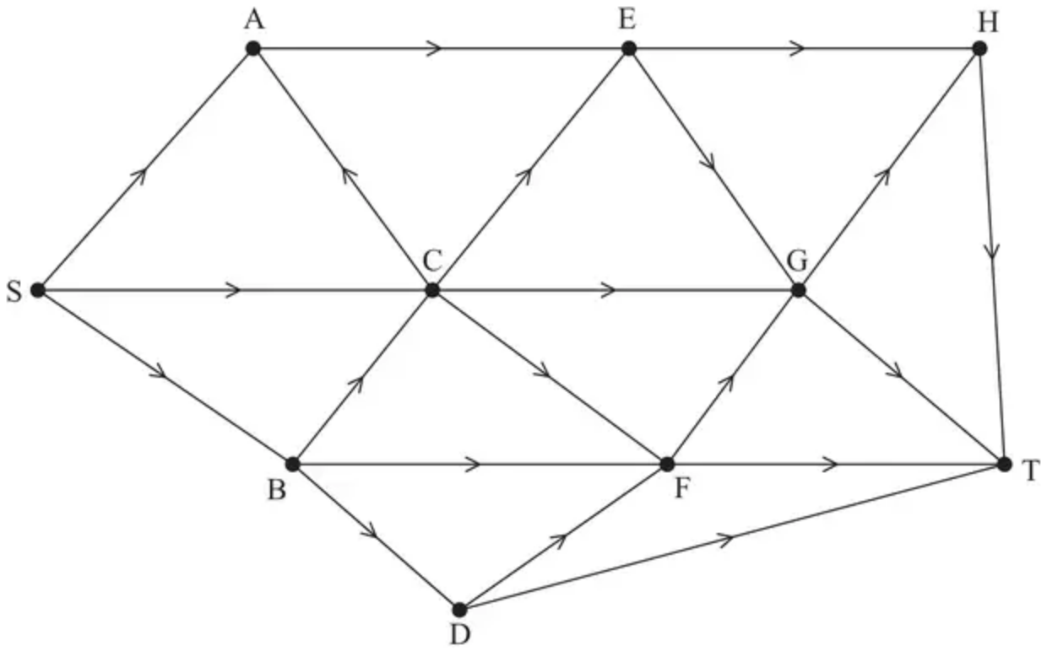
Maximum feasible flow
(Total 8 marks)
Edexcel A2 June 2019 Q6
2.
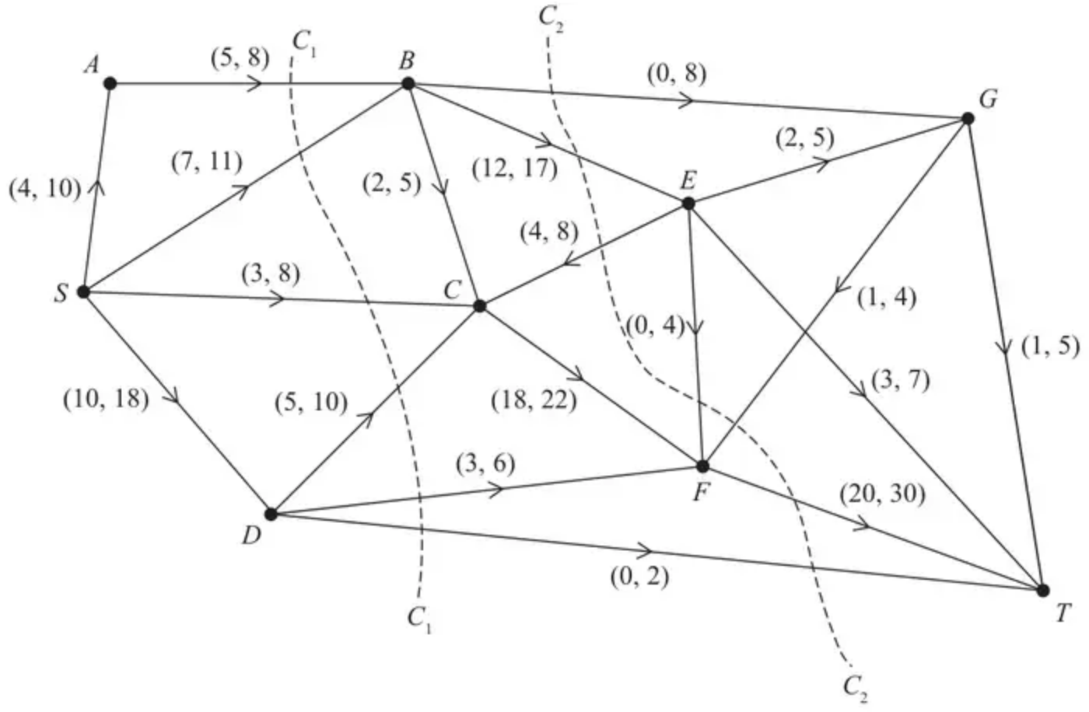
Figure 1
Figure 1 shows a capacitated, directed network. The network represents a system of pipes through which fluid can flow.
The weights on the arcs show the lower and upper capacities for the corresponding pipes, in litres per second.
(a) Calculate the capacity of
(i) cut $C_{1}$
(ii) cut $C_{2}$ (2)
(b) Using only the capacities of cuts $C_{1}$ and $C_{2}$, state what can be deduced about the maximum flow through the system. (1)
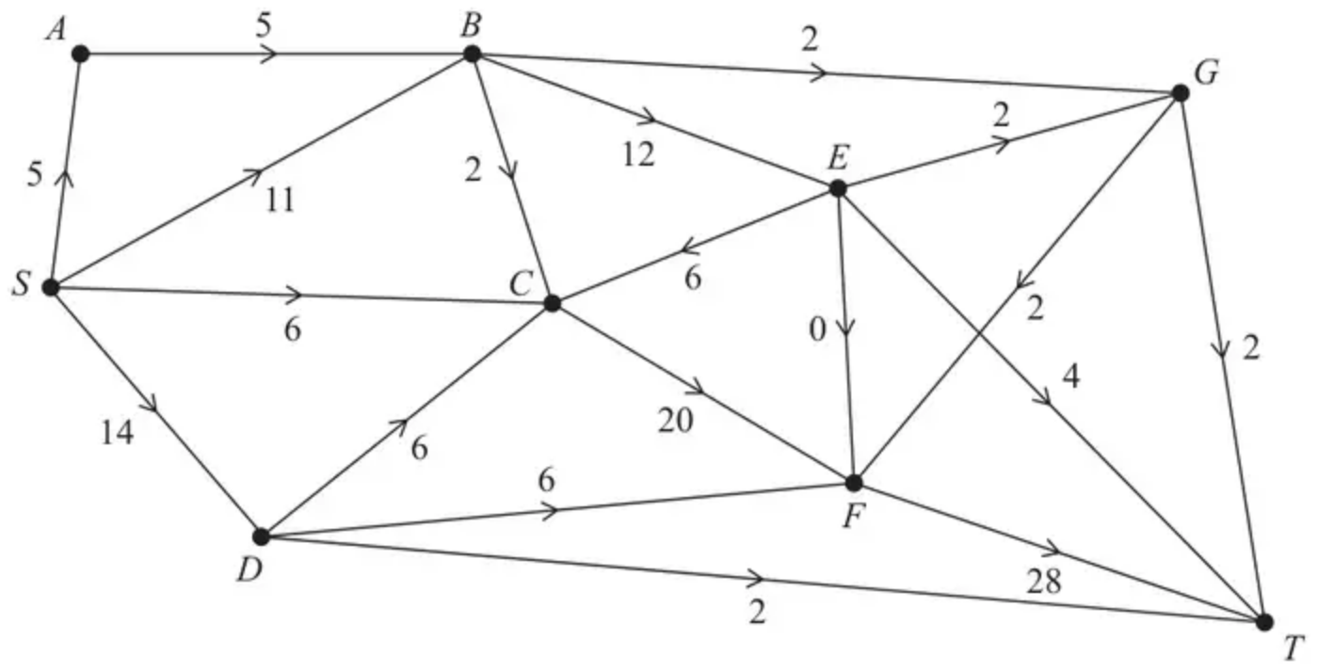
Figure 2
Figure 2 shows an initial flow through the same network.
(c) State the value of the initial flow. (1)
(d) By entering values along $BC$, $CF$ and $DT$, complete the labelling procedure on Diagram 1 below. (2)
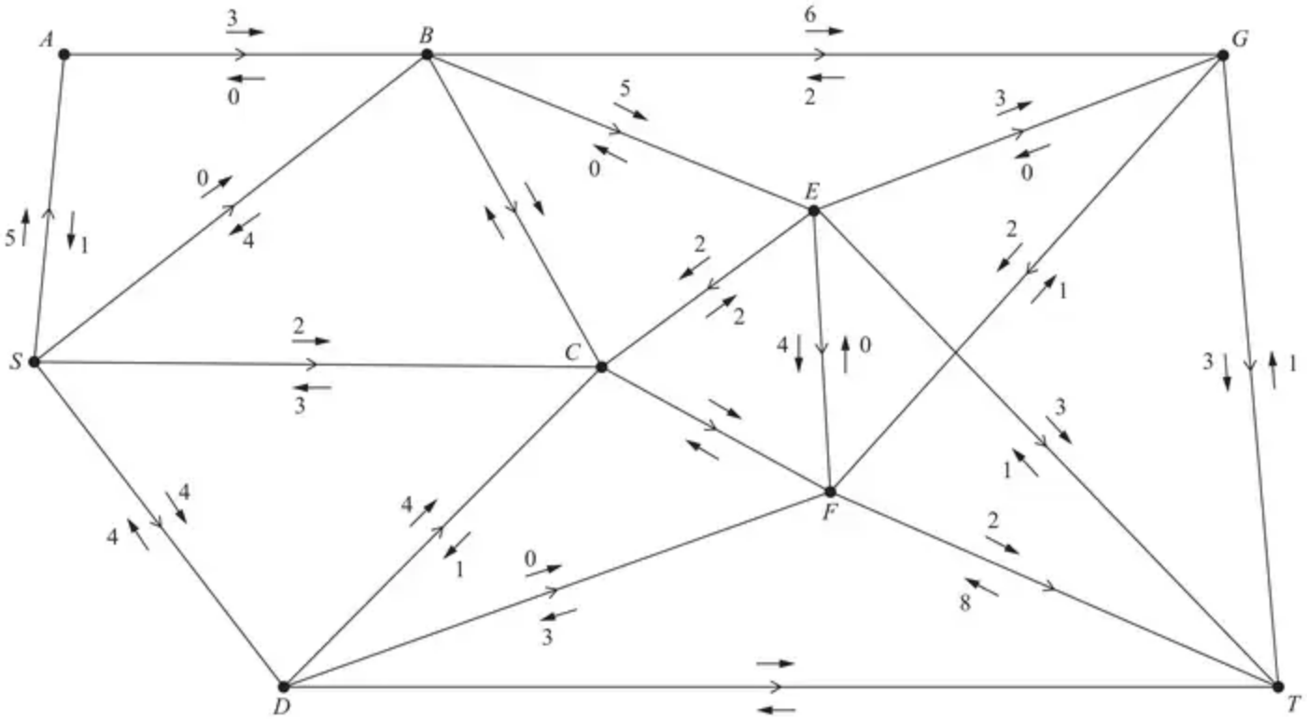
Diagram 1
(e) Use the labelling procedure to find a maximum flow through the network. You must list each flow-augmenting route you use, together with its flow. (3)
(f) Use your answer to (e) to find a maximum flow pattern for this system of pipes and draw it on Diagram 2 below. (1)
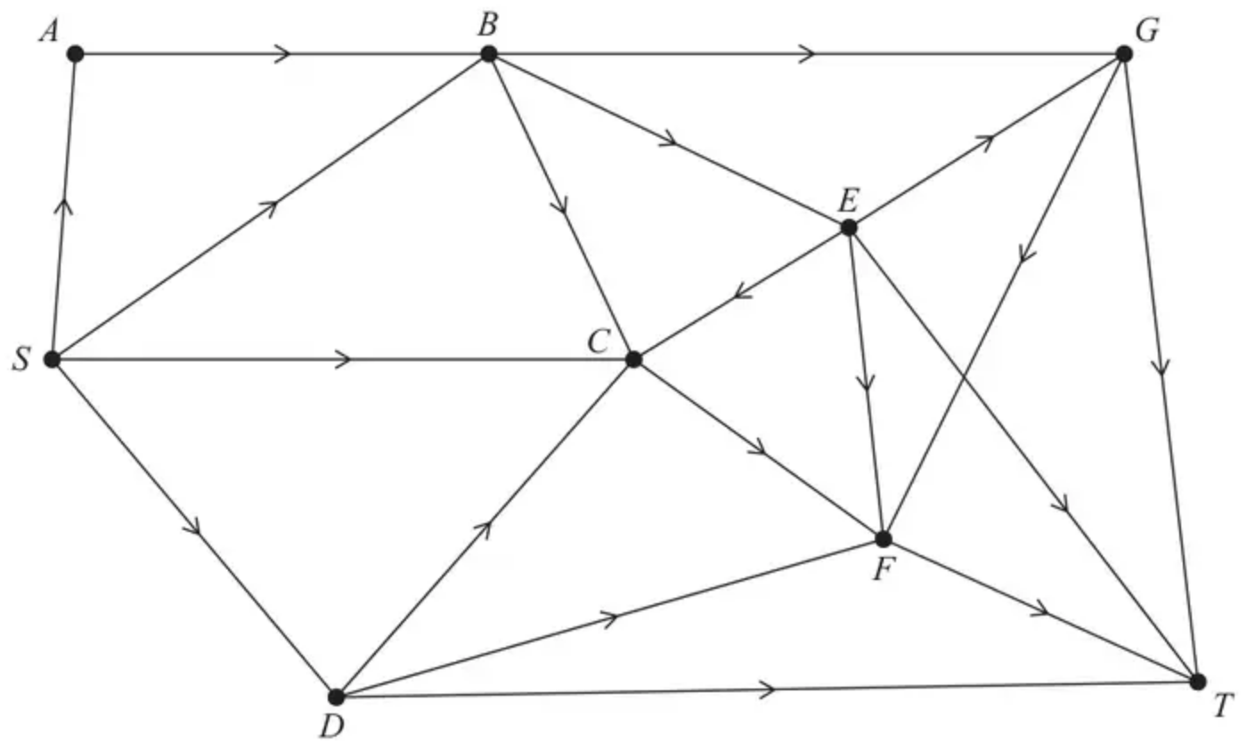
Diagram 2
(g) Prove that the answer to (f) is optimal. (3)
A vertex restriction is now applied to $B$ so that no more than 16 litres per second can flow through it.
(h)
(i) Complete Diagram 3 below to show this restriction.
(ii) State the value of the maximum flow with this restriction. (3)
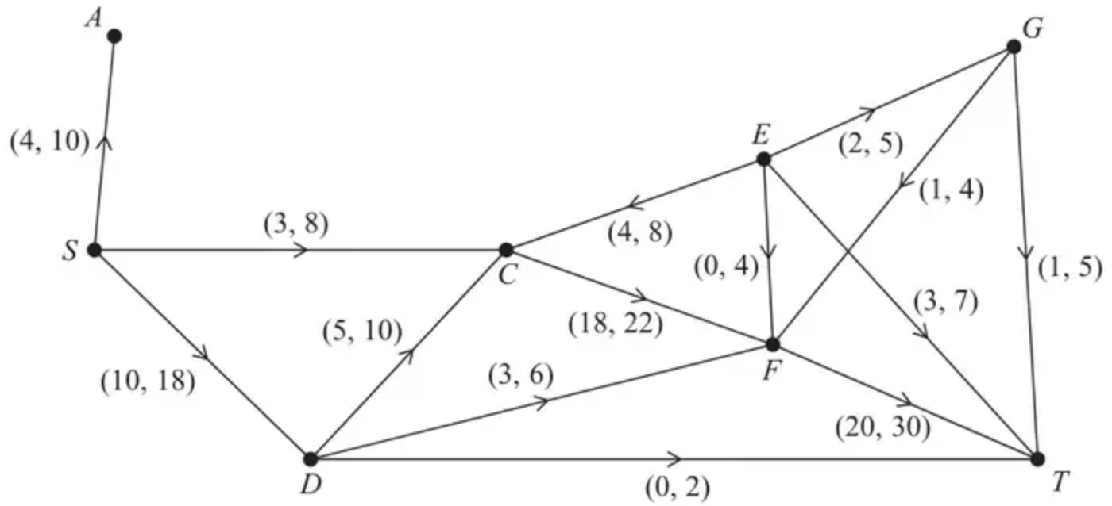
Diagram 3
(Total 16 marks)
Edexcel A2 October 2021 Q5
Solutions
1.
Mark scheme (a)
Scheme | Marks | AO
(i) $C_{1}=9+11+4+5+7=36$ | 1B1 | 1.1b
(ii) $C_{2}=8+5−2−3+11+4+5+2+4=34$ | 2B1 | 1.1b
 | (2)

Notes
(a)(i) 1B1: CAO
(ii) 1B1: CAO
Mark scheme (b)
Scheme | Marks | AO
If AE and CE were both full to capacity then $12+4=16$ litres per second would flow though E but the maximum capacity of the two arcs out of E (EH and EG) is only $8+5=13$ so AE and CE cannot both be full to capacity | 1B1 | 2.4
 | (1)

Notes
1B1: Calculates maximum capacity entering E and compares with maximum capacity leaving E. Concludes that maximum capacity into E exceeds maximum capacity out of E.
Condone statements such as ‘flow into E $=12+4<13$ which is the flow out of E’.
Mark scheme (c)
Scheme | Marks | AO
The minimum flow through the arcs AE, CE, CG, FG, FT and DT (which provides a cut for the network) is $10+2+5+5+6+4=32$ so a minimum of 32 must be flowing through the system so 31 is not possible. | 1B1 | 2.4
 | (1)

Notes
1B1: valid reason why the flow in the network cannot be 31 litres per second.
Note: If smallest of $C_{1}$ and $C_{2}$ in a) is less than 31 then DO NOT allow this mark for deducing that ‘31 > {smallest of answers from a} hence, flow of 31 is not possible’.
Mark scheme (d)
Scheme | Marks | AO
Attempt to find a flow of 32 using the answer to (c) | 1M1 | 3.4
E.g. Minimum flow of 32  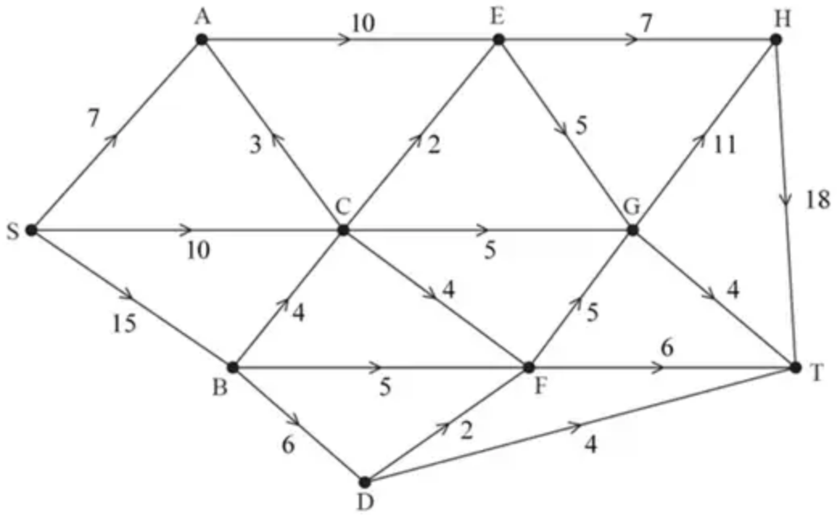 | 1A1 | 1.1b
Attempt to augment minimum flow and recognise that from (a) the maximum flow is less than or equal to 34 | 1B1 | 2.1
E.g. Maximum flow of 34  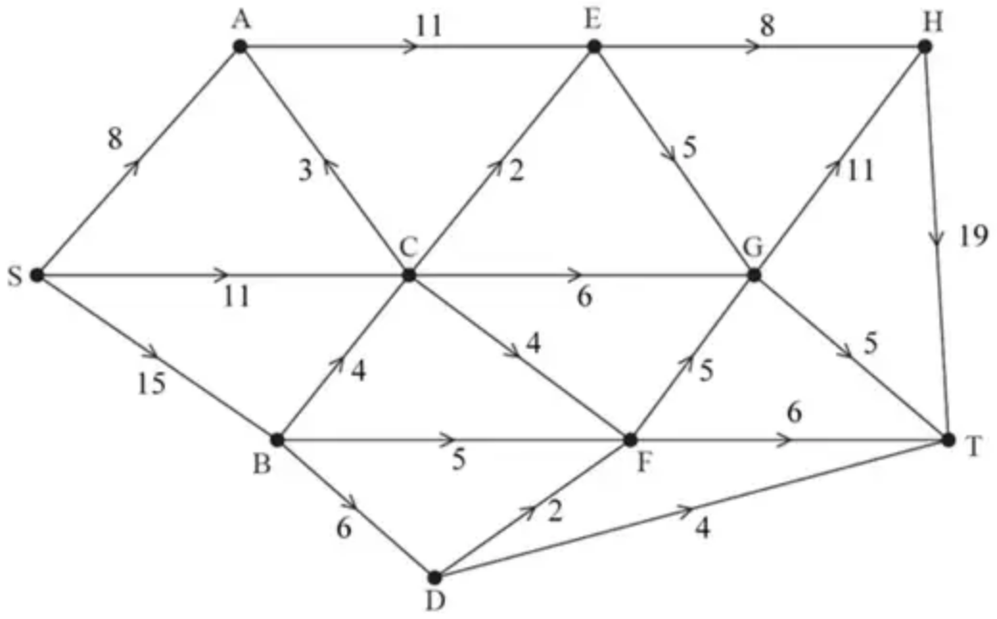 | 2B1 | 1.1b
 | (4)
 | (8 marks)

Notes
1M1: Award this mark for either:
• Indicates ‘minimum flow > 31 so minimum flow could be 32’, OR
• Attempts to find flow of 32 in which: the sum of flows along arcs from S is 32 and $7⩽$ flow along SA $⩽9$, $8⩽$ flow along SC $⩽11$ and $13⩽$ flow along SB $⩽17$, OR
• Attempts to find flow of 32 in which: the sum of flows along arcs into T is 32 and flow along DT = 4, $6⩽$ flow along FT $⩽8$, $4⩽$ flow along GT $⩽7$ and $17⩽$ flow along HT $⩽20$ (corrected from the printed mark scheme, which gives the upper bound for GT as 4)
• Identifies both ‘min flow = 32’ AND ‘max flow = 34’
Note: Only need consider arcs incident to S for the second bullet point above, or arcs incident to T for the third bullet point. Flows along other arcs may be incorrect or missing.
1A1: CAO for consistent flow of 32. One number per arc. Check for consistency at each node.
1B1: States that maximum flow must be 34 and makes some reference to (smallest cut in) part a).
1B1: CAO for consistent flow of 34. One number per arc. Check for consistency at each node.
2.
Mark scheme (a)
Scheme | Marks | AO
(i) $C_{1}=8+11+8+10+6+2=45$  (ii) $C_{2}=8+17−4−0−1+30+2=52$ | B1  B1 | 1.1b  1.1b
 | (2)

Notes
(i) B1: cao
(ii) B1: cao
Mark scheme (b)
Scheme | Marks | AO
Deduces the maximum possible flow is $⩽45$ litres per second | B1ft | 2.2a
 | (1)

Notes
B1ft: Deduced from their least value given in (a) - must include ‘less than or equal to’ (oe)
Mark scheme (c)
Scheme | Marks | AO
Initial flow = 36 | B1 | 1.1b
 | (1)

Notes
B1: cao
Mark scheme (d)
Scheme | Marks | AO
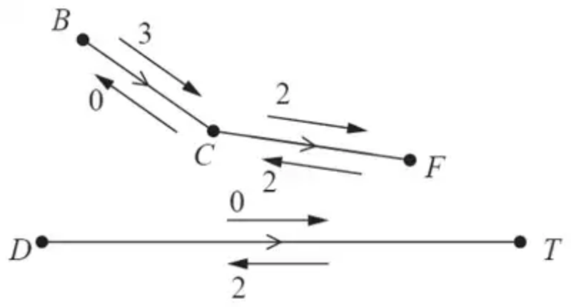 | M1  A1 | 1.1b  1.1b
 | (2)

Notes
M1: Two numbers on each arc and at least two arcs or four numbers correct (so correct numbers with the correct arrows)
A1: cao do give bod since they might well cross these numbers out
Mark scheme (e)
Scheme | Marks | AO
e.g., SABGT – 2, SCFT – 2, SDCET – 2, SABET – 1  e.g., SABGT – 3, SCFT – 2, SDCET – 2 | M1  A1  A1 | 1.1b  1.1b  1.1b
 | (3)

Notes
M1: One flow augmenting route found from S to T
A1: Two correct routes + flow values
A1: cso – increasing the flow by 7
Mark scheme (f)
Scheme | Marks | AO
e.g.  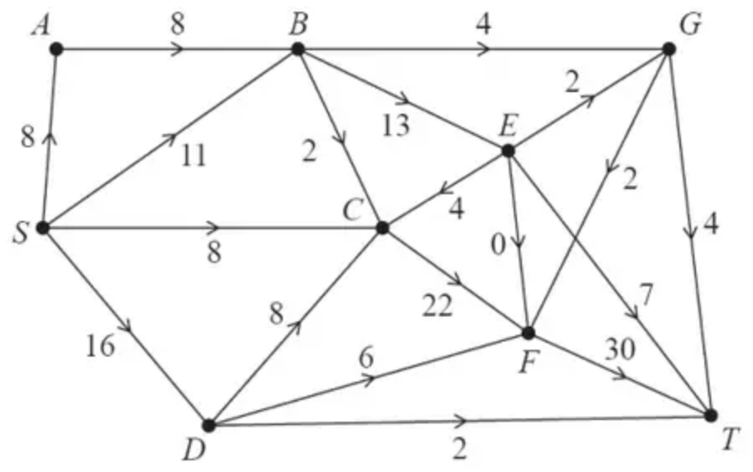 | B1 | 2.2a
 | (1)

Notes
B1: cao
Mark scheme (g)
Scheme | Marks | AO
Use of max-flow min-cut theorem  Identification of cut through AB, SB, BC, EC, CF, DF and DT  Value of flow = 43  Therefore it follows that flow is maximal | M1  A1  A1 | 2.1  3.1a  2.2a
 | (3)

Notes
M1: Construct argument based on max-flow min-cut theorem (e.g., attempt to find a cut through saturated arcs)
A1: Use appropriate process of finding a minimum cut: cut + value correct
A1: Correct deduction that the flow is maximal
Mark scheme (h)
Scheme | Marks | AO
(i)  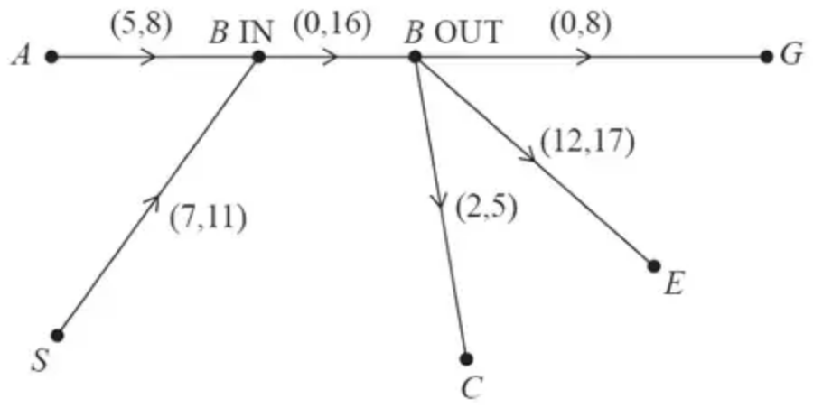 | B1  B1 | 3.3  3.3
(ii) maximum flow = 40 | B1ft | 2.2a
 | (3)
 | (16 marks)

Notes
B1: Flows into B go to B_{IN} and flows out of B go from B_{OUT}
B1: Arc of capacity 16 from B_{IN} to B_{OUT}
B1ft: value of their maximum flow – 3

