QQQ – Decision 2 – Chapter 3 – Flows in Networks 1 (Version 2)
Total Marks: 24
(24 = Platinum, 22 = Gold, 19 = Silver, 16 = Bronze)
1.
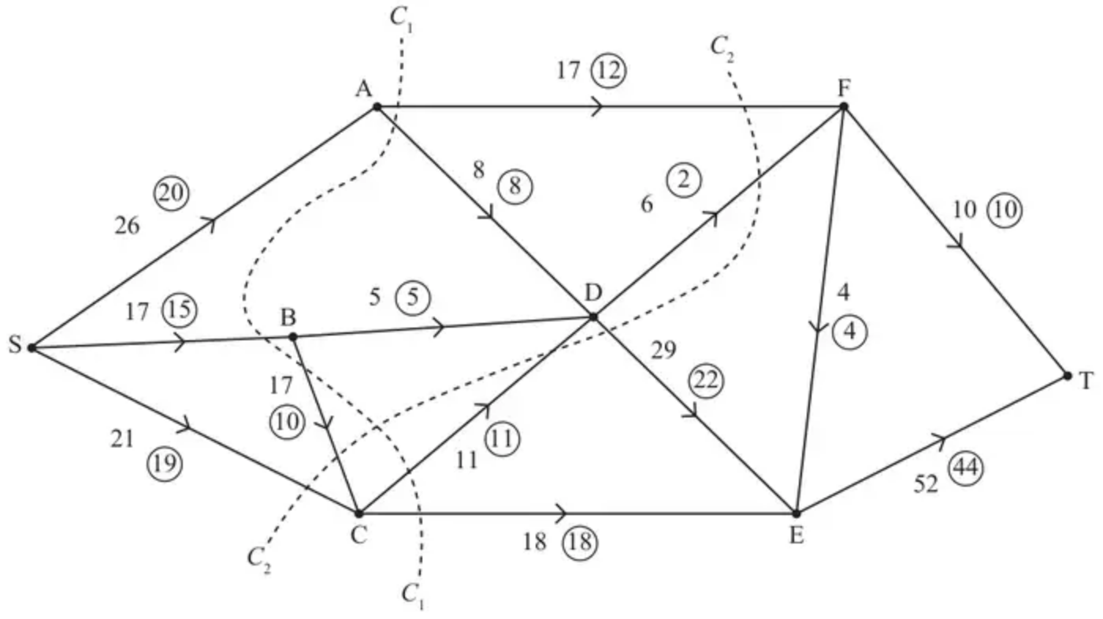
Figure 1
Figure 1 shows a capacitated, directed network of pipes. The number on each arc represents the capacity of that pipe. The numbers in circles represent a feasible flow from S to T.
(a) State the value of the feasible flow. (1)
(b) Find the capacity of cut $C_{1}$ and the capacity of cut $C_{2}$ (2)
(c) By inspection, find a flow-augmenting route to increase the flow by two units. You must state your route. (1)
(d) Prove that, once the flow-augmenting route found in (c) has been applied, the flow is now maximal. (3)
(Total 7 marks)
Edexcel A2 June 2023 Q1
2.
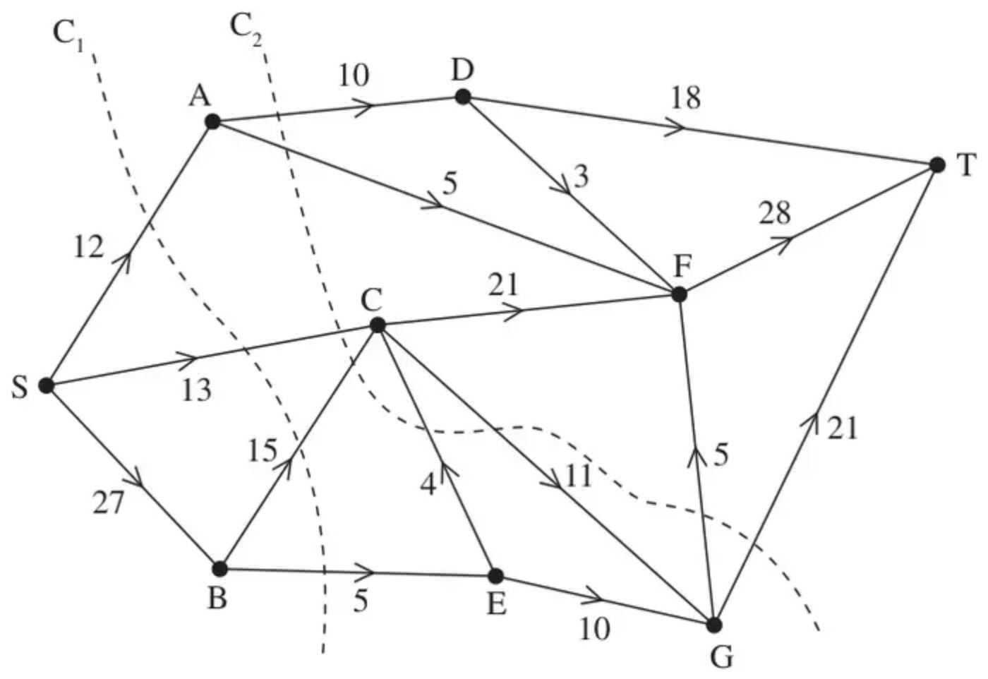
Figure 1
Figure 1 shows a capacitated network. The capacity of each arc is shown on the arc. Two cuts C${}_{1}$ and C${}_{2}$ are shown.
(a) Find the capacity of each of the two cuts. (2)
Given that one of these two cuts is a minimum cut,
(b) write down the maximum possible flow through the network. (1)
Given that the network now has a maximal flow from S to T,
(c) determine the flow along arc SB. (1)
(d) Explain why arcs GF and GT cannot both be saturated. (1)
Given that arcs EC, AD and DF are saturated and that there is no flow along arc GF,
(e) determine a maximum flow pattern for this network and draw it on Diagram 1 in the answer book. You do not need to use the labelling procedure to determine the maximum flow. (2)
(Total 7 marks)
Edexcel D2 June 2015 Q4
3.
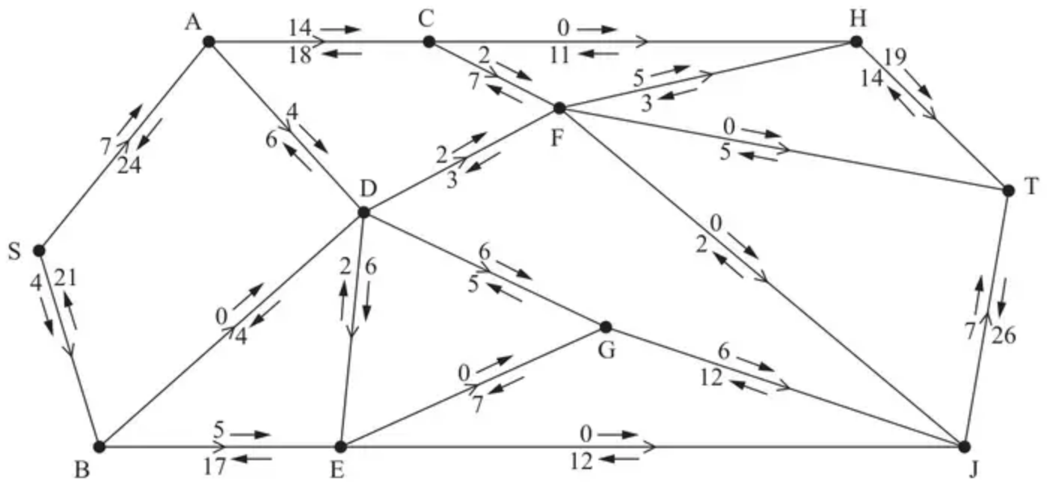
Figure 1
Alexa is monitoring a system of pipes through which fluid can flow from the source, S, to the sink, T. Currently, fluid is flowing through the system from S to T.
Alexa initialises the labelling procedure for this system, and the excess capacities and potential backflows are shown on the arrows either side of each arc, as shown in Figure 1.
(a) State the value of the initial flow. (1)
(b) Explain why arcs DF and DG can never both be full to capacity. (1)
(c) Obtain the capacity of the cut that passes through the arcs AC, AD, BD, DE, EG and EJ. (1)
(d) Use the labelling procedure to find a maximum flow through the network. You must list each flow-augmenting route you use, together with its flow. (3)
(e) Use your answers to part (d) to find a maximum flow pattern for this system of pipes and draw it on Diagram 1 in the answer book. (1)
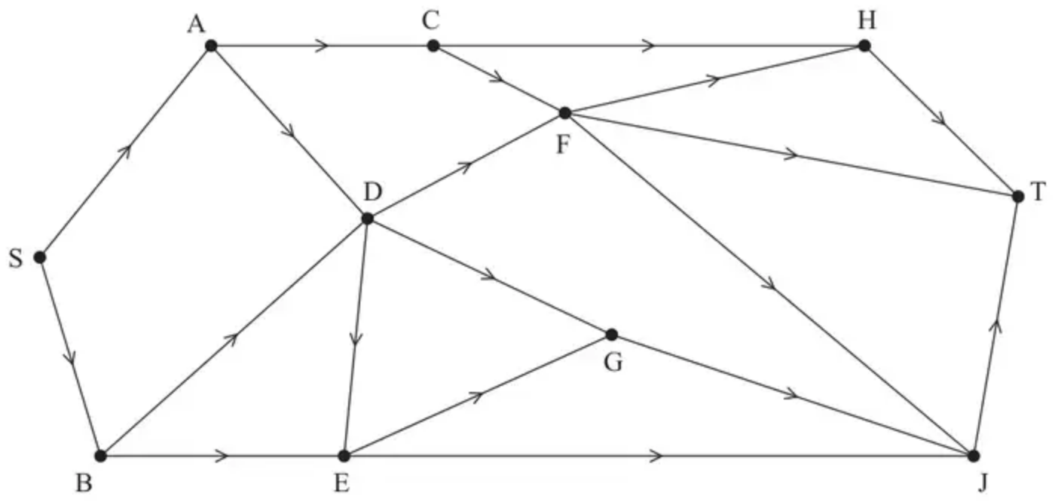
Diagram 1
(f) Prove that the answer to part (e) is optimal. (3)
(Total 10 marks)
Edexcel AS June 2019 Q3
Solutions
1.
Mark scheme (a)
Scheme | Marks | AO
54 | B1 | 1.1b
 | (1)

Notes
B1: CAO
Mark scheme (b)
Scheme | Marks | AO
$C_{1}(=17+8+17+11+18)=71$  $C_{2}(=17+6+29+17+21)=90$ | B1  B1 | 1.1b  1.1b
 | (2)

Notes
B1: CAO for $C_{1}$
B1: CAO for $C_{2}$
Mark scheme (c)
Scheme | Marks | AO
SAFDET | B1 | 1.1b
 | (1)

Notes
B1: CAO
Mark scheme (d)
Scheme | Marks | AO
Use of max-flow min-cut theorem  Identification of cut through FT, FE, DF, AD, BD, CD and CE  Value of flow = 56  Therefore it follows that flow is maximal | M1  A1  A1 | 2.1  3.1a  2.2a
 | (3)
 | (7 marks)

Notes
M1: Construct argument based on max-flow min-cut theorem (e.g. attempt to find a cut through arcs – must contain source on one side and sink on the other). Allow a cut drawn on the diagram (need not be the correct one). If cut not drawn, must list arcs not values.
A1: Use appropriate process of finding a minimum cut – FT, FE, DF, AD, BD, CD and CE plus value correct and value of flow through the network stated correctly (56)
A1: Correct deduction that the flow is maximal – must use all four words ‘maximum’, ‘flow’, ‘minimum’ and ‘cut’ (allow use of max and min) dependent on previous A1.
2.
Mark scheme (a)
Scheme | Marks
$C_{1}=45,C_{2}=73$ | B1 B1
 | (2)

Notes
a1B1: CAO for $C_{1}$ (45)
a2B1: CAO for $C_{2}$ (73)
Mark scheme (b)
Scheme | Marks
45 | B1ft
 | (1)

Notes
b1B1ft: 45 or the value of their smallest cut from (a)
Mark scheme (c)
Scheme | Marks
20 | B1
 | (1)

Notes
c1B1: CAO (20)
Mark scheme (d)
Scheme | Marks
The maximum capacity of the arcs flowing into G is 21 and so both GF and GT cannot be full to capacity as the capacity of the arcs flowing out of G is 26 | B1
 | (1)

Notes
d1B1: CAO – argument must be numerical in nature (as a minimum accept 26 > 21 (oe))
Mark scheme (e)
Scheme | Marks
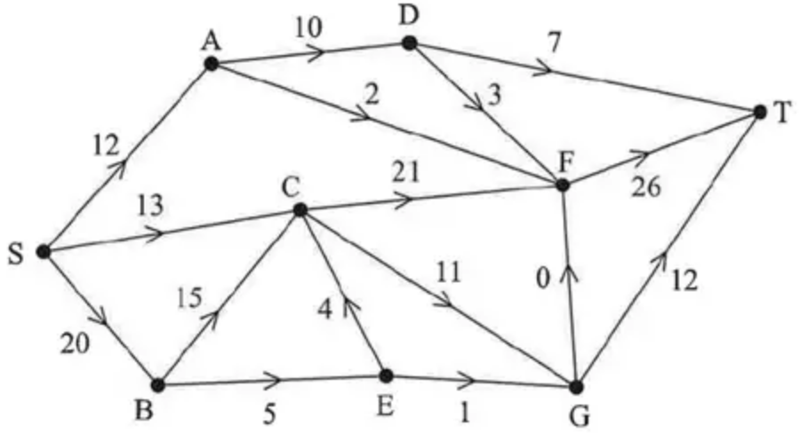 | M1 A1
 | (2)
 | 7 marks

Notes
e1M1: Consistent flow pattern – check each node, must have exactly 1 number per arc (arc EC must be 4, AD – 10 and DF – 3 but all other arcs may have over-capacatiated values)
e1A1: CAO
3.
Mark scheme (a)
Scheme | Marks | AO
45 | B1 | 1.1b
 | (1)

Notes
B1: CAO (45)
Mark scheme (b)
Scheme | Marks | AO
e.g. the total capacity of arcs DF and DG is 5 + 11 = 16. The capacity of the two arcs leading into D are 10 (from AD) and 4 (from BD) giving a total capacity into D of 14. As 14 < 16 arcs DF and DG cannot both be full to capacity | B1 | 2.4
 | (1)

Notes
B1: CAO (as a minimum accept mention that the max flow into D is 14 and max flow out of D is 16 together with comparison of these two values – (node) D must be mentioned)
Mark scheme (c)
Scheme | Marks | AO
Value of cut = 32 + 10 + 4 + 7 + 12 = 65 | B1 | 1.1b
 | (1)

Notes
B1: CAO (65)
Mark scheme (d)
Scheme | Marks | AO
e.g. SACFHT – 2; SADGJT – 4; SBEDFHT – 2  e.g. SACFHT – 2; SADGJT – 2; SADFHT – 2; SBEDGJT – 2  e.g. SACFHT – 2; SADGJT –4; SBEDGJT – 2 | M1  A1  A1 | 1.1b  1.1b  1.1b
 | (3)

Notes
M1: One correct flow augmenting route found from S to T + flow value or two correct routes
A1: Two correct routes + correct flow values
A1: CSO – increasing the flow by 8 only
Mark scheme (e)
Scheme | Marks | AO
e.g.  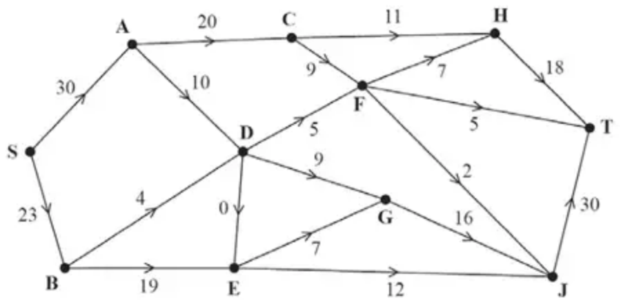  Alternative: DG 11, GJ 18, JT 32  DF 3, FH 5, HT 16 | B1 | 1.1b
 | (1)

Notes
B1: CAO – condone more than one value on an arc only if one of these values is circled – mark those that have been circled only
Mark scheme (f)
Scheme | Marks | AO
Use of max-flow min-cut theorem  Identification of cut through CH, CF, AD, BD, DE, EG and EJ  Value of flow = 53  Therefore by the max-flow min-cut theorem it follows that flow is maximal | M1  A1  A1 | 2.1  3.1a  2.2a
 | (3)
 | (10 marks)

Notes
M1: Construct the start of an argument based on the max-flow min-cut theorem (that is an attempt to find a genuine cut together with the value of either their cut or flow (but not re-iterating the cut given in (c) – AC, AD, BD, DE, EG, EJ))
A1: Use appropriate process of finding a minimum cut – must see correct cut + value correct (accept ‘53’ and the cut either stated or drawn on either diagram)
A1: Correct deduction that the flow is maximal by stating ‘maximum flow (equal to) minimum cut’ – dependent on previous A mark and the correct flow in (e)

