QQQ – Decision 2 – Chapter 3 – Flows in Networks 1 (Version 1)
Total Marks: 25
(25 = Platinum, 23 = Gold, 20 = Silver, 17 = Bronze)
1.
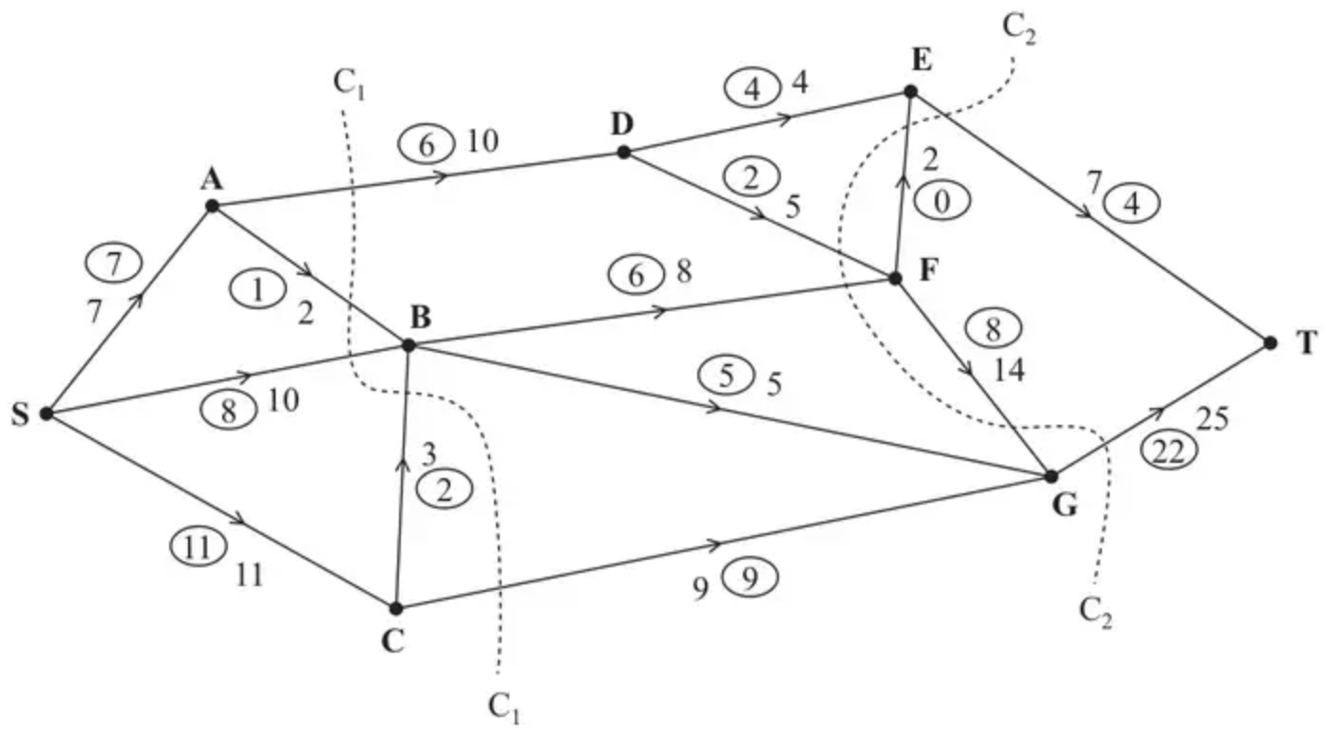
Figure 1
Figure 1 shows a capacitated network. The capacity of each arc is shown on the arc. The numbers in circles represent an initial flow from S to T.
Two cuts C${}_{1}$ and C${}_{2}$ are shown in Figure 1.
(a) Find the capacity of each of the two cuts. (2)
(b) Find the maximum flow through the network. You must list each flow-augmenting route you use together with its flow. (3)
(Total 5 marks)
Edexcel D2 June 2009 Q4
2.
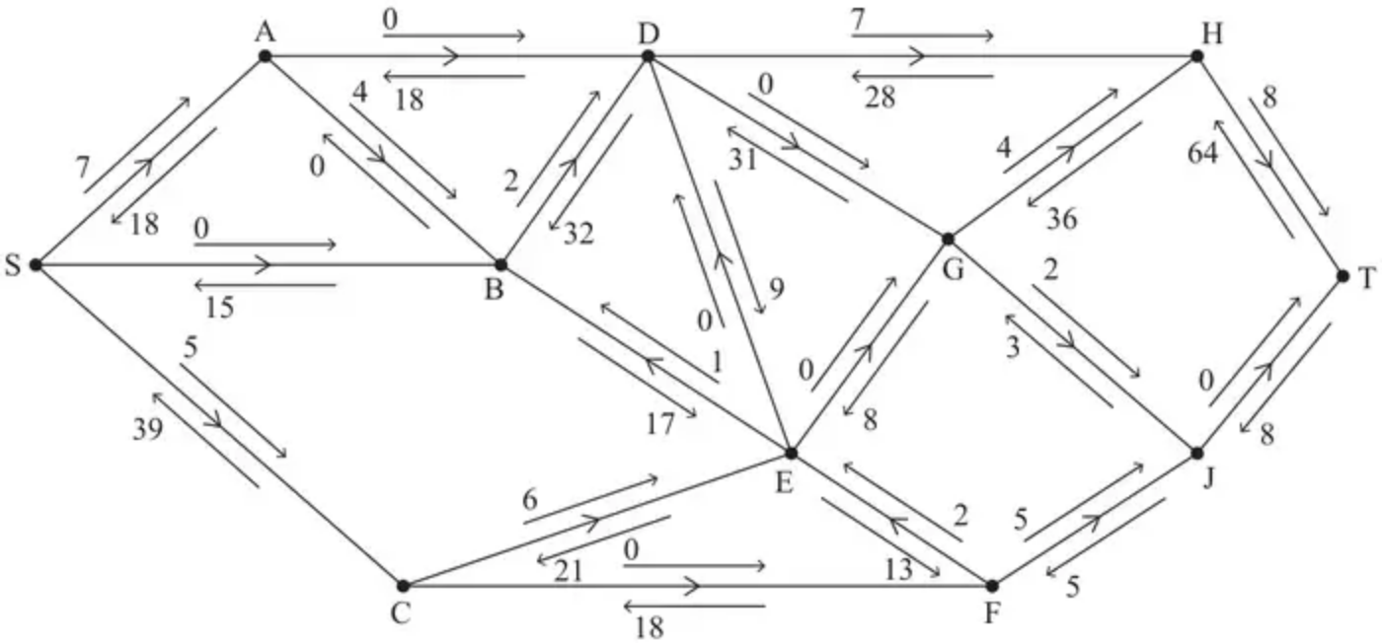
Figure 1
An engineer monitors a system of pipes through which a fluid flows from the source, S, to the sink, T.
The engineer initialises the labelling procedure for this system, and the excess capacities and potential backflows are shown on the arrows either side of each arc, as shown in Figure 1.
(a) State the value of the initial flow. (1)
(b) Obtain the capacity of the cut that passes through the arcs SA, SB, CE, FE and FJ. (1)
(c) Use the labelling procedure to find a maximum flow through the network. You must list each flow-augmenting route you use, together with its flow. (3)
(d) Use your answer to (c) to draw a maximum flow pattern on Diagram 1 in the answer book. (1)
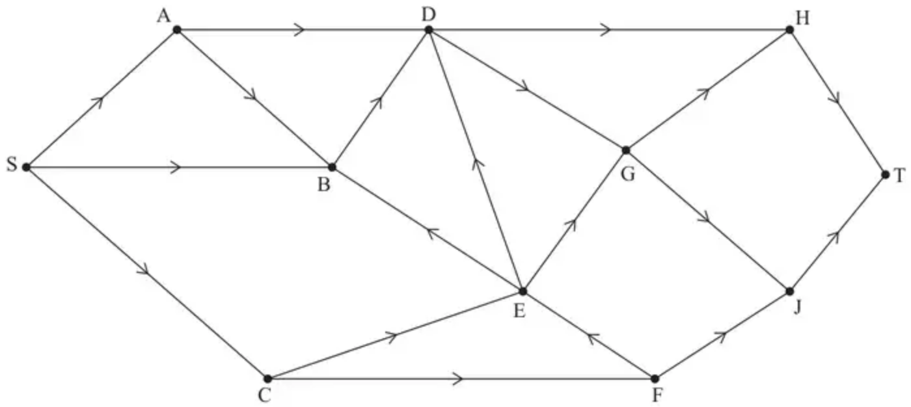
Diagram 1
(e) Prove that the answer to (d) is optimal. (3)
(Total 9 marks)
Edexcel AS June 2023 Q2
3.
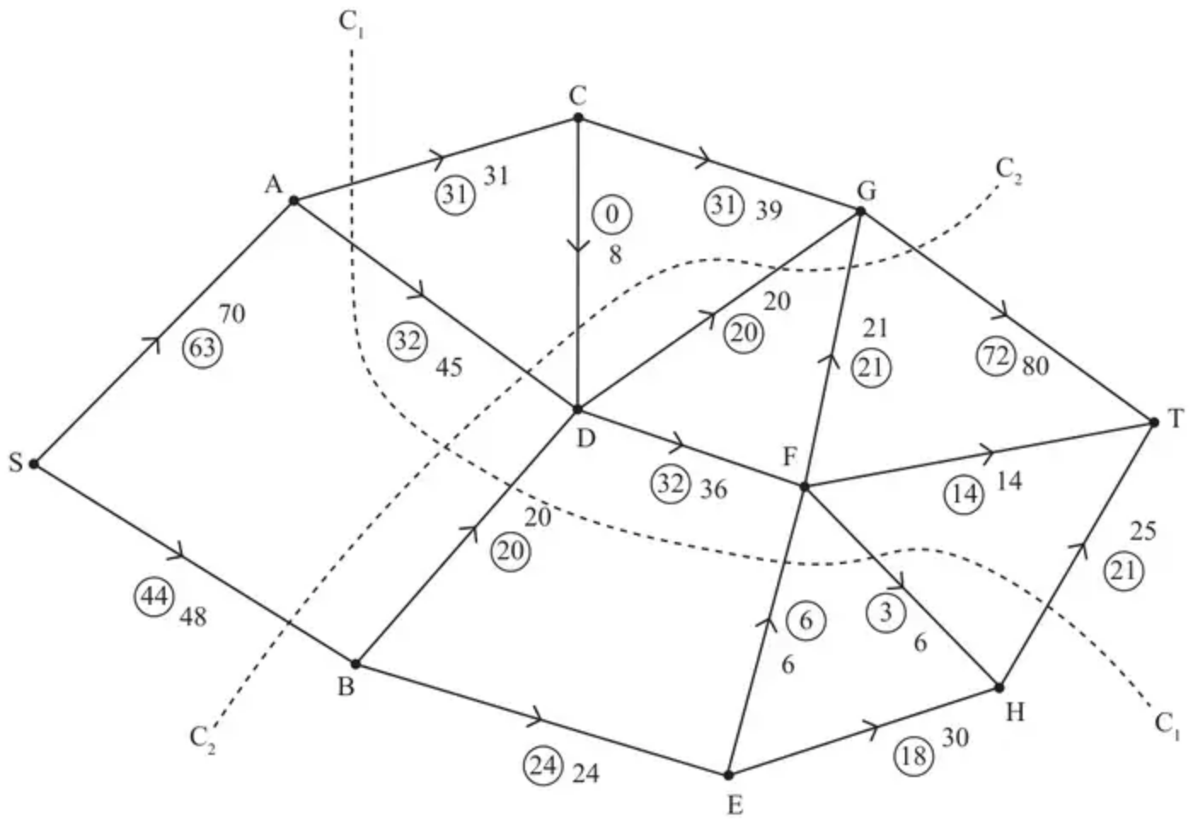
Figure 1
Figure 1 shows a capacitated, directed network of pipes. The number on each arc represents the capacity of the corresponding pipe. The numbers in circles represent a feasible flow from S to T.
(a) State the two conditions satisfied by a feasible flow. (2)
(b) List the seven saturated arcs in Figure 1. (1)
(c) Find the capacity of
(i) cut $C_{1}$
(ii) cut $C_{2}$ (2)
(d) Write down a flow-augmenting route that increases the flow by four units. (1)
(e) Use the answer to part (d) to draw the resulting flow pattern on Diagram 1 in the answer book. (2)
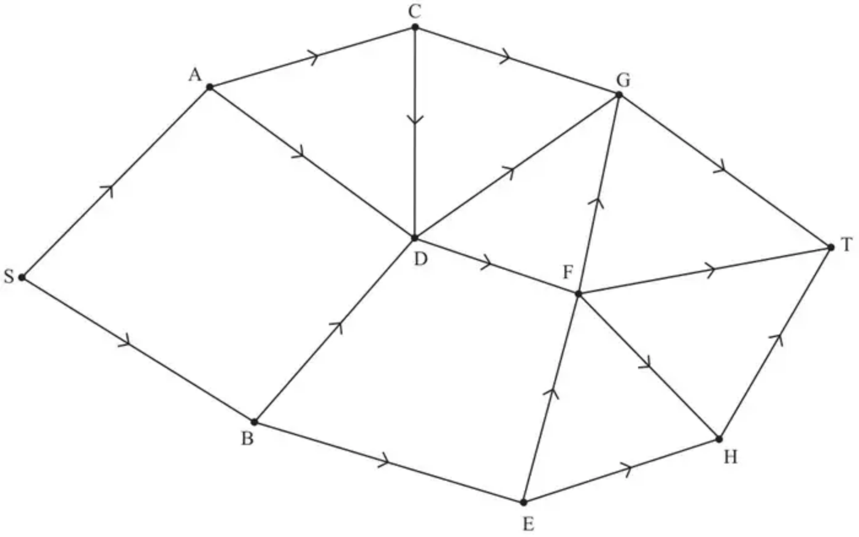
Diagram 1
(f) Prove that the answer to part (e) is a maximum flow. (3)
(Total 11 marks)
Edexcel AS June 2025 Q2
Solutions
1.
Mark scheme (a)
Scheme | Marks
Value of cut C${}_{1}$ = 34; Value of cut C${}_{2}$ = 45 | B1; B1
 | (2)

Notes
1B1: cao
2B1: cao
Mark scheme (b)
Scheme | Marks
S B F G T or S B F E T – value 2 | M1 A1
Maximum flow = 28 | A1=B1
 | (3)
 | (5 marks)

Notes
1M1: feasible flow-augmenting route and a value stated
1A1: a correct flow-augmenting route and value
1A1= B1: cao
2.
Mark scheme (a)
Scheme | Marks | AO
72 | B1 | 1.1b
 | (1)

Notes
B1: cao (72)
Mark scheme (b)
Scheme | Marks | AO
Value of cut = 25 + 15 + 27 + 15 + 10 = 92 | B1 | 1.1b
 | (1)

Notes
B1: cao (92)
Mark scheme (c)
Scheme | Marks | AO
e.g. SCEFJGHT – 3; SABDHT – 2  SCEFJGHT – 3; SCEBDHT – 1; SABDHT – 1  SABEFJGHT – 3; SABDHT – 2 | M1  A1  A1 | 1.1b  1.1b  1.1b
 | (3)

Notes
M1: One correct flow augmenting route found from S to T (so any routes that contain SB, BA, AD, CF, ED, EG, DG or JT are incorrect routes) - a ‘correct’ route is one in which the flow through the system can be increased
A1: Two correct routes (ignoring numerical value of the flow for this mark)
A1: cso – increasing the flow by 5 (and no more) – so at least two routes with corresponding correct values stated
Mark scheme (d)
Scheme | Marks | AO
e.g. (based on the first example in (c))  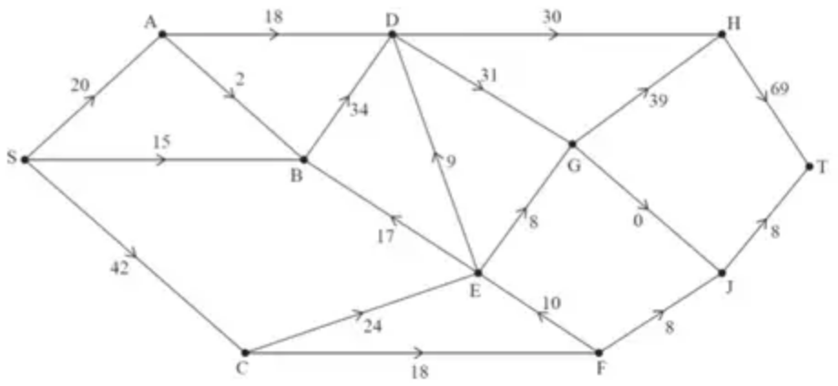 | B1 | 1.1b
 | (1)

Notes
B1: cao – if there are two numbers on each arc neither of which is circled then B0, if there are two numbers on each arc, one circled and one not, then consider the circled numbers only as the maximum flow pattern. Do not accept a blank arc as a zero
Mark scheme (e)
Scheme | Marks | AO
Use of max-flow min-cut theorem  Identification of cut through AD, BD, ED, EG, GJ and JT  Value of flow = 77  Therefore it follows that flow is optimal | M1  A1  A1 | 2.1  3.1a  2.2a
 | (3)
 | (9 marks)

Notes
M1: Construct an argument based on max-flow min-cut theorem (e.g. attempt to find a cut (but not the one through SA, SB, CE, FE, FJ) through saturated arcs – must contain source on one side and sink on the other) – allow cut shown on the Diagram 1 in the answer book – this mark is dependent on an attempt at part (d) (so values on all but two arcs)
A1: Use appropriate process of finding a minimum cut – cut (AD, BD, ED, EG, GJ, JT) and the value of the flow through the network stated correctly (77)
A1: Correct deduction that the flow is maximal – must use all four words ‘maximum’, ‘flow’, ‘minimum’ and ‘cut’ (allow abbreviations for maximum and minimum) – dep on first A mark and the B mark in (d)
3.
Mark scheme (a)
Scheme | Marks | AO
On every arc actual flow cannot exceed capacity. Total flow into a vertex equals total flow out of the vertex for all vertices apart from the source and the sink. | B1  B1 | 1.2  1.2
 | (2)

Notes
a1B1: Either condition.
a2B1: Both conditions (condone no mention of source and sink).
Mark scheme (b)
Scheme | Marks | AO
AC, BD, BE, DG, EF, FG, FT | B1 | 1.1b
 | (1)

Notes
b1B1: CAO
Mark scheme (c)
Scheme | Marks | AO
(i) $C_{1}=(31+45+20+6+25=)127$ | B1 | 1.1b
(ii) $C_{2}=(80+8+45+48=)181$ | B1 | 1.1b
 | (2)

Notes
ci1B1: CAO
cii1B1: CAO
Mark scheme (d)
Scheme | Marks | AO
SADFEHT | B1 | 1.1b
 | (1)

Notes
d1B1: A correct flow-augmenting route.
Mark scheme (e)
Scheme | Marks | AO
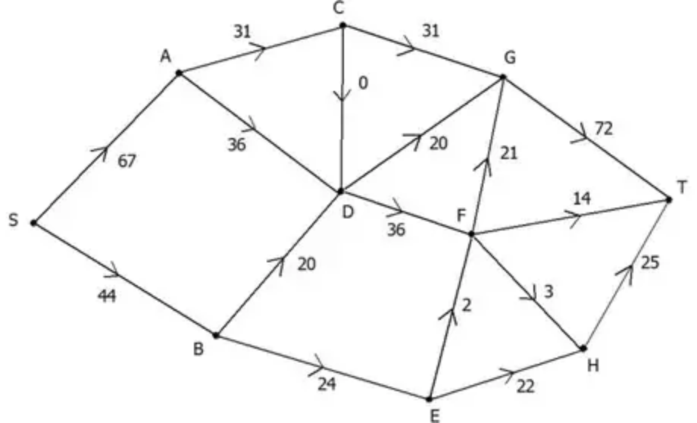 | M1  A1 | 1.1b  1.1b
 | (2)

Notes
e1M1: All arcs labelled with flows, condone two errors. Condone capacity as well (if clearly distinguished) for this mark
e1A1: Correct numbers labelled on all arcs (one number per arc)
Mark scheme (f)
Scheme | Marks | AO
Use of max-flow min-cut theorem  Identifies cut through, AC, DC, DG, DF, BE  or AC, CD, DG, FG, FT, HT capacity = 111  Value of flow =111  Therefore flow is maximal. | M1  A1  A1 | 2.1  3.1a  2.2a
 | (3)
 | (11 marks)

Notes
f1M1: Construct argument based on max-flow min-cut theorem so attempt to find a cut through saturated arcs (either stated or drawn).
f1A1: Use appropriate process for finding minimum cut, with cut and value correct.
f2A1: Correct deduction that flow is maximal. Must state value of the flow and see all 4 words max flow min cut and conclusion

