QQQ – Decision 1 – Chapter 8 – Critical Path Analysis (Version 2)
Total Marks: 22
(22 = Platinum, 20 = Gold, 18 = Silver, 15 = Bronze)
1.
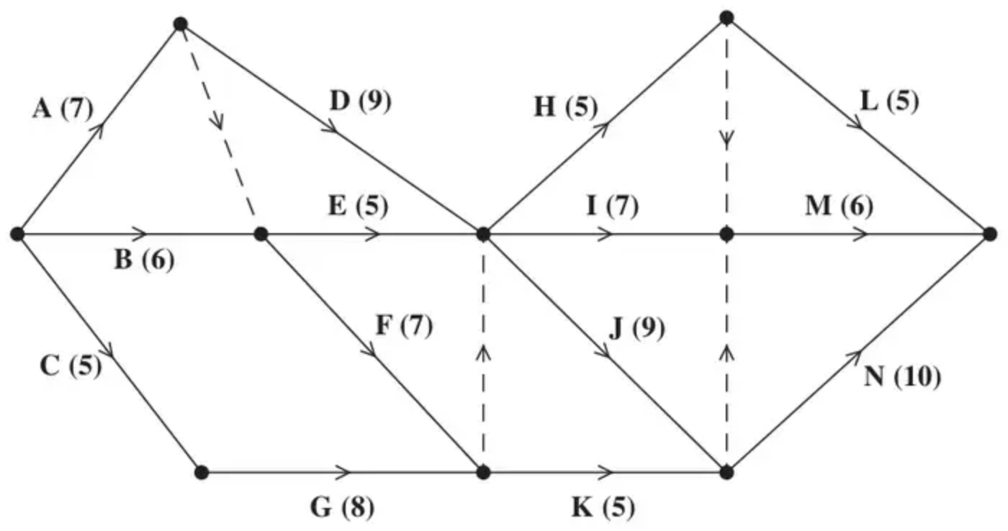
Figure 4
A project is modelled by the activity network shown in Figure 4. The activities are represented by the arcs. The number in brackets on each arc gives the time, in days, to complete the corresponding activity. Each activity requires one worker. The project is to be completed in the shortest possible time.
(a) Complete Diagram 1 in the answer book to show the early event times and the late event times. (4)
(b) State the critical activities. (1)
(c) Draw a cascade (Gantt) chart for this project on the grid in the answer book. (4)
(d) Use your cascade chart to determine the minimum number of workers needed to complete the project in the shortest possible time. You must make specific reference to times and activities. (You do not need to provide a schedule of the activities.) (2)
(Total 11 marks)
Edexcel D1 June 2018 Q6
2. The precedence table below shows the 12 activities required to complete a project.
Activity | Immediately preceding activities
A | –
B | –
C | –
D | A
E | A, B, C
F | A, B, C
G | C
H | D, E
I | D, E
J | D, E
K | F, G, J
L | F, G

(a) Draw the activity network described in the precedence table, using activity on arc.
Your activity network must contain the minimum number of dummies only. (5)
Each of the activities shown in the precedence table requires one worker. The project is to be completed in the minimum possible time.
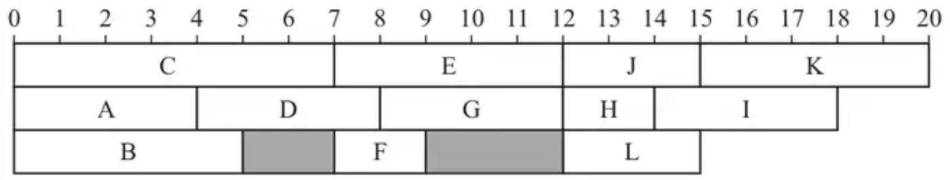
Figure 3
Figure 3 shows a schedule for the project using three workers.
(b)
(i) State the critical path for the network.
(ii) State the minimum completion time for the project.
(iii) Calculate the total float on activity B.
(iv) Calculate the total float on activity G. (4)
Immediately after the start of the project, it is found that the duration of activity I, as shown in Figure 3, is incorrect. In fact, activity I will take 8 hours.
The durations of all the other activities remain as shown in Figure 3.
(c) Determine whether the project can still be completed in the minimum completion time using only three workers when the duration of activity I is 8 hours.
Your answer must make specific reference to workers, times and activities. (2)
(Total 11 marks)
Edexcel A2 June 2024 Q6
Solutions
1.
Mark scheme (a)
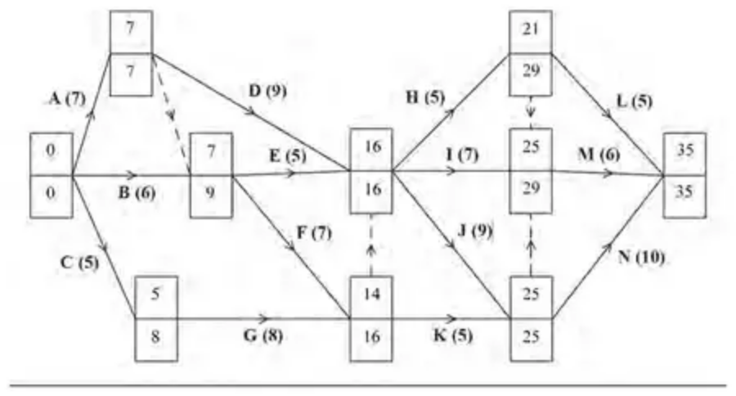
Scheme | Marks
 | M1
 | A1
 | M1
 | A1
 | (4)

Notes
a1M1: All top boxes complete, values in the top boxes generally increasing in the direction of the arrows (‘left to right’), condone one ‘rogue’ value (if values do not increase in the direction of the arrows then if one value is ignored and then the values do increase in the direction of the arrows then this is considered to be only one rogue value)
a1A1: CAO for the top boxes
a2M1: All bottom boxes complete, values generally decreasing in the opposite direction of the arrows (‘right to left’), condone one rogue. Condone missing 0 and/or 35 for the M only
a2A1: CAO for the bottom boxes
Mark scheme (b)
Scheme | Marks
Critical activities: A, D, J and N | B1
 | (1)

Notes
b1B1: CAO (A, D, J and N)
Mark scheme (c)
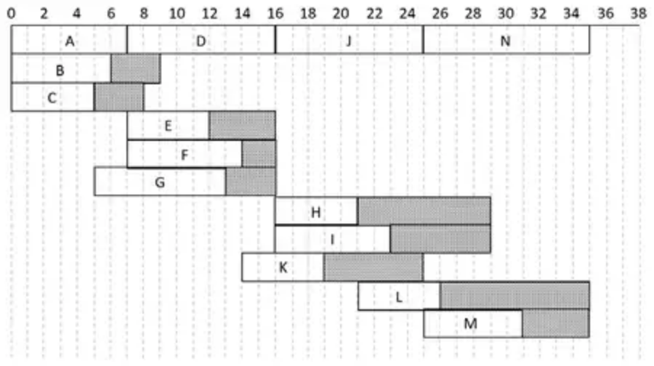
Scheme | Marks
 | M1
 | A1
 | A1
 | A1
 | (4)

Notes
c1M1: At least twelve activities including at least six floats. A scheduling diagram only scores M0 – however, if a scheduling diagram appears after a Gantt chart then mark Gantt chart and isw their scheduling
c1A1: The critical activities dealt with correctly and appearing just once (A, D, J and N) and three non-critical activities dealt with correctly
c2A1: Any seven non-critical activities correct (this mark is not dependent on the previous A mark)
c3A1: CSO – completely correct Gantt chart (exactly fourteen activities appearing just once)
Mark scheme (d)
Scheme | Marks
Minimum workers is 4 e.g. D, E, F and G | M1
together with $11<\text{time}<12$ | A1
 | (2)
 | (11 marks)

Notes
d1M1: Either a statement with the correct number of workers (4) and the correct activities (D, E, F and G) with any numerical time stated or the correct number of workers (4) and a correct time
d1A1: A completely correct statement with details of both time and activities. Candidates only need to give a time within the correct interval of $11<\text{time}<12$. Please note the strict inequalities for the time interval (e.g. implying a time of 11 is incorrect). Answers given as an interval of time are acceptable provided the time interval stated is correct for all its possible values (e.g. ‘time 11 – 12’ is A0, ‘in the interval 11 – 12’ is A0 but ‘betweeen 11 and 12’ is A1). Allow for example, ‘on day 12’ as equivalent to $11<\text{time}<12$
2.
Mark scheme (a)
Scheme | Marks | AO
e.g.  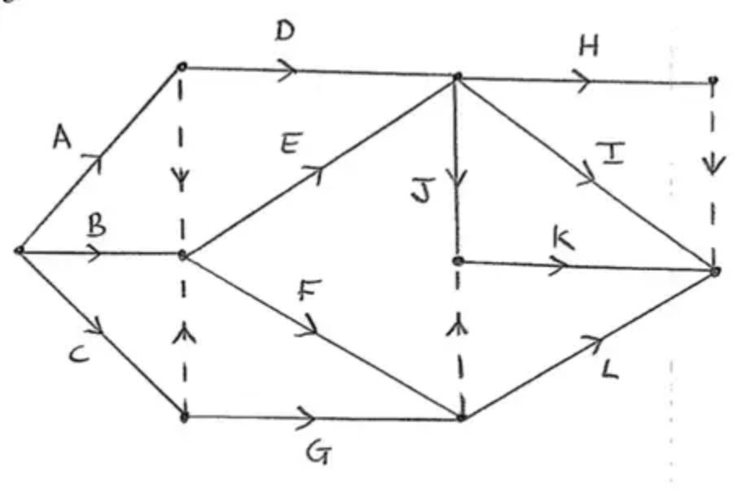 | M1  A1  A1  A1  A1 | 2.1  1.1b  1.1b  1.1b  1.1b
 | (5)

Notes
Condone lack of, or incorrect, numbered events throughout. ‘Dealt with correctly’ means that the activity starts from the correct event but need not necessarily finishes at the correct event, e.g. ‘H dealt with correctly’ requires the correct precedences for this activity, i.e. D and E labelled correctly and leading into the same node and H starting from that node but do not consider the end event for H. Activity on node is M0
If an arc is not labelled, for example, if the arc for activity C is not labelled (but the arc is present) then this will lose the first A mark and the final (CSO) A mark – they can still earn the second A mark on the bod. If two or more arcs are not labelled then mark according to the scheme. Assume that a solid line is an activity which has not been labelled rather than a dummy (even if in the correct place for where a dummy should be)
Note: if they make multiple attempts which are not clearly replaced mark the one which is best for the candidate
Ignore incorrect or lack of arrows on the activities for the first four marks only
M1: At least nine activities (labelled on arc), one start, at least two dummies placed
A1: Activities A, B, C, D and G dealt with correctly
A1: Activities E, F, H, I and J and the first two dummies (+ arrows) at the ends of A and C dealt with correctly (note H and I are interchangeable)
A1: Activities K, L and dummy at the end of F/G (+ arrow) dealt with correctly
A1: CSO – Final dummy (+ arrow) for uniqueness of H/I, all arrows present for every activity with one finish and no additional dummies. (Note direction of arrow on dummy between H and I is interchangeable) (Note the dummy could also be drawn at the start of H and I)
Please check all arcs carefully for arrows – if there are no arrows on dummies then M1A1max
Note that additional (but unnecessary) ‘correct’ dummies that still maintain precedence for the network should only be penalised with the final A mark if earned
Mark scheme (b)
Scheme | Marks | AO
(i) Critical path: C – E – J – K | B1 | 1.1b
(ii) Minimum completion time: 20 | B1 | 1.1b
(iii) Total float on activity B is 2 | B1 | 1.1b
(iv) Total float on activity G is 4 | B1 | 3.1b
 | (4)

Notes
(i) B1: CAO (critical path CEJK – in this order)
(ii) B1: CAO (20)
(iii) B1: CAO (2 – total float on B)
(iv) B1: CAO (4 – total float on G)
Mark scheme (c)
Scheme | Marks | AO
e.g.  (One worker continues to do the critical activities (in time 20))  Second worker completes A, D, G and H as originally planned but now completes activity L in the interval 14 to 20 (but must have started L by time 17 at the latest due to its duration of 3)  Third worker completes B and F as planned but now completes activity I exactly in the time interval 12 to 20  so yes, the project can be completed by 3 workers | B2, 1, 0 | 2.4  2.4
e.g.
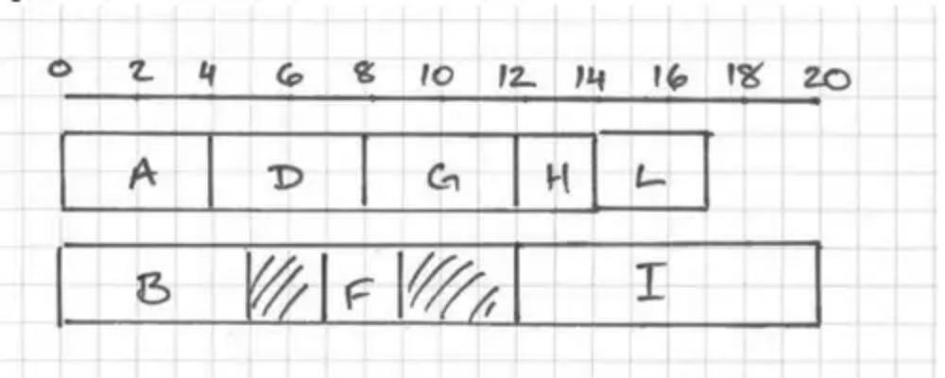
Yes – can be completed by 3 workers
 | (2)
 | (11 marks)

Notes
B1: Award this mark with an indication that either
• activities I and L have swapped workers
• activity H has swapped worker and I now starts at 12
B1: dependent on first B mark – must have a time reference for both I and either L or H for this mark (L or H may be a range) completely correct reasoning including mention of workers, times and activities (for example, clear indication that (H and) L (in either order) must take place in the interval 12 to 20 and that I must now be done in the interval 12 to 20 or states starts at 12 but not just ends at 20) and either concludes yes or clearly implies that it can be completed on time
Note their explanation must not include an incorrect statement
Alternatively redraws the schedule for worker 2 and 3 with one completing H and L (in either order) in the time interval 12 – 20 and the other completing I and concludes that the project can be completed by 3 workers

