QQQ – Decision 1 – Chapter 8 – Critical Path Analysis (Version 1)
Total Marks: 25
(25 = Platinum, 23 = Gold, 20 = Silver, 17 = Bronze)
1.
(a) Draw the activity network described in the precedence table below, using activity on arc and exactly two dummies. (5)
Activity | Immediately preceding activities
A | –
B | –
C | –
D | A, B
E | C
F | A, B
G | A, B
H | E, F
I | D
J | D, G
K | H

(b) Explain why each of the two dummies is necessary. (2)
(Total 7 marks)
Edexcel D1 June 2014 Q2
2.
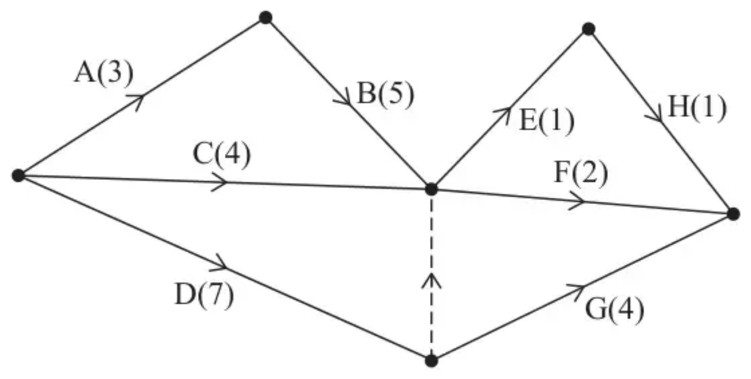
Figure 3
The network in Figure 3 shows the activities that need to be undertaken to complete a project. Each activity is represented by an arc and the duration, in hours, of the corresponding activity is shown in brackets.
(a)
(i) Complete Diagram 1 in the answer book to show the early event times and the late event times.
(ii) State the minimum completion time of the project. (3)
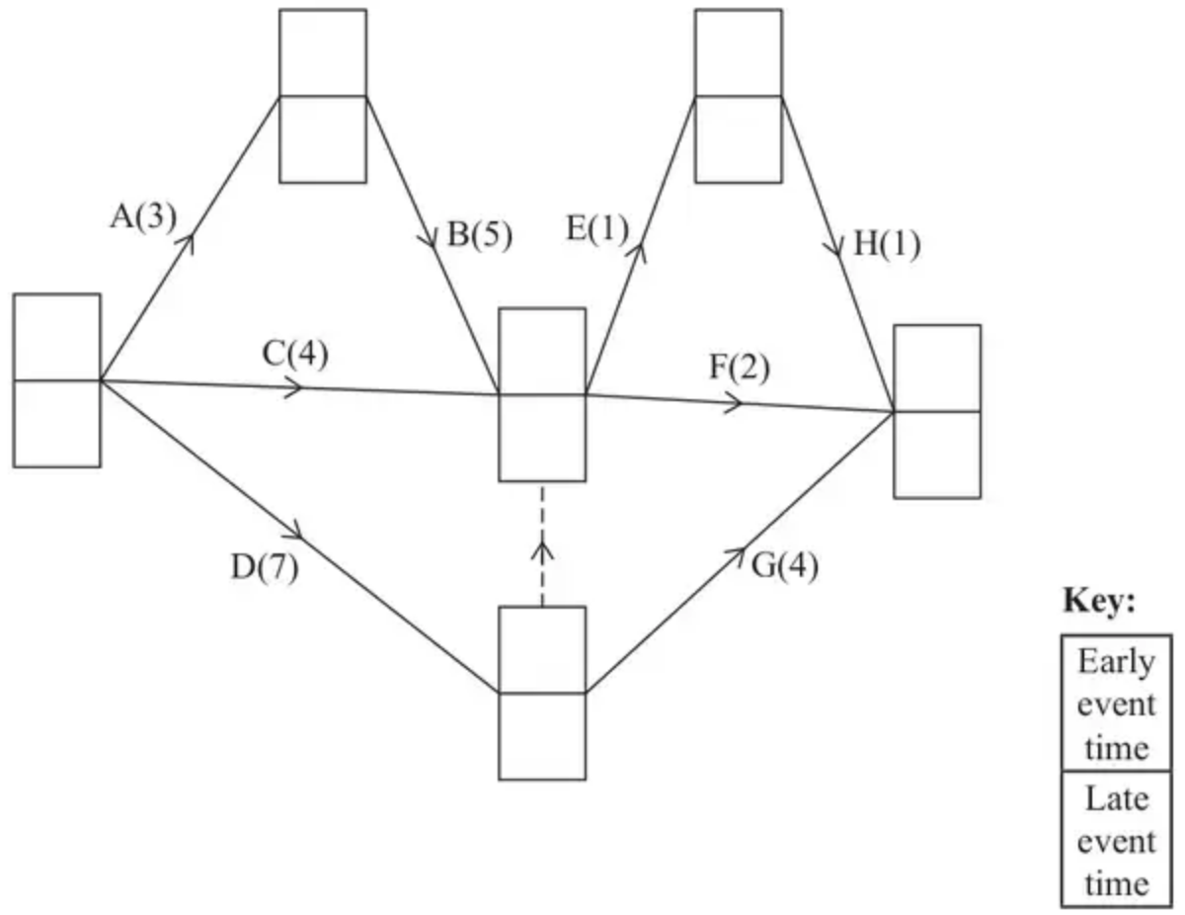
Diagram 1
The table below lists the number of workers required for each activity in the project.
Activity | Number of workers
A | 2
B | 1
C | 2
D | 2
E | 3
F | 2
G | 1
H | 3

Each worker is able to do any of the activities. Once an activity is started it must be completed without interruption. It is given that each activity begins at its earliest possible start time.
(b)
(i) On Grid 1 in the answer book, draw a resource histogram to show the number of workers required at each time.
(ii) Hence state the time interval(s) when six workers are required. (4)
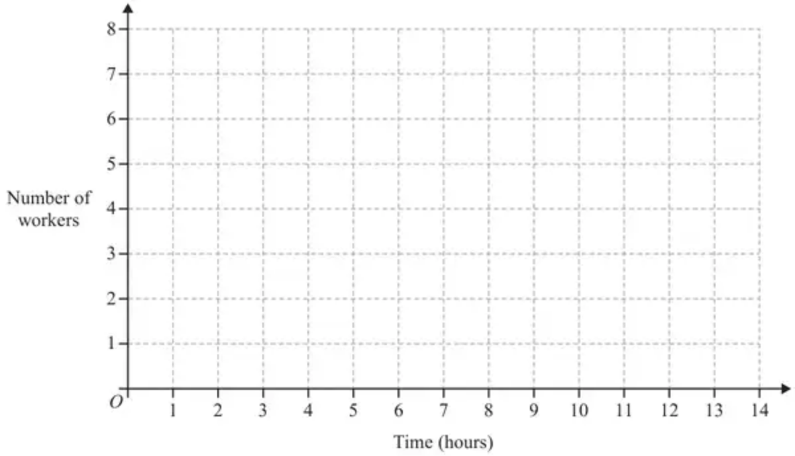
Grid 1
(Total 7 marks)
Edexcel A2 June 2023 Q2
3.
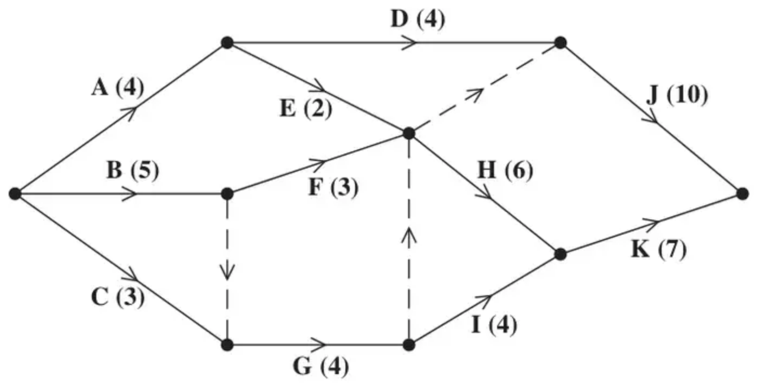
Figure 5
A project is modelled by the activity network shown in Figure 5. The activities are represented by the arcs. The number in brackets on each arc gives the time, in days, to complete the activity. Each activity requires one worker. The project is to be completed in the shortest possible time.
(a) Complete Diagram 1 in the answer book to show the early event times and late event times. (4)
(b) Calculate the total float for activity D. You must make the numbers you use in your calculation clear. (2)
(c) Calculate a lower bound for the number of workers needed to complete the project in the minimum time. You must show your working. (2)
The project is to be completed in the minimum time using as few workers as possible.
(d) Schedule the activities using Grid 1 in the answer book. (3)
(Total 11 marks)
Edexcel D1 June 2014 (R) Q7
Solutions
1.
Mark scheme (a)
Scheme | Marks
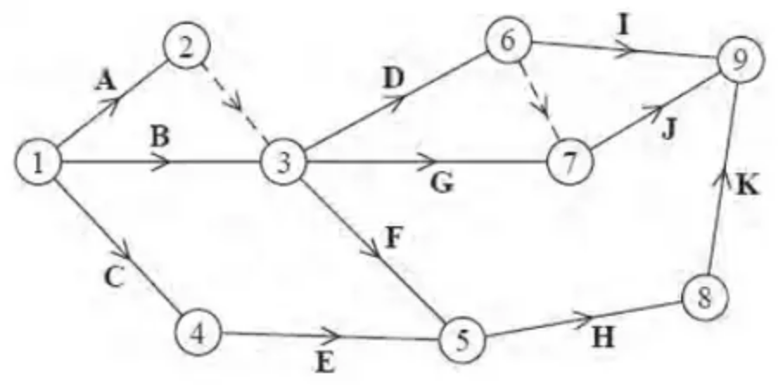 | M1  A1  A1  A1  A1
 | (5)

Notes
Throughout part (a) condone lack of numbered events throughout – also ‘dealt with correctly’ means that the activity starts from the correct event (but not necessarily finishing at the correct event) e.g. ‘H dealt with correctly’ requires F and E leading into the same event and H starting from that event (but not necessarily H leading into K). Activity on node is M0.
a1M1 7 activities and one dummy placed.
a1A1 One start + activities A, B, C and E dealt with correctly.
a2A1 Activities D, F, G, H and K and the 1st dummy dealt with correctly.
a3A1 Activities I and J and the 2nd dummy dealt with correctly.
a4A1 CSO (all four previous marks must have been awarded) - all arrows present and correctly placed with one finish – condone lack of arrows for the first four marks only. No ‘extra’ activities.
Note that another valid solution would be the dummy going from event 3 to event 2 and D, G and F coming out of event 2. Or the candidate could start with a dummy from event 1 to ensure the uniqueness of activities A and B.
Mark scheme (b)
Scheme | Marks
1st dummy – A and B both must be able to be described uniquely in terms of the events at each end. | B1
2nd dummy – I depends on D only but J depends on D and G. | B1
 | (2)
 | (7 marks)

Notes
b1B1 CAO – with no incorrect terminology (e.g. event for activity) - please note that e.g. ‘so that activities can be defined uniquely’ is not sufficient to earn this mark. There must be a mention of describing activities uniquely in terms of the events at each end. However give bod on statements that imply that an activity begins and ends at the same event e.g. ‘so that activites do not have the same start and finish’ is sufficient for B1.
b2B1 CAO – all relevant activities must be referred to – so activities D, G, I and J must all be mentioned for this mark.
2.
Mark scheme (a)
Scheme | Marks | AO
(i)  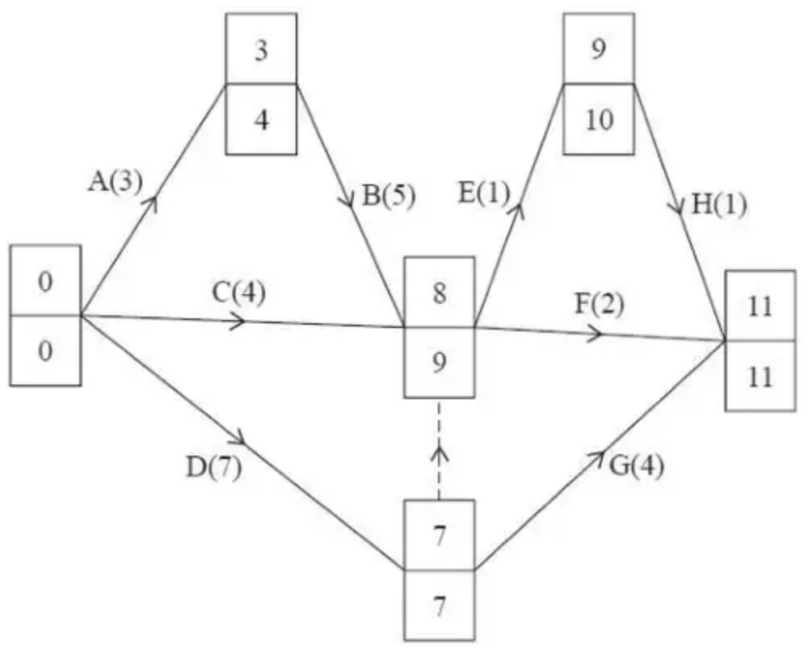 | M1  A1 | 1.1b  1.1b
(ii) 11 (hours) | A1ft | 2.2a
 | (3)

Notes
(a)(i)
M1: All top boxes and all bottom boxes completed. Values generally increasing left to right (for top boxes) and values generally decreasing from right to left (for bottom boxes). Condone missing 0s at the source node and/or their 11 in the bottom box at the sink node for M only. Condone one rogue value in top boxes and one rogue value in bottom boxes. For a rogue in the top boxes if values do not increase in the direction of the arrows then if one value is ignored and then the values do increase in the direction of the arrows then this is considered to be only one rogue value (with a similar definition for bottom boxes but in reverse)
A1: CAO - Top boxes and Bottom boxes (all completed)
(ii)
A1ft: Follow through their final early event time (the final late event time does not need to be the same as the final early event time to award this mark) – units not required and ignore incorrect units (just mark the value stated)
Mark scheme (b)
Scheme | Marks | AO
(i)  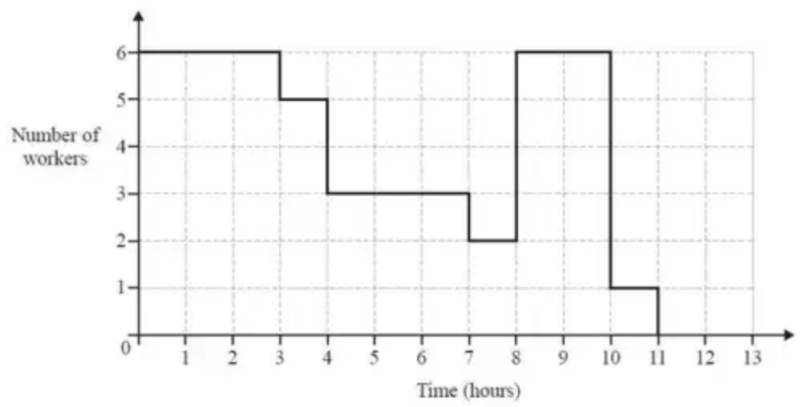 | M1  A1  A1 | 1.1b  1.1b  1.1b
(ii) Six workers are required in the time intervals 0 – 3 and 8 – 10 | A1 | 2.2a
 | (4)
 | (7 marks)

Notes
(b)(i) Do not consider the placement of the activities (if shown) in the histogram – consider only the placement of each vertical bar
M1: Plausible histogram (correct up to time 4) with no holes or overhangs (must go to at least 10 on the time axis)
A1: Histogram correct to time 8
A1: Histogram correct from time 8 to time 11 with no activities taking place after time 11
(b)(ii)
A1: CAO (0 to 3 and 8 to 10) – allow any indication of an interval from 0 to 3 and 8 to 10 (so accept any use of $<,⩽$ or just a dash but not, for example, 0 to 2.999…)
3.
Mark scheme (a)
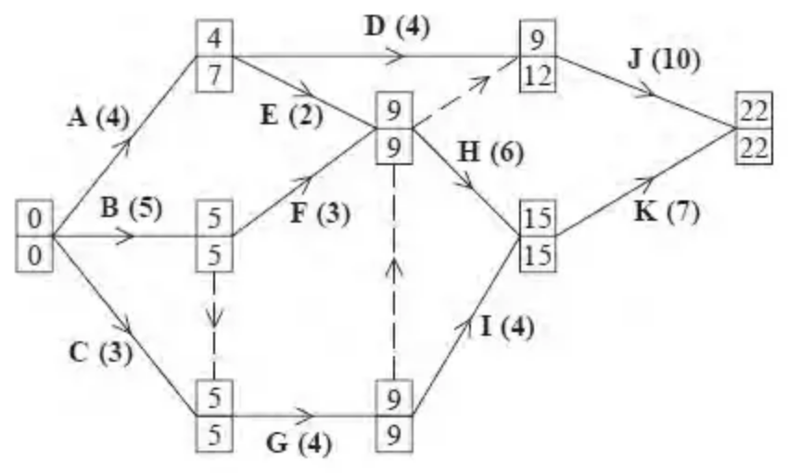
Scheme | Marks
 | M1 A1
 | M1 A1
 | (4)

Notes
a1M1: All top boxes complete, values generally increasing left to right, condone one rogue.
a1A1: CAO
a2M1: All bottom boxes complete, values generally decreasing right to left, condone one rogue. Condone missing 0 or 22 for the M only.
a2A1: CAO
Mark scheme (b)
Scheme | Marks
Total float for D = 12 – 4 – 4 = 4 | M1 A1
 | (2)

Notes
b1M1: Correct calculation for their activity D seen – their three numbers correct. Final value must be non-negative.
b1A1: CAO – no ft on this mark. The answer of 4 (with no working) scores no marks.
Mark scheme (c)
Scheme | Marks
$\frac{52}{22}≈2.36$ so 3 workers | M1 A1
 | (2)

Notes
c1M1: Attempt to find lower bound: [42-62 / their finish time].
c1A1: CAO – correct calculation seen then 3. No working scores M0 A0.
Mark scheme (d)
e.g.
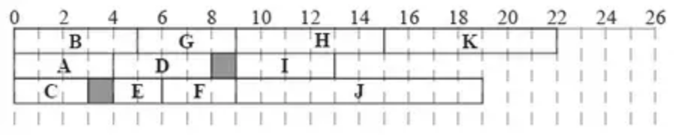
Scheme | Marks
 | M1
 | A1
 | A1
 | (3)
 | (11 marks)

Notes
d1M1: Not a cascade chart. 3 ‘workers’ used at most and at least 7 activities placed.
d2A1: 3 workers. All 11 activities present (just once). Condone one error either precedence, time interval or activity length.
d3A1: 3 workers. All 11 activities present (just once). No errors.
For reference:
Activity | Duration | Time interval | IPA
A | 4 | 0 – 7 | -
B | 5 | 0 – 5 | -
C | 3 | 0 – 5 | -
D | 4 | 4 – 12 | A
E | 2 | 4 – 9 | A
F | 3 | 5 – 9 | B
G | 4 | 5 – 9 | B, C
H | 6 | 9 – 15 | E, F, G
I | 4 | 9 – 15 | G
J | 10 | 9 – 22 | D, E, F
K | 7 | 15 – 22 | H, I

